User Manual

How to run Linphone Cordova Demo App
We assume that we are using Mac OS & Cordova already installed for these steps.
Step 1: Open Terminal app & go to demo app’s root folder.
Step 2: To build & run app.
- On Android, enter the following line:
cordova run android
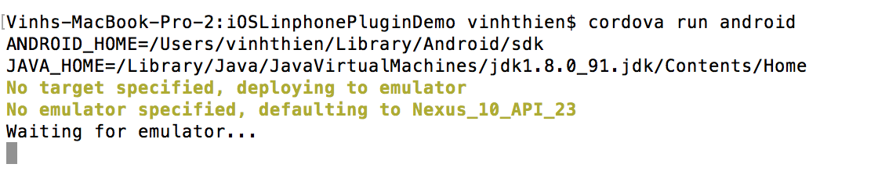
If you are waiting so long time, stop the progress (press Ctrl + C) and enter “cordova run android” again.

And the you will see app built & running.
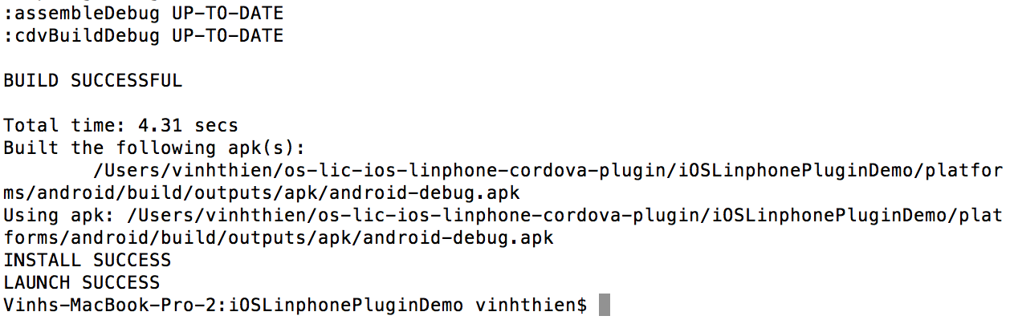
- On iOS, enter the following line:
cordova run ios
And the you will see app built & running.
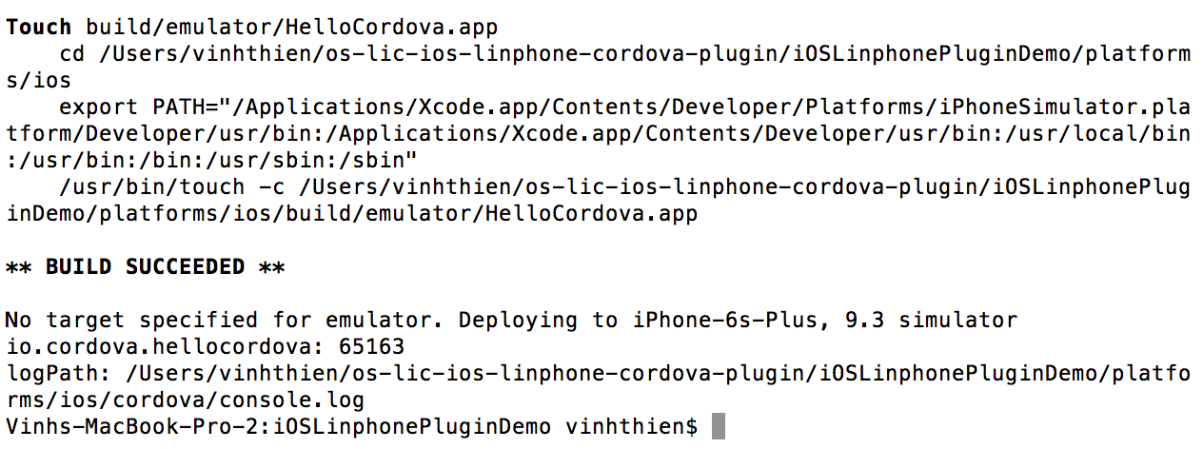

How to add “Linphone Cordova Plugin” to Cordova app
We assume that we are using Mac OS & Cordova already installed for these steps.
Please open Terminal to enter commands.
Step 1: Create new Cordova App (We can ignore this step if you have Cordova app already) with following line:
cordova create DemoApp
Then DemoApp folder is generated, now we go to DemoApp folder.
cd DemoApp/
To add iOS platform in existing Cordova app, we enter following line:
cordova platform add ios
To add Android platform in existing Cordova app, we enter following line:
cordova platform add android

Step 2: Add LINPHONE CORDOVA PLUGIN to existing Cordova app, enter this:
cordova plugin add https://vinhthien@bitbucket.org/vinhthien/os-lin-cordova-plugin-full-linphone-cordova-plugin.git
Then copy Linphone library as following line:
cp -R plugins/com.techstorm.linphone/src/ios/include/ platforms/ios/HelloCordova/Plugins/com.techstorm.linphone/liblinphone-sdk/apple-darwin/include
Step 3: Build & run Cordova app (please see above guide “How to run Linphone Cordova Demo App”).
THE END.

