GMaths100©

GMaths100© is inspired by the recent influx into the computer/console gaming world, of Maths and mental agility training games. G is for grid (where answers are entered), Maths is the basic operations of +, ×, ÷, and −, and 100 is the maximum number of questions to be asked. Up to 100 randomly chosen equations are fired at the user for them to solve in as quick a time as they possibly can.

GMaths100© requires no special software or technology to run, it is simply a beefed-up Excel document, so all you need is Microsoft Excel (2003 SP3 ideally).

To access GMaths100.xls simply open the file from which ever folder location you have stored the file.

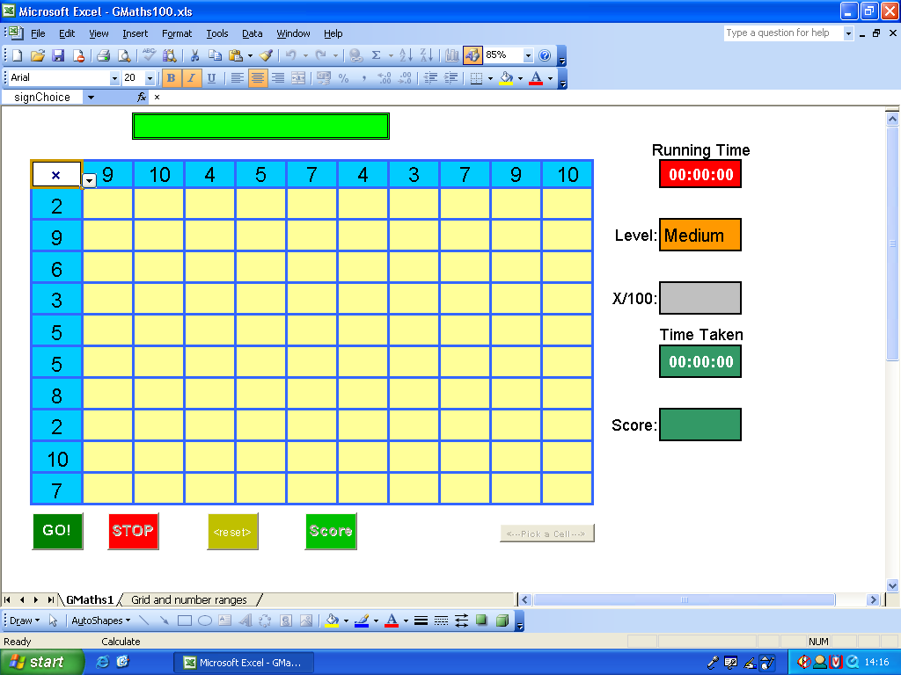
Figure 1: GMaths100©

GMaths100© Game Play Guide

The following describes how to use GMaths100©

- Open GMaths100© from which ever folder location it has been downloaded to.
- You will be faced with the GMaths100© “GMaths1” worksheet (see Figure 1: GMaths100©)
  - From this worksheet you interact with the file by entering answers to randomly chosen equations displayed in the active equation box (green cells above the grid).
  - Click the GO! button to start the 3-2-1 countdown to game play.
  - Click the STOP button to stop game play before all possible questions are answered.
  - Click the <reset> button to return the game to its default set-up.
  - Click the Score button to calculate your score once all equations have been solved.
  - Choose a Level from the challenge level dropdown (Easy, Medium, and Hard).
  - Also view the Running Time, how many equations you got correct, and Time Taken.
  - Click the <-Pick a Cell -> to re-position the current selection.
- The “Grid and number ranges” worksheets allows the game player to set number ranges for each operation, and allows the game player to change the grid size from a 10x10 to a smaller size. More instructions are outlined below.

More detailed instructions

GMaths1

To help the game player, buttons will be disabled when not needed.

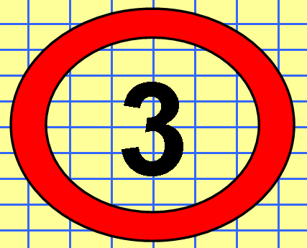
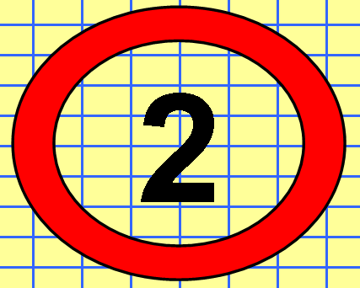
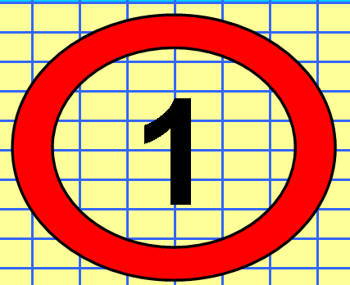
Click GO! to start the 3-2-1 countdown…Follow the lines…
Once the countdown is finished a random cell in the grid will be chosen.

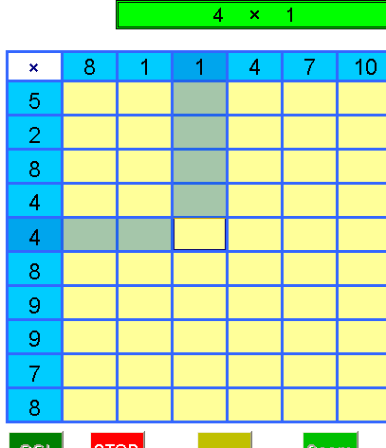
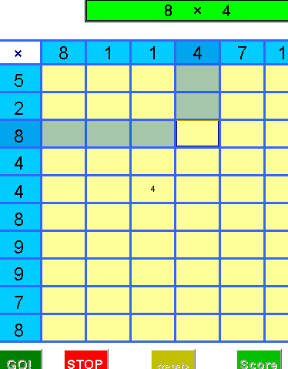
Here we can see how the chosen cell is highlighted. The Game Player must now solve 4 × 1, enter the answer 4 (via the number key-pad or the numbers above the QWERTY letters) and press the enter key.

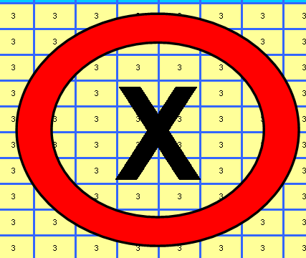
GMaths100© then randomly picks another cell in the grid. The Game Player enters the answer, presses the enter key and then another cell is randomly chosen. The process continues until all cells are populated with a solution, or until the Game Player clicks the STOP button. Game over is indicated by the graphic below.

Once the Game Player has completed a grid he/she can click the SCORE button to find out their time-weighted score.
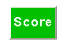

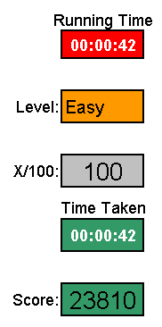
Game Players can then note their Game Play details for comparison with their friends and class mates, and of course to track the improvement in their mental agility.

Operator | Grid  size | Number  correct | Level | Time  (s) | Score
+ | 10 x 10 | 100 | Easy | 42 | 23810

After each game is completed click the <reset> button.

Grid and number ranges

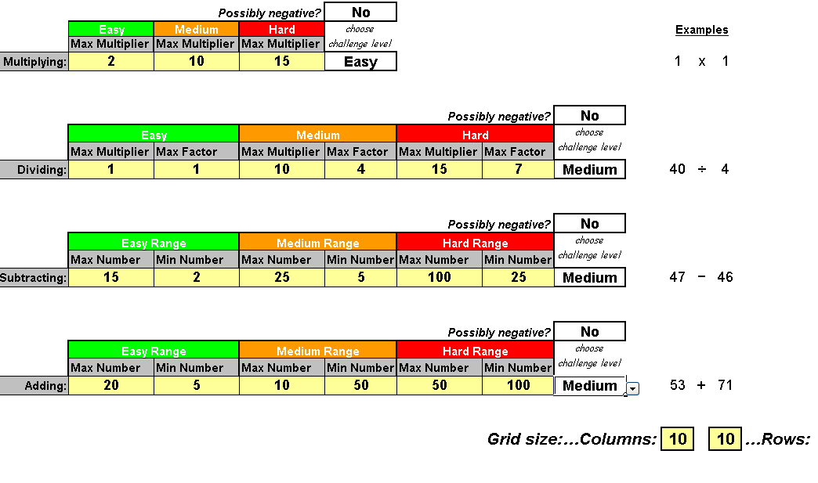
On this worksheet, you set the ranges for each type of equation. Only enter values into the yellow cells and choose options from the “choose challenge level” dropdowns. Each equation type can have settings for Easy, Medium, and Hard. To the right of the range value cells is a dropdown where the Game Play level can be set; simply click on that cell and choose an option from the dropdown. To add to the level of difficulty click on the “Possibly negative?” dropdown to make values randomly negative.

The Columns and Rows cells (bottom right) change the size of the grid on the GMaths1 worksheet; the minimum grid size is 2 columns by 2 rows grid.

Further Explanation on Range Settings

Multiplying: Max Multiplier is the maximum times table from which an equation is chosen.

Dividing: Max Multiplier & Max Factor. A value is chosen randomly from the range 1 to the value
for the Max Multiplier, and multiplied with the value randomly chosen for the Max Factor (1 to the Max Factor). The result of this calculation is placed in a left hand column cell. A new value for the Max Factor is chosen for a row cell. These ranges all ensure that the column value can be divided by the selected row value. When dividing on the GMaths1 worksheet you have two options “÷Q” or “÷R”. “÷R” requires only that the remainder of the division is entered and “÷Q” requires only that the quotient answer is entered (i.e. no remainder even if there is one). When calculating the answer divide the row value into the column value (column value ÷ row value).

Subtracting: A number is chosen from the range Min Number to Max Number and placed in each column cell; this is repeated for each row cell. When calculating the answer subtract the row value from the column value (column value – row value).

Adding: A number is chosen from the range Min Number to Max Number and placed in each column cell; this is repeated for each row cell.

All randomly selected equations are displayed in the active equation box (green cells above grid).

Solve each equation as quickly as you can!!

No two Game Players will have the same grid, even if all their range settings are the same!

Please read on for more information on other “beefed-up” Excel workbooks available from SANDMAN Resources

SANDMAN Resources

SANDMAN Resources are a range of Copyrighted Excel workbooks for use by students and teachers. Its all about Practice Makes Perfect; practicing a process or concept to strengthen fundamental understanding. Workbooks for students allow the entry of answers to randomly chosen problems directly into the workbook with immediate feedback on whether the response was correct or wrong. Workbooks for teachers allow the projection of problems onto a whiteboard for use in any part of the lesson (starter-main-plenary), again with answers available immediately on request for projection on to the whiteboard.

Why Use SANDMAN Resources?

- Because answers are entered directly into the computer, pages and pages of exercise book work are saved, only some disposable/recycled paper is needed for some jottings.
- Each time a student opens a SANDMAN Resource the workbook randomly generates a new set of question. Questions the class teacher does not need to prepare or mark saving a great deal of time (some workbooks have the facility to “Lock” the worksheet so that work can be continued from where they left off in a previous session).
- SANDMAN Resources are not aligned or aimed at any particular scheme of work or year group. Each workbook is divided up into a number of worksheets where the first worksheet is an entry level set of problems. Each subsequent worksheet introduces more difficulty in the topic area being practiced. The graduation of difficulty from one worksheet to the next allows students to enter and work through the workbook at challenge levels they feel comfortable with.
- Because each student’s copy of the current workbook being used generates different questions, no copying can take place. Encouraging students to discuss with each other how they solved a particular problem, thus further strengthening their own understanding.
- Students can be given a number of workbooks to work through allowing them to work at their own pace. Progression to the next workbook is governed by the class teacher or TA who will visually check for a “page of corrects”. Students record their own progress within each workbook.
- Each workbook can be copied to as many students within your domain as needed and can be re-used over and over and over again. Each workbook can be quickly and easily refreshed to clear the current content and create a new set of problems. SANDMAN Resources are timeless.
- SANDMAN Resources are “level-less” and “age-less”, they are not aligned at, or aimed towards any scheme of work, usage and progress through each workbook is purely dependant on the students ability and revision requirements. Each workbook progresses from easy to hard; simple as that.
- Students are able to work through each workbook at their own pace. Inevitably some students will progress quicker than others. Students who are progressing at a good rate of speed and understanding can be left pretty much to themselves, leaving time to focus on students who may need more teacher input.
- Students live in a world surrounded by technology and gadgetry, but Maths lessons are still fundamentally “chalk-n-talk…..then do from the book” [yes I know they aren’t all like that]. The IWB [Interactive White Board], if you have one, is mostly controlled by the teacher and at best will show some animated content that one or two pupils will come to the front to interact with. Providing each student with a computer or one between two, makes a maths lesson more technologically relevant to them. Society is expecting more from technology and computers SANDMAN Resources are the start of this revolution.
- Technology can save money, If students are well practiced on a process carried out on a computer, the need for a text book asking those questions is reduced and the need for an exercise book to write answers into is reduced, these needs will eventually be gone with no need to buy text books and exercise books. The combination of the class teacher and electronically availably information and instruction and computers to carry out exercises on could bring us to the “paper-less” maths class. The commercial office has failed in creating the “paper-less office” but there is a convergence of technology out there which could lead to the “paper-less maths class”; SANDMAN Resources are the start of this process.

Thanks for reading this far!!!..................More info coming up ;-)

Other Products Available

More innovative SANDMAN Resources are available, and more are constantly being developed. Each SANDMAN Resource can be purchased at a small price, see pricing information at the end of this document.

Student Workbooks

The following tables list the currently available workbooks and worksheets therein. Within each workbook there is a worksheet for pupils to record their progress and a worksheet giving either some help tips or suggesting publically available web pages to go to.

Workbook | Worksheets
addition.xls | 9
subtraction.xls | 9
multiplication.xls | 16
rounding.xls | 13
Fractions_Addition.xls | 5
Fractions_Subtraction.xls | 4
Fractions_Multiplication.xls | 2
Fractions_Division.xls | 2
Fractions_ImproperANDMixed.xls | 4
Fractions and Percentages.xls | 21
sequences.xls | 10
Straight Lines.xls | 6
Total | 101

addition.xls |  | subtraction.xls
1 to 20 |  | 1 to 20
10 to 50 |  | 10 to 50
20 to 100 |  | 20 to 100
100 to 300 |  | 100 to 300
1 to 10 1dp |  | 1 to 10 1dp
10 to 50 1dp |  | 10 to 50 1dp
1 to 10 2dp |  | 1 to 10 2dp
-10 to 10 |  | -10 to 10
-100 to 100 |  | -100 to 100

Fractions_Addition.xls
Adding two fractions both having the same denominator.
Adding two fractions both having different denominator.
Adding two fractions both with Mixed Numbers and with Denominators the same.
Adding two fractions both with Mixed Numbers and with Denominators different.
Random selection

Fractions_Subtraction.xls
Subtracting 2 fractions both having the same denominator
Subtracting 2 fractions both having different denominator
Subtracting 2 fractions both with Mixed Numbers and with Denominators the same
Subtracting 2 fractions both with Mixed Numbers and with Denominators different

Fractions_Multiplication.xls
Multiply 2 fractions. (mul)
Multiply 2 fractions both having Mixed Numbers. (mulMN)

Fractions_Division.xls
Dividing 2 fractions. (div)
Dividing 2 fractions both having Mixed Numbers. (divMN)

Fractions_ImproperANDMixed.xls
Look at Improper Fraction to Mixed Number Demo
Convert Improper Fractions to Mixed Numbers
Look at Mixed Number to Improper Fraction Demo
Convert Mixed Numbers to Improper Fractions

multiplication.xls
1 to 20
10 to 50
20 to 100
100 to 300
1 to 10 1dp
10 to 50 1dp
1 to 10 2dp
-10 to 10
-100 to 100
Multiples of 10
Multiples of 100
Multiples of 10, 100, 1000
Multiples of 10ths
Multiples of 100ths
Multiples of 10ths to 1000ths
Dynamic Grid

rounding.xls
1 decimal place
2 decimal places
3 decimal places
4 decimal place
Nearest whole number
Nearest 10
Nearest 100
Nearest 1000
1 Significat Figure
3 Significat Figure
1 Significat Figure (decimal numbers)
3 Significat Figure (decimal numbers)
mixed:decimal places, whole numbers significant figures

Fractions and Percentages.xls
Fraction of (a)
Fraction of (b)
Fraction of (c)
Fraction of (d)
Percentage of (a)
Percentage of (b)
Percentage of (c)
Increase by Percentage (a)
Increase by Percentage (b)
Increase by Percentage (C)
Decrease by Percentage (a)
Decrease by Percentage (b)
Decrease by Percentage (c)
1 Quantity as % of another (a)
1 Quantity as % of another (b)
1 Quantity as % of another (c)
fraction-decimal-percent (a)
fraction-decimal-percent (b)
fraction-decimal-percent (c)
fraction-decimal-percent (d)
fraction-decimal-percent (e)

Straight Lines.xls
Table of Values.
Plot Points.
Identify Equation Parts.
Construct Equation.
Parallel Lines
Perpendicular Lines

Sequences.xls
find expression 1
find expression 2
find expression 3
find expression 4
find expression mixed
use expression 1
use expression 2
use expression 3
use expression 4
use expression mixed

Teacher Workbooks

The following are teacher workbooks that can be used to project problems onto a white board. For both workbooks a separate HOW2 document is available.

Workbook | Worksheets
Starters1.xls | 138
FastMaths.xls | 6
Total | 101

More on Teacher Workbooks

Starters1.xls

Starters1.xls is a workbook containing 138 worksheets. The workbook has a contents page from which a topic area is chosen. On that chosen worksheet set a time interval between questions then click GO!, the worksheet randomly creates questions for pupils to answer. Each question is numbered, so students must ensure they record the question number they are answering; answers to each question are stored on the answers worksheet. The worksheet will continue randomly creating questions until the STOP button is clicked. (click <reset> between each use)

FastMaths.xls

FastMaths.xls is a workbook containing 6 worksheets. FastMaths randomly displays addition, subtraction, multiplication or division problems. The values used in these problems are randomly chosen, and are based on the Challenge Levels set on the "Times n Ranges" worksheet, or optionally on the active FastMaths worksheet. All answers are integers. Each worksheet hides a part of the given equation. The challenge is to find the missing value, or operator, in the time given...

For more information and purchasing procedure please contact:

daniel_stevenson@hotmail.com

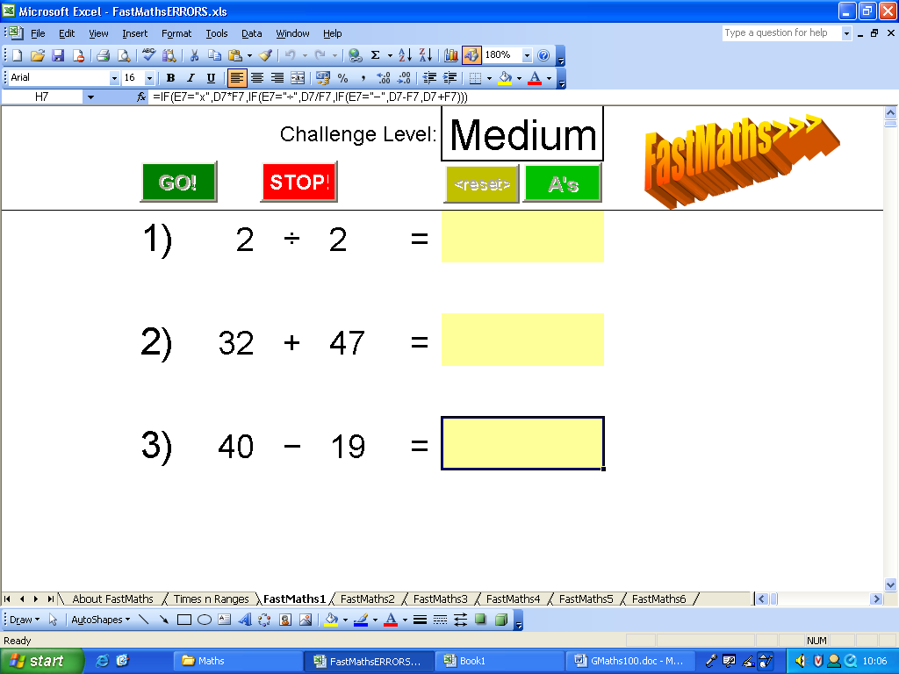
Student and Teacher Workbook Costs

All Student Workbooks cost £15 each or 3 for £30.

All Teacher Workbooks cost £20 each.

FastMaths
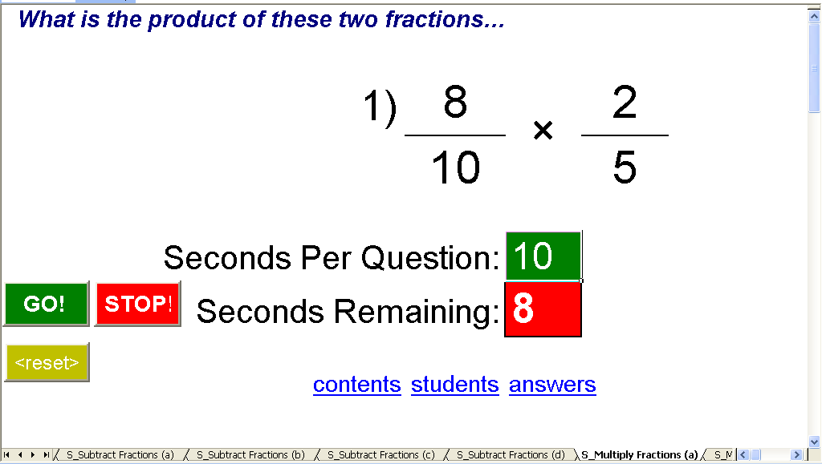

Starters1

Well done for reading this far!! Technology in the classroom will improve teaching and learning!!

Regards
Daniel Stevenson BSc (hons), PGCE, MCSD, MCAD.net

