Git & GitHub
A Beginner's Guide

Committing to GitHub • Remotes • Branches • Forks • Pull Requests • Merge Conflicts

1. Committing Your Project to GitHub
So, what if we wanted to commit our project to GitHub — how do we do so? Well, first we need to create a repository on GitHub. Then, to connect this project to that repository, we run:
git remote add origin <link of your repository>
So, it would look something like this:
git remote add origin https://github.com/dannyude/Danny-s.git

2. What Is a “Remote”?
In Git, a remote is a way to reference a repository that exists outside of your local machine. It's essentially a bookmark or shortcut that points to another repository, typically hosted on a different server or online platform like GitHub, GitLab, or Bitbucket.
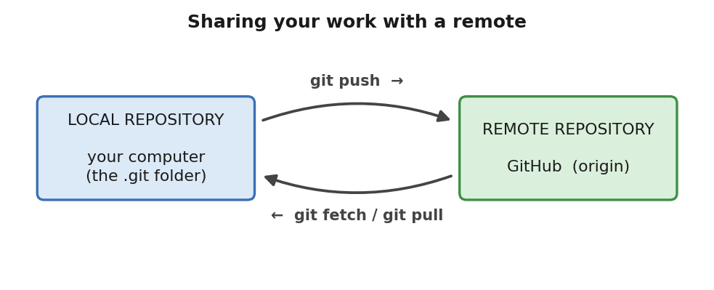
Figure 1 — Your local repository talks to a remote through push and fetch/pull.
Breaking the command down:
- add — means you are adding a connection to the repo.
- origin — the name you give to the URL you want to add.
- <URL> — followed by the URL itself.
If I wanted to see the list of all names and URLs tied to the current repo, I'd run:
git remote -v

How It Works
- Local Repository: the folder on your computer where you have a .git directory. This directory contains all the history, configuration, and data for your project's version control.
- Remote Repositories: repositories hosted on platforms like GitHub, GitLab, or Bitbucket (or even your own server). Think of them as centralized copies of your project that you can push changes to and pull changes from.
- Remote Connections: when you run git remote add, you create a connection between your local repository and a specific remote repository. This connection has a name (often origin) and a URL that points to the remote repository.
- git remote -v output: lists the names and URLs of all the remote repositories your current local repository is connected to.

3. Anatomy of git remote add origin <URL>
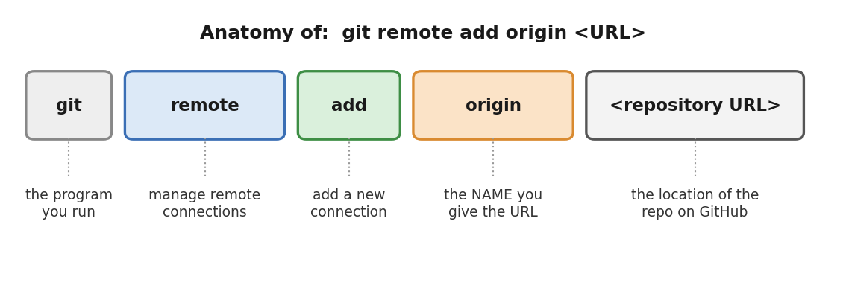
Figure 2 — Each part of the command, and what it means.

4. Pushing Your Changes
If I wanted to push my changes to my GitHub repo, I'd run:
git push origin master

5. Branches
Think of branches as timelines. You have the main timeline — usually your master code — and then alternate timelines that deviate from the main timeline each time you want to fix a bug or add a new feature. Actions you take on these parallel timelines don't affect your main codebase. That's the whole point of branches.
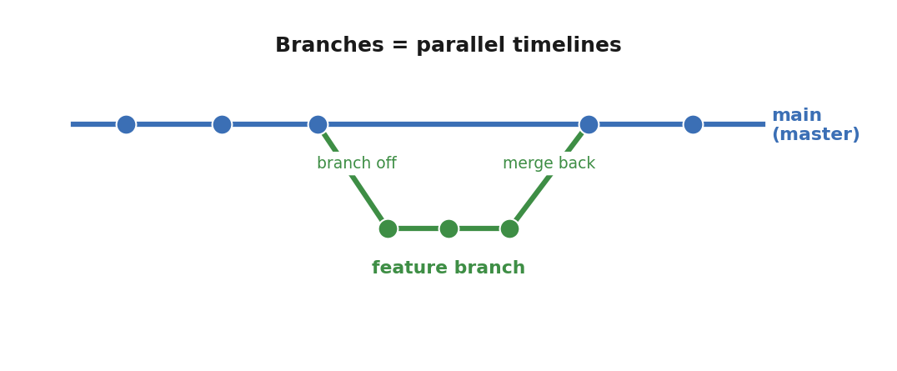
Figure 3 — A feature branch splits off the main line and is later merged back.
Some common commands:
git checkout main # Switch to the main branch
git fetch origin main # Fetch latest changes from the remote main
git merge feature-x # Merge your branch
git push origin main # Push the merged changes (if applicable)
Note: the remote main is usually the contribution of others working on that same repo — it tracks their changes too.

Creating a New Branch
If I wanted to create a new branch, the command would be:
git branch <name>
And then, to switch to that branch:
git checkout <name> # the HEAD will now point to this branch instead
So, all your git add . and git commit -m "comments" would now go to this new branch.

HEAD, Master / Main
- HEAD is a pointer telling you which branch you are currently on.
- Master / Main is the default name given to the main branch.

6. Forking
Whenever we use GitHub, we cannot directly make changes in anyone else's account (for obvious reasons), so we fork it. To contribute to someone's project, we have to fork their repo.
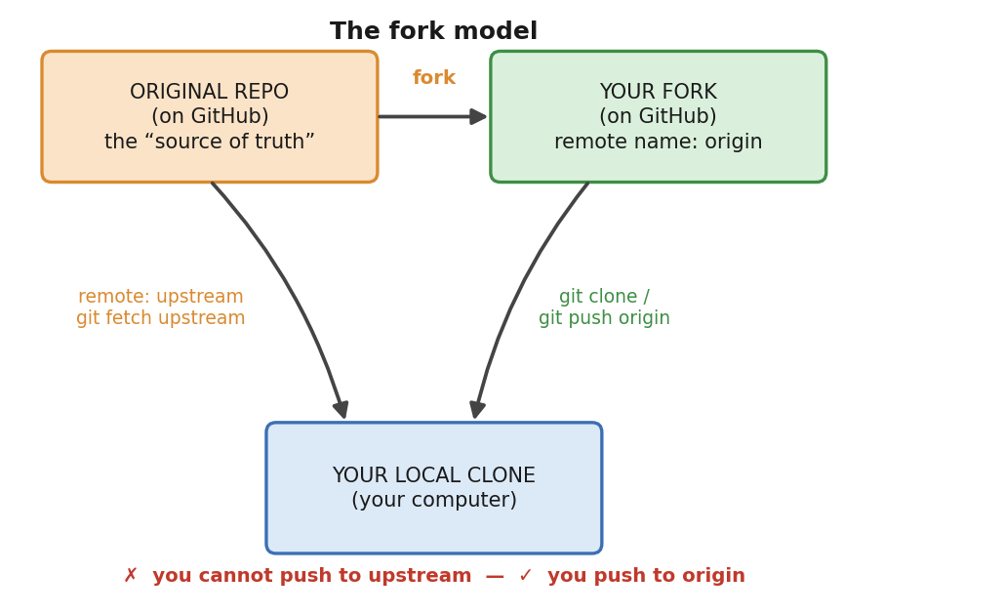
Figure 4 — origin points to your fork; upstream points to the original repo.
By convention, whenever you fork a repo, you name the remote upstream, which points to the original repository you forked from. This is the source of truth you want to keep in sync with (note that this doesn't happen automatically). So you can have a remote (origin) that points to your own repository — which contains the forked repo — and another remote (upstream) that points to the original repo you forked from.
You can't push to upstream, because that URL is the actual location of the main project you forked from. However, you can push to your own repository with the changes you've made on your local machine.

7. Pull Requests
A pull request (PR) is essentially a request for someone else (usually the maintainer or owner of the original repository) to review your code changes and consider incorporating them into their main branch.
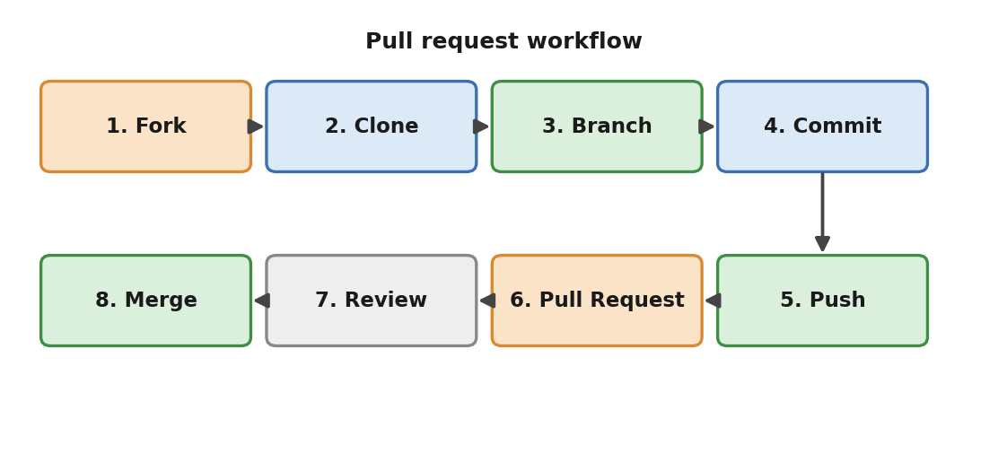
Figure 5 — The pull-request workflow, from fork to merge.

How This Works
- Fork: create a copy of the original repository on your own account.
- Clone: download your forked repository to your local machine.
- Branch: create a new branch in your local repository to work on your changes. To create a new branch, we do:
git checkout -b <branchname> # creates a new branch AND switches to it
- Commit: make changes and commit them to your branch.
- Push: push your branch to your forked repository on GitHub.
- Pull Request: open a pull request on GitHub. This notifies the maintainers of the original repository that you have changes you'd like them to review.
- Review and Discussion: the maintainers review your changes, provide feedback, and may request further modifications.
- Merge (or Close): if the maintainers are happy with your changes, they merge your branch into the main branch of the original repository. If not, they can close the pull request.
★ One branch = one pull request.
Say you're working on a feature, and you create a new branch to work on it. Once you ask to merge it into the main branch and — after suggestions and reviews — it is merged, that's it. You cannot use the same branch any longer, because GitHub associates one branch with one pull request. So if you want to fix another bug, it's highly recommended that you create another branch, so that when you want to merge, the main branch gets a fresh pull request.

8. Deleting a Commit
If I wanted to delete a commit on our main branch, we target the commit below the one we want to delete and then run:
git reset <hash key>

9. Committing vs. Pushing
- Committing: git commit saves your changes locally, creating a checkpoint in your project's history. This is useful even if you don't immediately push to a remote.
- Pushing: git push is how you share your commits with the remote repository, making them accessible to collaborators or serving as a backup.

10. Keeping Your Fork Up to Date with Upstream
Remember we created two connections: upstream (the source of truth we forked from) and origin (our own fork, which still contains the forked repo but which we can modify). Since the upstream repo is usually untouched, we need to make sure our fork stays up to date with the source of truth.
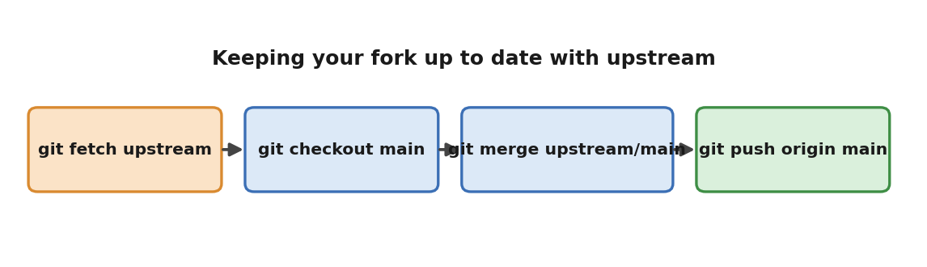
Figure 6 — The four commands that bring upstream changes into your fork.

Fetch Upstream Changes
git fetch upstream
This downloads the latest commits and branches from the upstream repository without merging them into your current branch.

Merge Upstream Changes into Your Main Branch
git checkout main
git merge upstream/main
This switches you to your main branch, then merges the changes from upstream/main (the latest version from the original repository) into your local main branch.
Resolve Conflicts (if any): if there are any conflicts between your changes and the upstream changes, Git will pause the merge process. You'll need to manually edit the files to resolve these conflicts and then commit the resolved changes.
Push Changes to Your Fork (optional): if you want to share the updated code with others or have a backup, push your changes back to your forked repository (origin).

Another Way: git pull
Another way to do this is to use git pull. Here's how it works:
- Fetch: git pull first performs a git fetch, which downloads the latest commits and branches from the specified remote (usually origin or upstream).
- Merge: then it automatically merges the fetched changes from the specified branch into your current branch. This is equivalent to running git merge origin/main (or whatever branch you're pulling from).

11. Git & GitHub in Practice: git remote -v
This command lists the named remote repositories that are associated with your local Git repository. For each remote, it shows the name (e.g. origin, upstream, or in our case remote), the URL of the remote repository, and the action associated with it (fetch or push).
Example output:
remote https://github.com/dannyude/Danny-s.git~ (fetch)
remote https://github.com/dannyude/Danny-s.git~ (push)
- Remote Name: here there is a single remote named remote. Typically the default and most common name for the main remote repository is origin.
- Remote URL: https://github.com/dannyude/Danny-s.git~ is the location of your remote repository on GitHub.
- Fetch and Push: this remote is configured for both fetching (downloading changes) and pushing (uploading your local changes).
★ The ~ at the end of the URL shouldn't be there — it's likely a typo or an artifact from an earlier error.
To correct this, remove the existing remote and add it back with the correct name and URL:
git remote remove remote
git remote add origin https://github.com/dannyude/Danny-s.git

Why Use Named Remotes?
- Organization: named remotes help you keep track of the different repositories you work with — e.g. origin for your own fork and upstream for the original repository you forked from.
- Convenience: instead of typing the full URL every time, you just use the shorter name (e.g. git push origin master).

12. Troubleshooting: “Refusing to Merge Unrelated Histories”
This error typically happens when Git believes the local repository and the remote repository have no common commit history. This often happens when two separate repositories are being merged, or when a repository is initialized differently locally and on GitHub.

1. Allow the Merge of Unrelated Histories
The easiest way to solve the issue is to tell Git to allow the merge:
git pull origin main --allow-unrelated-histories
This command allows the local and remote histories to merge, even though they are unrelated. It will merge any differences between your local and remote repositories, assuming there aren't major conflicts.

2. Fix Conflicts (if any)
If Git finds any conflicts during the merge, it will pause the process and prompt you to resolve the conflicts manually. Open the files with conflicts, edit them, and then mark the conflicts as resolved with:
git add <conflicted-file>
Once all conflicts are resolved, continue by committing the merge:
git commit -m "Resolved merge conflicts"
However, this isn't always automatic. There are times when Git will not resolve these conflicts for you — they must be resolved manually. To see the status of files with conflicts, run:
git status
This will show you a list of files that have conflicts.

13. Resolving Merge Conflicts
When you have a merge conflict, Git presents the conflicting changes in the file with markers like this:
<<<<<<< HEAD
<h1>Welcome to My Website</h1>
<p>This is the local version of the homepage.</p>
=======
<h1>Welcome to Our Website</h1>
<p>This is the remote version with updates from the team.</p>
>>>>>>> decaabcf84290e395ebb3f5b30271262fb648c65
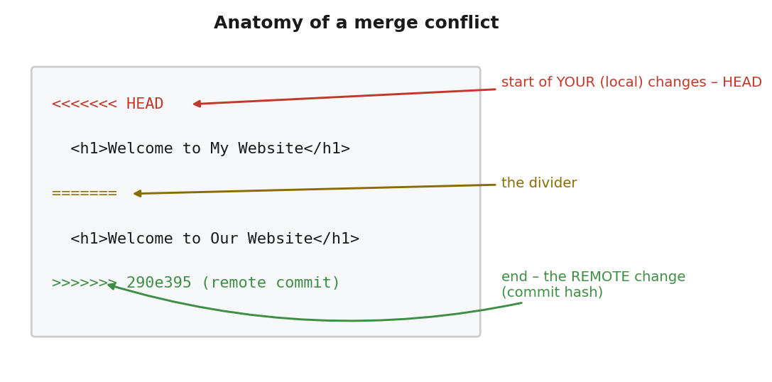
Figure 7 — What each conflict marker means.
This indicates that:
- HEAD contains the code in your local repository (your branch).
- decaabcf84290e395ebb3f5b30271262fb648c65 refers to the code from the remote branch you're merging.

How to Decide Which Code to Keep
Keep the local version — remove the remote version and the conflict markers:
<h1>Welcome to My Website</h1>
<p>This is the local version of the homepage.</p>
Keep the remote version — keep the remote version and remove your local version:
<h1>Welcome to Our Website</h1>
<p>This is the remote version with updates from the team.</p>
Merge both versions — manually combine them:
<h1>Welcome to My/Our Website</h1>
<p>This is the homepage with updates from both the local and remote branches.</p>
Make a new change — sometimes neither version is good enough on its own, so you rewrite the section entirely:
<h1>Welcome to the Unified Website</h1>
<p>This is a new version that combines ideas from both branches.</p>

Steps to Resolve the Conflict
- Open the file with the conflict (e.g. flaskr/templates/index.html).
- Look at the changes between HEAD (your version) and the remote branch.
- Decide which version to keep (local, remote, or a combination).
- Remove the markers (<<<<<<<, =======, and >>>>>>>) after making your changes.
- Save the file.
Once you've finished resolving the conflicts for all files, proceed to stage and commit the changes.

