Databases: A Starter Guide
Back-End Class — Foundations of Relational Databases
Wednesday, June 3, 2026
Daniel Ude • Facilitator, ICBM Technical Bootcamp

1. Entities and Attributes
When dealing with a database, there are two things we need to talk about:
- an entity, and
- the attribute.
An entity is the real-world concept that we would like to store data about — say, a Person.
Anything we store data about is an entity. It could be a supermarket, a business, or a bank.
The attributes of that entity are the things about it — say their name, first name, last name, address, and so on. We store these attributes in a table.
So a person might have: Name = Mr. Williams, username = MrWill, password = MrWill1234.

Storing Attributes with Values
When dealing with a database, you store these attributes together with their values. So the attributes would be: Name, Username, Password. And the values of those attributes would be: Mr. Williams, MrWill, MrWill1234.

What is a Row and What is a Column?
A row holds all the values for the attributes of a single entity (one complete record), and a column holds all the values for one specific attribute.

2. The RDBMS, the Database, and the Tools
A Relational Database Management System (RDBMS) is the complex engine that allows us to search for data, manipulate it, and also view it. In other words, it lets us query our database. Examples of an RDBMS would be PostgreSQL, SQLite, and so on.
It helps to keep these three things separate in your mind:
- PostgreSQL (the RDBMS): the complex software running in the background, managing the data.
- The Database: the actual tables (rows and columns) of data being managed by PostgreSQL.
- pgAdmin (the GUI): the terminal sitting on the librarian’s desk that you use to easily click around and send instructions, rather than shouting them through a command line.
In practice, though, we try not to treat the RDBMS and the database as two separate things, since we always use them together.
When you install a DBMS, its job is to present your database in a way that is readable to you as the administrator. When you store data, it is saved on a hard drive somewhere — on a remote server, or perhaps on your local machine — and that data could be scattered all over the disk. So it is the duty of the RDBMS to gather all that data and present it as columns (attributes) and rows (records). And the RDBMS is what enables us to run the complex queries we will see in a moment.

3. SQL
SQL is the language used to communicate with a DBMS (or a database). This same language is used by every RDBMS. We use SQL:
- to define the structure, and
- to manipulate the data, or insert a new value into our database.
So if we wanted to insert a new row into the database, we would use SQL to do so.

JOINs and Views
Another thing SQL does is the JOIN. Remember I told you that when building a database, you want each table to be about one particular entity. So in a typical e-commerce website or healthcare system, you will have different tables for different entities, and you want to be able to relate them to each other — which is exactly what a relational database gives us. We use a JOIN to produce a new view that looks like one big, combined table, so it appears as though we never broke our data into multiple tables at all.
From this we can create a view. A view is simply the outcome of a query — a saved query that masquerades as a table — formed by joining the attributes of two or more separate tables.

Naming Conventions
Keep this in mind
Any time we write an SQL command, we write it in ALL CAPS. And for the things we name ourselves, we use lower case.

4. Database Design
A database design is a method of separating information across multiple tables, rather than keeping every entity in one huge table.

Data Integrity in Design
Some examples of database integrity problems would be:
- Stale data. You want your database to be up to date; you don’t want stale data sitting in it. (Very dangerous.)
- Inconsistent data. You cannot have two different addresses for one person, or two different IDs for one person. If you do, you have a serious data-integrity problem.

The Three Phases of Building a Database
When building out our database, we move through three phases:
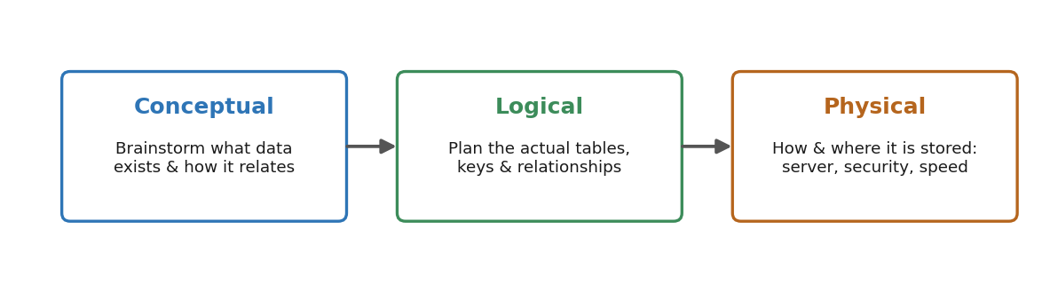
Figure 1. The three phases of database design.
A. Conceptual (the brainstorming phase). This is where we think about how the data is related. For an e-commerce business, you realise you need users and you need products, and users need to buy products. So it is fair to make the logical connection that a user needs to buy a product.
B. Logical phase. Here we actually begin to plan the tables we thought about in the conceptual phase: how do we relate the Users table to the Products table? How do we relate Products to Sales? And so on. (For example, a user can buy multiple products.)
C. Physical schema. A schema is simply how we design our database architecturally. This is where we talk about how we bring the database to life and where it will be stored — because our data lives on a server, and you want to make sure that wherever it is stored is reliable, since many people will be accessing it at once. Think of Jumia, for example. This is also where we plan the forms and views, and where we think about security and optimisation, because we don’t want people breaking into our database or causing data-integrity issues.
Bottom line: database design is so important because the database is the life of your back end. If you want to work for big companies or startups, you have to be careful and follow best practices when designing it.

5. Relationships, Primary Keys and Foreign Keys
I have been throwing the word relationship around, so let’s get into what it means.
Back to our Jumia example: you need users, but users need to order products to buy — without which there would be no Jumia. So logically, there has to be some kind of connection, or relationship, between users and their orders. An orders table would look like this:
- user_id — who bought it (FK)
- product_id — what they bought
- quantity — how many they bought
- order_date
And so you need to connect the orders table back to the users table.

Primary Key (PK) — the Unique Identifier
A primary key is a column (or a combination of columns) that uniquely identifies every single row in a table. Think of it like a person’s National ID or a digital fingerprint.
The strict rules of a PK:
- Absolute uniqueness: no two rows in the same table can ever share the same primary-key value.
- Never null: a primary key can never be empty. Every record must have an ID to exist.
- Immutability: once assigned, a primary-key value should ideally never change.
Real-world example: in a Users table, the primary key is usually an id column (User 1, User 2, User 3). Even if you have two users named “John Smith,” they will have different PKs, allowing the database to tell them apart.

Foreign Key (FK) — the Relationship Linker
A foreign key is a column in one table that points directly to the primary key of another table. It is the physical anchor that establishes a relationship between two entities. While the primary key establishes identity inside its own home table, the foreign key acts as a “guest passport” in a child table to refer back home.
The rules of an FK:
- It must match: the value in a foreign-key column must exactly match an existing primary key in the parent table (or be completely null if the relationship is optional).
- Duplicates are allowed: unlike a PK, a foreign key can repeat its values as often as necessary — which is exactly how we create one-to-many relationships.
Real-world example: in an Orders table, you create a column called user_id. This column is a foreign key. If Bob’s user ID is 2 (his PK in the Users table), every order Bob places will stamp the number 2 into the user_id column of the Orders table.
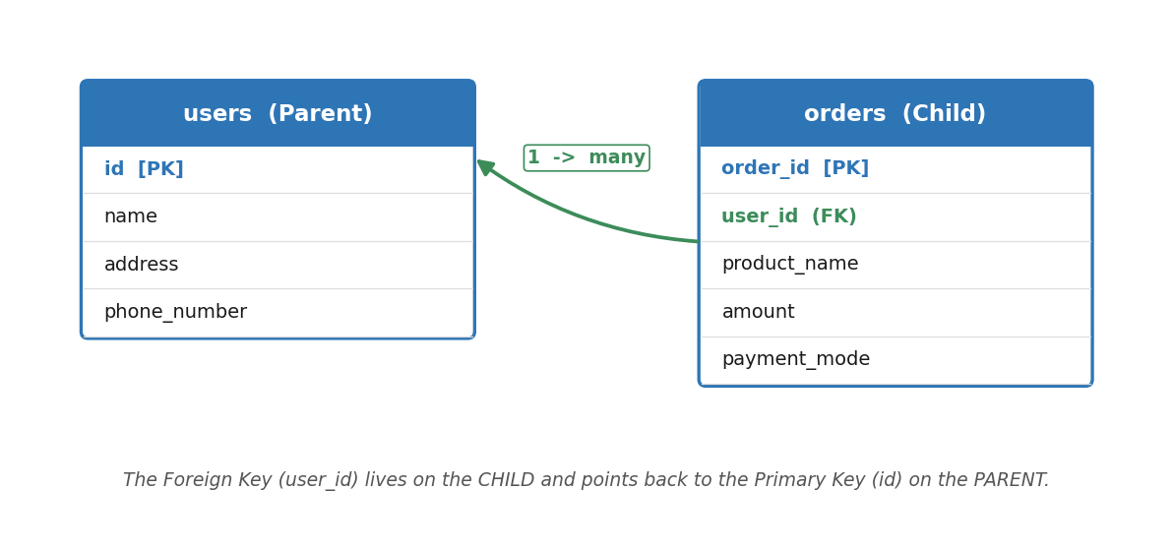
Figure 2. The FK lives on the child (orders); the PK lives on the parent (users).
Golden rule
The foreign key goes on the child, and the primary key goes on the parent.

The “Giant Table” Problem
Imagine a user named Alice who buys 50 different items on Jumia over a year.
- If everything is in one giant table, Alice’s full name, home address, and phone number have to be typed into the database 50 separate times.
- The integrity risk: if Alice moves house, a developer has to find and update all 50 rows. If they miss even one, the database now holds conflicting, corrupted data.
The relational solution. By splitting the entities, you solve the problem instantly:
1. The Customers entity (the “who”): id (PK, e.g. 101), name (Alice), address, phone_number.
2. The Orders entity (the “what”): order_id (PK), user_id (FK → 101), product_name, amount, payment_mode.
So a database with correct integrity might have a user with id 7, and an order with id 3 that points back to that user. That is data integrity. Now imagine that user 7 made an order, but for some reason the user is removed from the database before the order is fully processed — now you have a data-integrity problem on your hands, and you don’t want that.

6. The Three Main Types of Data Integrity

A. Entity Integrity
An entity is anything we store data about. In our table we usually have a key (the id), and one of the things we use it for is to enforce uniqueness. You enforce entity integrity by defining a primary key for every table.
- The primary key must be completely unique (no duplicates).
- The primary key can never be null (empty).
Classroom example: in an Animals table, you cannot have two different animals sharing id: 3, and you cannot have a mystery animal with no ID at all. If you try, the RDBMS yells at you and blocks the insert.

B. Referential Integrity (the Relationship Rule)
Referential integrity is the glue that keeps relationships between separate tables synchronised. It ensures that cross-references between tables are always valid, and it is enforced using foreign keys.
The rule: a foreign key in a child table must point to a valid, existing primary key in the parent table. This prevents “orphaned” records.
Classroom example: imagine Instagram, which of course has users. If a user makes a comment on someone else’s post, that comments table has a PK and an FK that links back to the Users table. When you delete a user from your endpoint, you also want to delete that user’s records across the other tables, so as not to leave orphan rows — although, by default, referential integrity actually blocks you from deleting a parent that still has children unless you explicitly choose ON DELETE CASCADE, RESTRICT, or SET NULL, and for financial or order records the standard practice is a soft delete (flagging the row as deleted) rather than removing it outright. To that end, primary keys are designed to be immutable (they never change once created).

Why primary keys must never be re-used or shifted
a. The “invoice in the email” problem. Alice buys a phone on Jumia and is assigned order_id: 104. Jumia emails her a receipt: “Thank you for order #104!” If Bob (order #102) later deletes his account and the database shifts order 104 down to become 102, Alice’s emailed receipt now points to the wrong, non-existent order. If she calls support about “order 104,” the agent can’t find it. A primary key must be a permanent anchor.
b. The performance catastrophe. Imagine a platform like Amazon with 50 million orders. If order #5 is deleted and the database has to shift every later order number down by one to fill the gap, it would have to modify almost 50 million rows for a single deletion. The server would freeze and the site would go offline. Gaps cost the database zero processing power; re-indexing everything would destroy it.
c. The audit trail (security & history). Gaps are informative. If an auditor sees order sequences going 101, 104, 105, they immediately know that 102 and 103 were cancelled or deleted. If the system silently re-arranged the numbers, it would be covering its tracks, making fraud detection and auditing impossible.

C. Domain Integrity (the Column-Format Rule)
Domain integrity is about the acceptable values for a column — the range of what we allow for that particular column. We enforce it using data types and specific constraints. Some examples of the ranges we have are:

1. Numeric types (the numbers)
- INT (INTEGER): standard whole numbers, no decimals (e.g. 42, -500). The range limit: a standard INT usually maxes out around 2 billion. If you need bigger numbers, domain integrity forces you to use a BIGINT.
- DECIMAL(p, s) / NUMERIC: exact fractional numbers — what you must use for money. DECIMAL(10, 2) means 10 digits total, with 2 after the decimal point (e.g. 999.99).
- FLOAT / REAL: approximate decimal numbers, usually used for scientific calculations where speed matters more than exact rounding.

2. String / character types (the text)
- VARCHAR(n): variable-length text. VARCHAR(50) allows up to 50 characters, but “Cat” (3 characters) only takes up 3 characters’ worth of space.
- CHAR(n): fixed-length text. If you set CHAR(2) for a state code like “NY,” and someone types “New York,” the DBMS will reject it.
- TEXT: massive blocks of text with no strict limit (like a blog post or a product review).

3. Date and time types (the calendar)
- DATE: just the calendar date, YYYY-MM-DD (e.g. 2026-06-05).
- TIME: just the time of day, HH:MM:SS (e.g. 14:30:00).
- TIMESTAMP / DATETIME: both combined, pinpointing an exact second (2026-06-05 14:30:00).

4. Boolean (the yes / no)
- BOOLEAN (BOOL): only accepts TRUE or FALSE (often 1 or 0 under the hood). Perfect for columns like is_active or has_paid.

A Quick Note on Data Types
These database data types are not to be confused with Python’s data types. They are similar, but they belong to two different languages: Python is its own language, and SQL is its own language.
When dealing with our database, something can be stored as a number, text, or date. Data types put limits on what we store. So if we had a username column and wanted to say it should not exceed 20 characters, we would use VARCHAR(20).
For referential integrity we can also apply foreign-key constraints. For example, on Instagram, if a user makes comments on a post, we should be able to tie those comments back to the user. And if that user is deleted, all of their comments are deleted too, to preserve data integrity.

7. Types of Relationships
There are three relationship types to know:
- One-to-One (1:1)
- One-to-Many (1:M)
- Many-to-Many (M:N)

A. One-to-One (1:1)
You have your NIN, and ideally your NIN belongs only to you — no other citizen can have the same NIN. Another example is marriage: a man can have one wife and a woman can have one husband, where neither can have more than one.
When designing a one-to-one relationship, the entities in each table are exclusive to each other. A good example is a bank customer and a biometrics record: one biometrics record belongs to one bank customer, and one customer has only one set of biometrics. Another example is a card holder and the cards table.
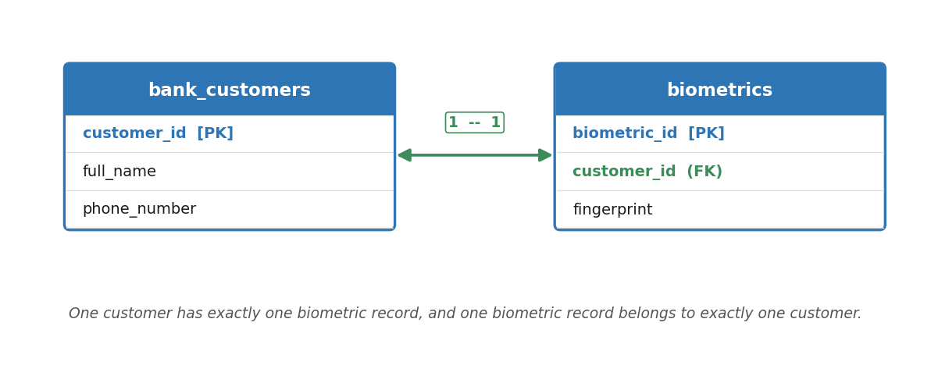
Figure 3. A one-to-one relationship: one customer ↔ one biometric record.
When designing a one-to-one relationship, we want every attribute in a table to depend on the entity itself — not on a fellow attribute. Once an attribute no longer makes sense when you look at the entity, it should not live on that table. For example, if the Customers table only held a card number, that might not be much of a challenge. But once we add something like card_type, that card_type depends on the card attribute, not on the customer entity. So rather than cramming card details into the Customers table, we create a separate Cards table. We do this so we don’t end up with a bad design.
Remember the rule
A particular table has to be about one entity, not two.

B. One-to-Many (1:M)
The one-to-many relationship is the most common type in relational databases. It occurs when a single record in one table can be associated with multiple records in another table, but those multiple records can only ever point back to that one original record.
Example: bank customers and bank cards. A single bank customer can own multiple cards (a Verve debit card, a Mastercard credit card, and a virtual dollar card). However, each physical card has a unique 16-digit number that belongs strictly to one person.
The two-way sentence test. Always test the relationship in both directions:
- Forward: “one customer can have many bank cards.” (True)
- Backward: “one bank card belongs to exactly one customer.” (True)
Since it is “many” in one direction and “one” in the other, it is a 1:M relationship. To implement it, we place the primary key of the “one” side into the “many” side as a foreign key.
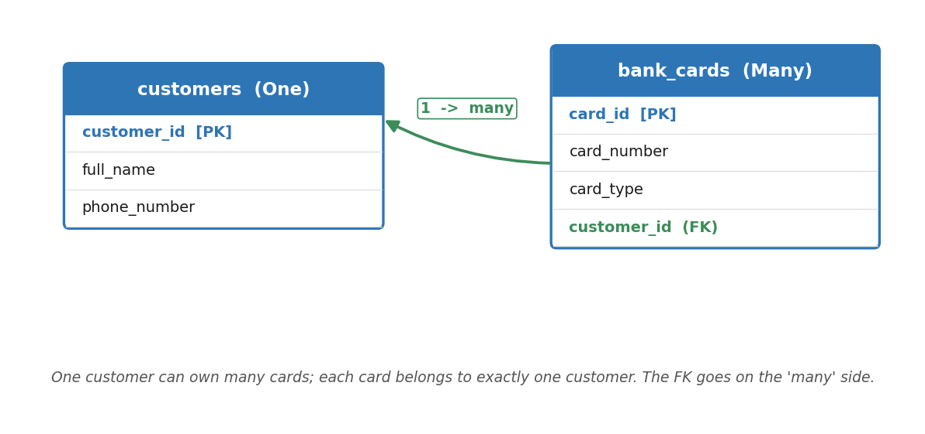
Figure 4. One customer can own many cards; the FK lives on the 'many' side.

Customers table (the “one” side)
customer_id (PK) | full_name | phone_number
101 | Chimdimma | 0701498888
102 | Obasi | 080222666

Bank_Cards table (the “many” side)
Notice how customer_id 101 appears twice, proving Chimdimma owns two cards.
card_id (PK) | card_number | card_type | customer_id (FK)
1 | 5399-1111-2222-3333 | Mastercard Debit | 101
2 | 4000-5555-6666-7777 | Visa Virtual Dollar | 101
3 | 5061-9999-8888-1111 | Verve Prepaid | 102

Golden rule for your notes
In a one-to-many relationship, the foreign key always goes into the table on the “many” side, and that table can hold duplicate values of the foreign key.

C. Many-to-Many (M:N)
A many-to-many relationship occurs when multiple records in Table A can be associated with multiple records in Table B. For example, students and the courses they take: a student can take many courses, and a course can be taken by many students. Say a faculty offers five courses: Mathematics, English, Political Science, Literature, and Sociology.

Why design pattern 1 is a nightmare (horizontal growth)
The first idea is to give every course its own column:
id (PK) | student_id | Maths | English | Pol. Sci. | Literature | Sociology
1 | 100 | Yes | Yes | — | — | —
2 | 80 | Yes | Yes | Yes | Yes | —
3 | 90 | — | Yes | Yes | — | Yes

The issue: what happens if the university offers 200 courses next semester? An administrator would have to manually alter the table to add 195 new columns. Worse, most cells would be empty (null), because a student only takes 4 or 5 courses out of 200. It is a massive waste of space. Growing a table horizontally (adding columns) is bad.

Why design pattern 2 is still flawed
The second idea stores one row per course taken, with the course name as text:
id (PK) | student_id (FK) | course
1 | 100 | Mathematics
2 | 100 | English
3 | 80 | Mathematics
4 | 80 | English
5 | 80 | Political Science
6 | 80 | Literature
7 | 90 | English
8 | 90 | Political Science
9 | 90 | Sociology

This is a step up, but the fatal flaw is the course column. Storing the raw course name as text creates three problems:
a. The typo disaster (data integrity). If one row says “Political Science” and another says “political science,” and you ask the database to count students taking “Political Science,” it will miss the second one, because computers treat different casing as completely different text.
b. The update anomaly. If the school renames “Mathematics” to “Mathematics 101,” a developer has to find and update the text in potentially thousands of rows. Miss one, and the data is corrupted.
c. Where do the course details go? Every course has extra data — a professor’s name, a room number, a credit weight. If you put those in this table, you’d be retyping “Prof. Johnson, Auditorium” hundreds of times for every student taking English.

The final evolution: the three-table solution
To fix this, we use a junction (bridge) table to connect the Students table and the Courses table using foreign keys.
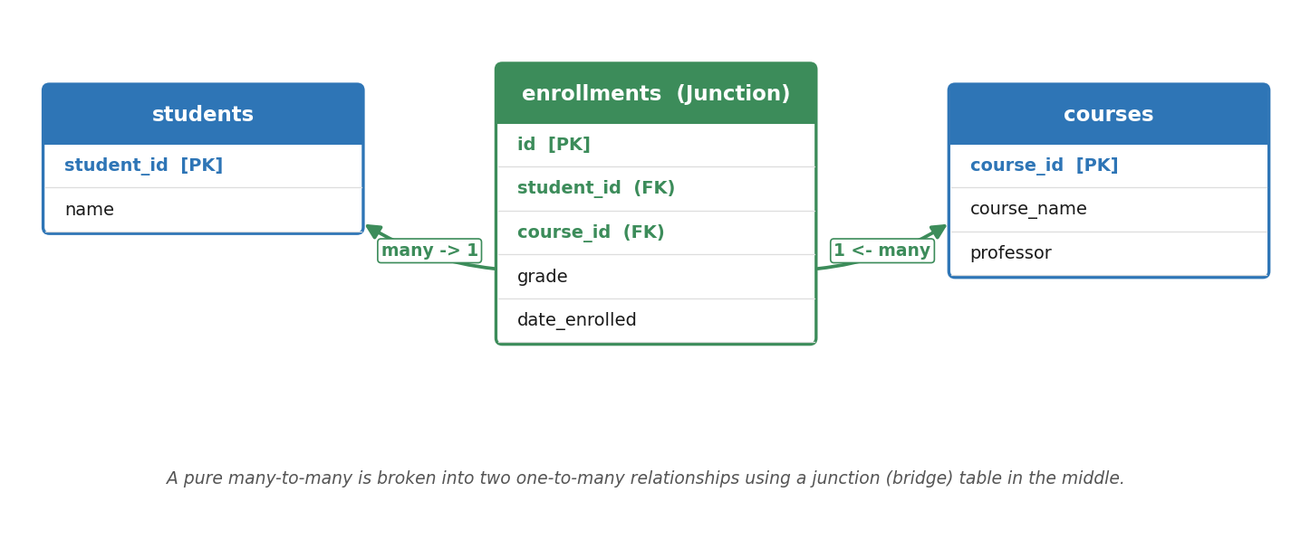
Figure 5. A many-to-many relationship resolved into two one-to-many relationships.

Students table
student_id (PK) | name
100 | Bob
80 | Chimdimma
90 | Joshua

Courses table
course_id (PK) | course_name | professor
10 | Mathematics | Prof. Jide Chime
11 | English | Prof. Smith
12 | Political Science | Prof. Ade
13 | Literature | Prof. Obi

Enrollments junction table
Instead of typing the messy text “Mathematics,” we just drop in the course_id.
id (PK) | student_id (FK) | course_id (FK)
1 | 100 | 10 (Mathematics)
2 | 100 | 11 (English)
3 | 80 | 10 (Mathematics)
4 | 80 | 11 (English)
5 | 80 | 12 (Political Science)

Pop question
If we wanted to add grades to our database, where would they go?
Can it go in the Students table? No. Alice takes Mathematics and English. If she gets an A in one and a C in the other, you cannot fit both grades into a single row for Alice.
Can it go in the Courses table? No. Fifty students take Mathematics; you cannot put Alice’s A and Bob’s B into the single row for that course.
The answer: the grade belongs to the relationship itself. It only exists at the exact intersection where a student meets a course. So we keep the Students and Courses tables clean and expand the junction table to hold it:
id (PK) | student_id (FK) | course_id (FK) | grade | date_enrolled
1 | 100 (Bob) | 10 (Mathematics) | A | 2026-06-01
2 | 90 (Joshua) | 11 (English) | C | 2026-06-01
3 | 80 (Chimdimma) | 10 (Mathematics) | B | 2026-06-02

Why the junction table scales so well
Suppose the class sizes are: Political Science = 90, English = 200, Literature = 30 — a total of 320 course registrations. That means the Enrollments table will have exactly 320 rows.
Now take Joshua. If he registers for 4 of the 5 available courses, the database simply adds 4 rows. His footprint looks like this:
id (PK) | student_id (FK) | course_id (FK) | grade
321 | 90 (Joshua) | 10 (Mathematics) | …
322 | 90 (Joshua) | 11 (English) | …
323 | 90 (Joshua) | 12 (Political Science) | …
324 | 90 (Joshua) | 13 (Literature) | …

In a bad horizontal table where every course has its own column, Joshua’s single row would carry his 4 grades plus an empty, wasted cell for Sociology (which he isn’t taking). With 500 courses, his row would have 496 empty, wasted cells. In the junction table, Joshua’s ID appears exactly 4 times — four rows, no waste. The course he didn’t take takes up zero space.
The junction table only stores a single point of truth. If a relationship doesn’t exist, it takes up zero space.
So whenever we have a many-to-many relationship, we always break it down into two one-to-many relationships using an intermediary (junction) table. As the name suggests, the intermediary table simply connects the “many” sides: a dedicated Students table, a dedicated Courses table, and a joiner table that sits between them. This also solves the problem of orphaned data — when a student drops out, we can remove their data cleanly across the tables.

Key Takeaways
- An entity is anything we store data about; its attributes become columns, and each record is a row.
- The RDBMS (e.g. PostgreSQL) manages the data; SQL is the language we use to query and change it.
- Write SQL keywords in UPPER CASE; write the names you choose in lower case.
- Good design separates data across tables and protects entity, referential, and domain integrity.
- The foreign key goes on the child; the primary key goes on the parent; PKs are unique, never null, and immutable.
- Resolve every many-to-many relationship with a junction table.

