Homework 4
  - JavaFX
The following problem set is worth 100 points. Please submit a zip file containing all source code (Java) I need to run your assignments. Code will be graded on elegance and correctness.

Problem 1: Notepad Problem (25 points)
Produce a JavaFX notepad application such as the following:
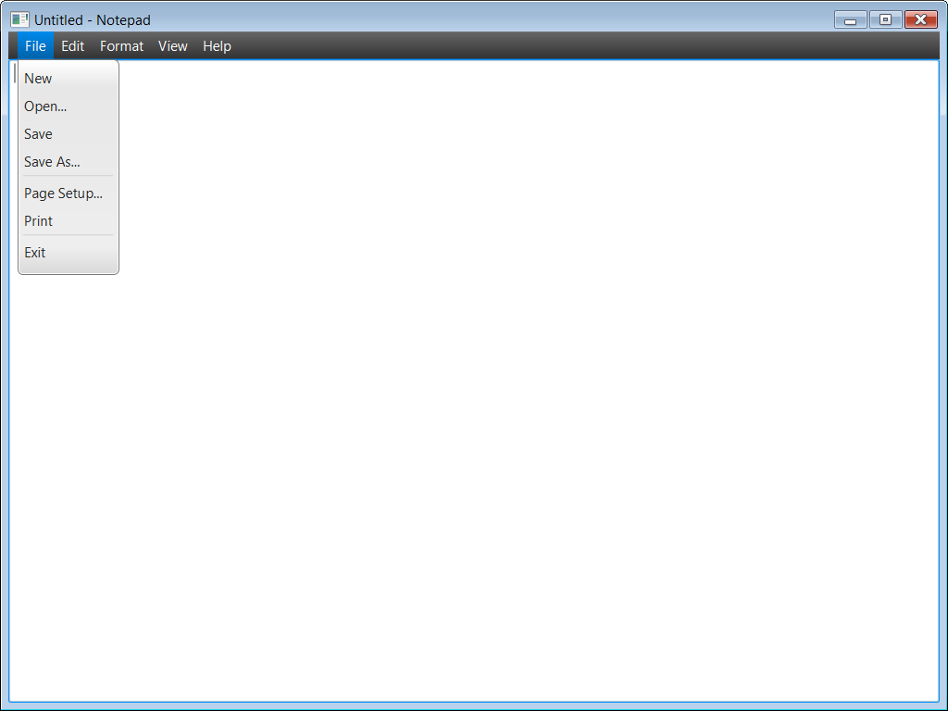
At minimum your application should function like how Notepad functions in Microsoft Windows. Your application should allow the user to Open an existing file or create a new file. Once the user has created their file, the user should be able to Save their changes to the filesystem.

Problem 2: Candlestick Problem (25 points)
In trading, candlestick patterns provide investors with tools for technical analysis, providing insight into market sentiment and potential price action. As an example, the price of Bitcoin looks like the following over the past month:
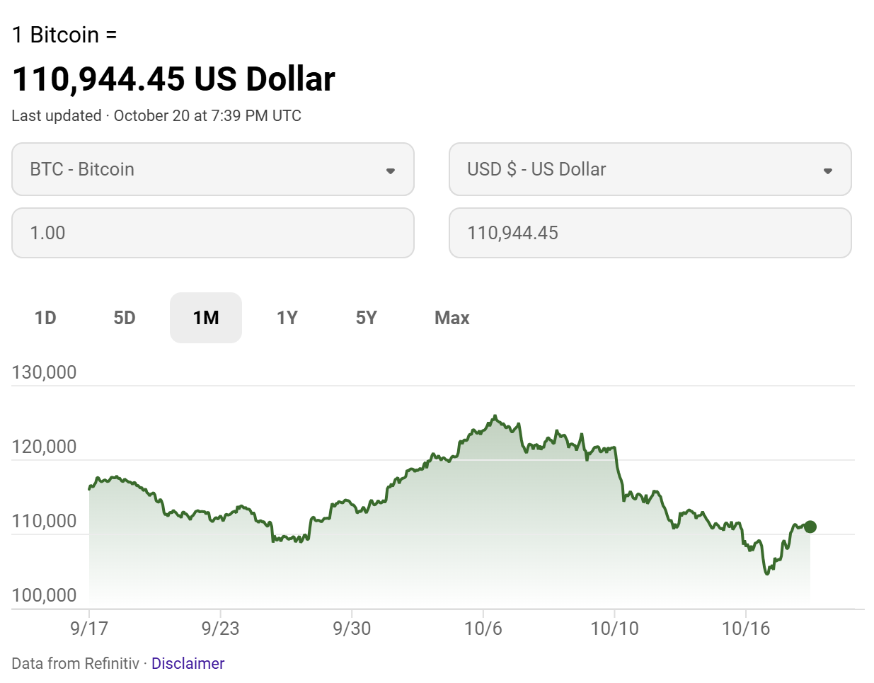
People who trade Bitcoin look at the data at a more granular level. For instance, the following chart shows the Bitcoin price action using four-hour handles:
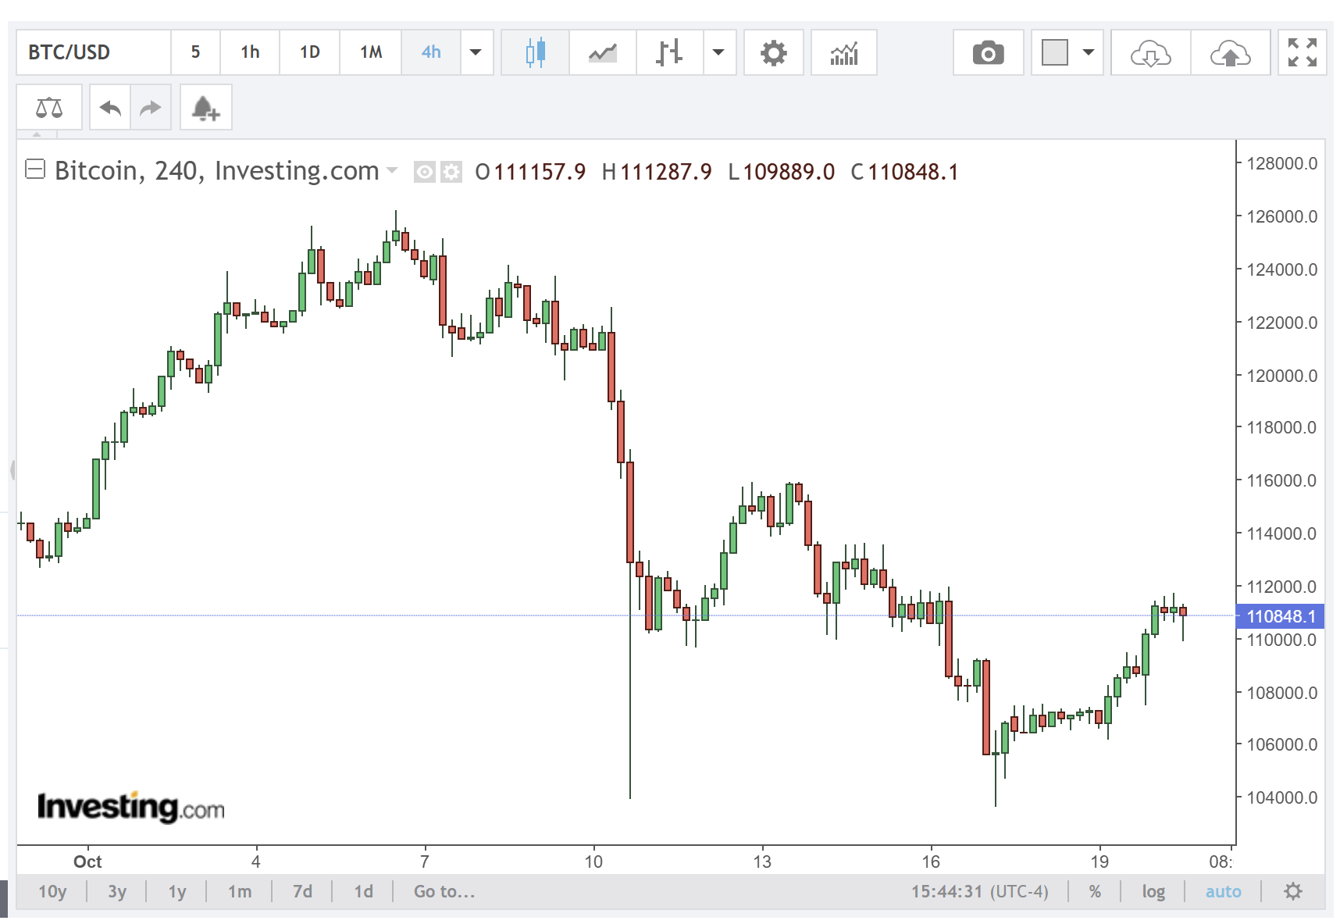
You can download this trading data yourself. As an example, both Kraken and Binance provide historical data for you to download to use. Binance’s data can be downloaded here: https://www.binance.us/institutions/market-history
For this assignment, download candlestick data from Binance (as a plain text file) and use it to produce a JavaFX application which displays a chart like the following when you load the application:
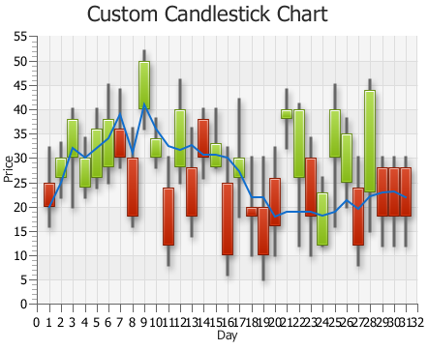

Problem 3: Calculator Problem (25 pts)
Produce a JavaFX calculator like the following:
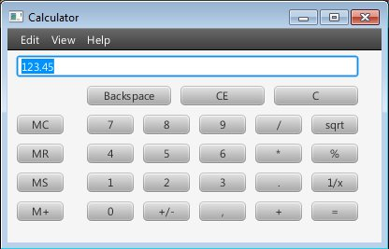
At minimum, you should implement the buttons above. For details about how the memory buttons work, there are numerous guides available outlining how they function.

Problem 4: Fractal Problem (25 pts)
In mathematics, the Vicsek fractal is a fractal that can be generated using a recursive approach (like other fractals such as the Sierpinski carpet).
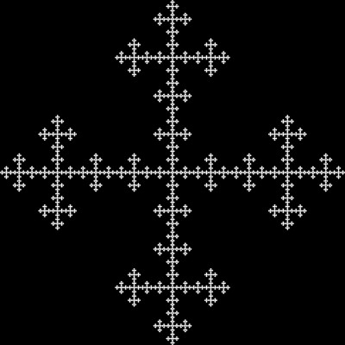
The recursive approach is the following. At level one you produce the following five (black) squares on a pane:

At level two, you subdivide each of the five (black) squares with the same approach you did for level one:

Level three is similar in that you apply the level two pattern to each of the black squares in the images. Additional levels can be extrapolated as follows:
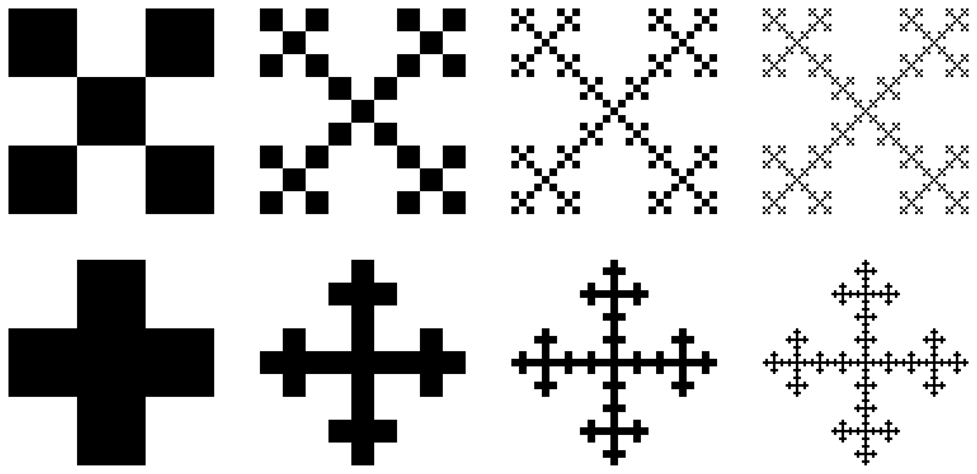

For this assignment you are to build a JavaFX application which will generate Vicsek fractals. Include one text box on your application: the iteration number. When the user enters a different iteration number, you will regenerate the fractal on change. As an example, in the above figure iteration 1 is base case (the five black squares). Any iteration greater than 1 will recursively generate the fractal on the application.

Submission Requirements
Please submit a zip file containing all Java source code I need for testing before the closing of the Canvas drop box.

