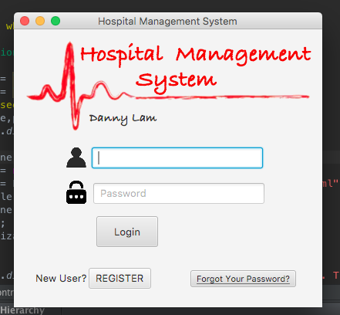

This is the Hospital Management System: by Danny Lam

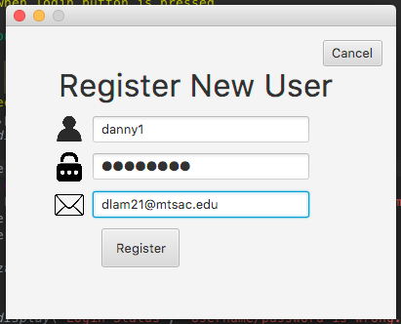



Register as a new user. Enter your username, password, and email.

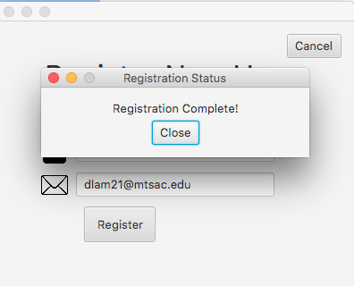

Popup will appear saying your registration is complete.

Data will be stored into the ‘admin’ table in MySQL database.

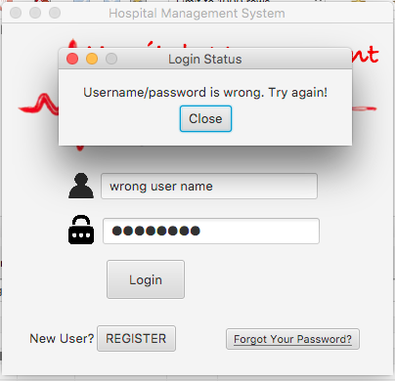

If you input an incorrect username and password, then you will receive an error and will ask you to try again.

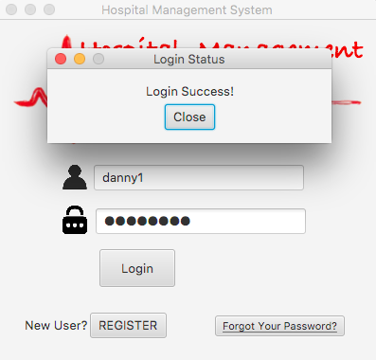

When we enter the correct username and password, the app will confirm our successful login! Yay we are in! 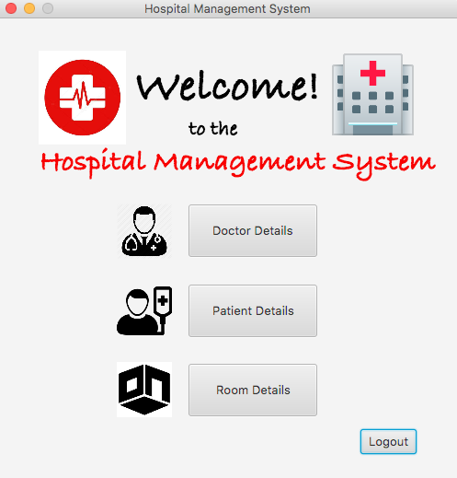

This is the main menu of the hospital management system. Here we have 3 different panels: Doctor, Patient, and Room. We can hit “Logout” to take us back to Login screen.

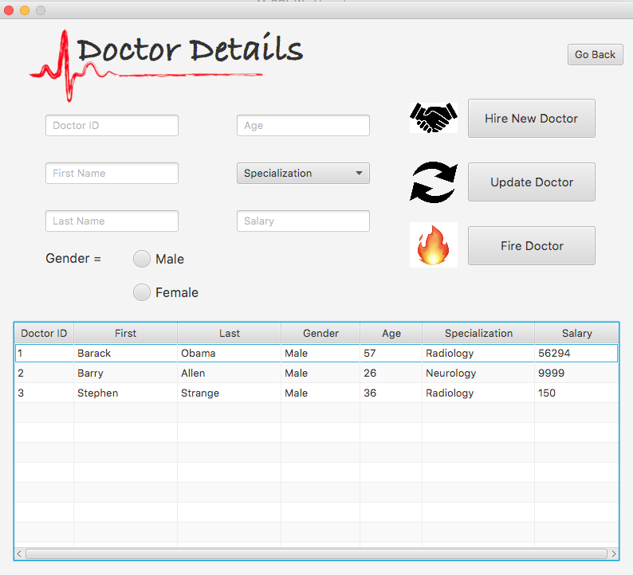

This is the GUI of the Doctor Details. Here we can hire a new doctor to the hospital, update an existing doctor’s information, or fire the doctor!

Below is a table view of the doctor’s table.

Input data to hire a new doctor. When you get the gender section, there will be 2 radio buttons asking you for male or female.

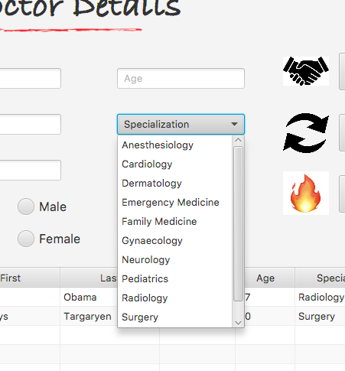

The Specialization combo box as a list of different departments that doctor specializes in.

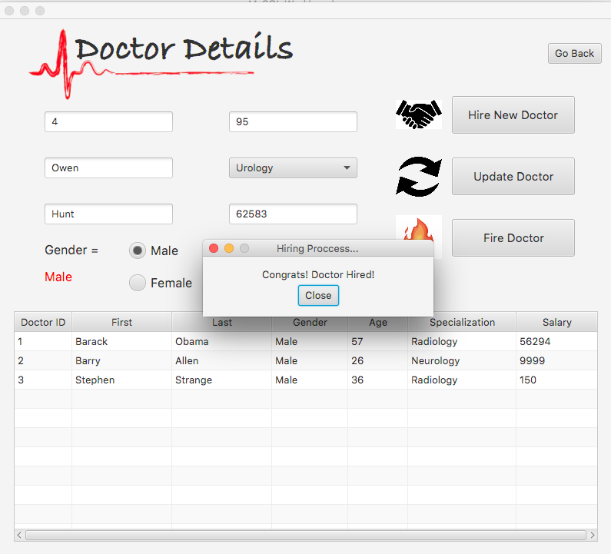

Click the “Hire Doctor” button and you will be notified that the doctor is hired! Yay new job$$$!

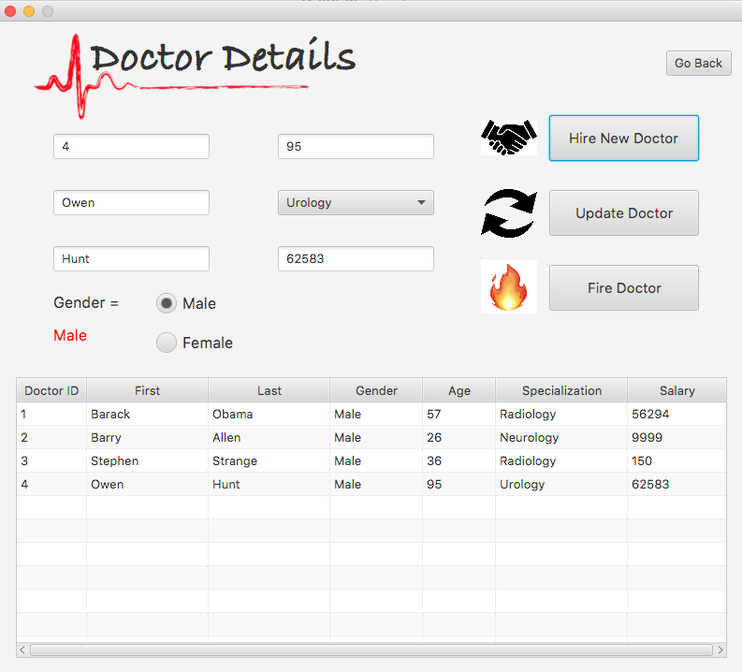



The table view will automatically load with the new doctor record stored.

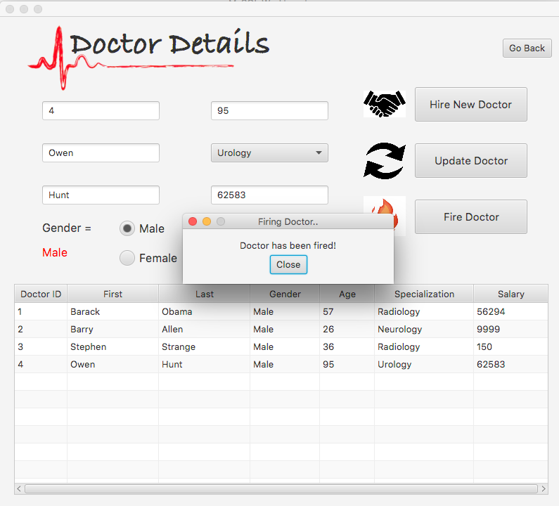

When you type in the doctor’s ID in the textfield and hit the “Fire Doctor” button, it will delete the special record.

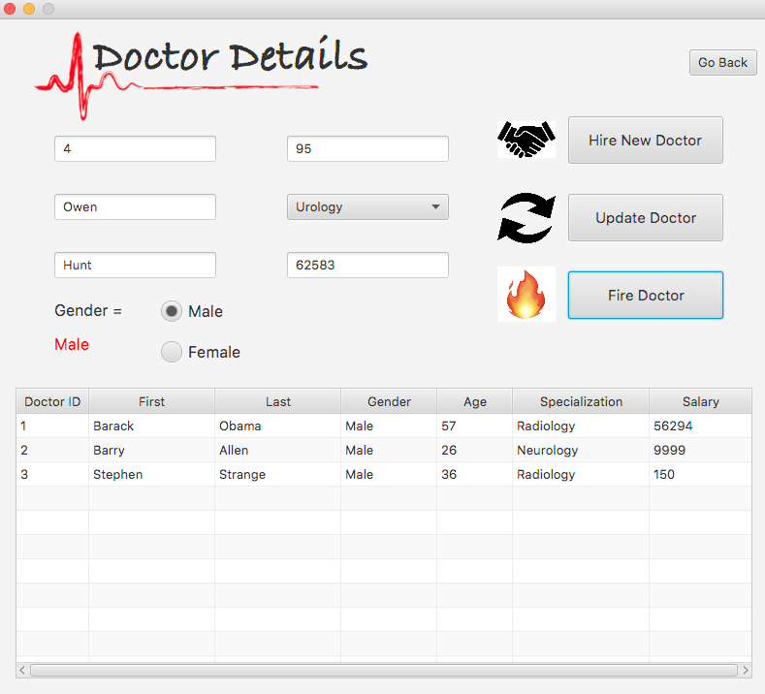



Now Dr. Owen Hunt is has been fired from the hospital! Bye bye!

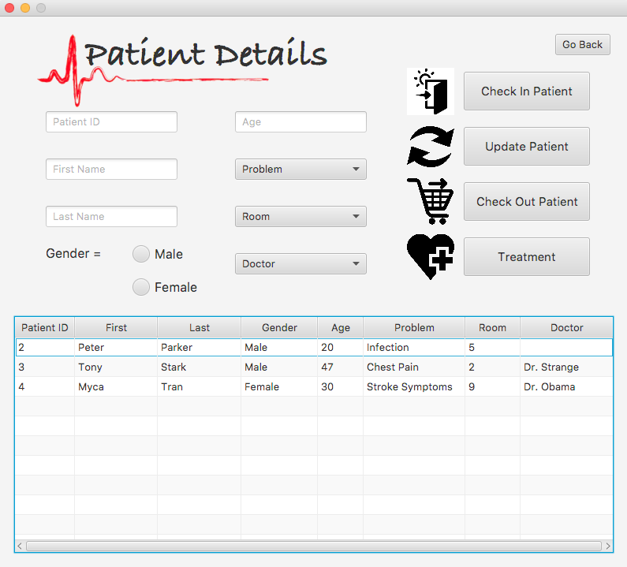

This is the Patient Detail page where you can check in patients, update their info, check them out of the hospital, and prescribe the treatment.

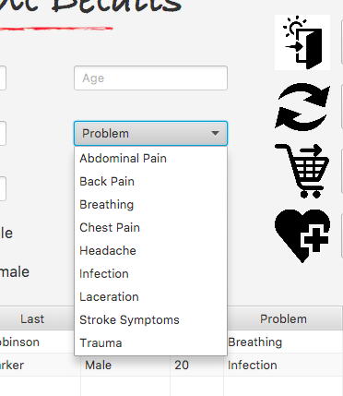

Here, you also input new data to check in a new patient. When you get to the “Problem” combo box, there will be a list requesting what problem does the patient have.

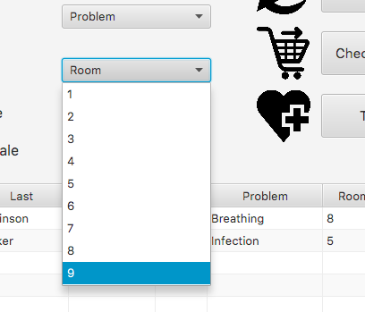

Admin can also choose which room # they will get admitted into.

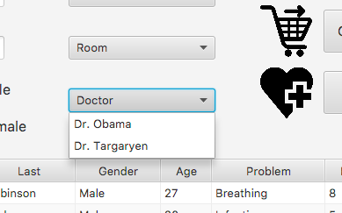

For the “Doctor” combo box, there will be a list of the available doctors that are currently working in the hospital. When new doctors are hired, their name will be loaded into the combo box. Patients are then assigned a doctor (based on their problem and the doctor’s specialization).

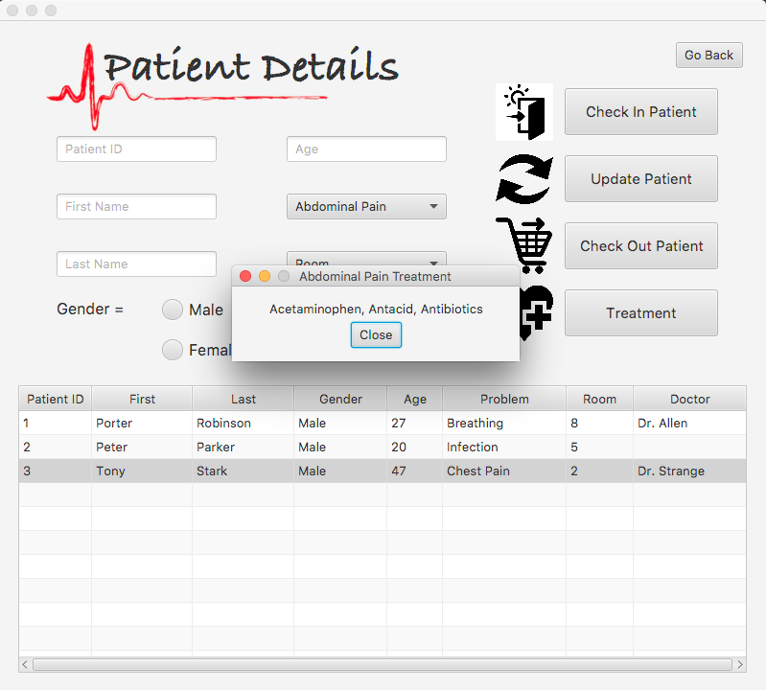



When you choose a problem for the patient, you can hit the “Treatment” button and the doctor will give you general treatments to treat the patient.

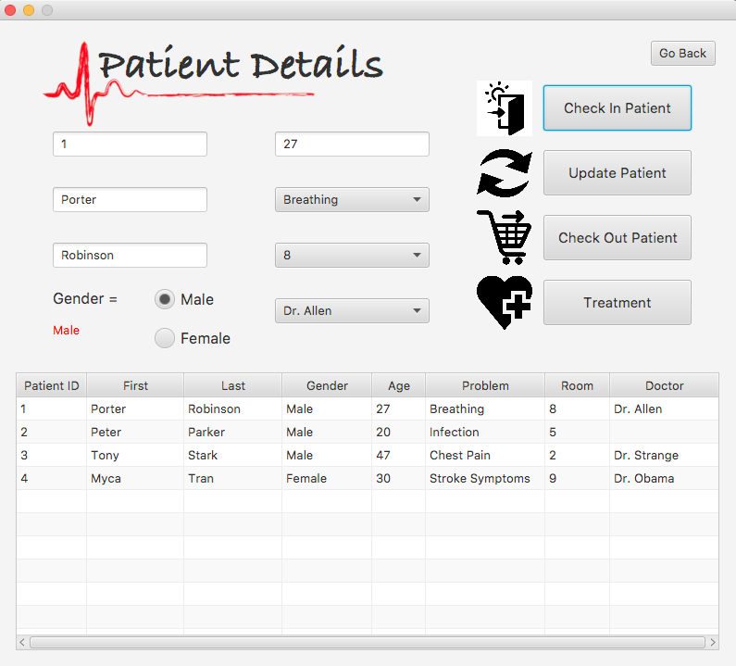



Input the data and hit “Check In” to check in the new patient into the hospital.

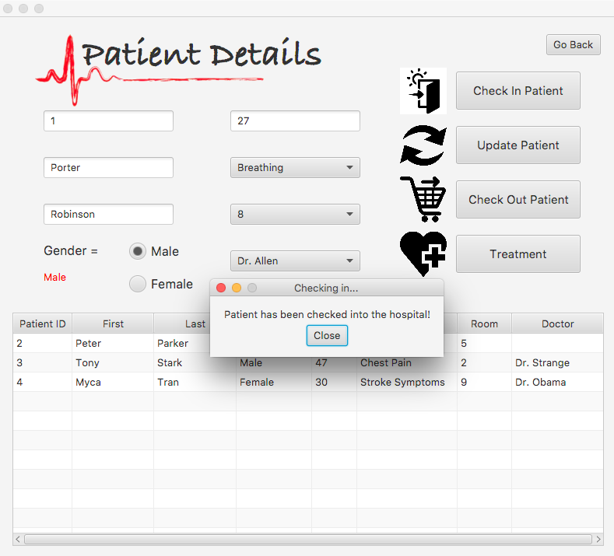

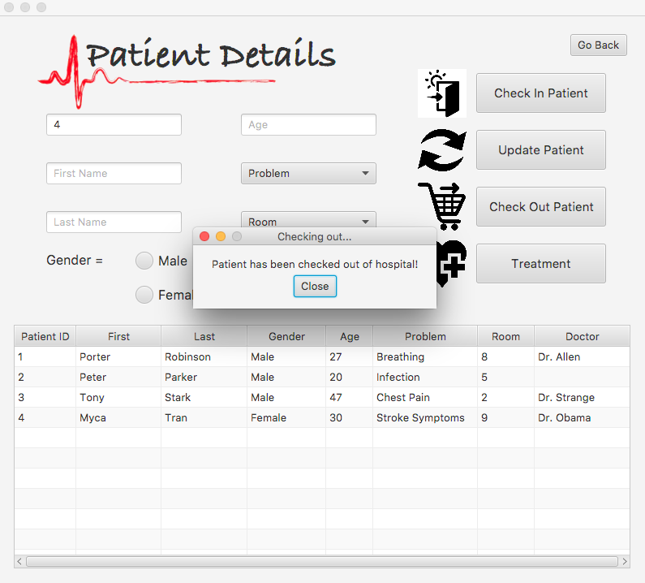



When the patient is feeling better and is ready to go home to heal up, use the patient ID to declare which patient needs to go. Hit the “Check Out” button and the patient will be successfully checked out of the hospital!

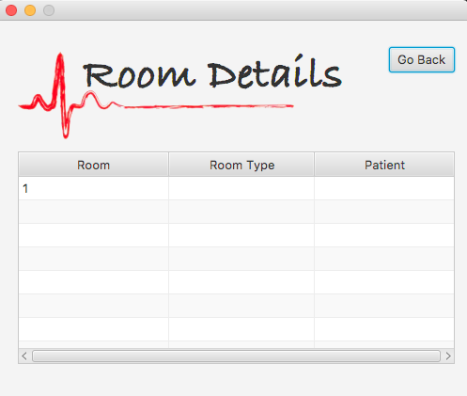

(In progress…)

The Room Details will display the room number, type of room, and which patient is staying in that room.