# Medicare data analysis

**Hospital Readmissions Reduction Program [HRRP]**

## summary

Exploratory analysis of Medicare’s effort to reduce hospital readmissions within a 30-day window for six specific conditions. Under this initiative, payments for services rendered are reduced, up to 3%, for *substandard* quality of care. As noted below, the focus of this analysis is to evaluate the “relative performance” metric as it relates to the designated quantifiable metric, readmission.

“…the 21st Century Cures Act requires CMS to assess a hospital’s performance relative to other hospitals with a similar proportion of patients who are dually eligible for Medicare and full-benefit Medicaid beginning in FY 2019.”

Conditions of focus when determining risk-standardized unplanned readmission measures, as outlined within the HRRP program:

* Acute Myocardial Infarction [AMI]
* Chronic Obstructive Pulmonary Disease [COPD]
* Heart Failure [HF]
* Pneumonia [PNA]
* Coronary Artery Bypass Graft Surgery [CABG]
* Elective Primary Total Hip Arthroplasty and/or Total Knee Arthroplasty [THA/TKA]

## DATA

The data was sourced directly from Medicare via their API. The dataset retrieved consisted of 19,674 rows with 12 variables that spanned a timeframe beginning on 07/01/14 and terminating on 06/30/17. Note, in *figure one*, the number of discharges values have been rounded to their respective whole value.

|  |  |  |
| --- | --- | --- |
|  | Number of discharges | readmission ratio |
| count | 11,532 | 11532 |
| mean | 393 | 1.007 |
| standard dev. | 355 | 0.088 |
| min | 27 | 0.598 |
| 25th percentile | 162 | 0.953 |
| 50th percentile | 291 | 1.003 |
| 75th percentile | 508 | 1.055 |
| max | 8,931 | 1.825 |

*Figure 1*

On average, a given hospital will often exceed their maximal ratio value of 1.00, thereby causing a reduction in their reimbursements from Medicare. Medicare reimbursements for physicians stands at $36.0391, the merit-based incentive payment system (MIPS) has a budget neutrality mandate. This mandate stipulates that all *negative* performance reductions will be awarded to hospitals through an *exceptional performance bonus* to ensure a “neutral” budget, e.g. no surplus nor overtures.

Medicare evaluates hospitals under the following parameters: “excess readmissions are measured by a ratio, by dividing a hospital’s number of “predicted” 30-day readmissions for one of the six procedures by the number that would be “expected”, based on an average hospital with similar patients. A ratio greater than 1.0000 indicates excess readmissions.” As shown below in figure 3 and figure 4, we can see the distributions of readmissions and discharges for all procedures.

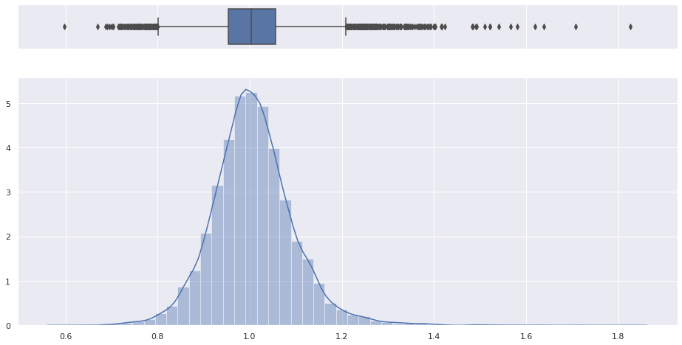

*Figure 3*

*Medicare Readmission [Ratios]*

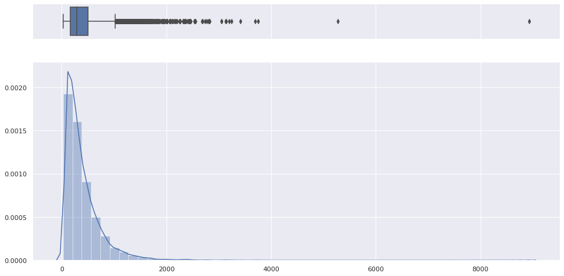

*Figure 4*

*Medicare Discharges [Counts]*

## Analysis

*Figure 5*

Figure 5, summary of total counts by procedure. Respiratory issues account for two of the top three disease/illness processes, heart failure is the secondary only to pneumonia. This is aligned with our initial judgements as the populace that utilizes Medicare is greater than 65 years of age. These processes are in-line with the major aliments for that populace, as heart failure and COPD are both illnesses that degrade the patient as measured in years/decades.

|  |  |
| --- | --- |
| MEASURE/SERVICE TYPE | MEAN |
| HEART FAILURE  [HF] | 1.003496 |
| PNEUMONIA  [PNA] | 1.004801 |
| CHRONIC OBS. PULM. DISEASE  [COPD] | 1.004936 |
| ACUTE MYOCARDIAL INFARCTION  [AMI] | 1.005694 |
| HIP/KNEE REPLACEMENT SURGERY  [HIP_KNEE] | 1.022134 |
| CORON. ART. BYPASS GRAFT SURGERY  [CABG] | 1.022244 |

*Figure 6*

Figure 6, procedures as viewed by the mean, indicate that *corrective* procedures have the highest *average* likelihood for readmissions post-procedure. This is a manual process that is prone to human error as this can vary by surgeon to surgeon, as well as, an indicator that the given physical property has failed within that patient. The remaining processes can, and often are, treated with non-invasive allopathic methods.

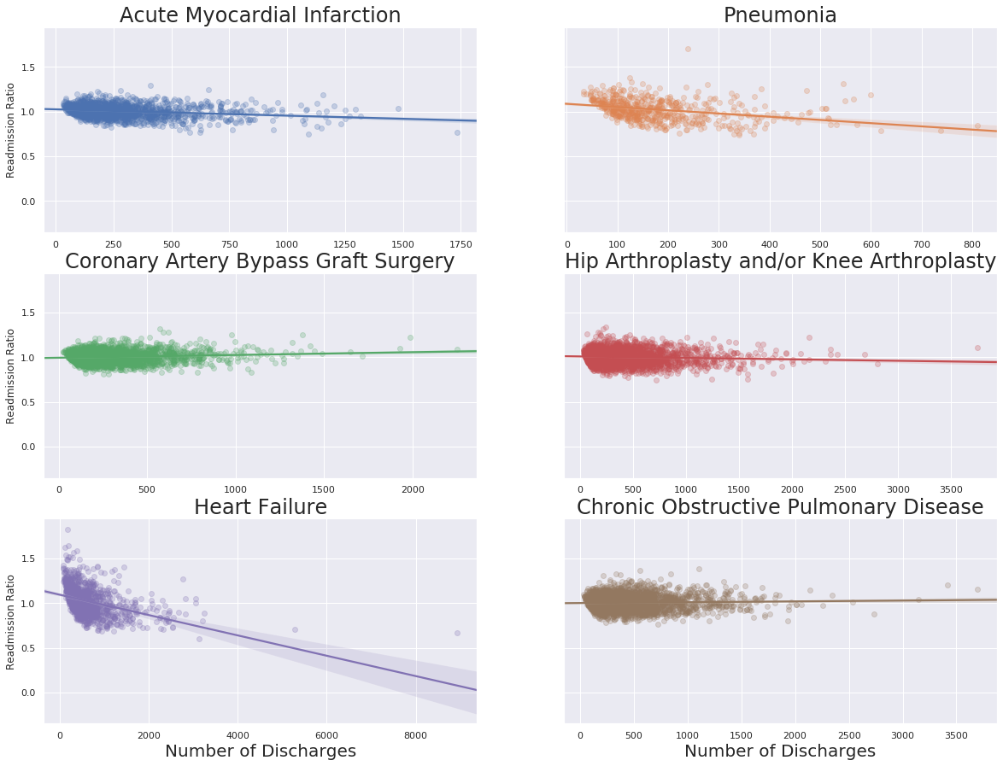

*Figure 7*

Figure 7, readmission ratios by a given procedure, observe that heart failure and pneumonia both indicate a lower likelihood of readmission. If the care is rendered at a hospital that treats that specific process at a high frequency.

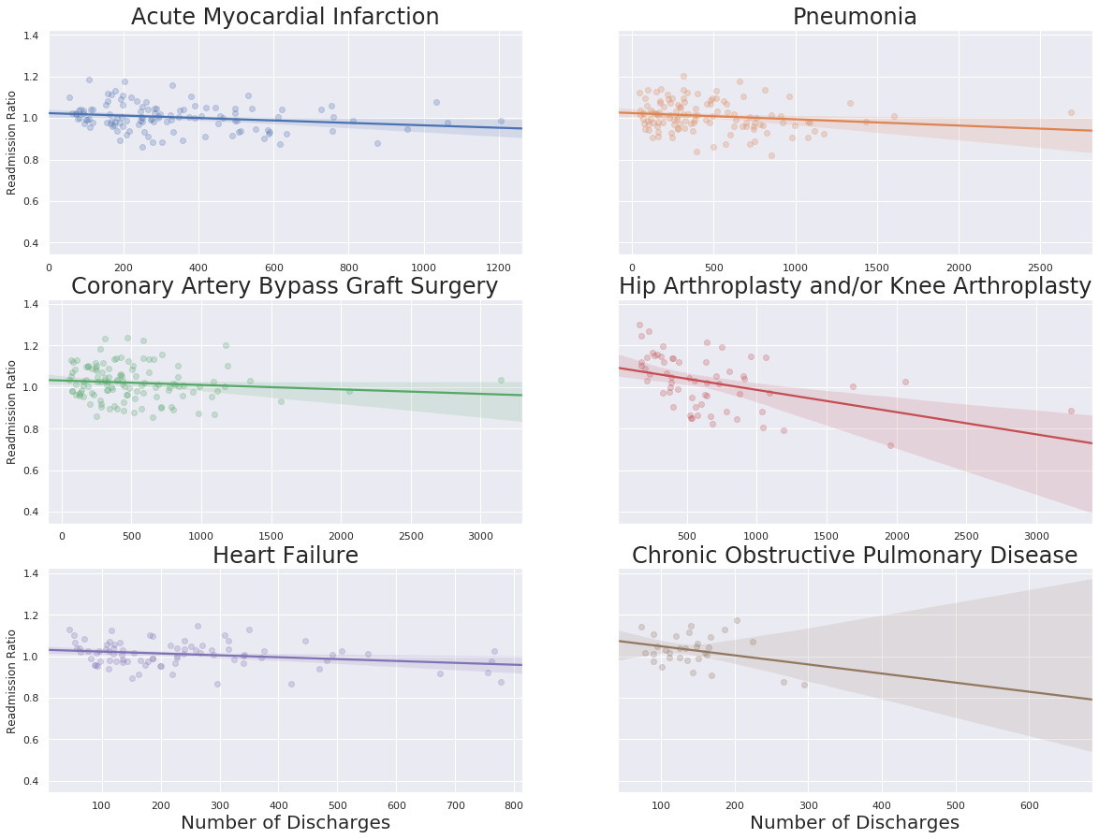

*figure 8*

Figure 8, reflects the readmission trends for all of Illinois. As observed, the trends observed within Illinois indicate that on average across all procedures one can expect a lower likelihood of readmission. It is worth noting that CABG and hip/knee procedures exceed the significant threshold of 1.2 for readmissions if total discharges are less than 1500.

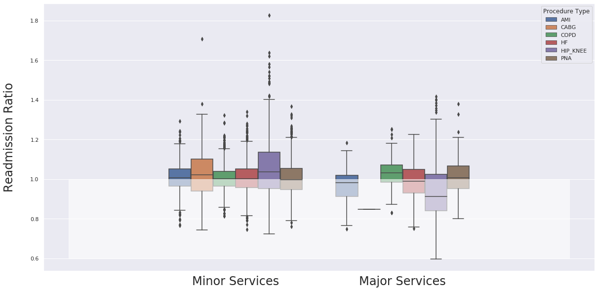

*Figure 9*

Figure 9, visualization of variance between procedures by *size* of service, e.g. the level and resources expended to stabilize a patient well enough to qualify for discharge. We see that with minimal care for these procedures there’s a larger readmission ratio, one can suspect this can be attributed to the current model of medicine, this approach has favored a graduated approach in treatment.

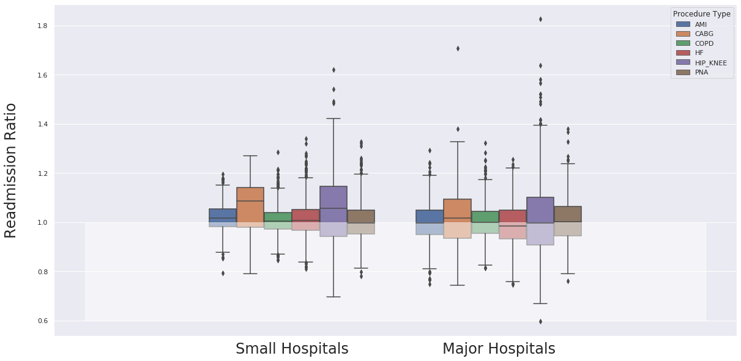

*Figure 10*

Figure 10, bifurcates the procedures group between small sized hospitals and large sized hospitals while accounting for readmission ratios. COPD, heart failure, and pneumonia are the three drivers, there is no major variance between the size of the facility w.r.t. to these primary procedures. The two procedures, both surgical in nature, CABG and hip/knee total replacements have the greatest variance within their respective group, as well as between groups. We can conclude that smaller hospitals have a greater readmission ratio w.r.t. these procedures due to the fact that surgical procedures have an inherent variance from surgery to surgery and surgeon to surgeon, and frequency dictates experience, e.g. larger hospitals staff have greater domain experience. Whereas, the other procedures follow standardized regimes of treatment, we can infer that the readmission variance is not significant between hospitals when grouped by size of the hospital.

## conclusion

In conclusion, smaller hospitals are on par as a group with larger hospitals w.r.t. the procedures that account for the largest proportion of services rendered. Only when we focus on the two procedures that introduce variance of care at the provider level do we see a palpable change in readmissions. This dataset does not include any features that have predictive power if we wanted to reduce readmissions. At the current granular level, we can only conclude which hospitals perform well versus their counterparts. In addition, we can translate CMS’s “excess readmission ratio” into more easily digestible statistic, the percentage of readmissions. This simple metric can tell one what the likelihood is that a given patient will be admitted. This early exploratory analysis has shown that current metrics are utilizing a weak correlation, that variance is greatest at the surgical level, and the current data fails to capture the latent variables driving the variance.

## refrences

Test blah blah