Touch-22
“Can’t Touch This”
Software Design and Documentation
Team Members: Jonathon Wu, Danielle Geffert, Dan Moseley, Logan Moseley

Project Status Report:
During the first iteration of our construction period, Touch 22’s focus seemed to rest more on the hardware than the software. This resulted in the screen being built in a relatively short period of time. However, once plugged in and powered on, the results weren’t exactly up to standard. This is the first and biggest risk we ran into during the Construction phase; not getting our screen to work would obviously put a damper on the most significant part of our project. There are still possible fixes that we have yet to try; these include adding extra LEDs with the idea that the brighter the light, the easier the camera can pick up touches, and upgrading the webcam itself, as the model we are currently using isn’t the best of its kind. Even if we are unable to get the screen working, we have a way of simulating multi-touch input with various infrared light sources, and will still be able to demonstrate our finished software.
The second half of construction involved shifting our focus to the software aspect of the project. We mentioned during Elaboration that our selected paint program, TuxPaint, was structured in such a way that compatibility with our project was a large risk. As it turned out, this risk was so significant it forced us to look for another, more usable program. We found another simple paint program which already demonstrated using touch input. Since it was considered to be able to handle our touch input and was also easily modified, the group decided that this was the best option. We were able to insert a majority of our desired functionality, but there are still a few bugs that haven’t been completely resolved. During the final stages of the project, the team will definitely put in additional time and effort to resolve existing bugs as well as to augment the project with additional functionality.

Contribution Summary
Task | Completed By
Beta Release | Group
Project Status Report | Danielle
Contribution Summary | Dan & Logan
Interaction Diagrams | Jon
Static Class Diagram | Jon
Testing Plan | Dan & Logan

Use Case | Status
UPaint | Completed(Group)
UChange | Completed(Group)
UClear | Completed(Dan)
USave | Completed(Logan)
ULoad | Completed(Logan)
USize | Completed(Dan)
ULine | Completed(Dan)
UUndo | Completed(Dan & Logan)
UShapes | Completed(Logan)
UFill | Completed(Dan)
UEraser | Completed(Logan)
USelect | INCOMPLETE(Jon)
UZoom | INCOMPLETE(Jon)

Communications Diagrams
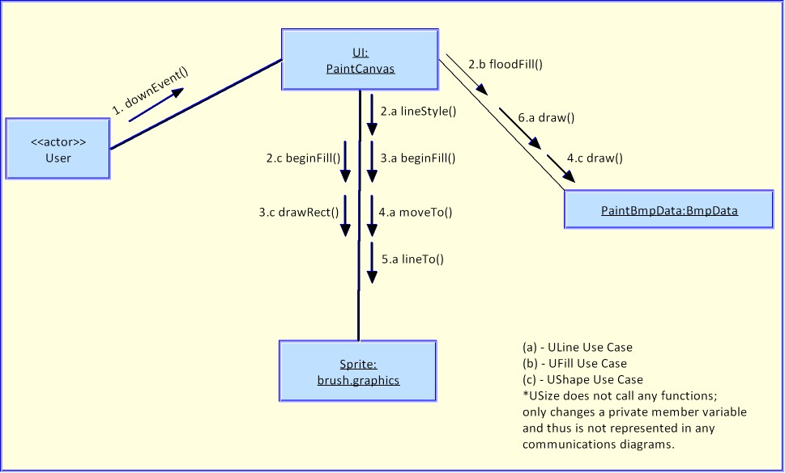
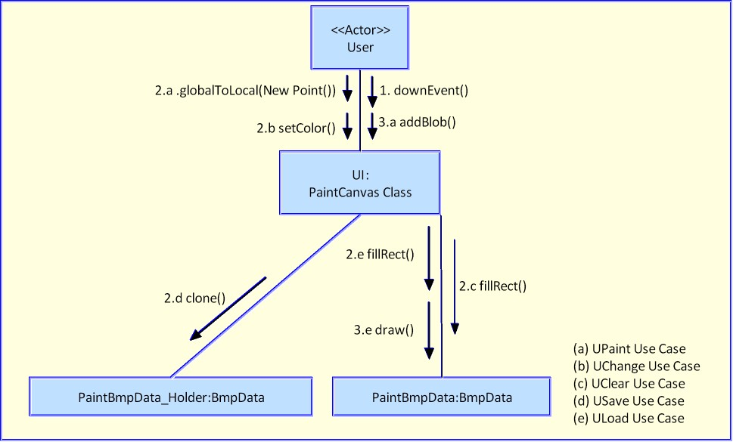
Static Class Diagram
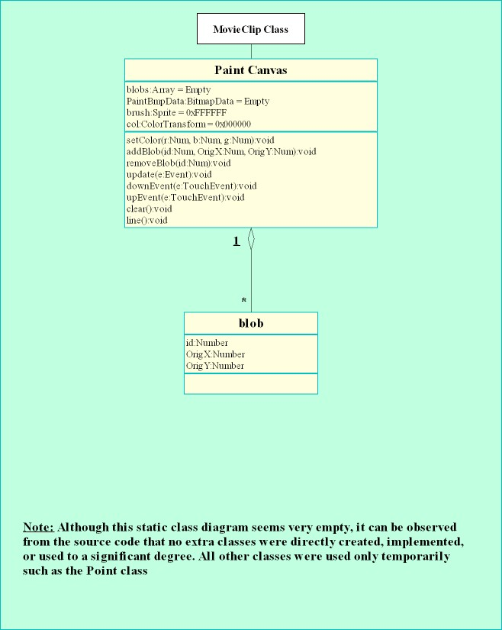

Test Plan
Testers will be given our Test Case Specifications to follow in initial trial runs. Afterwards, testers are allowed a sandbox testing environment, in which they are allowed free reign on our system in an effort to break it. We aim for a minimal amount of bugs, both in internal testing and external testing, in which the input from the battery of testers is evaluated and bugs resolved.
The procession of test users include the designers and programmers, John Sturman, Anita Kuchera, students and TAs of Section Two of Software Design & Documentation, and Rensselaer Society of Engineers house residents. Developer tests throughout development; SD&D tests April 17th, 2008; RSE tests the weekend of April 25th
Test Case Specifications
- UPaint: Touch the screen at a vacant location. Does this action make a mark?
- UChange: Touch a color and verify correct color under UPaint directives. Is the color correct? Repeat for each color.
- UClear: Touch the "Clear" button. Are all marks erased?
- USave/ULoad: Paint on the canvas. Touch the "Save" button. Perform any action(s). Touch the " Load" button. Is the canvas returned to the state in which it was saved?
- USize: Touch the size button desired. Paint on the canvas. Does the mark's size correspond to the size selected?
- ULine: Touch the "Line" button. Paint a starting point mark. Paint an ending point mark. Does a line connect the two? Is it the right color?
- UUndo: Paint on the canvas. Paint once more. Touch the "Undo" button. Does the canvas return to the immediately previous state?
- UShape: Touch the "Shape" button. Paint a point where the center of the shape should be. Does a shape appear? Is it centered on that point? Is it the right color?
- UFill: Touch the "Fill" button. Paint a point from which the fill of your color will propagate. Is the entirety of adjacent paintings, of the same color, recolored to yours?
- USelect: Touch the "Select" button. Touch the upper-left corner of the desired selection box. Touch the lower-right corner. Does a box appear outlining this area? Is painting on the canvas only allowed within this selection?
- UZoomIn: Touch the "Zoom" button. Touch the upper-left corner of the desired zoom box. Touch the lower-right corner. Is the canvas magnified, making this box the viewable area?
- UZoomOut: Touch the "Zoom" button. Touch the lower-right corner of some box. Touch the upper-left corner. Is the viewable area shrunk, revealing a larger canvas?

Preliminary Test Results
- UPaint: Yes, touching makes a mark.
- UChange: Yes, changing the color works.
- UClear: Yes, the canvas is cleared.
- USave/ULoad: Yes, loading returns the canvas to the correctly saved version.
- USize: Yes, all three size selections resize the brush correctly.
- ULine: Yes, a line of the right color connects the start and end points.
- UUndo: Yes, the canvas is reverted back one action.
- UShape: Yes, the shape appears, centered on the point with the correct color.
- UFill: Yes, the amoeba of color is filled to my specification.
- USelect: Not yet implemented.
- UZoomIn: Not yet implemented.
- UZoomOut: Not yet implemented.

Source Code
It is important to note that the source code is all code from a class definition; the PaintCanvas class. All adjustments to the original code is made in this class definition. The source code is additionally attached within this zip file.

