Touch-22
“Can’t Touch This”
Software Design and Documentation
Team Members: Jonathon Wu, Danielle Geffert, Dan Moseley, Logan Moseley

Domain Model Diagram
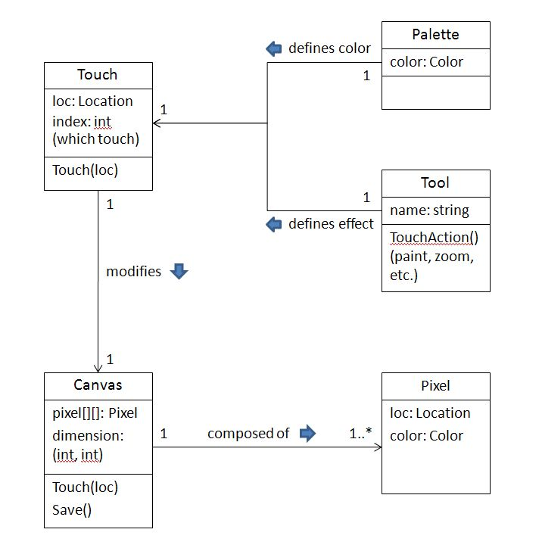
Supplemental Specifications
M(ust):
- Accept user touch input
- Paint program must provide basic drawing
  - canvas to draw on
  - freehand
  - select color
  - clear/erase
- Color palette buttons are more than ½” inch tall on projected display.
- Relevant documentation for all implemented features.
S(hould)
- Paint program should provide the following drawing tools
  - lines
  - shapes
  - text
  - selection
  - zoom in/out
  - brush change
- Paint program should provide save options for paintings
- Paint program should provide load options for paintings
- 80% uptime.
- If the program crashes, it should be well documented for serviceability.
- 0.5 second response time
- Gestures (e.g., drag up to zoom in, drag down to zoom out)
C(ould):
- Extended file type support ( jpg, bmp, etc)
- System auto-saves the canvas every 5 minutes.
- If the program crashes, provide a way to recover data.
- Cross-platform support (OS X, Windows, etc)
- Multi-language support
W(ont):
- Animation support
- Layer support
- Non-shape selection
  - freehand
  - magnetic
  - color/region

Deployment Diagram
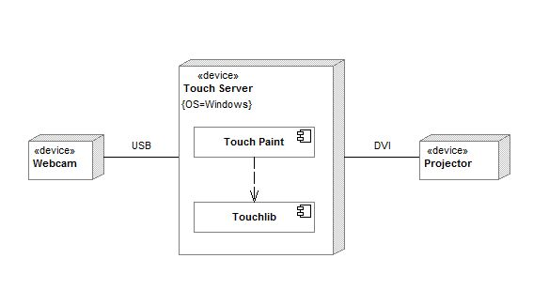
We are using a windows operating system on the touch server because the touchlib library we chose runs natively on the windows platform, and our group has the most experience on windows. For the webcam, Kieran picked out a cheap model on ebay which happened to come with the internal IR filter already removed which saved us some work. We are unsure of what specific kind of projector we will be using because Kieran will be borrowing one for us from somewhere. These two aspects of the project are not important at this point because nothing is dependent upon which kind of either we have.
Use Cases
Use Case: Paint Things
Identifier: | UPaint
Description: | Painting things
Actors: | User
Preconditions: | - Paint is open
Flow of events: | - User touches the screen on a region within the canvas boundaries.  - Any pixel that comes into contact with the touch of the user changes into the color that is selected from the palette.
Postconditions: | - The design drawn by the user stays on the canvas in the color that was selected at the time

Use Case: Change Color
Identifier: | UChange
Description: | Changing the color
Actors: | User
Preconditions: | - Paint is open
Flow of events: | - User selects a color from the palette  - The color of the brush changes to that color and any touch event that occurs after the changing of the color will result in the new selected color being painted
Postconditions: | - All paint events that occur after this use case will be in the color selected in this use case.

Use Case: Clear Canvas
Identifier: | UClear
Description: | Clears the canvas of all marks
Actors: | User
Preconditions: | - Paint is open
Flow of events: | - User selects the ‘clear canvas’ button from the menu bar.  - All marks and paintings on the canvas disappear and is replaced by a blank white board. The selected color from the palette remains the same.
Postconditions: | 1. The canvas is completely white and void of marks

Use Case: Save Painting
Identifier: | USave
Description: | Saves the current painting to a user selected location
Actors: | User
Preconditions: | - Paint is open  - User has an open painting to save
Flow of events: | - User selects the ‘save’ option from the menu bar  - In the ‘save’ box that opens, User browses to or enters the location where they would like to save their painting  2a. If the entered location already exists, the user decides whether they would like to overwrite the existing painting, or enter a new location
Postconditions: | 1. The painting is saved so that the user can open it later

Use Case: Load Painting
Identifier: | ULoad
Description: | Loads a previously saved painting so the user can continue working on it
Actors: | User
Preconditions: | - Paint is open  - User has previously saved a painting (USave)
Flow of events: | - User selects the ‘load’ option from the menu bar  - In the ‘load’ box that opens, User selects the painting they would like to load
Postconditions: | 1. The saved painting is open so the user can continue working on it

Use Case: Select area
Identifier: | USelect
Description: | Selects an area of the canvas for user to work in
Actors: | User
Preconditions: | - Paint is open
Flow of events: | - User chooses the ‘select’ button from the menu bar  - On the canvas, user drags a selection box around the area they would like to have selected
Postconditions: | 1. An area is selected for the user to work in

Use Case: Place text on the Canvas
Identifier: | UText
Description: | Allows the user to write text on the canvas
Actors: | User
Preconditions: | - Paint is open
Flow of events: | - User selects the ‘text’ option from the menu bar  - User selects the place on the canvas where they would like their text to start  - User enters the text they would like to have on the canvas
Postconditions: | 1. The user entered text is displayed on the canvas

Use Case: Zoom in/out
Identifier: | UZoom
Description: | Zooms closer to or farther from the painting
Actors: | User
Preconditions: | - Paint is open
Flow of events: | - User selects the ‘zoom’ option from the menu bar  - User selects the spot on the canvas he would like to zoom in or out on  3a. To zoom in, user drags forward  3b. To zoom out, user drags backwards
Postconditions: | 1. The painting is zoomed to where the user wants it

Use Case: Draw line
Identifier: | ULine
Description: | Allows the user to draw a straight line on the canvas
Actors: | User
Preconditions: | - Paint is open
Flow of events: | - User selects the ‘draw line’ option from the menu bar  - User selects a spot on the canvas where he would like the line to begin  - User selects a spot on the canvas where he would like the line to end
Postconditions: | 1. A line is displayed starting and ending at the points the user specified

Use Case: Fill
Identifier: | UFill
Description: | Allows the user to fill in an area of the canvas with a solid color
Actors: | User
Preconditions: | - Paint is open
Flow of events: | - User selects a color from the palette (UChange)  - User clicks on an area of the canvas he would like to fill
Postconditions: | 1. An area of the canvas that the user selected has been filled with the color he selected  1a. If the user had an area selected (USelect), only canvas inside that area will have been filled with color

Use Case: Draw Shapes
Identifier: | UShapes
Description: | Allows the user to draw premade shapes on the canvas
Actors: | User
Preconditions: | - Paint is open
Flow of events: | - User selects the ‘shape’ option from the menu bar  - In the ‘Select Shape’ screen that opens, the user selects the shape he would like to draw  - User clicks on the point on the canvas he would like to start the shape  - User drags in any direction until the shape is the correct size
Postconditions: | 1. The user selected shape has been drawn on the canvas in the specified spot

System Sequence Diagrams
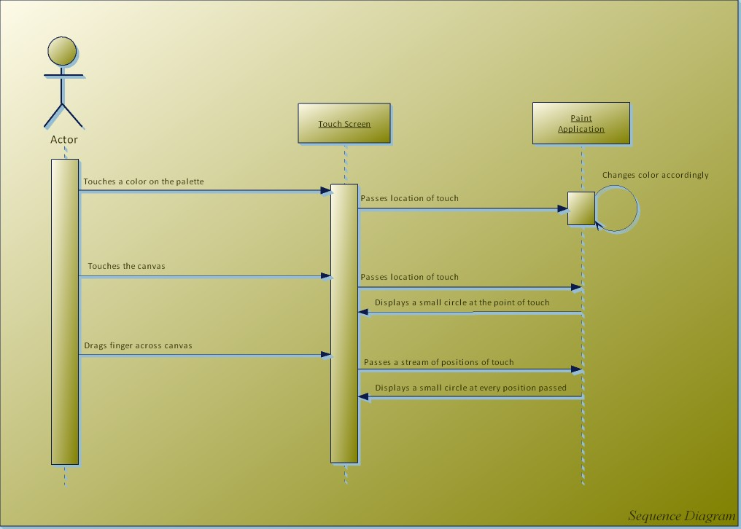
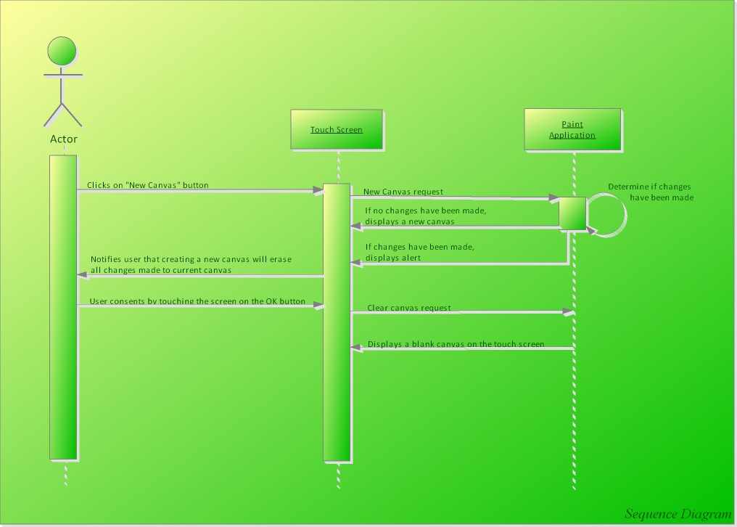
Schedule: (Same as original)
- February 11, 2008: Inception deliverables due, including our vision statement, more than 20% of all known use cases, a basic glossary, along with a tentative schedule and budget for the project.
- March 3, 2008: Elaboration deliverables due, including a domain model diagram, supplemental specifications, system sequence diagrams, a deployment diagram, more than 80% of all known use cases, and an updated schedule.
- March 24, 2008: First iteration is over. The GUI for the paint program will be finished, including basic design and layout (drawing area, color palette, and tool bar). Basic drawing ( Use case UPaint ), color selecting ( UChange ), and clearing the canvas ( UClear ) will be completed and working by this point. Materials to build the hardware components will have been acquired and building started.
- March 31, 2008: Second iteration is over. More drawing tools (all above cases) will be working. Hardware will be tested and working, and input from the touch screen will be implemented in the drawing application. Product tests will have been planned out and initial testing started.
- April 7, 2008: Third iteration is over. The paint program will be finished and in the process of being bug tested. Preliminary test results will be available, and bugs will be recorded for later fixing. The product will also be readied for its beta release.
- April 14, 2008: Beta release; Construction deliverables due, including interaction diagrams, a static class diagram, and a testing plan with any preliminary test results.
- April 28, 2008: Final release; Transition deliverables due, including documentation, final test results, documentation of best practices used, and peer reviews from each team member. Projects will have been presented by this point.
Task Breakdown
Building the frame
- Buy wood
- Assemble frame out of wood
- Attach acrylic screen inside frame
- Attach matting onto back of the screen
- Attach LEDs to the sides of the screen
- Calculate voltage distribution among LEDs
- Connect LEDs to power source
- Position webcam under screen
- Set up projector under screen
- Test for blob detection

Use cases
- Painting things
- Changing color
- Clearing canvas
- Saving canvas
- Loading canvas
- Select area
- Apply text
- Zoom in/Zoom out
- Draw line
- Fill area
- Draw shapes
Project Status Report:
Touch 22's focus has been refined and the project is progressing steadily. With the group concentration on a single application, a greater amount of attention can go into the detail, quality, and completeness of our multi-touch product.
We have acquired the two webcams, infrared LEDs, and acryllic pane needed to build the hardware side, the touch-screen itself. In addition to the hardware, TuxPaint(www.tuxpaint.org), an open source project, has been elected as the basis for software coding. We will be modifying TuxPaint code to accept touch points, in lieu of mouse clicks, and more than one input at a time. Not only is TuxPaint open source, simple, and easy to use, its big buttons are perfect for finger pointing and relatively little code allows us to spend less time figuring it out and more time coding.
The biggest risk with the multi-touch project at the moment is the structure of TuxPaint, in that it may or may not be easy, or even possible, to have it accept more than one point of input at a time. Also, the group as a whole does not have extensive experience working with LEDs and building a precise hardware suite around them. No major issues have been encountered.

Contribution Summary:
Project Status Report: Logan Moseley
Domain Model Diagram: Logan Moseley
Supplemental Specification: Danielle Geffert
System Sequence Diagram: Jon Wu
Deployment Diagram: Dan Moseley
Use Cases: Danielle Geffert
Work Breakdown Structure: Original
Compilation: Dan Moseley

