**Argument**

Digital Humanties is by now an well-established field of academic research. For some outsiders, it might trigger the impression that it is simply a hip buzzword, or merely a passing trend. The trend definetly isn’t going to fade out any time soon, since the digital age remains unrelenting since it’s dawn in the late 80’s / early 90’s. As for the other part of our binomial, the Humanities, to attempt to compress its rich history and tradition in a paper’s argument would be mean either naivety or arrogance. However, the humanties cannot be possible divorced by the tehnical progress that occurs within societies. The classic, widely known example: Gutenberbg’s press - it revolutionized the capacity of text production and circulation. Therefore, we arrive at the conclusion that it fundamentaly changed hows scholars structured their activity, since the text was always their fundamental work object.

It is also true that the humanties evolved to be more specialized and branched out, to suit the needs of the increasing body of knowledge that it produced, but also the demands for accuracy and veracity (a classic example is how ancient and medieval historians/chroniclers depicted events vs. the modus operandis of contemporary historians). This shift is itself indicative of a change of paradigm, from the generalist, Rennaisance scholar to the modern, highly specialized in his niche modern researcher. In this context, I’m stating that the Digital Humanities is itself a field of subfields, an umbrella term, similarly to how the Humanities, in their traditional understanding hold the same significance. Therefore, the adjective “digital” is a consequence of the Humanities continuing to exist in the current paradigm. It isn’t, by any means, a micro-niche made up by some pretentious researchers as a result of their unconventional experimentation (although such practices have their merits and have lead to unexpected breakthroughs across all fields of research).

In Humanistic research, as I’ve already stated, text is usually the main object of study. There are also connected domains that mainly study real-life, palpable objects (archeology, numismatics), or social realities and human behavior (anthropology, psychology neurosciences). But before these modern disciplines and their methods, the humanist tradition lies on fundamental texts: The Bible, Homer’s Illiad and Odyssey, Plato’s Republic, Aristotle’s Poetica and so on.

Nowadays, information is being generated and circulated at overwhelming rates. The internet is an ever-shifting environment where different media coexist and combine. Patrik Svenson’s provides insights on this phenomenon:

One important and apparent consequence of increased digitalization and, in particular, the web, is highly increased access to and availability of different types of content and media. Some of this content is born-analogue and much of it is born-digital. Increasingly, but not necessarily, these expressions are media rich, polytextual and mixed. [Schnapp & Shanks 2009, 147] discuss "fungibility" — the gathering of many types of content (moving image, text, music, 3D-design, database, graphical detail, virtual walk-through etc.) into a single environment — as the core of digital mediation. Content can accordingly be infinitely manipulated and remobilized without loss.

[Svenson, Patrik. The Landscape of Digital Humanities in the Digital Humanties Quaterly, Providence Vol.4. 2010]

As shown by Svenson, content produced in the digital age is heterogeneous by nature. In contrast, established literary works, fiction or non-fiction, are just blocks of texts, and sometimes images. Them existing in digital format doesn’t mean a fundamental transformation at the content level. However, this format opens up the usage of digital tools and, therefore, new angles of viewing established works. Svenson (2010) provides his take on what the general aim of digital humanties should be:

The digital humanities comprise the study of what happens at the intersection of computing tools with cultural artefacts of all kinds. This study begins where basic familiarity with standard software ends. It probes how these common tools may be used to make new knowledge from our cultural inheritance and from the contemporary world. [Ibidem]

What I focus on in this paper are textual cultural aretfacts: literary texts that I enjoy and am familiar with, with the aim of revisting them from a different angle using a machine. Although it was theorized by various scholars and given multiple defintions, distant reading, as a general, collective term, encompasses the usage of various digital tools applied to literary corpora.

In this paper, I am employing several distant reading tools with aim of tracing and comparing the works of established authors in the Sci-fi genre. The selected corpora are run trough BookNLP, a a python based data-mining pipeline, specialized for narrative fiction. Other Python libraries are beyond employed for combing and visualizing the obtained data, as well as the web-based platform, Voyant.

**Introduction**

* 1. **The authors**

I selected for analysis the works of three wildely influental authors of sci-fi (altough the work of the first two were attached to different labels also, they remain under the sci-fi umbrella in broad sense): H.P. Lovecraft, Philip K. Dick, William Gibson. Their work spawned significant followings and fandoms, which arguably became subgenres of their own under the sci-fi umbrella. The authors’ work extends well beyond their fiction into philosophical essays, social critique, and correspondance with other authors and thinkers.

**Howard Phillips Lovecraft** (1890-1937) devoleped a shared universe between his various short stories and novellas, governed by an impressive mythos of his own creation. This wicked imagery is a direct extension of his phiolopshy: cosmicism, which states that human life holds no significance against the vast, hostile and incomprehensible universe that hosts it. His work is to a great extent a reflection of his hypondriac personality and precarious health that was a constant throughout his life. Unfortunately, much of his social anxieties fell under the spectre of racism and white supremacism, that were common in his time. He spawned a genre that is now known as cosmic horror, or even Lovecraftian horror, when his mythos is directly referenced.

**Philip Kindred Dick**’s (1952-1982) fiction is usually centered on his characters struggle to comply with their given reality. His fears reflect the unstable political enviorment of his youth during the cold war, which mainly involved distrust in the government and the looming nuclear menance. His heavy use of substances, which eventually brough him to an early end, fueled a dystopic, convoluted imagery, where the controived reality is controlled by entities (govermental superstructures, aliens, artificial intelligence) beyond human understanding. Besides sci-fi, his work has been labelled as paranoid fiction or even philosophical fiction, but nonetheless, the dangers of technology.

**William Ford Gibson** (1948) had a later literary debut, he is actually 4 years younger than Philip K. Dick. Both visionary and foreboding, his work, just as Lovecraft’s, devoleped over a shared universe that entails the definitive aeshtetics and socio-politics of cyberpunk. This subgenre has been succinctly defined by the “high-tech, low-life” tennet. Gibson warns about a world where human life becomes increasingly expandable, crumbling under the pervasive and domineering technology that far surparsses its creators. His characters deal with loss of identity, as their conciousness is being fragmented by systems outside of their understanding. The cyberpsace, a term which he coined, although occult and inaccesible for the uninitiated, still accurately portrays many aspects of today’s internet and the toll it’s taking on our lives.

**1.2. Selected corpora**

My aim was to collect a balanced corpus across the authors. For each, I selected one longer work – a short novel or a novella, and 4 short stories, resulting in a corpus of ~100.000 words per author.

**1.3. BookNLP**

The digital tool that I am employing is a Python-based NLP pipeline suggestively named BookNLP. It was devoloped by David Bamman, associate professor in the School of Information at Berkeley, University of California. The GitHub documentation page lays out the pipeline’s capacities:

BookNLP is a natural language processing pipeline that scales to books and other long documents (in English), including:

* Part-of-speech tagging
* Dependency parsing
* Entity recognition
* Character name clustering (e.g., "Tom", "Tom Sawyer", "Mr. Sawyer", "Thomas Sawyer" -> TOM_SAWYER) and coreference resolution
* Quotation speaker identification
* Supersense tagging (e.g., "animal", "artifact", "body", "cognition", etc.)
* Event tagging
* Referential gender inference (TOM_SAWYER -> he/him/his)

[Bamman, David, BookNLP Github repository, 2022 <https://github.com/booknlp/booknlp>]

W.J.B. Mattingly, researcher at Smithosian Data Science Lab and United States Holocaust Memorial Museum, used the pipeline extensively in his work and also created learning resources for making it more accesible (Youtube tutorial series and a website that holds examples and lessons). He explains the rationale behind converting the pipeline, which was originally conceived in Java, to Python:

BookNLP is a new Python library created by David Bamman. It was originally created as a Java library in 2014 under the same name, BookNLP by David Bamman, Ted Underwood, and Noah Smith (see, David Bamman, Ted Underwood and Noah Smith, “A Bayesian Mixed Effects Model of Literary Character,” ACL 2014). While Java is a powerful coding language, both in speed and ease-of-use, not many digital humanists code in Java primarily. I suspect (I want to emphasize I could be wrong) the reason for the Python library was to address the larger Python-coding community both in general and specifically within the digital humanities.

[Mattingly, William. *Introduction to BookNLP*, 2022. [booknlp.pythonhumanities.com](https://booknlp.pythonhumanities.com/booknlp.pythonhumanities.com)]

Mattingly also further layous out what the pipeline’s intended use is:

Both the documentation and this textbook emphasize the word *large* here. The reason? Because most language models do not perform well with larger documents. Old RNN-based language models had a hard time remembering earlier words and while newer transformer-based models, such as BERT, have a larger memory and can look forwards and backwards, the size of the input they can take in is only 512 words. For larger documents, therefore, different solutions (and libraries) should be considered. This is where BookNLP comes in. It also addresses several problems associated with books and larger documents, such as:

* Characters (and people) are referenced by different names. BookNLP solves this problem with name clustering and coreference resolution. This is a task in NLP where we try and find all uses a name and correctly assign them to the same identifier, such as Harry, Harry Potter, and Mr. Harry Potter all being the same person, Harry Potter.
* An adjacent problem is referential gender inferencing. Like coreference resolution, often times in a book or larger document, a person will be referred to as a pronoun. This is where referential gender inferencing comes in. This allows a user to correctly assign the antecedent or postcedent to the correct pronoun. When done successfully, this also allows you to make decisions about the gender of the character or person based on how they are referenced in the text. Because this task is so delicate, given the delicate nature of assigning gender, BookNLP fortunately gives users the data with each pronoun used to reference a character and also includes non-binary pronouns.
* Another issue is quotation speaker identification. This is when we need to understand who is speaking, so that we can correctly link characters to their dialogues. It is possible to do this with spaCy, but it is extremely difficult to do well. BookNLP does a remarkable job of handling this problem and it does it with a fair degree of accuracy, from what I have seen.
* Event tagging is another key issue with longer documents and books. There are machine learning models that find events and you can easily cultivate a list of domain-specific events to improve a pipeline, but for BookNLP event is defined more broadly. From my experience, it is more based around key actions, rather than named events (as it is in named entity recognition). This has a tangential benefit known as triple extraction. In my opinion, it might be a bit better to view BookNLP events through this lens. Triple extraction is when we try and extract three pieces of information, such as (Actor, Action, Recipient) or (Actor, IS, Something). With these types of tuples, we can construct a knowledge tree about a corpus fairly easily. This a very challenging problem in NLP because triple extraction can be very domain-specific. BookNLP provides a great starting place for triple extraction with its events.

[Ibidem]

Citations

Treating literary works themselves as networks, however, poses distinct computational challanges. While research into information propagation in social media tends to presume access to explicit networks, the character networks represented in novels are implicit.

[Sims, Matthew; Bamman, David, Measuring Information Propagation in Literary Social Networks].

Our goal in this work is to investigate the behaviour of information propagation in literary texts. In order to identify acts of propagation in this context, we need to determine the underlying network structure of a novel, including the nodes (by infering characters) and the edges (by inferring some interactions between them).

[Ibidem]

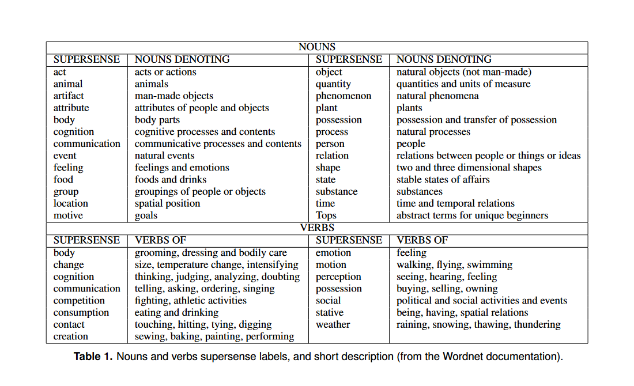

Ciaramita, Massimilano et. Altun, Yasemin, Broad-Coverage Sense Disambiguation and Information Extraction with a Supersense Sequence Tagger

Events remain a contested category across narrative theory, philosophy and linguistics, with definitions varying depending on discipline, application, and context. Most linguistic event classifications nevertheless trace their lineage back to Vendler (1957), who proposed four categories to distinguish the different relationships that exist between verbs and time: activities (dynamically) unfolding processes), achievments (occurances that are completed almost instantaneously), accomplishements (occurances that have some duration but also predetermined endpoint), and states (persistent conditions that span a period of time and don’t have any definite endpoint).

A simpler classification that some scholars have traced back to Aristotle (Sasse, 2002) simply distinguishes between event and states, the latter usually defined as non-dynamic situations that pertain over time. Many event annotation systems […] also treat changes of state as being events, since such changes indicate a dynamic break from prior conditions.

In our annotation approach, we include activities, achievements, accomplishments, and changes of state as being events.

[Sims, Matthew et. Park, Jong Ho et. Bamman, David, Literary event detection]

The role of events in literary fiction, however, is very different from their role in fact-based reporting of events in the real world, including historical texts (Sprugnoli and Tonelli, 2017). Novels and even most short stories tend to be much longer than news articles, and tend to have more complex narrative structures both locally (individual scenes) and globally (plot) than works of non-fiction. Furthermore, literature is a creative enterprise. Journalistic discourse typically reports what actually happened in the real world and depicts definite casual chains connecting events, this causality is not hard coded into literary event sequences.

[Ibidem]

This question reaches back at least as far as the 1920s, when literary theorists from the Russian Formalist school began making distinctions between syuzhet (the way in which events are presented in a narrative) and fabula (the chronological sequence of events, distinct from the way they’re represented) (Shklovsky, 1990; Propp, 2010). Even on a far more localized scale, events are often considered to play a fundamental role in how literary narratives progress. Morreti (2013), for instance, describes the inherent productivity of events in Daniel’s Defoe novel Robinson Crusoe, where one event invokes another in a chain of occurences that seem to flow in “micro-narrative sequences.” Such localized sequences in turn relate to the larger arhitecture of plot, which has its own distinct modes of organization generation (Forster, 1927; Genette, 1983; Brooks, 1992). The status of events in literature thus inevitabily engages larger questions about scale and narrative technique.

Entity recognition refers to the task of detecting all references to entities (e.g., characters, location) in a text corpus. These references can either be explicitly named references (e.g. “Bilbo Baggins, “Smaug”), noun phrases (e.g., “the hobbit”, “the dragon”) or pronouns (e.g. “she, “they”). BookNLP uses an entity annotation model that has been trained on a large annotated data set [27] to identifiy named entities, noun phrases as well as pronoun references. After these references have been detected, in a next step coreference resolution can be applied, which is a very hard task in general [28] and is especially hard in the context of literary texts due to the high variation of references used and the very long texts [29, 30]. Confirming this view, our initial analyses revealed that the performance of BookNLP’s coreference resolution, which was trained on a data set of annotated coreferences [31] was not satisfactory when applying it to our corpus. We thus decided to focus on named references, and resolve these using a set of simply manually-created disambiguation rules (e.g. “Sam” -> “Sam Gamgee”, “Peregrin” -> “Pippin”). Although this approach may yield a low recall (i.e. there are many unidentified coreferences since pronouns and noun phrases are not considered), we find that this coreference resoluion yields high precision (i.e. almost all resolved coreferences that we inspected manually were correct). We found this approach preferable over a “full” coreference resolution for two reasons: First, considering our focus on character co-occurences that would harm our analyses of graph learning techniques. Second, our corpus of Tolkien’s Legendarium is special in the sense that it has a large number of named references, which give rise to rich character networks despite limiting our view to named references.