Sugarcane Irrigation Methods Report

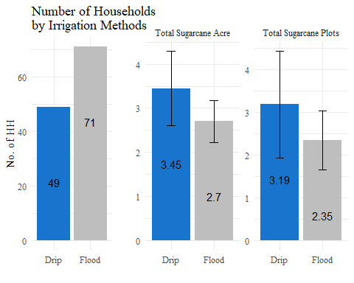

## Water Source

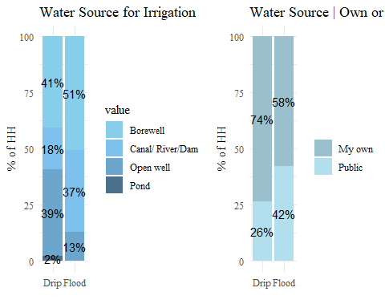

## Irrigation Pattern

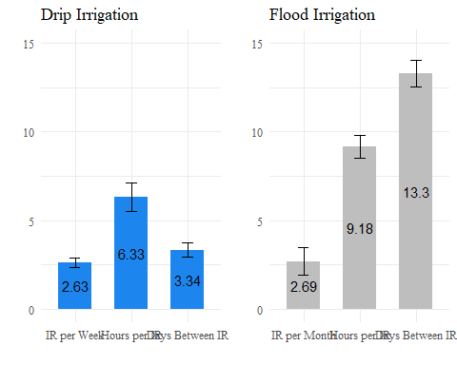

## Flood irrigation in fields with drip irrigation

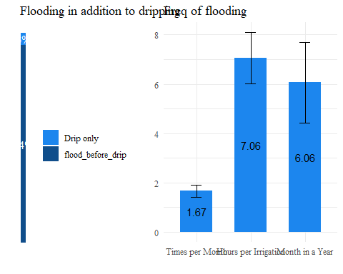

## Sugarcane treatments

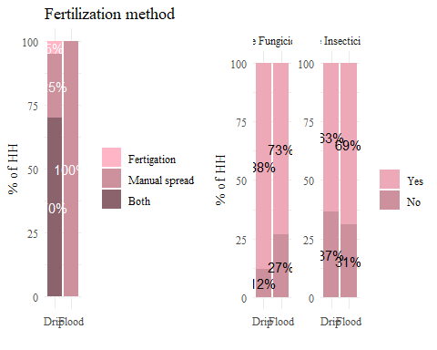

## Crop Other then Sugarcanes

## # A tibble: 7 × 2  
## crop n  
## <chr> <int>  
## 1 Ginger 4  
## 2 Maize 3  
## 3 Mango 2  
## 4 Onion 3  
## 5 Other 3  
## 6 Soybean 3  
## 7 Wheat 2

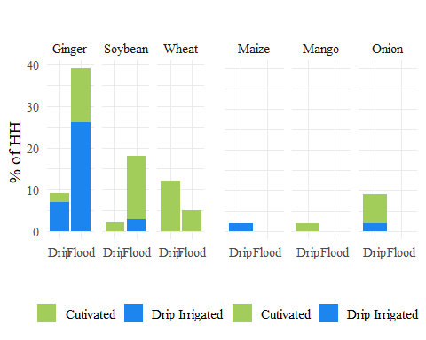

## Economy

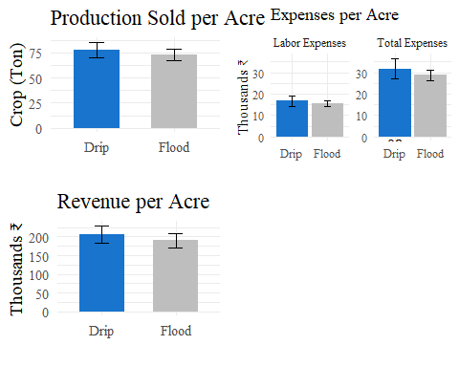

## Opinion

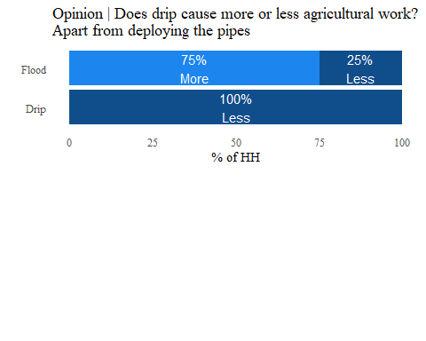

## installations | Farms with Drip-Irrigation

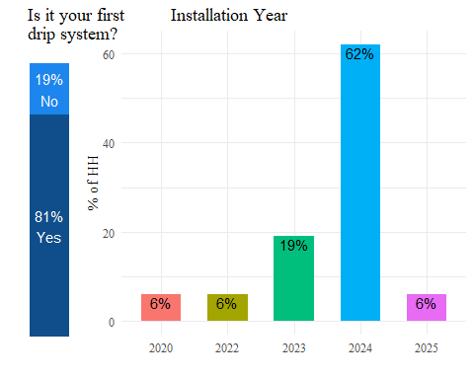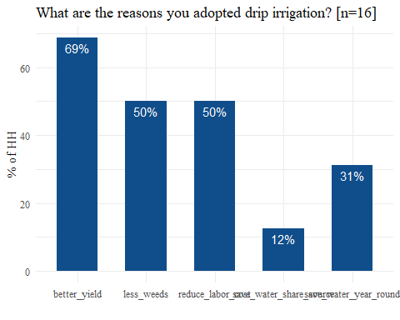

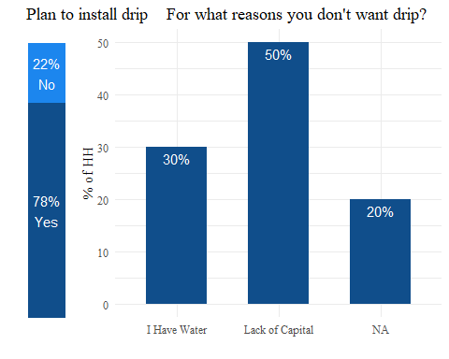

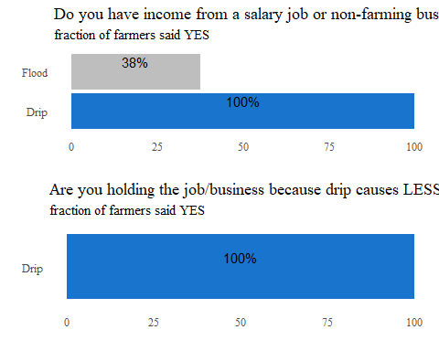

**Are you concerned that drip will prevent you from holding a job/business?** ir_method==Flood & ${job_biz_income} = ‘1’ and plan_install_drip} = ‘1’

**Do you think using drip will prevent you from holding your job/business?** ir_method==Flood & $job_{b}iz_{i}ncome=′1′$ {plan_install_drip} = ‘0’

This is some text.

This is text after an empty line.

% a bit of vertical space

% slightly less space

% custom space