Федеральное государственное автономное образовательное учреждение высшего образования «Национальный исследовательский университет ИТМО».

Факультет программной инженерии и компьютерной техники

Курсовая работа
Часть №3

Выполнил
Путинцев Данил Денисович
Группа P3307
Проверил(а)
Преподаватель: Харитонова А.Е.

Санкт-Петербург 2025 год

Диаграмма классов, представляющую общую архитектуру системы
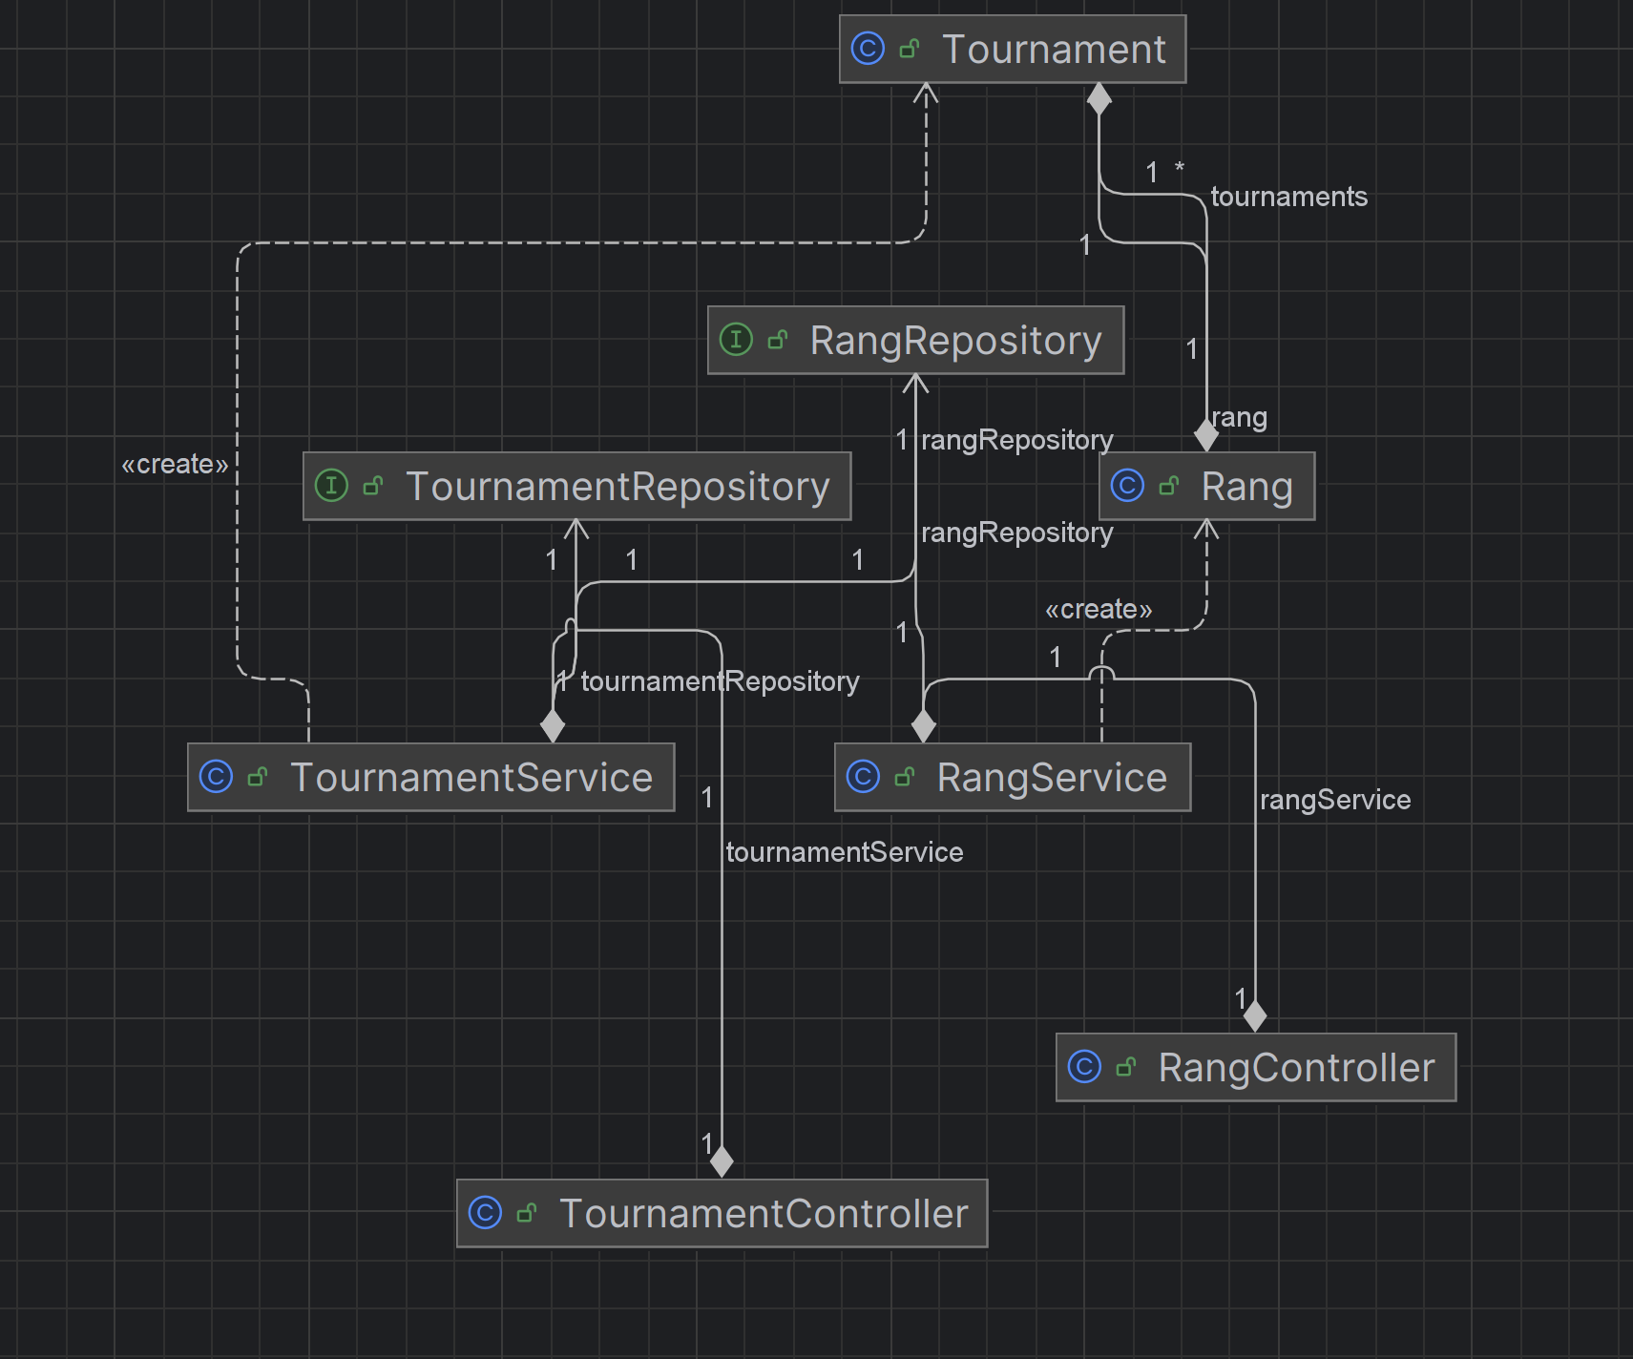

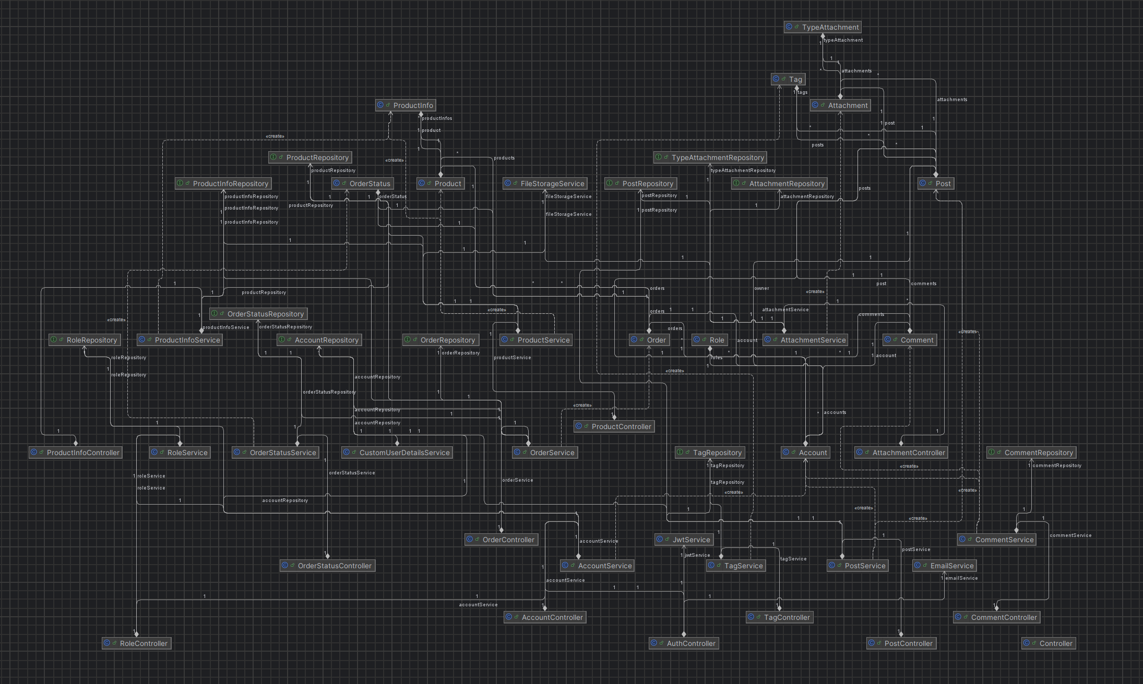

Реализовать уровень хранения информационной системы на основе разработанной на предыдущем этапе базы данных.

package com.danp1t.backend.model;
import jakarta.persistence.*;
import lombok.Getter;
import lombok.Setter;
import java.time.LocalDateTime;
import java.util.List;
@Getter
@Setter
@Entity
@Table(name = "Account")
public class Account {
@Id
@GeneratedValue(strategy = GenerationType.IDENTITY)
private Integer id;
@Column(name = "name", nullable = false)
private String name;
@Column(name = "email", nullable = false, unique = true)
private String email;
@Column(name = "password", nullable = false)
private String password;
@Column(name = "enabled")
private boolean enabled = false;
@Column(name = "verification_code")
private String verificationCode;
@Column(name = "verification_code_expiry")
private LocalDateTime verificationCodeExpiry;
@Column(name = "reset_password_token")
private String resetPasswordToken;
@Column(name = "reset_password_token_expiry")
private LocalDateTime resetPasswordTokenExpiry;
@OneToMany(mappedBy = "owner", cascade = CascadeType.ALL)
private List<Post> posts;
@OneToMany(mappedBy = "account", cascade = CascadeType.ALL)
private List<Comment> comments;
@ManyToMany(fetch = FetchType.EAGER)
@JoinTable(
name = "AccountRole",
joinColumns = @JoinColumn(name = "account_id"),
inverseJoinColumns = @JoinColumn(name = "role_id")
)
private List<Role> roles;
@OneToMany(mappedBy = "account", cascade = CascadeType.ALL)
private List<Order> orders;
}

package com.danp1t.backend.model;
import jakarta.persistence.*;
import lombok.Getter;
import lombok.Setter;
@Getter
@Setter
@Entity
@Table(name = "Attachment")
public class Attachment {
@Id
@GeneratedValue(strategy = GenerationType.IDENTITY)
private Integer id;
@Column(name = "name", nullable = false)
private String name;
@Column(name = "path", nullable = false)
private String path;
@ManyToOne(fetch = FetchType.LAZY)
@JoinColumn(name = "post_id", nullable = false)
private Post post;
@ManyToOne(fetch = FetchType.LAZY)
@JoinColumn(name = "type_id", nullable = false)
private TypeAttachment typeAttachment;
}

package com.danp1t.backend.model;
import jakarta.persistence.*;
import lombok.Getter;
import lombok.Setter;
import java.time.LocalDateTime;
@Getter
@Setter
@Entity
@Table(name = "Comment")
public class Comment {
@Id
@GeneratedValue(strategy = GenerationType.IDENTITY)
private Integer id;
@Column(name = "created_at", nullable = false)
private LocalDateTime createdAt;
@Column(name = "user_comment", columnDefinition = "TEXT")
private String userComment;
@ManyToOne()
@JoinColumn(name = "post_id", nullable = false)
private Post post;
@ManyToOne()
@JoinColumn(name = "account_id", nullable = false)
private Account account;
}

package com.danp1t.backend.model;
import jakarta.persistence.*;
import lombok.Getter;
import lombok.Setter;
import java.time.LocalDateTime;
import java.util.ArrayList;
import java.util.List;
@Getter
@Setter
@Entity
public class Order {
@Id
@GeneratedValue(strategy = GenerationType.IDENTITY)
private Integer id;
@Column(name = "address", nullable = false)
private String address;
@Column(name = "created_at", nullable = false)
private LocalDateTime createdAt;
@Column(name = "total_amount", nullable = false)
private Integer totalAmount;
@Column(name = "phone")
private String phone;
@Column(name = "email")
private String email;
@Column(name = "customer_name")
private String customerName;
@Column(name = "delivery_method")
private String deliveryMethod;
@Column(name = "payment_method")
private String paymentMethod;
@Column(name = "postal_code")
private String postalCode;
@Column(name = "notes")
private String notes;
@Column(name = "order_items_json", columnDefinition = "TEXT")
private String orderItemsJson;
@ManyToOne
@JoinColumn(name = "account_id", nullable = false)
private Account account;
@ManyToOne
@JoinColumn(name = "status_id", nullable = false)
private OrderStatus orderStatus;
@ManyToMany
@JoinTable(
name = "OrderProduct",
joinColumns = @JoinColumn(name = "order_id"),
inverseJoinColumns = @JoinColumn(name = "product_id")
)
private List<Product> products = new ArrayList<>();
}

package com.danp1t.backend.model;
import jakarta.persistence.*;
import lombok.Getter;
import lombok.Setter;
import java.util.List;
@Getter
@Setter
@Entity
@Table(name = "OrderStatus")
public class OrderStatus {
@Id
@GeneratedValue(strategy = GenerationType.IDENTITY)
private Integer id;
@Column(name = "name", nullable = false)
private String name;
@Column(name = "description")
private String description;
@OneToMany(mappedBy = "orderStatus", cascade = CascadeType.ALL)
private List<Order> orders;
}

package com.danp1t.backend.model;
import jakarta.persistence.*;
import lombok.Getter;
import lombok.Setter;
import java.time.LocalDateTime;
import java.util.List;
@Getter
@Setter
@Entity
@Table(name = "Post")
public class Post {
@Id
@GeneratedValue(strategy = GenerationType.IDENTITY)
private Integer id;
@Column(name = "title", nullable = false)
private String title;
@Column(name = "text", columnDefinition = "TEXT")
private String text;
@Column(name = "created_at", nullable = false)
private LocalDateTime createdAt;
@Column(name = "count_like")
private Integer countLike;
@OneToMany(mappedBy = "post", cascade = CascadeType.ALL)
private List<Attachment> attachments;
@ManyToMany
@JoinTable(
name = "TagPost",
joinColumns = @JoinColumn(name = "post_id"),
inverseJoinColumns = @JoinColumn(name = "tag_id")
)
private List<Tag> tags;
@ManyToOne()
@JoinColumn(name = "owner_id", nullable = false)
private Account owner;
@OneToMany(mappedBy = "post", cascade = CascadeType.ALL)
private List<Comment> comments;
}

package com.danp1t.backend.model;
import jakarta.persistence.*;
import lombok.Getter;
import lombok.Setter;
import java.util.List;
@Getter
@Setter
@Entity
@Table(name = "Product")
public class Product {
@Id
@GeneratedValue(strategy = GenerationType.IDENTITY)
private Integer id;
@Column(name = "name", nullable = false)
private String name;
@Column(name = "description")
private String description;
@Column(name = "category")
private String category;
@Column(name = "base_price")
private Integer basePrice;
@Column(name = "popularity")
private Integer popularity = 0;
@Column(name = "images", columnDefinition = "TEXT")
private String images;
@ManyToMany(mappedBy = "products")
private List<Order> orders;
@OneToMany(mappedBy = "product", cascade = CascadeType.ALL)
private List<ProductInfo> productInfos;
public List<String> getImagesList() {
if (images == null || images.isEmpty()) {
return List.of();
}
return List.of(images.split(","));
}
}

package com.danp1t.backend.model;
import jakarta.persistence.*;
import lombok.Getter;
import lombok.Setter;
@Getter
@Setter
@Entity
@Table(name = "ProductInfo")
public class ProductInfo {
@Id
@GeneratedValue(strategy = GenerationType.IDENTITY)
private Integer id;
@ManyToOne
@JoinColumn(name = "product_id", nullable = false)
private Product product;
@Column(name = "size_name", nullable = false)
private String sizeName;
@Column(name = "count_items", nullable = false)
private Integer countItems;
@Column(name = "price")
private Integer price;
}

package com.danp1t.backend.model;
import jakarta.persistence.*;
import lombok.Getter;
import lombok.Setter;
import java.util.List;
@Getter
@Setter
@Entity
@Table(name = "Rang")
public class Rang {
@Id
@GeneratedValue(strategy = GenerationType.IDENTITY)
private Integer id;
@Column(name = "name", nullable = false, unique = true)
private String name;
@Column(name = "description")
private String description;
@OneToMany(mappedBy = "rang", cascade = CascadeType.ALL)
private List<Tournament> tournaments;
}

package com.danp1t.backend.model;
import jakarta.persistence.*;
import lombok.Getter;
import lombok.Setter;
import java.util.List;
@Getter
@Setter
@Entity
@Table(name = "Role")
public class Role {
@Id
@GeneratedValue(strategy = GenerationType.IDENTITY)
private Integer id;
@Column(nullable = false, unique = true)
private String name;
@Column
private String description;
@ManyToMany(mappedBy = "roles")
private List<Account> accounts;
}

package com.danp1t.backend.model;
import jakarta.persistence.*;
import lombok.Getter;
import lombok.Setter;
import java.util.List;
@Getter
@Setter
@Entity
@Table(name = "Tag")
public class Tag {
@Id
@GeneratedValue(strategy = GenerationType.IDENTITY)
private Integer id;
@Column(name = "name", nullable = false, unique = true)
private String name;
@Column(name = "description")
private String description;
@ManyToMany(mappedBy = "tags")
private List<Post> posts;
}

package com.danp1t.backend.model;
import jakarta.persistence.*;
import lombok.Getter;
import lombok.Setter;
import java.time.LocalDateTime;
@Getter
@Setter
@Entity
@Table(name = "Tournament")
public class Tournament {
@Id
@GeneratedValue(strategy = GenerationType.IDENTITY)
private Integer id;
@Column(name = "name", nullable = false)
private String name;
@Column(name = "start_date")
private LocalDateTime startDate;
@Column(name = "finish_date")
private LocalDateTime finishDate;
@Column(name = "address")
private String address;
@Column(name = "link")
private String link;
@Column(name = "archived", nullable = false)
private Boolean archived = false;
@Column(name = "minimal_age")
private Integer minimalAge;
@ManyToOne(optional = false)
@JoinColumn(name = "rang_id", nullable = false)
private Rang rang;
}

package com.danp1t.backend.model;
import jakarta.persistence.*;
import lombok.Getter;
import lombok.Setter;
import java.util.List;
@Getter
@Setter
@Entity
@Table(name = "TypeAttachment")
public class TypeAttachment {
@Id
@GeneratedValue(strategy = GenerationType.IDENTITY)
private Integer id;
@Column(name = "name", nullable = false, unique = true)
private String name;
@Column(name = "description")
private String description;
@OneToMany(mappedBy = "typeAttachment", cascade = CascadeType.ALL)
private List<Attachment> attachments;
}

При реализации уровня хранения должны использоваться функции/процедуры, созданные на втором этапе с помощью pl/pgsql. Нельзя замещать их использование альтернативной реализацией аналогичных запросов на уровне хранения информационной системы.

@Repository
public interface RangRepository extends JpaRepository<Rang, Integer> {
boolean existsByName(String name);
@Query(value = "SELECT insert_rang(:name, :description)",
nativeQuery = true)
Integer callInsertRangFunction(@Param("name") String name,
@Param("description") String description);
}

package com.danp1t.backend.repository;
import com.danp1t.backend.model.Account;
import jakarta.transaction.Transactional;
import org.springframework.data.jpa.repository.JpaRepository;
import org.springframework.data.jpa.repository.Modifying;
import org.springframework.data.jpa.repository.Query;
import org.springframework.data.repository.query.Param;
import org.springframework.stereotype.Repository;
import java.util.List;
import java.util.Optional;
@Repository
public interface AccountRepository extends JpaRepository<Account, Integer> {
Optional<Account> findByEmail(String email);
boolean existsByEmail(String email);
@Query("SELECT a FROM Account a LEFT JOIN FETCH a.roles WHERE a.id = :id")
Optional<Account> findByIdWithRoles(@Param("id") Integer id);
Optional<Account> findByResetPasswordToken(String resetPasswordToken);
@Query("SELECT a FROM Account a LEFT JOIN FETCH a.posts WHERE a.id = :id")
Optional<Account> findByIdWithPosts(@Param("id") Integer id);
@Query("SELECT a FROM Account a LEFT JOIN FETCH a.comments WHERE a.id = :id")
Optional<Account> findByIdWithComments(@Param("id") Integer id);
@Query("SELECT COUNT(a) FROM Account a JOIN a.roles r WHERE r.id = :roleId")
Long countByRoleId(@Param("roleId") Integer roleId);
@Query("SELECT a FROM Account a JOIN a.roles r WHERE r.id = :roleId")
List<Account> findByRoleId(@Param("roleId") Integer roleId);
@Modifying
@Query(value = "CALL ban_user(:accountId)", nativeQuery = true)
void banUser(@Param("accountId") Integer accountId);
}

package com.danp1t.backend.repository;
import com.danp1t.backend.dto.CommentDTO;
import com.danp1t.backend.model.Comment;
import org.springframework.data.jpa.repository.JpaRepository;
import org.springframework.data.jpa.repository.Modifying;
import org.springframework.data.jpa.repository.Query;
import org.springframework.data.repository.query.Param;
import org.springframework.stereotype.Repository;
import java.util.List;
import java.util.Optional;
@Repository
public interface CommentRepository extends JpaRepository<Comment, Integer> {
List<Comment> findByAccountId(Integer accountId);
@Query("SELECT c FROM Comment c LEFT JOIN FETCH c.post LEFT JOIN FETCH c.account WHERE c.id = :id")
Optional<Comment> findByIdWithDetails(@Param("id") Integer id);
@Query("SELECT c FROM Comment c LEFT JOIN FETCH c.account WHERE c.post.id = :postId ORDER BY c.createdAt DESC")
List<Comment> findByPostIdWithAccount(@Param("postId") Integer postId);
@Query(value = "SELECT * FROM create_comment(:userComment, :postId, :accountId)",
nativeQuery = true)
Integer createComment(
@Param("userComment") String userComment,
@Param("postId") Integer postId,
@Param("accountId") Integer accountId
);
}

На основе описания бизнес-процессов из первого этапа и построенного уровня хранения реализовать уровень бизнес-логики информационной системы.

Реализация доступна по ссылке: https://github.com/danp1t/ITMO/tree/main/course3/information_system/course_work/part3/backend

Вывод
В данной части курсовой работы была реализован уровень бизнес-логики информационной системы. Я использовал Controller, Service и Repository для структуризации кода. Помимо этого я познакомился со Spring Security для организации работы информационной системы с различными ролями пользователя. Также был реализован компонент FileStorageService, который отвечает за хранение файлов на жестком диске, для того чтобы не хранить медиа-файлы в базах данных.

