Supplementary File 2. Detailed notes for searches of tobacco industry lobbying
Registers searched 13 May 2024 -
**note that Chile, Ireland and Scotland’s logs were reviewed for more information about the meeting details communicated.
Search terms: “Philip Morris”, PMI, Altria, “British American”, BAT, Tobacco (or their translation)

Australia
Neither PMI nor BAT were listed when we searched for their names (and aliases) in the main search function. Based on a previous study we had conducted in which we extracted, cleaned and linked data from the federal, state and territory lobbyist registers in Australia, we identified three lobby firms that had previously represented PMI and five for BAT in at least one Australian jurisdiction. Based on this, we did a targeted search of the client histories for each firm, identifying six firms that had previously represented a tobacco company. In the absence of this data, it would be too time-consuming to manually search the history of the 337 organisations currently registered.
Lobby firm | Tobacco client | Registered | Deregistered | Revolving door lobbyists (Cessation date)
Capetal Advisory | Philip Morris Limited | - | 27 Feb 2024 | -
Woodhill Communications | Philip Morris (Australia) Ltd  PMI Australia | 27 Jan 2023  - | 13 Jul 2023  14 Feb 2022 | Stephen Woodhill (director): Press Secretary for the Hon JJ Fahey in NSW Government Dep Head Corporate Affairs for CAA (now AirServices Australia) Head Corporate Affairs & Marketing for ATO Executive Director (SEL) Corporate Affairs for ASIC Last employed by Government agency in 2011 (ASIC); (27 Nov 2009)
OPR Agency (Ogilvy PR) | (PMI, but not listed in federal register) | - | - | -
Cornerstone Group | (BAT, but not listed in federal register) | - | - | -
Public Policy Solutions (deregistered) | British American Tobacco Australia | - | 16 Mar 2023 | Scott Briggs: Political staff member for the Howard Government; (1 January 1998)
Strategic Political Counsel Pty Ltd (DEREGISTERED) | British American Tobacco Australia  British American Tobacco Australia | 23 Sep 2022  - | 9 Aug 2023  1 Sep 2022 | Michael John Edward Kauter; Senior advisor; (1 Dec 2014)
Wells Consulting Group | British American Tobacco Australia Limited  British American Tobacco Australia Limited | 27 Sep 2022  - | 14 Mar 2024  1 Sep 2022 | John Wells; Press Secretary to leader of the opposition; (1 Apr 1990)
WELLS HASLEM MAYHEW STRATEGIC PUBLIC AFFAIRS PTY. LTD. (DEREGISTERED) | British American Tobacco Australasia | - | 20 May 2020 | Philip John Wells (No) [Though we note it is unclear if this is the same individual as John Wells above].

Austria
Company | Field of activity | Lobbyists | Expenses
Philip Morris Austria GmbH | [Trade in all kinds of goods, in particular tobacco products, as well as the provision of marketing activities for the traded products] (translation) | Florian Groß (06.12.1986)  Laura Sperlich (05.02.1983)  Thomas Zlabinger (14.01.1973)  Maximilian Aracena (06.02.1987) | Lobbying expenses > EUR 100,000: No

Belgium
Company | Lobbyists | Manages interests for | Web
British American  Tobacco Belgium | Filip Buntinx  Pieter Van Bastelaere | British American  Tobacco Belgium | www.bat.com
Philip Morris Benelux  B.V. | Andrea Grebori  Tom Janssens  Frederic Reynaert | [sellers of tobacco products and related products.] (translated) | www.pmi.com

Canada
When Philip Morris was searched, it came up with 155 registrations for: Philip Morris companies (1996-2003), Medicago (2020-2021, a vaccine manufacturer), Kraft Canada (1996-2005), and Rothmans, Benson & Hedges Inc. (1999-2024, a subsidiary of Philip Morris International Inc.).
When British American tobacco was searched, it came up with 82 registrations for: Imperial Tobacco Canada Limited (2005-2024, parent company British American Tobacco); Nicoventures Ltd. (2015-2016, parent company British American Tobacco)
All ‘active’ returns are documented below. Meeting counts are only for currently active in-house and consulting firms, further analysis of inactive consultant lobbyists would reveal more meetings.
company | Meetings | lobbyists | Subject matter details | Who is being lobbied | Communication techniques
Rothmans, Benson & Hedges Inc. (in-house), parent company: Philip Morris International | 120 meetings | 4 (all named, none disclosed having held public office) | Legislative Proposal, Bill or Resolution  Customs Act/Customs Tariff - with regard to customs duties on tobacco products.  Excise Act, 2001 -with regard to tobacco duties, stamps or collection.  Excise Tax Act - Part IX  Income Tax Act - Part II  Tobacco and Vaping Products Act with regards to the classification of tobacco products, product regulation, packaging and labeling  Legislative Proposal, Bill or Resolution, Policies or Program, Regulation  Any new legislative or regulatory proposals or policies relating to the recycling of tobacco-related products.  Any new legislative or regulatory proposals or policies relating to tobacco and/or vaping including taxation, product regulation, flavouring, packaging and labeling requirements and contraband.  Any new legislative or regulatory proposals, or policies, relating to harm reduction as it pertains to combustible tobacco products.  Any new legislative or regulatory proposals, or policies, relating to non-combustible, smoke-free, nicotine products | Agriculture and Agri-Food Canada (AAFC)  Canada Border Services Agency (CBSA)  Canada Revenue Agency (CRA)  Crown-Indigenous Relations and Northern Affairs Canada (CIRNAC)  Environment and Climate Change Canada (ECCC)  Finance Canada (FIN)  Global Affairs Canada (GAC)  Health Canada (HC)  House of Commons  Indigenous Services Canada (ISC)  Innovation, Science and Economic Development Canada (ISED)  Justice Canada (JC)  Prime Minister's Office (PMO)  Privy Council Office (PCO)  Public Health Agency of Canada (PHAC)  Public Safety Canada (PS)  Royal Canadian Mounted Police (RCMP)  Senate of Canada | Written communication  Oral communication  Grass-roots communication  Arrange one or more meetings
Rothmans, Benson & Hedges Inc. (client of Crestview Strategy) | 2 | Kerem Karabeyoglu | Customs Act/Customs Tariff - with regard to customs duties on tobacco products; Excise Act, 2001 -with regard to tobacco duties, stamps or collection; Excise Tax Act - Part IX - with regard to tobacco products (within the meaning assigned by section 2 of the Excise Act, 2001); The Tobacco Act - Tobacco Products Information Regulations and Tobacco Reporting Regulations | Agriculture and Agri-Food Canada (AAFC)  Canada Border Services Agency (CBSA)  Canada Revenue Agency (CRA)  Employment and Social Development Canada (ESDC)  Finance Canada (FIN)  Health Canada (HC)  House of Commons  Innovation, Science and Economic Development Canada (ISED)  Prime Minister's Office (PMO)  Public Safety Canada (PS)  Royal Canadian Mounted Police (RCMP)  Senate of Canada | Written communication  Oral communication  Grass-roots communication  The lobbyist has arranged or expects to arrange one or more meetings on behalf of the client between a public office holder and any other person in the course of this undertaking.
Rothmans, Benson & Hedges Inc. (client of Crestview Strategy) | 14 | Ashton Arsenault | Customs Act/Customs Tariff - with regard to customs duties on tobacco products.  Excise Act, 2001 -with regard to tobacco duties, stamps or collection.  Excise Tax Act - Part IX - with regard to tobacco products (within the meaning assigned by section 2 of the Excise Act, 2001)  The Tobacco Act - Tobacco Products Information Regulations and Tobacco Reporting Regulations | Agriculture and Agri-Food Canada (AAFC)  Canada Border Services Agency (CBSA)  Canada Revenue Agency (CRA)  Employment and Social Development Canada (ESDC)  Finance Canada (FIN)  Health Canada (HC)  House of Commons  Innovation, Science and Economic Development Canada (ISED)  Prime Minister's Office (PMO)  Public Safety Canada (PS)  Royal Canadian Mounted Police (RCMP)  Senate of Canada | Written communication  Oral communication  Grass-roots communication  The lobbyist has arranged or expects to arrange one or more meetings on behalf of the client between a public office holder and any other person in the course of this undertaking.
Rothmans, Benson & Hedges Inc. (client of Crestview Strategy) | 5 | Chad Rogers | Customs Act/Customs Tariff - with regard to customs duties on tobacco products.  Excise Act, 2001 -with regard to tobacco duties, stamps or collection.  Excise Tax Act - Part IX- with regard to tobacco products (within the meaning assigned by section 2 of the Excise Act, 2001)  The Tobacco Act - Tobacco Products Information Regulations and Tobacco Reporting Regulations | Agriculture and Agri-Food Canada (AAFC)  Canada Border Services Agency (CBSA)  Canada Revenue Agency (CRA)  Employment and Social Development Canada (ESDC)  Finance Canada (FIN)  Health Canada (HC)  House of Commons  Innovation, Science and Economic Development Canada (ISED)  Prime Minister's Office (PMO)  Public Safety Canada (PS)  Royal Canadian Mounted Police (RCMP)  Senate of Canada | Written communication  Oral communication  Grass-roots communication  The lobbyist has arranged or expects to arrange one or more meetings on behalf of the client between a public office holder and any other person in the course of this undertaking.
Imperial Tobacco Canada (in-house) | 121 | 3 (all ‘no public office held’) | Finance: Continue to demonstrate the unintended consequences of a high taxation regime on the illicit trade of cigarettes in Canada.  Finance/Public Safety/Health Canada: Lobby the federal government to raise the awareness of illegal tobacco trade activities in Canada; to dedicate more enforcement resources to combat this illegal industry; and to bring the illicit trade of cigarettes in line with the taxation and regulation regimes that the tobacco industry is submitted to.  Health Canada: Advocate for reasonable tobacco control policies and regulations.  Monitor all developments regarding Bill S-5 An Act to amend the Tobacco Act and the Non-smokers’ Health Act and to make consequential amendments to other Acts  Small Business & Tourism: Lobby in favor of the implementation of the federal government`s Red Tape Reduction Commission and advocate for the inclusion of principles that are specific to the tobacco industry. | Canada Border Services Agency (CBSA)  Canada Revenue Agency (CRA)  Crown-Indigenous Relations and Northern Affairs Canada (CIRNAC)  Finance Canada (FIN)  Health Canada (HC)  House of Commons  Indigenous Services Canada (ISC)  Innovation, Science and Economic Development Canada (ISED)  Justice Canada (JC)  Prime Minister's Office (PMO)  Privy Council Office (PCO)  Public Safety Canada (PS)  Royal Canadian Mounted Police (RCMP)  Senate of Canada  Treasury Board Of Canada Secretariat (TBS) | Written communication  Oral communication
Imperial Tobacco Canada (client of Temple Scott Associates Inc.) | 1 | Brian Klunder | Monitor all developments to the Tobacco Act and its regulations; Monitor development of new policy for the banning of the sale of illegal cigarettes (contraband tobacco enforcement strategy); Monitor all developments regarding Health Canada regulation of vaping products | Canada Revenue Agency (CRA)  Crown-Indigenous Relations and Northern Affairs Canada (CIRNAC)  Finance Canada (FIN)  Fisheries and Oceans Canada (DFO)  Health Canada (HC)  House of Commons  Indigenous Services Canada (ISC)  Innovation, Science and Economic Development Canada (ISED)  Justice Canada (JC)  Privy Council Office (PCO)  Public Safety Canada (PS)  Senate of Canada  Treasury Board Of Canada Secretariat (TBS) | Written communication  Oral communication  The lobbyist has arranged or expects to arrange one or more meetings on behalf of the client between a public office holder and any other person in the course of this undertaking.
Imperial Tobacco Canada (client of Temple Scott Associates Inc.) | 36 | Scott Thurlow | Monitor all developments to the Tobacco Act and its regulations; Monitor development of new policy for the banning of the sale of illegal cigarettes (contraband tobacco enforcement strategy); Monitor all developments regarding Health Canada regulation of vaping products | Canada Revenue Agency (CRA)  Crown-Indigenous Relations and Northern Affairs Canada (CIRNAC)  Finance Canada (FIN)  Fisheries and Oceans Canada (DFO)  Health Canada (HC)  House of Commons  Indigenous Services Canada (ISC)  Innovation, Science and Economic Development Canada (ISED)  Justice Canada (JC)  Privy Council Office (PCO)  Public Safety Canada (PS)  Senate of Canada  Treasury Board Of Canada Secretariat (TBS) | Written communication  Oral communication  The lobbyist has arranged or expects to arrange one or more meetings on behalf of the client between a public office holder and any other person in the course of this undertaking.
Imperial Tobacco Canada (client of Temple Scott Associates Inc.) | 85 | DUNCAN RAYNER | Monitor all developments to the Tobacco Act and its regulations; Monitor development of new policy for the banning of the sale of illegal cigarettes (contraband tobacco enforcement strategy); Monitor all developments regarding Health Canada regulation of vaping products | Canada Revenue Agency (CRA)  Crown-Indigenous Relations and Northern Affairs Canada (CIRNAC)  Finance Canada (FIN)  Fisheries and Oceans Canada (DFO)  Health Canada (HC)  House of Commons  Indigenous Services Canada (ISC)  Innovation, Science and Economic Development Canada (ISED)  Justice Canada (JC)  Privy Council Office (PCO)  Public Safety Canada (PS)  Senate of Canada  Treasury Board Of Canada Secretariat (TBS) | Written communication  Oral communication  The lobbyist has arranged or expects to arrange one or more meetings on behalf of the client between a public office holder and any other person in the course of this undertaking.
Imperial Tobacco Canada (client of Temple Scott Associates Inc.) | 1 | Scott Munnoch | Monitor all developments regarding Bill S-5 An Act to amend the Tobacco Act and the Non-smokers’ Health Act and to make consequential amendments to other Acts  Monitor all developments to the Tobacco Act and its regulations  Monitor development of new policy for the banning of the sale of illegal cigarettes (contraband tobacco enforcement strategy) | Canada Revenue Agency (CRA)  Crown-Indigenous Relations and Northern Affairs Canada (CIRNAC)  Finance Canada (FIN)  Fisheries and Oceans Canada (DFO)  Health Canada (HC)  House of Commons  Indigenous Services Canada (ISC)  Innovation, Science and Economic Development Canada (ISED)  Justice Canada (JC)  Privy Council Office (PCO)  Public Safety Canada (PS)  Senate of Canada  Treasury Board Of Canada Secretariat (TBS) | Written communication  Oral communication  The lobbyist has arranged or expects to arrange one or more meetings on behalf of the client between a public office holder and any other person in the course of this undertaking.

Chile
The lobbyist register includes all meetings of lobbyists employed by organisations, including those held on behalf of other organisations. For PMI, a number of meetings were held for Organon Chile (linked to a lobbyist who worked for both companies). These meetings were all after the lobbyist had left PMI (according to their Linkedin Profile, and the topics were unrelated to tobacco). For this reason the meetings have been excluded from the count. A small number of meetings for BAT were also unaffiliated with tobacco/not linked to the company, and were likewise excluded. The below counts are based on our best judgement but the original filings should be reviewed for confirmation. Current lobbyists are those who held a meeting in 2024.
Name | Current lobbyists (total) | # meetings
Philip Morris | 0 (10) | 21 (2018-2022)
British American Tobacco; British American Tobacco Chile S.A. | 3 (36) | 96 (2015-2024)

Colombia - NO

Estonia - NO

Finland
Company | Main line of business: | Overview of operations | Organisation's memberships in associations engaged in lobbying
Philip Morris Finland Oy | Food, beverage and tobacco agency activities | Philip Morris Finland Oy is a leading import and wholesale company of tobacco and nicotine products on the Finnish market.
British American Tobacco Finland Oy |  | BAT Finland is a part of an international organization selling tobacco and nicotine products. | [Tobacco Industry Association] (translation)

France
Name | Lobbyists | Lobbying expenses | Most recent activities | association membership
PHILIP MORRIS FRANCE | MARTEL Stéphanie  Directrice des affaires externes  REVA Kevin  Manager des affaires publiques  BRUQUEL Daniel  Chef du Service Prévention du Commerce Illicite  CHRISTIANSEN Emeric  Responsable des affaires fiscales  RUDINGER Benoit  Responsable des affaires publiques  RANNOU Solène  Responsable des affaires publiques | PÉRIODE CONCERNÉE 01-01-2023 au 31-12-2023  400-500K Euros | PERIOD CONCERNED: 01-01-2022 to 31-12-2022  OBJECT: PLF and PLFSS 2023: Sharing information on previous tobacco-related tax increases and potential consequences of new tax increases based on uncapped inflation  Type of interest representation actions: Submit suggestions to influence the drafting of a public decision  Category of public officials  - Job holder at the decision of the Government  - Collaborator of the President of the Republic  - Deputy, senator, collaborator of the President of the National Assembly or the President of the Senate, of a deputy, of a senator or of a parliamentary group, agents of the services of the parliamentary assemblies  - Member of the Government or member of ministerial cabinet - Prime Minister, Economy and Finance  - State agent - Agent of a public administrative establishment of the State | UNION FABRIC. PROTECT PROPRIETE INDUST.  ENTR TAILLE HUMAINE INDEPEND CROISSANCE ASSOCIATION FRANCAISE DES INDUSTRIELS DU TABAC
BRITISH AMERICAN TOBACCO FRANCE | MARBOIS Pascal  Directeur relations institutionnelles  ZAPPIA Vincent  Responsable relations institutionnelles  SCALES Charlotte  Responsable relations institutionnelles | PÉRIODE CONCERNÉE 01-01-2023 au 31-12-2023  200-300K Euros | PERIOD CONCERNED: 01-01-2023 to 31-12-2023  OBJECT  Obtaining a differentiated tobacco regulatory framework for vaping products in the Public Health Code  Type of interest representation actions  Organize informal discussions or one-on-one meetings  Transmit information and expertise to public decision-makers with the aim of convincing them  Transmit suggestions to influence the drafting of a public decision  Organize hearings, formal consultations on legislative acts or other open consultations  Establish regular correspondence (by email, by post, etc.)  Category of public officials  - Job holder at the decision of the Government  - Collaborator of the President of the Republic  - Deputy, senator, collaborator of the President of the National Assembly or the President of the Senate, of a deputy, of a senator or of a parliamentary group, agents of the services of the parliamentary assemblies  - Member of the Government or member of ministerial cabinet - Prime Minister, Economy and Finance  State agent - Agent of a public administrative establishment of the State | • ASSOCIATION DES FOURNISSEURS DE TABACS A FUMER  • UNION FABRIC. PROTECT PROPRIETE INDUST.  • UNION PATRONALE DEPARMENTALE - MEDEF PARIS  • FRANCE VAPOTAGE

Georgia – NO

Germany
Company | lobbyists | Memberships | Annual financial expenses in the area of ​​advocacy:
Philip Morris GmbH (in-house) | 14 (all named) | Memberships (20):  Aktion Plagiarius e.V.  American Chamber of Commerce in Germany e.V.  Atlantic Bridge e.V.  British Chamber of Commerce Germany e.V.  Federal Association of German Startups e.V.  DGAP German Society for Foreign Policy e.V.  DIN e.V. - Standards Committee for Food and Agricultural Products (NAL)  DVAI German Association of the Flavor Industry e.V.  European Movement Germany e.V.  Green Economic Dialogue e.V.  IGT – Tobacco Industry Interest Group e.V.  Food Association Germany e.V.  Markenverband e.V.  vbw - Association of Bavarian Business e.V.  Economic Advisory Council of the Union e.V.  Economic Forum of the SPD e.V.  Economic Policy Club Germany e. v.  Economic Council of the CDU e.V.  ZAW FREEDOM FOR ADVERTISING e.V.  Future Forum for Public Security e.V. | 1,240,001 to 1,250,000 euros (2022)
Philip Morris (client of Stefan von der Heiden – 3 other clients) | (1-10), assume 1 independent consultant |  | Fiscal year: 01/22 to 12/22  20,001 to 30,000 euros
Philip Morris GmbH (client of Deekeling Arndt Advisors in Communications – 11 other clients) | 13 (all named) | New Responsibility Foundation | Fiscal year: 01/22 to 12/22  810,001 to 820,000 euros
Philip Morris GmbH (client of MSLGROUP Germany – 29 other clients) | 23 |  | Fiscal year: 01/22 to 12/22  1,580,001 to 1,590,000 euros
British American Tobacco (IN-HOUSE) | 7 | - Federal Association of the Tobacco Industry and Novel Products (BVTE)  - Brand Association eV  - Association of the eCigarette Trade (VdeH)  DZV German Cigarette Association eV | Fiscal year: 01/22 to 12/22  790,001 to 800,000 euros
British American Tobacco (CLIENT OF EUTOP Brussels SRL, only listed client) | 2* (ONLY CLIENT, SO INCLUDE ALL HERE) | European Policy Centre | Fiscal year: 01/22 to 12/22  30,001 to 40,000 euros
British American Tobacco (CLIENT OF Bernstein Public Policy, 20 other clients) | 17 (have 20 clients in total) | - degepol  - Cybersecurity Council Germany eV  - Economic Council of the CDU  - Economic Forum of the SPD eV  - BCCG British German Chamber of Commerce e:v.  Aerospace Forum | Fiscal year: 01/22 to 12/22  190,001 to 200,000 euros

Greece - NO

Isreal - NO

Ireland
Name | No. logged activity periods | No current lobbyists (total) | No meetings
PMI (permanently ceased lobbying, last return from 18 Jan 2023) | 12 periods of activity lodged from 2016-2018 | 0 (2) | 12 (lower estimate based on ranges, upper limit = 17)
P. J. Carroll & Company (subsidiary of BAT) | 62 periods of activity lodged from (2016-2024) | 1 (5) | 36
P. J. Carroll & Company (subsidiary of BAT), client of Red Flag Consulting | 2 periods logged (2018) | (1) | 1

Italy
Name | Lobbyists | Reports | Activities from 2023 report
Philip Morris Italia | 1 | 6 filed from 2018-2023 | Preparation of information material to support the topics of interest; meetings with Ladies at the offices of the Chamber of Deputies.  c) the contacts actually established Hon. SALTAMARTINI, BARBARA; Hon. RUGGIERI, ANDREA;hon. CENTEMERO, GIULIO;hon. FORNARO, FEDERICO;hon. UNCERTAIN, ANTONELLA no details to communicate d) of the personnel employed (employees or collaborators) 6 employees: Eleonora Santi, Andrea Guglielmo, Gian Marco Milardi, Simona Delvecchio, Michele Samoggia Zerbetto, Federico Colajanni
British American Tobacco Italia | 2 | 6 filed from 2018-2023 | Meetings at the Chamber offices for the presentation of information material relating to above topics, such as, by way of example, data analysis and insights.  c) the contacts actually established Hon. PIZZIMENTI, GRAZIANO; Hon. DE MONTE, ISABELLA; Hon. GADDA, MARIA CHIARA; Hon. GALLINELLA, FILIPPO;hon. SERRACCHIANI, DEBORA; Hon. NARDI, MARTINA; Hon. BUBISUTTI, AURELIA; Hon. DE CARLO, SABRINA; Hon. MANTOVANI, LUCREZIA MARIA BENEDETTA;hon. CATTANEO, ALESSANDRO;hon. PANIZZUT, MAXIMILIANO d) of the personnel employed (employees or collaborators) MARIO CHIAPPERI (Regulatory Engagement Manager)

Latvia - NO
Society | About the manufacturer | Activities | Target
"Traditional and smokeless tobacco product association" | expanded accountability systems the creation of tobacco for products with for filters and filters, which are intended for use with tobacco products | participation between ministries and in other meetings, letters, telephone conversations | Environmental protection department

Lithuania
**Yes – but difficult to search/aggregate. Cannot search for client names directly in the registration search function. Can search for the client or beneficial in the contact log portal, which allows us to identify two firms: UAB META Advisory Lithuania and Algis Čaplikas, with 5 and 8 meetings documented for each respectively from 2021-2023). However, if each firm is searched separately in the register portal, then the current declarations and clients can be viewed. From this, two additional lobbyist declarations can be identified for UAB, and co current declarations for Algis.
When searching for BAT, no declaration identified through the beneficiary search, and 848 results for the client search (first five viewed all irrelevant). Instead the topic of ‘tobacco and alcohol’ was searched in the declaration tab, (36 declarations). Manual review identified other tobacco companies (JTI Baltic – Japan Tobacco International, Swedish Match) but not BAT.
Name | Meetings/declarations | Lobbyists | Legal act targeted
Philip Morris (client of UAB META Advisory Lithuania) | 6 (2021-2024) | 6  IEVA VALEŠKAITĖ  Eugenijus Gentvilas  TOMAS TOMILINAS  MATAS MALDEIKIS  VYTAUTAS GAPŠYS  Andrius Reznikovas | 5-6 2024  EXCISE LAW NO. IX-569 LAW AMENDING ARTICLES 23, 24, 25, 26, 30, 31, 65 AND 74
Philip Morris (client of Algis Čaplikas) | 8 (2021-2022) | 8  Andrius Mazuronis  EVELINA DOBROVOLSKA  TOMAS VYTAUTAS RASKEVIČIUS  Zigmantas Balčytis  LAIMA LIUCIJA ANDRIKIENĖ  ORINTA LEIPUTĖ  IEVA KAČINSKAITĖ-URBONIENĖ  JURGITA SEJONIENĖ | 3-22-2022:  Resolution of the Seimas "On the National Agenda on Drug, Tobacco and Alcohol Control, Consumption Prevention and Drug-Related Harm until 2035"

Mexico - NO

Montenegro – NO

Netherlands - NO

Peru – NO
Searched in three-month blocks going backwards until Jan 2023 for both companies – no matches. System does not allow for searching of or viewing entire database.

Poland – NO
All three sources searched, 10 percent of lobbyist links were viewed.

Romania – NO
Reviewed register and agenda – no mention of companies; also reviewed sample of consulting/PR firms in register, but not listed as clients

Scotland
Name | # meetings | # active lobbyists (and total listed)
Philip Morris Limited | 20 (2018-2023) | 1 (4)
British American Tobacco UK | 7 (2020-2023) | 2 (4)

Serbia - NO

Slovenia
Name | Number of meetings | Exp meeting info | Purpose of lobbying:
Philip Morris Ljubljana d.o.o. | 5 (2023) | 30 Mar 2023  MINISTRY OF ECONOMY, TOURISM AND SPORT Civil servant | Influence on the adoption of regulations and other general acts  Act on Amendments to the Act on the Restriction of Tobacco and Related Products
British American Tobacco | 15 (2023) | 12 Sept 2023  MINISTRY OF FINANCE Civil servant | Influence on the adoption of regulations and other general acts  Excise Law

UK
Name | Employed
Philip Morris Limited (client of CT Group (UK)) | April 2021- Dec 2023
British American Tobacco (client of FTI Constulting LLP) | Jan 2015 – Dec 2022
British American Tobacco (client of Cavendish Advocacy Limited) | July 2019 – Dec 2022

USA
No current Philip Morris listings (last hists were in 2008 for ​‘Philip Morris USA by its Service Co Altria Corporate Services’)
When Altria is searched for 2024, there are 27 1st quarter reports filed – 26 consultant firms, 1 in house. BAT has one consulting firm in 2024, no in-house.

 | Amount disclosed in 1st quarter of 2024 | 3 lobbyists in most recent period | Specific lobbying areas
Altria Client services | $3,170,000 | 9 (no covered positions listed) | HR 2882 Further Consolidated Appropriations Act 2024; provisions related to regulation of tobacco, including enforcement efforts related to illegal e-cigarette and other unauthorized tobacco products  HR 4368/S 2131 FY2024 Agriculture, Rural Development, Food and Drug Administration, and Related Agencies Appropriations Bill; provisions related to enforcement efforts concerning illicit electronic nicotine delivery systems (ENDS) products and FDA rulemaking  HR 4366 Consolidated Appropriations Act 2024; provisions related to regulation of tobacco, including tobacco product standards and enforcement efforts related to illegal e-cigarette and other unauthorized tobacco products
Altria Client services (client of 26 lobby firms: DOBBINS CONSULTING, LLC  THE MATHIS HARPLE GROUP  LIZ WILLIAMS AND COMPANY  SUSAN PLATT  VENTURE GOVERNMENT STRATEGIES, LLC (FKA HOBART HALLAWAY & QUAYLE VENTURES, LLC)  BROWNSTEIN HYATT FARBER SCHRECK, LLP  CAPITOL LEGISLATIVE STRATEGIES LLC  MCGUIREWOODS CONSULTING (A SUBSIDIARY OF MCGUIREWOODS LLP)  NORTH SOUTH GOVERNMENT STRATEGIES F/K/A JDM PUBLIC STRATEGIES, LLC  RAFFANIELLO & ASSOCIATES  SLAIMAN CONSULTING LLC  THORN RUN PARTNERS  WASHINGTON2 ADVOCATES  RICHARD F. HOHLT  AKIN GUMP STRAUSS HAUER & FELD  FORBES-TATE  HARBINGER STRATEGIES, LLC  POLARIS GOVERNMENT RELATIONS, LLC  RESOLUTION PUBLIC AFFAIRS, LLC  CROSSROADS STRATEGIES, LLC  FARRAGUT PARTNERS LLP  MARSHALL & POPP, LLC  MILLER STRATEGIES, LLC  THEGROUP DC, LLC  THE RUSSELL GROUP, INC.  CAPITOL TAX PARTNERS, LLP) | $1,149,500 | 71 (based on Open Secrets API scrape, 1 disclosed former member of Congress)
British American Tobacco (Client of Capitol Consulting Group) | $​40,000.00 | 1 (not covered official) | educated members of congress on FDA processes

AUSTRALIA
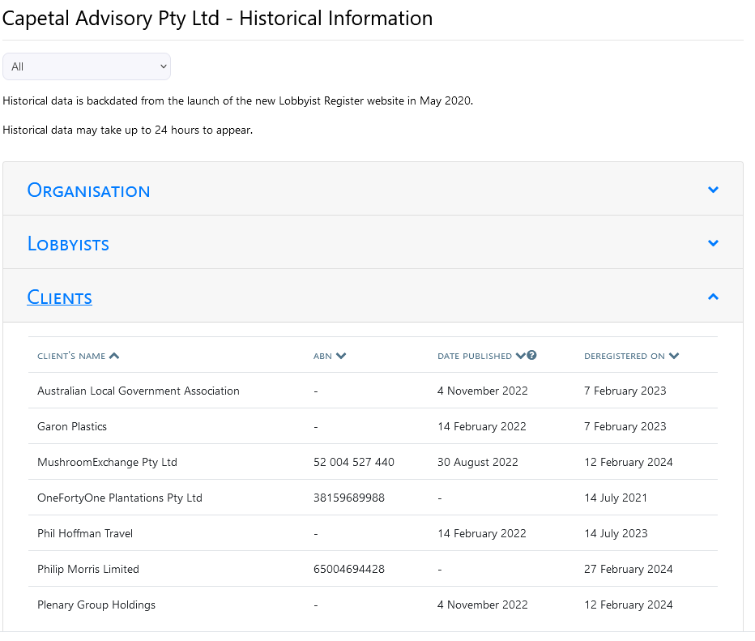
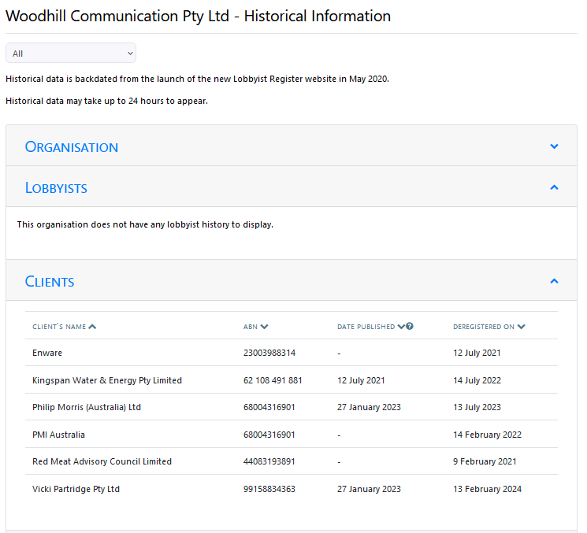
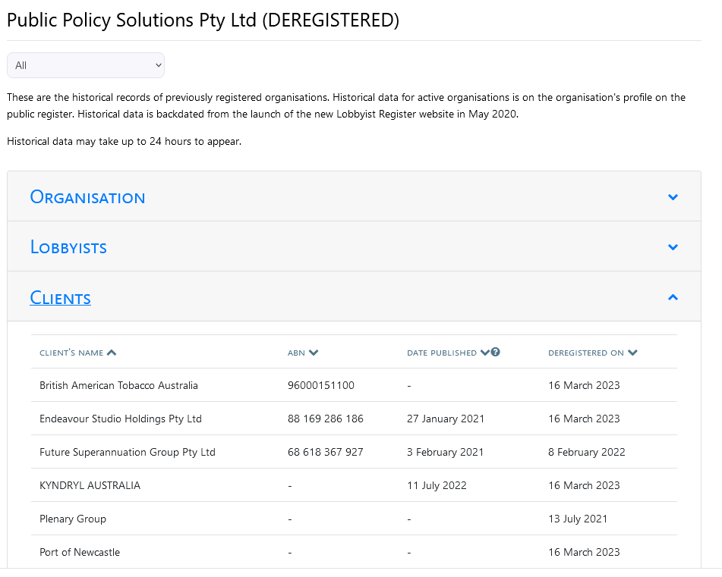
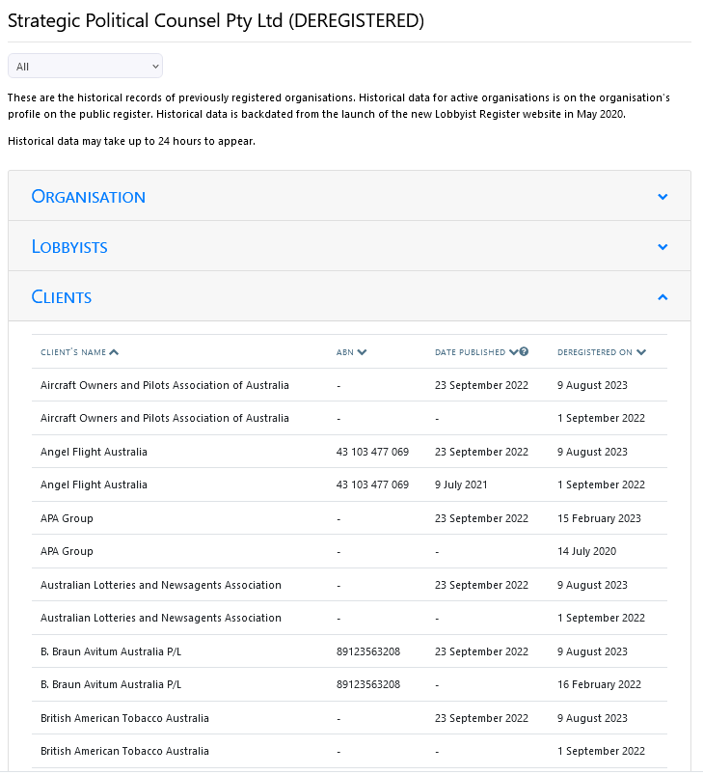
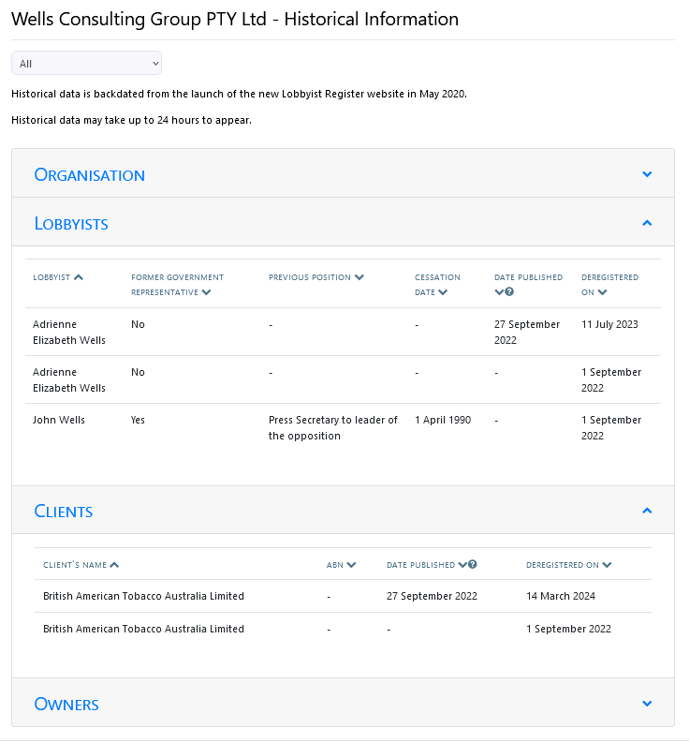

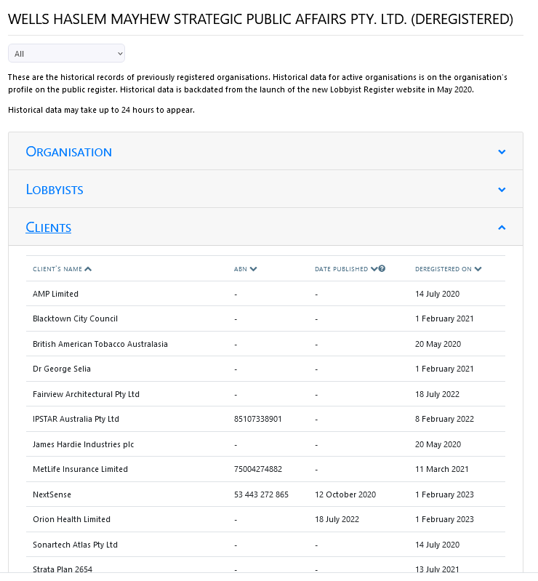 AUSTRIA

https://www.thelancet.com/journals/lanres/article/PIIS2213-2600(23)00053-X/fulltext

