**API for Spring Commerce**

1. **Product**

* Get all products:

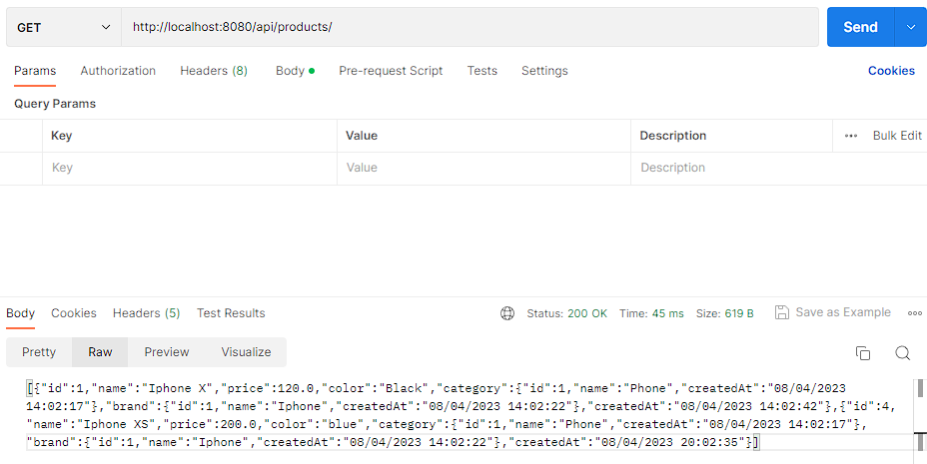

* Get a product by id:

* Create new a product

* Edit a product

* Delete a product

1. **Cart**

* Get cart

* Add a product to cart

* Delete a product from cart

* Checkout

* History

**Data Schema**

