### OBJECTIVE

Full Stack Development, Data Analysis and Machine Learning *(Rapid Prototyping)*.

### TERMS

Contracting: Near Philadelphia or Remote Work.

### TECHNOLOGIES

Python, NumPy, Pandas, Flask, uWSGI, TensorFlow, R, MySQL, Oracle, Go, iOS (Swift), Linux, RabbitMQ, Nginx, App Engine, AngularJS, Docker, Photoshop, InDesign.

**Google, AWS, DigitalOcean**

### EDUCATION

#### M.S. in Computer Science/Mathematics –

Villanova University

B.A. in Computer Science/Mathematics –

Rutgers University

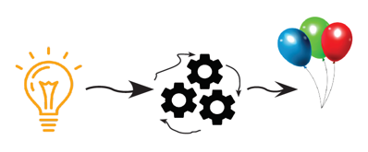

### Experience

#### Machine Learning - - FULL STACK • CWXSTAT • 2015 - 2017

Restful API: Building systems to collect and analyze real time data, displaying on Google Maps, iPhone, Web, Messaging Apps.

#### DATA ANALYTICS - - DevOps • FAA (CSC) • 2009 - 2015

Supporting and developing the TFMS Project. Built performance modeling systems (Python, Pandas, NumPy, R, Oracle, Google Big Query, iOS, Golang).

#### LINUX Administrator, Data Analysis •VWR 2007 - 2009

Developed custom pricing tools for price prediction, market analysis, and sales rep. performance.

#### Linux/DevOps • Fiberlink • 2006-2007

Automating VMware applications in a clustered environment. Oracle DBA and Linux.

#### DevOps: POSTFIX EMAIL • Thomas Jefferson University •2005-2006

Managing Postfix/Cyrus email system for 18,000 accounts. Created custom intelligent filters/programs for email processing and analysis.

#### Linux/DevOps • SilverStorm Tech • Now Intel • 2004-2005

Fast paced startup. Managing complex system and supporting software development.

#### LINUX/DEVOPS • University of Pennsylvania • 1999-2004

Constructed on-line video learning system. (the first of its kind) – Also served as IT Director.

IT Director/Software Developer • AON • 1987-1988

Building Executive Compensation Products – Data Analysis.