Delegation Scripts for PPM  
Analysis Document

Author: Riznad

29.05.2014

Contents

Executive Summary 3

Purpose of the Study 3

Limitations 3

1. Updating Direct Manager Field and take it back 4

Limitations: 4

1.1. Technical Design 4

1.1.1. Inserting Delegation information to the system 4

1.1.2. The Update Query 5

1.1.3. Run query in a scheduled time interval 5

1.1.4. The rollback of direct manager update 6

2. Adding delegate as resource pool managers to resource pools whose resource pool manager is delegator and rollback. 8

3. Adding delegate as project manager to projects whose project manager is delegator and rollback. 8

4. Changing parameters and visible parameters of custom fields of ppm from delegator to delegate and rollback 8

# Executive Summary

HP PPM system has only delegation on time sheet approval system. Other delegation capabilities are not supported. In this study, delegation on 4 major PPM process will be added by scripts. First one is all free, the analysis of remaining three are also free. Technical design of the remaining there costs a small fee and scripts are also cost a small fee. Please contact Riznad (riznad@gmail.com) for development and implementation.

# Purpose of the Study

PPM system does not have a build in delegation mechanism. What is why, if a personnel goes to vacation or temporary out of work the work of the personnel cannot be substituted by a delegate. The level 1 support worker changes fields or add another personnel as project manager in each cases. All the temporary assignment is performed one by one on demand of delegate. This situation causes huge work load and too much time effort.

With this study, 4 major PPM authorities will be delegated automatically to delegate by scripts. And then, delegation will be taken back when delegation time is over. For the 4th topic there are two ways. One is updating all parameters automatically, the other is making updates according to definitions by PPM analysis and PPM technical leader definitions. The four delegation topics are

1. Changing direct manager on knta_users table from delegator to delegate.
2. Adding delegate as resource pool managers to resource pools whose resource pool manager is delegator.
3. Adding delegate as project manager to projects whose project manager is delegator.
4. Changing parameters and visible parameters of custom fields of ppm from delegator to delegate.

## Limitations

1. If direct manager field is updated by LDAP import jobs in each day (or in any time period) the first topic should be performed after the each import.
2. In first and fourth topic, the delegate will be the only responsible. Delegator cannot make any operation unit the end of delegation time. Delegate and delegator can make operations for second and third topics.
3. The study assumes there is an ONE_DELEGATION table holds required information. The information should be entered via a page (or any other way). How to fill the table depends of the organization’s tools. I can provide extra help according to your structure (cost extra)

# Updating Direct Manager Field and take it back

PPM system stores direct manager on direct manager column in knta_users table. Direct manager can be assigned as approver for steps in a flow of a request. Also direct manager can be responsible other time management activities according to definitions.

In my approach, the delegator and the delegate will be subjected to this operation. The direct manager column will be updated for the rows whose value are delegator. And delegate will be assigned as a new value. Of course if delegation period is started. The process has to be analyzed for each organization. If a LDAP job imports user each day the update query should be run after the completion of the job. Also there is no need of rollback because LDAP job rollbacks ever time. If there is not an automatic user data update the process should be revised at the finish of the delegation period.

## Limitations:

* If direct manager is mapped to a field on a scheduled impor user job, it will change automatically. The update script should be scheduled after the import user job.
* The delegator (the person who gives his authority to someone else) could not make any operation related with being a direct manager in the time period. If delegator comes early to job or anything else, the operation should be roll backed.
* If there is a mapping to a scheduled job, no need for rollback after the time period ends. If not a revise query should be run.
* I build delegation daily not hourly. If hourly is needed the trunk function on the query should be changed.

# Technical Design

## Inserting Delegation information to the system

Delegation information will be inserted to one_delegation table. The table can be feed from any system according to organization.

The insert process should be performed to those columns

TABLE "PPM_PROD"."ONE_DELEGATION"

(

"DELEGATOR_LDAP" VARCHAR2(200 CHAR) NOT NULL ENABLE,

"DELEGATE_LDAP" VARCHAR2(200 CHAR) NOT NULL ENABLE,

"START_DATE" DATE NOT NULL ENABLE,

"FINISH_DATE" DATE NOT NULL ENABLE,

"CREATION_DATE" DATE DEFAULT sysdate

)

I assumed LDAP user name = knata_users.username. It can be different in any organization. After insert the PPM user id can be updated to the table. Or a trigger can be developed.

updateone_delegation d set d.DELEGATE_PPM_USER_ID=

(selectuser_id from knta_usersku where ku.username=d.DELEGATE_LDAP)

whered.DELEGATE_PPM_USER_ID is null and d.DELEGATE_LDAP is not null;

updateone_delegation d set d.DELEGATOR_PPM_USER_ID=

(selectuser_id from knta_usersku where ku.username=d.DELEGATOR_LDAP)

whered.DELEGATOR_PPM_USER_ID is null and d.DELEGATOR_LDAP is not null;

If there is a change on delegation such as early coming of delegator or cancel of a delegation, the information should be entered in the table. The exception should be covered within the organization. Wheter changing a data on one_delegation table or adding active/passive coulumn to the table.

## The Update Query

With the below query the delegator is replaced with delegate. Green part finds delegate, yellow part finds delegator. A simpler query should be developed with one_delegation. DELEGATE_PPM_USER_ID and one_delegation. DELEGATOR_PPM_USER_ID

updateknta_users ku1 set ku1.manager_user_id=(select ku2.user_id from knta_users ku2 where ku2.username=

(select d1.delegate_ldap from one_delegation d1 where trunc(sysdate) >= trunc(d1.start_date) and trunc(d1.finish_date)>=trunc(sysdate)

and d1.delegator_ldap=(Select ku5.username from

knta_users ku5 where ku1.manager_user_id=ku5.user_id) and ku1.end_date is null))

where

ku1.end_date is null and ku1.manager_user_id =(select ku3.user_id from knta_users ku3 where ku3.username = (

select d1.delegator_ldap from one_delegation d1 where trunc(sysdate) >= trunc(d1.start_date) and trunc(d1.finish_date)>=trunc(sysdate)

and d1.delegator_ldap=(Select ku6.username from

knta_users ku6 where ku1.manager_user_id=ku6.user_id) and ku1.end_date is null

))

## Run query in a scheduled time interval

The query can be runned on ppm server with a scheduler job. I prefer to write a bat file and call sql plus command for oracle. It depends on operating system and used data base. It should be scheduled right after user import jobs. If there is no import job it can be 2 hours before working hours. Also if hourly delegation is considered, the job should be called in shorter (10 minutes) periods, of course trunk should be removed on the query.

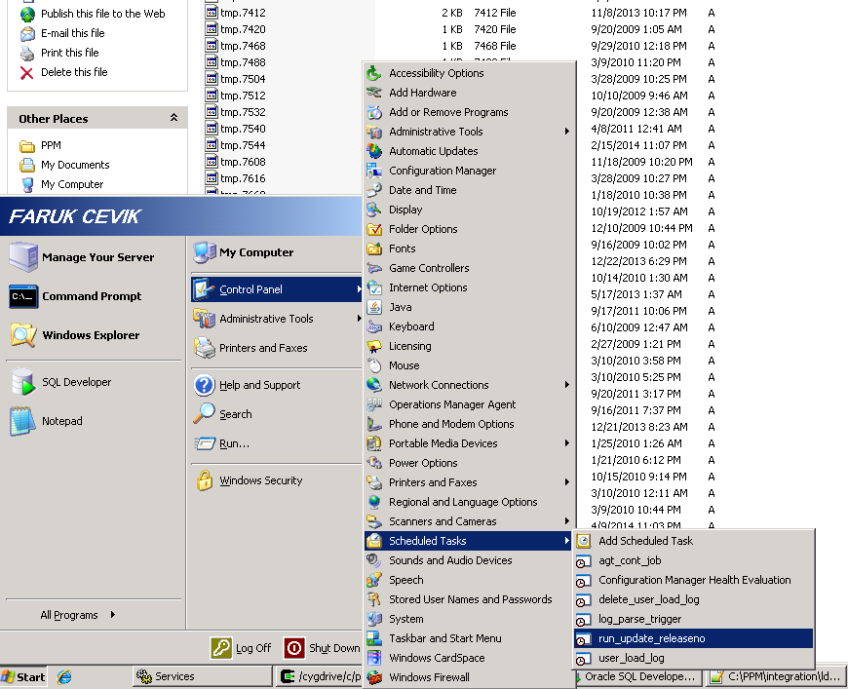

The sample bat file:

sqlplus PPMschemausername/PAssword@DBserverDBmainserver.<"c:/updatedirectmanager.sql"

Exit

updatedirectmanager.sql should contain the code on 1.1.2

## The rollback of direct manager update

If there is a user import job on daily basis, no need for rollback. If no user import than the rollback query should be developed. In my case I did not log the delegation because there is an import user job. The process should be logged to a new table. The log table must be used for rollback operation because delegate can be a real manager for some knta_users. I am giving connectional design. I can create all working scripts on demand for $300.

I desing one_directmanager_log table

TABLE "PPM_PROD"." one_directmanager_log"

(

“Changed_Username” NOT NULL ENABLE,

"DELEGATOR_LDAP" VARCHAR2(200 CHAR) NOT NULL ENABLE,

"DELEGATE_LDAP" VARCHAR2(200 CHAR) NOT NULL ENABLE,

"CREATION_DATE" DATE DEFAULT sysdate  
“IS_DELEGATION_GIVEN” VARCHAR (‘Y’/’N’)

“GIVEN_DATE” DATE

“IS_TAKEN_BACK” VARCHAR (‘Y’/’N’)

“TAKEN_BACK” DATE

)

Before update on 1.1.2, I log the information to the one_directmanager_log table. I will develop delegation rollback query by referencing one_directmanager_log

Also the 1.1.2 update query should be changed to a procedure and after each user update a record should be inserted to one_directmanager_log.  
So, steps for without user import:

1. Insert one_directmanager_log

“Changed_Username” ,

"DELEGATOR_LDAP" ,

"DELEGATE_LDAP" ,

“IS_DELEGATION_GIVEN  
Values

(select ku.username,d. DELEGATOR_LDAP,d. DELEGATE_LDAP, ‘N’  
from knta_users ku, one_delegation d

Where ku. manager_user_id=d.DELEGATOR_PPM_USER_ID  
and trunc(sysdate) >= trunc(d1.start_date) and trunc(d1.finish_date)>=trunc(sysdate))

1. Update knta_users table. Direct manager from delegator to delegate
2. Update one_directmanager_log table’s

“IS_DELEGATION_GIVEN” =“Y”

“GIVEN_DATE” DATE = systate

# Adding delegate as resource pool managers to resource pools whose resource pool manager is delegator and rollback.

I will find resource pools whose manager is delegator. I will record to a table. Than I will call web service of ppm on a loop. I will rollback with the same way. Contact me to buy technicial design document. riznad@gmail.com

<Host>:<Port>/itg/ppmservices/ResourceService?xsd=xsd0

updateResourcePools web service

# Adding delegate as project manager to projects whose project manager is delegator and rollback.

I will find security groups of delegator and check if the delegate has the groups. If not I log to a table and then I will give the security groups to the delegate. Than I will find projects (status active) whose manager is delegator. I again log to a table and call web service in a loop. I will rollback in the same way. Contact me to buy technicial design document. [riznad@gmail.com](mailto:riznad@gmail.com)

<Host>:<Port>/itg/ppmservices/ProjectService?xsd=xsd0

updateProject service

# Changing parameters and visible parameters of custom fields of ppm from delegator to delegate and rollback

PPM uses user defined field in parameter fields. A parameter field can be used as a token on a workflow step’s security definition. Such as, parameter1 on kcrt_req_header_details can be used as developer and the related token can be assigned as security (step approver) on security tab on work flow. If delegator in this field it should be replaced with delegate

In way one, I will find all parameters on kcrt_request_details and kcrt_req_header_details fit with the one of the 9 combinations below. I will log to a table and I update. Then I will rollback with the same method. All the custom fields will be changed from delegator to delegate. Whether, it is used in any security field or not.

|  |  |
| --- | --- |
| Parameter is equal to | Visible Parameter is squal to |
| PPM user ID | PPM user ID |
| PPM user ID | LDAP User Name |
| PPM user ID | Full Name |
| LDAP User Name | LDAP User Name |
| LDAP User Name | PPM user ID |
| LDAP User Name | Full Name |
| Full Name | LDAP User Name |
| Full Name | PPM user ID |
| Full Name | Full Name |

In way two:

PPM admin will enter related information via a screen. The 6 information will be recorded.

Workflow name  
Table Name (kcrt_request_details or kcrt_req_header_details)  
Batch Number (1 or 2 or 3 or 4 or 5)  
ParameterNo (1 to……)  
parameter data type (ppm user id, lda  
Visible parameter data type (PPM user ID, LDAP User Name, Full Name)

Than a data base procedure updates tables according to definiations.

I have sample screen in Turkish

