SWE 573

Milestone Report

Ömer Faruk Çevik

# Executive Summary

So far, I have talked with my teacher friends and analyze currently working websites related with education. I realized that all of them missing identifying candidate students, guidance and collaboration facilities. In my personal opinion, combination of general appetite tests, psychological tests and content specific tests should be applied to the candidate students prior to the course enrollment. Thus, our learning portal can provide specialized content depending on the candidate profile.

# List of deliverables

|  |  |  |  |
| --- | --- | --- | --- |
| No | Name | Status | Explanation |
| 1 | Requirements elicitation | %80 complete |  |
| 2 | A working website | %10 complete | Partly running on my local. |
| 3 | Analysis document | %50 complete |  |
| 4 | Mockup screens | % 50 complete | Subjected to change as project progress |

# Introduction

When I started to check the learning websites such as coursera, udemy and masterclass, I realized that the content is the same for all the attendees and they lack of collaboration facilities. I worked on how to solve the issues. A think that benchmarking of toptal website is a good idea. The toptal career website make tests to the candidates at first, then interviews the candidate online and gives small project to complete to verify his or her skills. After all those steps the toptal website helps the candidate to find a job. I take the website as an example and tried to apply the same principles to our collaboration and special content. I think that we need a recommender system and guidance system in our learning portal.

# Software Requirements Specification

## Collaboration Types

### Peer learning:

This type of learning should be established between students in the same level. Two or more student can come together to jump a limit which they are struggling to reach. Again, I don’t have a pedagogical formation degree, and it is better to employ someone who is professional on education.

Req 1: A student should be able to publish his pair learning request by either indicating his demand on his own words to a textbox or by selecting combo boxes.

Req 1.1. The instructor be able to ban a student if he or she abused the system. In other words, he or she behaved in an inappropriate way

Req 2: The recommender system should direct student to demand a pair learning in the predefined path.

### Learning by teaching:

This type of learning should be associated between a student who passed a level recently and a student who is struggle to pass the level. Instructors of the course probably passed preliminary learning levels long time ago. They might even get bored when a simple question is asked. On the other hand, a student who has passed from the learning path can help a person who has some difficulty.

Req 3: A student should be able to demonstrate a help request from the students who passed a level specific level recently for example between 2 months.

Req 4: A student should be able to demonstrate being a teacher request for a specific level in a certain course.

### Try it your self

Req 5: The learning portal should contain try it yourself for programming courses. For example, the student can write sql code to a text box and run the query in the cloud server.

## Student Identification Tests

### General Appetite Tests

In my opinion verbal general appetite questions, quantitative general appetite question, personality identification test questions are necessary to build an effective learning portal. A question pool should be created by experts. Again, in my opinion education level, age interval and question type should be selected from the screen. There can be an all option for education level and age. Thus, an education professional can design a course for a student cluster whose general quantitative test result is at top 5 percent. Similarly, an instructor can also create a course for a python course for high school graduates with a quantitative result is at lowest 5 percent. In the former one video content can be a bit short and less explanation might exist. In the later one, long hours of explanations and dozens of examples can exist.

Req 6: An education specialist should be able to create quantitative general appetite question. The question should be added to the question pool.

Req 6.1: The question can be multiple choice, matching, more than one selection or free text.

Req 6.2: The question submitter should determine target test taker profile information by selecting age, education level.

### Content Specific Test Creation

Suppose you are designing a python course. If a person knows mathematics very well, knows another programming language but new to python. Does the person will face the same course content with a person whose math level is limited, do not know any programming language? of course not. Also, he former person's requirements from the interaction in the class is different than the later one.

### Personality Test

According to the psychiatrists, some people are introverted, extroverted and some are ambivert. Knowing the personality of the student can enable the software to provide specialized content or guidance. For example, if the person is introverted, the software can suggest much more reading or individual study suggestions and less social interaction. If the person is extroverted the software can suggest chatting and social interaction. The content can vary according to personality tests. Moreover, a psychiatrist can make an interview too. According to interview result and personality test, the specialized content can be shown to the candidate. Again, this design process more related with education professionals not IT professionals.

## UML Diagrams

### Actors:

**Test content creator:** Parent actor of all test creators. The questions can be multiple choice, matching, text entry and others.

**Quantitative appetite test creator:** This actor creates quantitative appetite questions and sends to approval for entry to the question pool.

**Verbal appetite test creator:** This actor creates verbal test and sends to approval for entry to the question pool.

**Personality test creator:** Probably psychiatrists create this content to identify personality of the students.

**Content specific test creator:** Math, algorithm, geography or any other general content questions created by the content specific test creator.

**Course creator:** The creator arranges course by recording videos, writing text book or other ways.

Student:

**Learn by teaching students:** The student expresses his desire to help other students in a predefined level which he passed recently.

**Peer leering student:** The student express his claim to study a specific topic with a student in the same level.

**Help requestor student:** The student claims he or she needs help about something anytime.

**Education moderator:** The actor checks the question or education material and approves, sends for review or rejects the content. The moderator’s right to approve is defined in his or her info. In other words, if the moderator is a verbal appetite test approval then he or she approves only that content. Similarly, if the education moderator has right to approve programming test questions and verbal appetite questions than the education moderator can approve the two types of questions.

**Admin:** The user right to define creator’s right, ban students or moderator and change content.

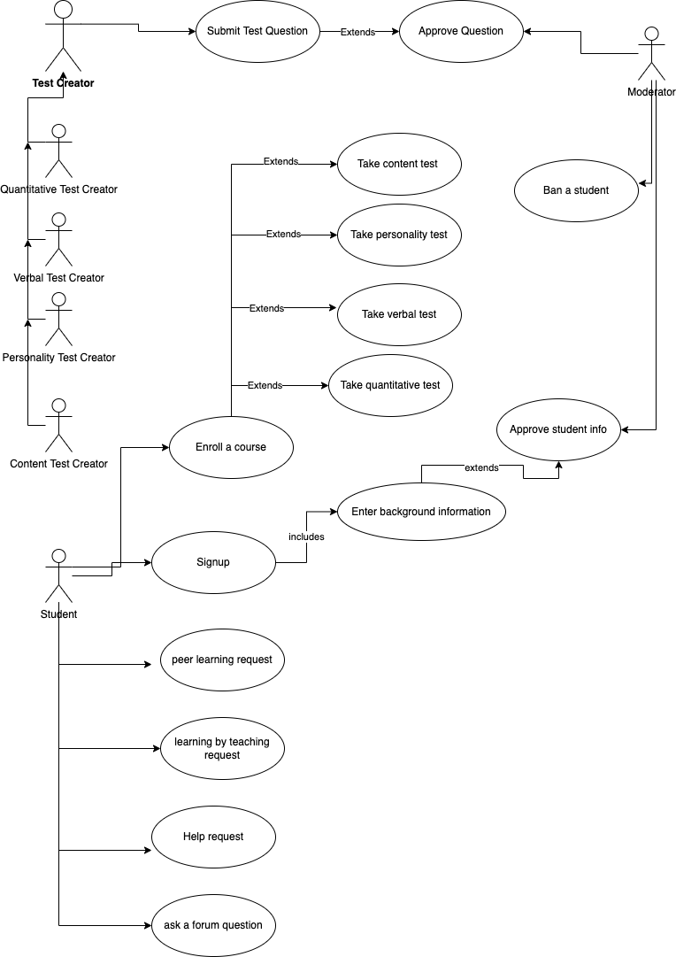

# Mockup Screens