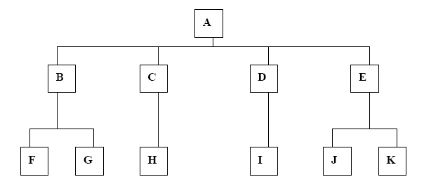

15.{J};{K};{I};{H};{G};{F};{B};{C};{D};{E};{A};{A,B,C,D,E,F,G,H,I,J,K}
a. Top-down testing
b. Bottom-up testing
c. Sandwich testing
d. Big-bang testing
e. Modified top-down testing

16.{A};{A,B,C,D,E};{A,B,C,D,E,F,G,H,I,J,K}
a. Top-down testing
b. Bottom-up testing
c. Sandwich testing
d. Big-bang testing
e. Modified top-down testing

17.{F};{G};{H};{I};{J};{K};{B,F,G};{C,H};{D,I};{E,J,K};{A,B,C,D,E,F,G,H,I,J,K}
a. Top-down testing
b. Bottom-up testing
c. Sandwich testing
d. Big-bang testing
e. Modified top-down testing

18.{A};{B};{C};{D};{E};{A,B,C,D,E};{F};{G};{H};{I};{J};{K};{A,B,C,D,E,F,G,H,I,J,K}
a. Top-down testing
b. Bottom-up testing
c. Sandwich testing
d. Big-bang testing
e. Modified top-down testing

19.{A};{F};{G};{H};{I};{J};{K};{B,F,G};{C,H};{D,I};{E,J,K};{A,B,C,D,E,F,G,H,I
,J,K}
a. Top-down testing
b. Bottom-up testing
c. Sandwich testing
d. Big-bang testing
e. Modified top-down testing

20.In a function of a component in the cashier subsystem of the GSCS, a
variable does not get initialized properly. Which type of testing would
be most likely expose this defect?
a. unit testing
b. integration testing
c. acceptance testing
d. installation testing
e. performance testing

21.A function X in component A requires a pointer to an integer to be passed as an argument, but a call to the function X in component B passes the
value of an integer instead. Which type of testing would most likely
expose this defect?
a. unit testing of component A
b. integration testing of components A and B
c. performance testing
d. installation testing
e. acceptance testing

22.The gas pump subsystem is supposed to allow the user to choose whether or not a receipt is printed, but the print function has not been implemented. Which type of testing would most likely expose this defect?
a. unit testing
b. integration testing
c. performance testing
d. acceptance testing
e. function testing

23.A configuration file used by the reporting subsystem is not placed in the correct directory in the customer's environment. Which type of testing would most likely expose this defect?
a. integration testing
b. installation testing
c. performance testing
d. acceptance testing
e. function testing

24.A change is made to correct a fault. The fault has been fixed, but it has caused a fault in previously functioning code. Which type of testing would most likely expose this defect?
a. unit testing
b. acceptance testing
c. regression testing
d. performance testing
e. installation testing

25.The customer is unhappy with the number of screens that must be traversed before getting to the parts list screen, a screen accessed frequently when using the system. Which type of testing would most likely expose this defect?
a. integration testing
b. installation testing
c. performance testing
d. acceptance testing
e. function testing

