Moffat Bay Marina Test Plan
To complete the test case plan, fill out the information for Project, Course, Description and Date in the header below.
Project: Moffat Bay Marina - Jonathan, Abram, Daniel
Course: CSD460
Description: Test plan for landing, login, and registration pages.
Date: September 2, 2026

TABLE OF CONTENTS
Landing Page - Test 1 2
Landing Page - Test 2 4
Login Page - Test 1 5
Login Page - Test 2 8
Registration Page - Test 1 10
Registration Page - Test 2 12
Reservation Page - Test 1 13
Reservation Page - Test 2 15
Reservation Summary Page - Test 1 15
Reservation Summary Page - Test 2 16
About Us Page - Test 1 18
About Us Page - Test 2 19

Test 1 | Landing Page - Test 1
 | Test Objective: Verifies that primary navigation links and call-to-action buttons correctly direct users to key application views (such as Login and Registration). | Developer:  Date tested: <yyyy/mm/dd> | Peer tester: A. Denzlinger  Date tested: 2026/09/04
Step | Action | Expected results: | Developer pass/fail | Tester pass/fail
1 | Load the Landing Page in a standard web browser. | The page renders fully with the agreed-upon color palette, logo, and typography without layout shifts. | <yes/no> | YES  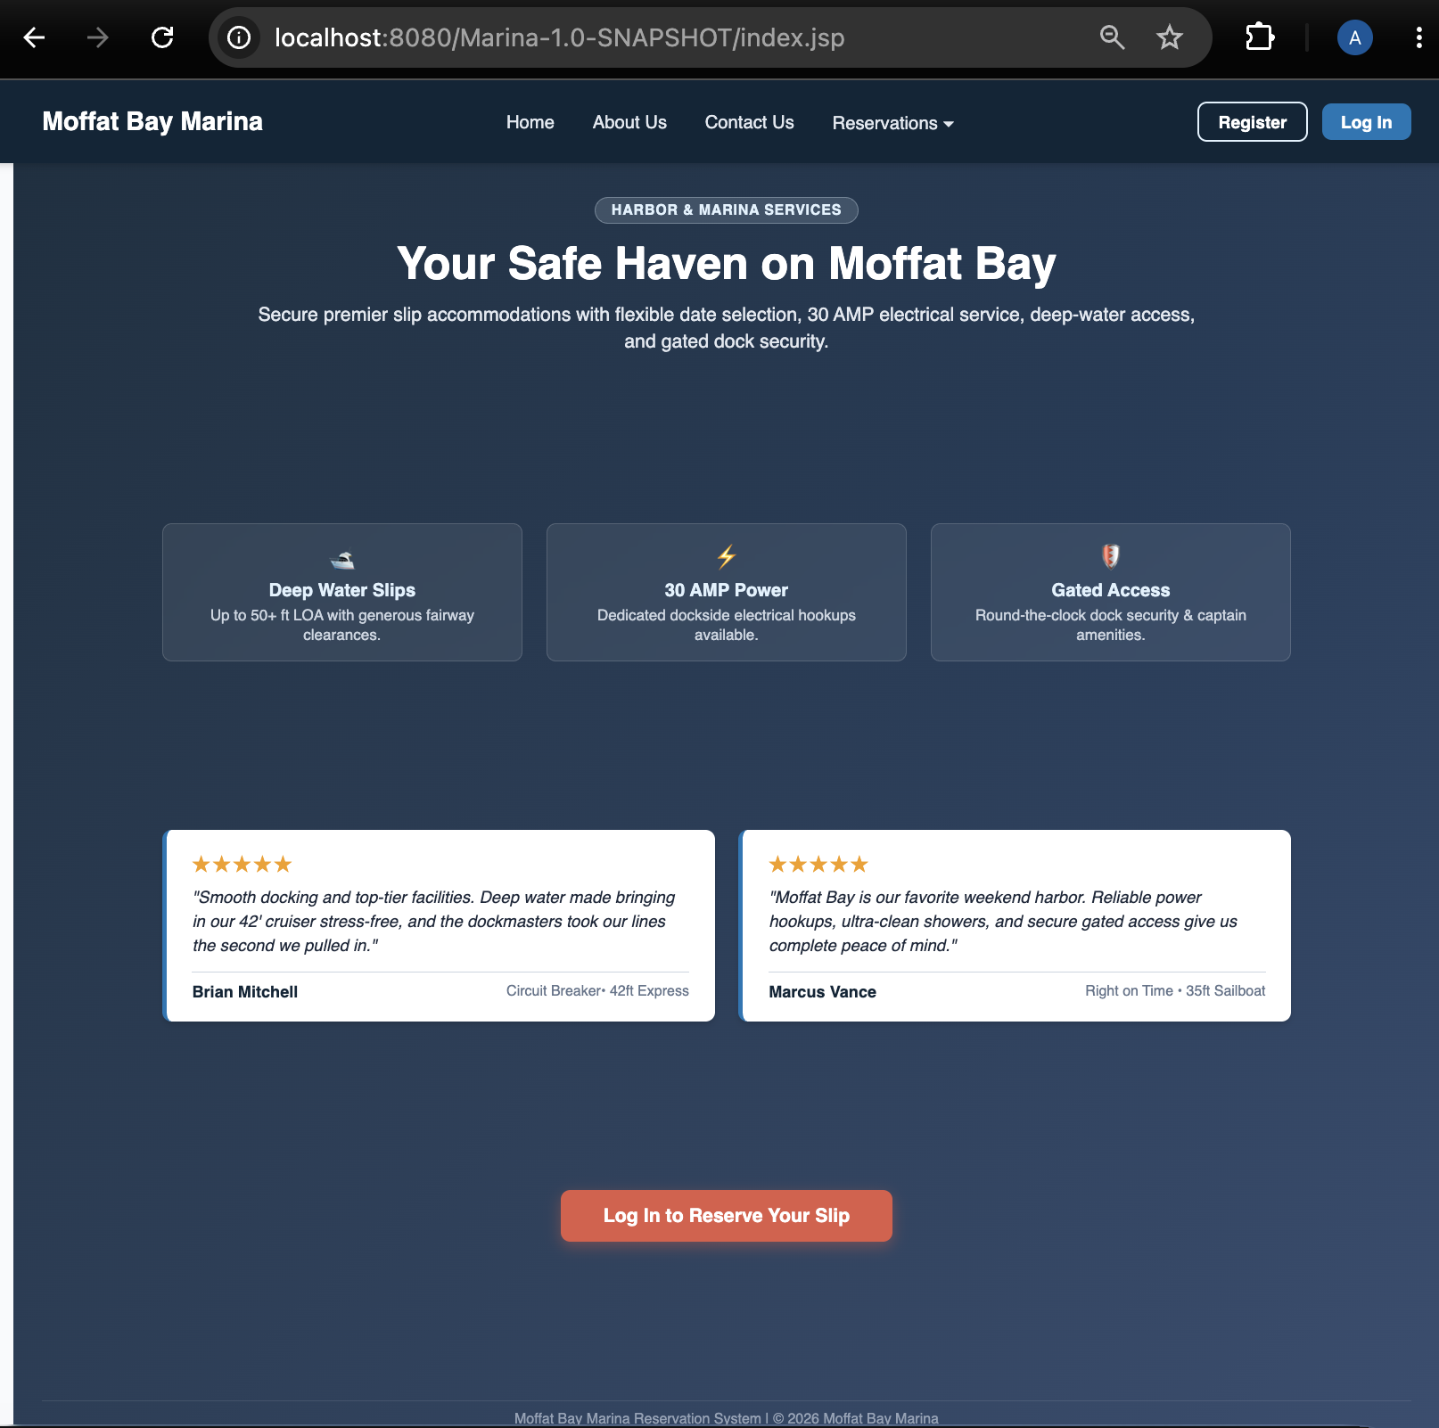
2 | Click on the "Login" navigation link or button. | The browser successfully navigates to the Login page (login.php or equivalent route). | <yes/no> | YES  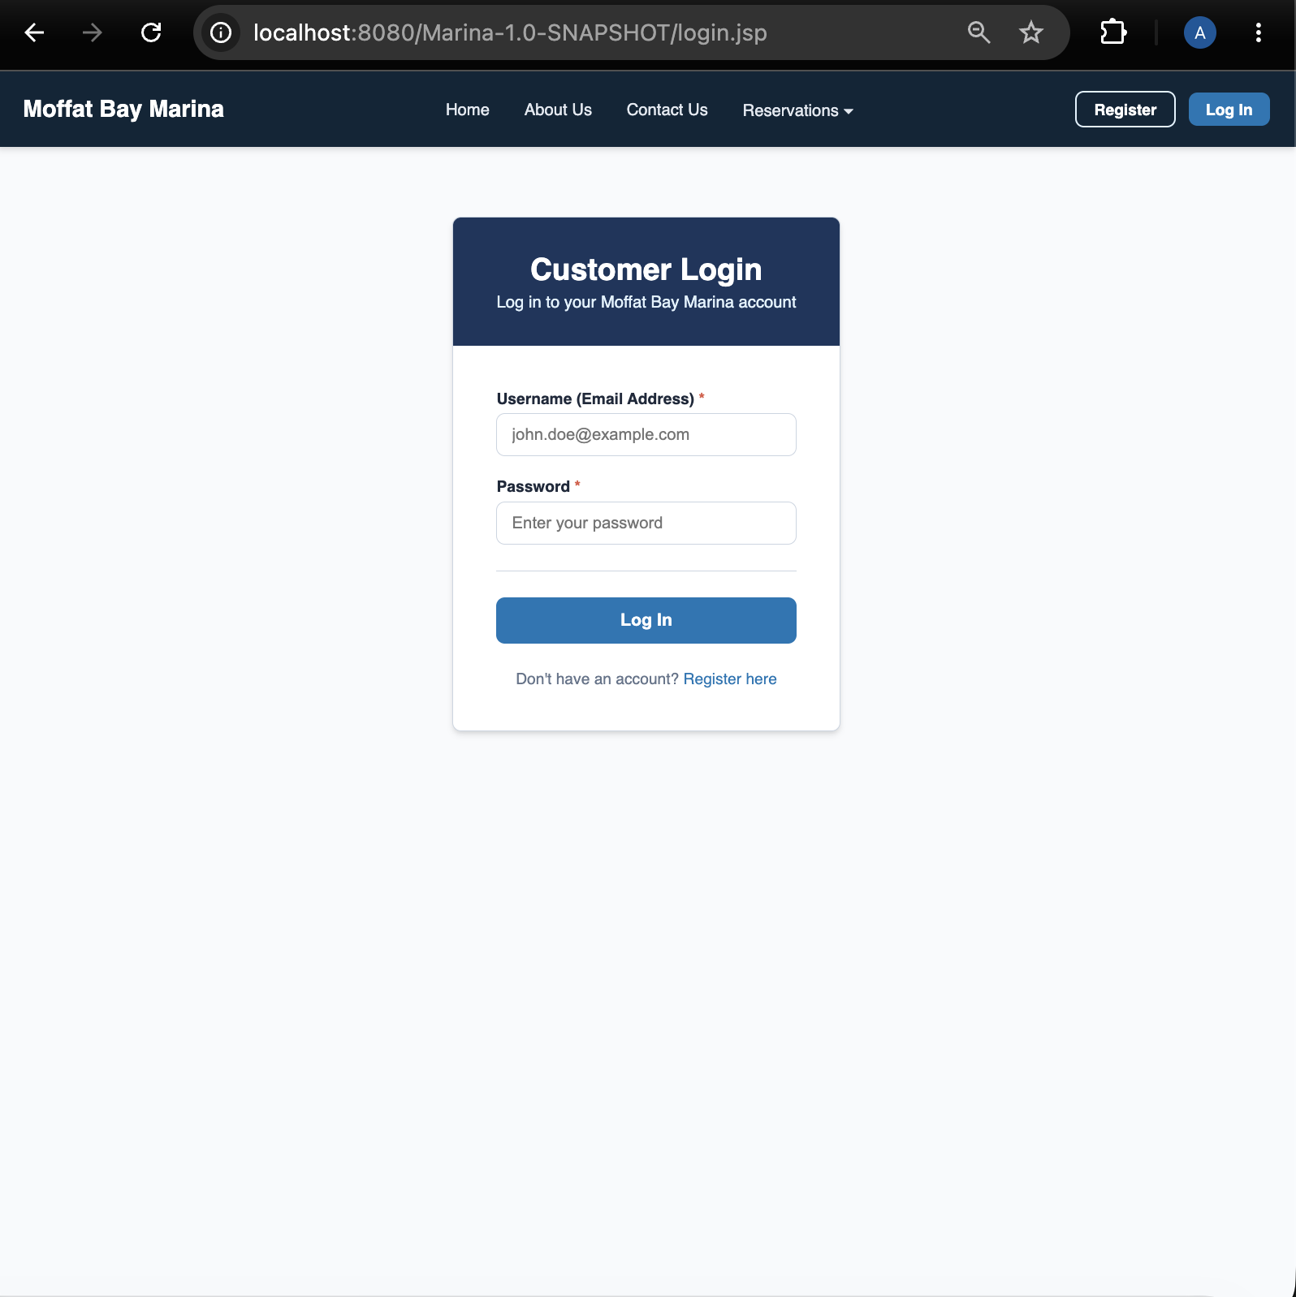
3 | Use the browser back button to return to the Landing Page. | The Landing Page re-displays correctly. | <yes/no> | YES  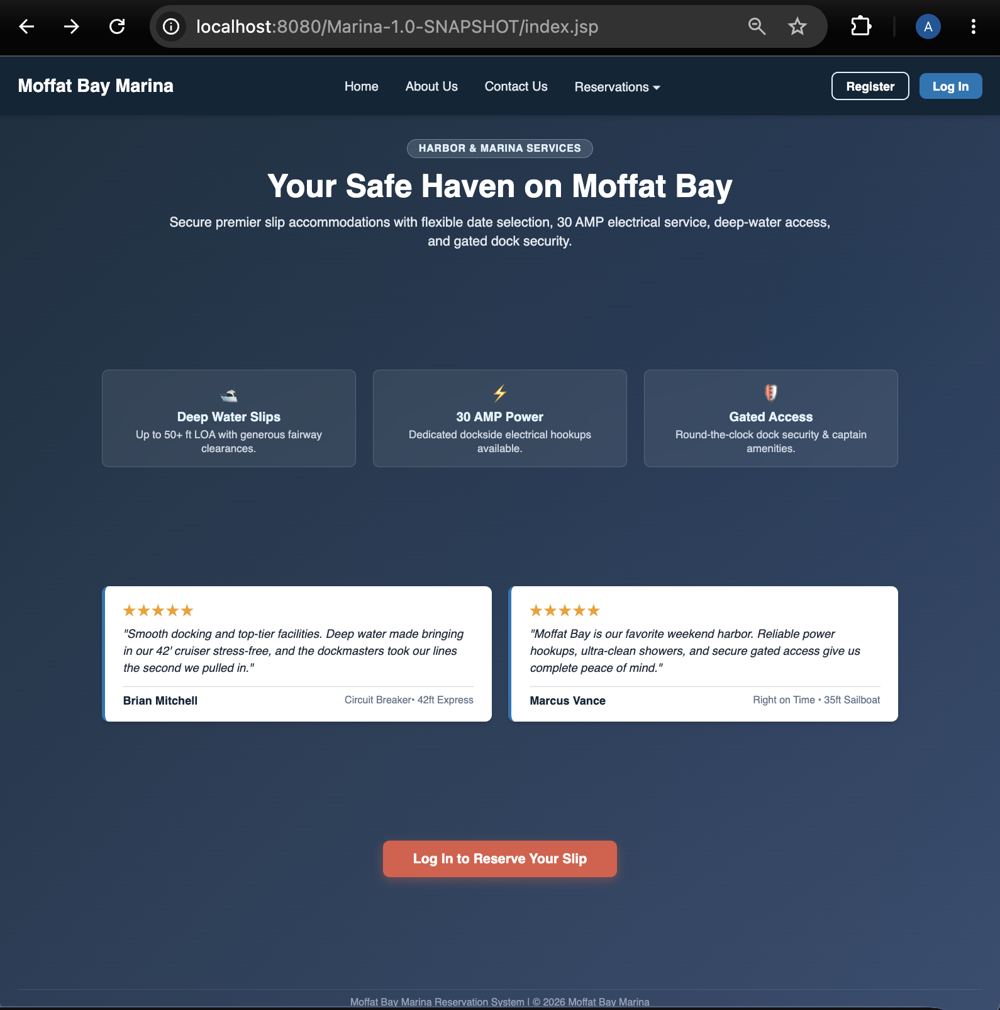
4 | Click on the "Register" or "Sign Up" call-to-action button. | The browser successfully navigates to the User Registration page. | <yes/no> | YES  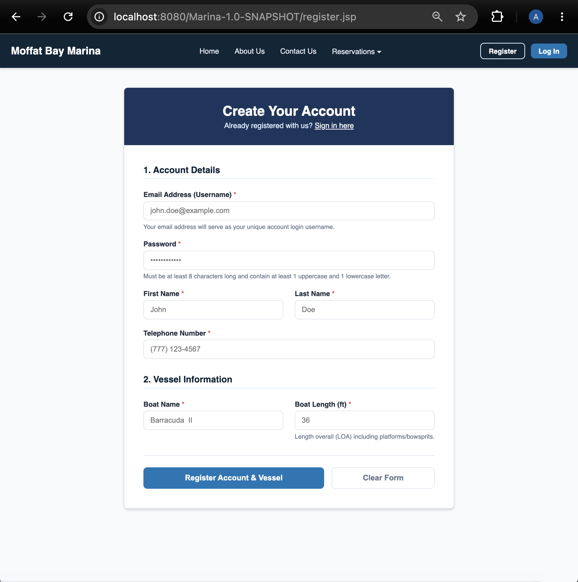
5 |  |  | <yes/no> | <yes/no>
Comments | The home page renders fully with appropriate styling and layout. The login page displays as prototyped but with styling added. The registration page displays as prototyped but with styling added.

Test 2 | Landing Page - Test 2
 | Test Objective: Verifies that introductory content, imagery, and branding elements load correctly and maintain consistency with project guidelines. | Developer:  Date tested: <yyyy/mm/dd> | Peer tester: A. Denzlinger  Date tested: 2026/09/04
Step | Action | Expected results: | Developer pass/fail | Tester pass/fail
1 | Navigate to the Landing Page and inspect the header section. | The title and introductory branding banners display clearly. | <yes/no> | YES  
2 | Check all embedded image assets or background graphics. | Images load without 404 errors or missing asset placeholders. | <yes/no> | YES  
3 | Review paragraph text blocks for alignment and readability. | Text contrast against background colors meets readability standards with no overflow or clipping. | <yes/no> | YES  
4 | Inspect footer display and content | Footer is visible and correctly styled. | <yes/no> | YES  
5 |  |  | <yes/no> | <yes/no>
Comments | The title and banners display as expected. The icons load without error. The text is clean and clearly visible. The footer displays as expected.

Test 3 | Login Page - Test 1
 | Test Objective: Verifies that entering valid credentials authenticates the user and successfully redirects them to their account dashboard. | Developer:  Date tested: <yyyy/mm/dd> | Peer tester: A. Denzlinger  Date tested: 2026/09/04
Step | Action | Expected results: | Developer pass/fail | Tester pass/fail
1 | Navigate to the Login page. | The email/username and password input fields render along with a submit button. | <yes/no> | YES  
2 | Enter a valid registered user email/username into the user field. | The text populates correctly in the input box. | <yes/no> | YES  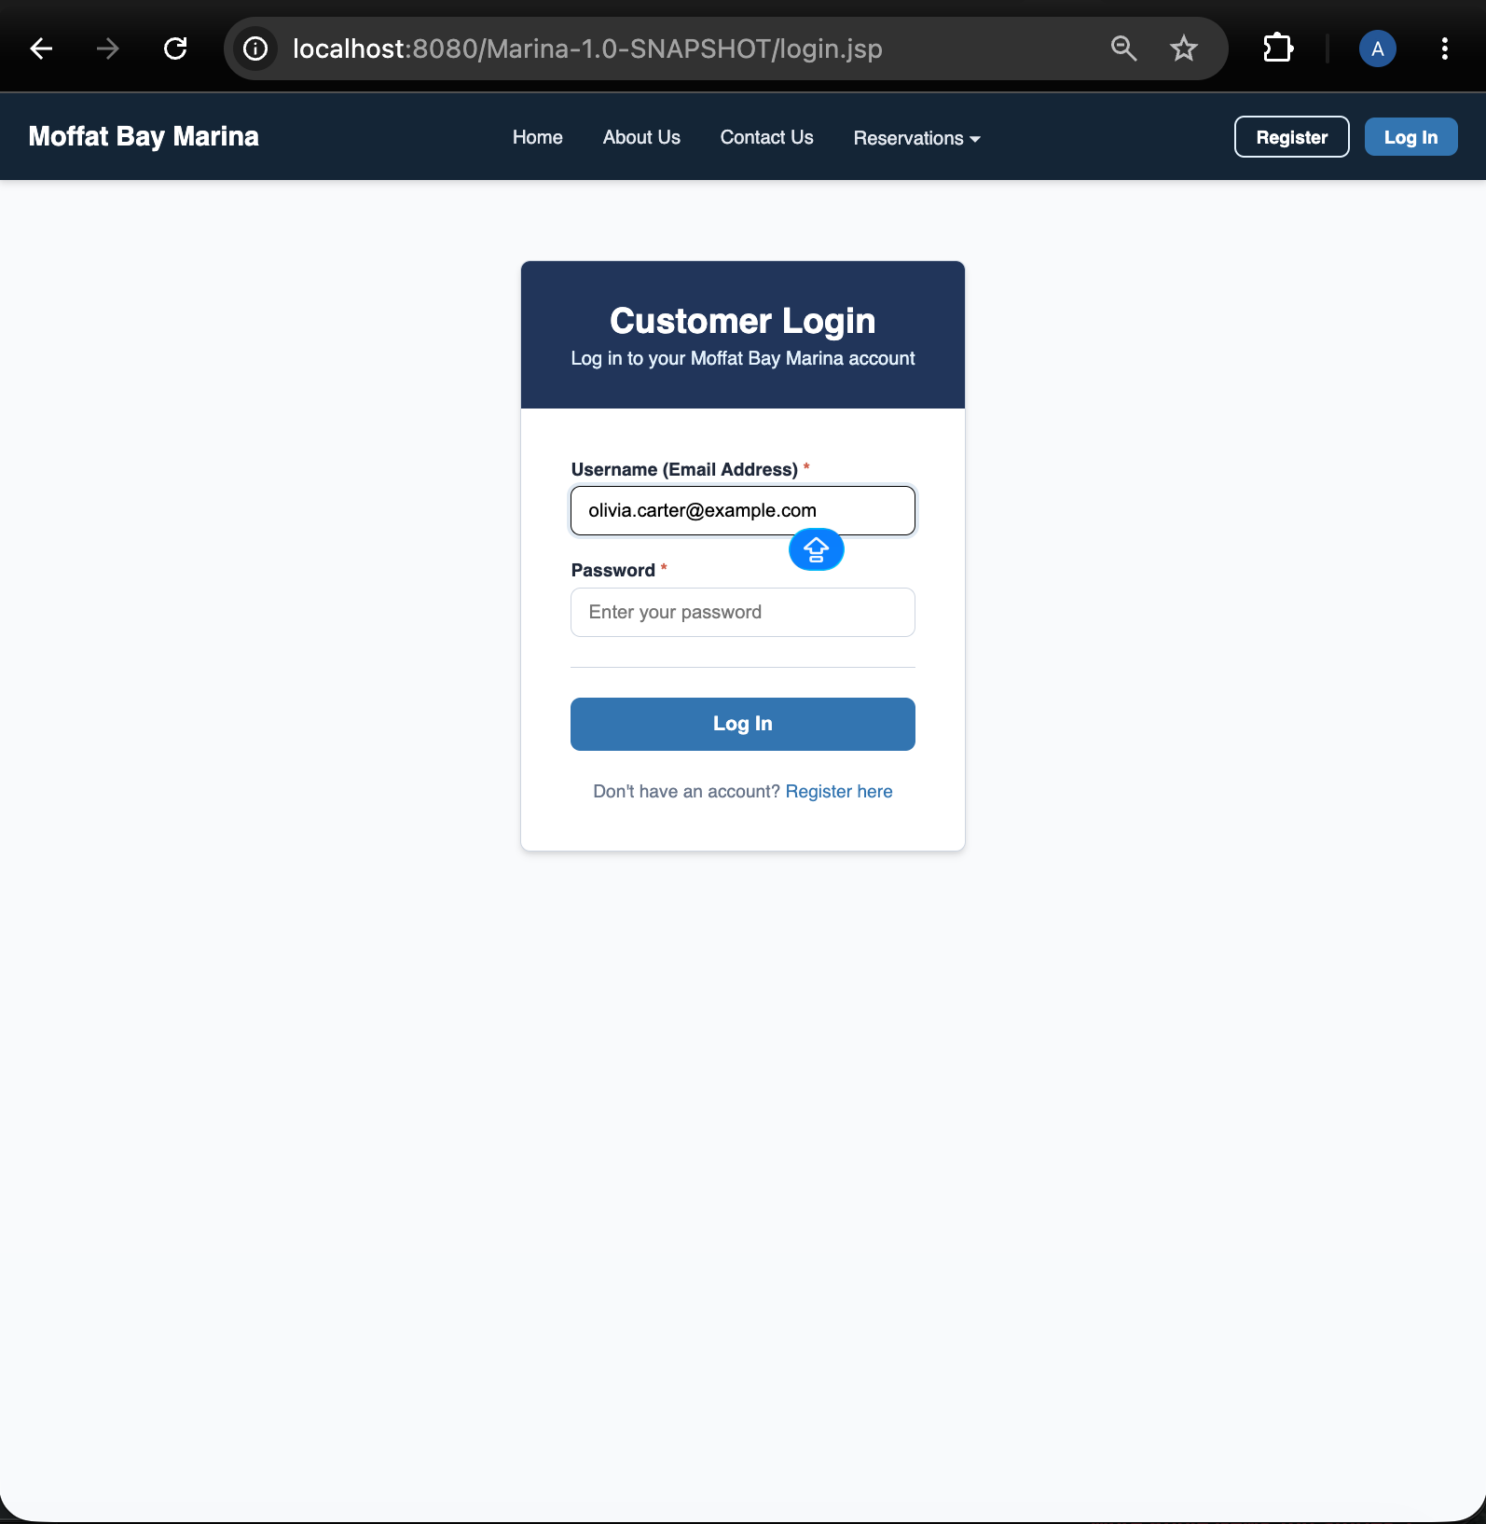
3 | Enter the correct matching password into the password field. | Password input characters are masked securely (displayed as dots/asterisks). | <yes/no> | YES  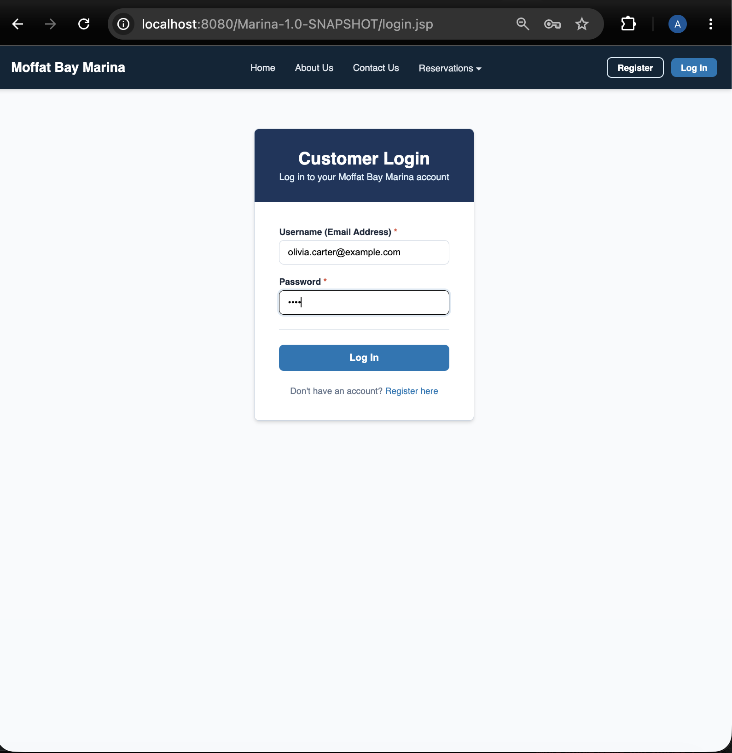
4 | Click the "Log In" submit button. | Credentials are submitted to the backend for verification against the database. | <yes/no> | YES  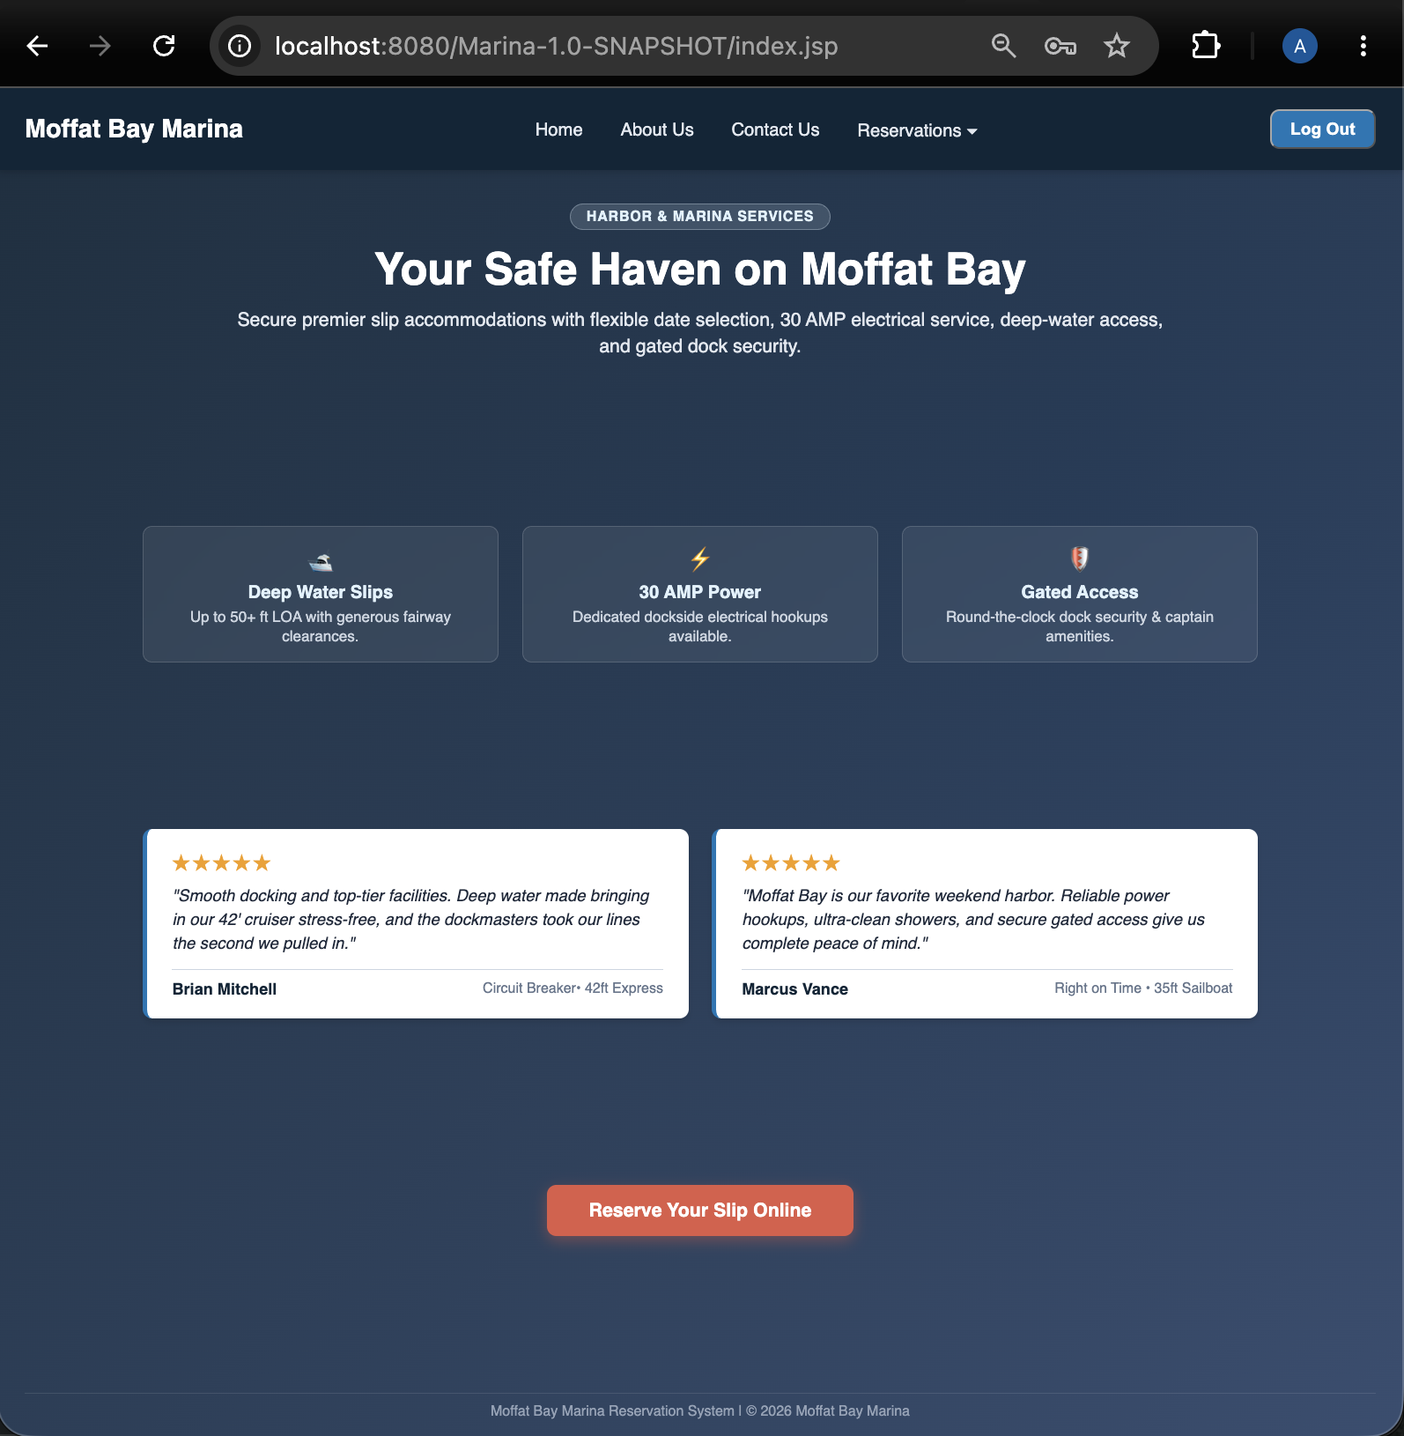
5 | Observe the post-login behavior. | The user session is initialized, and the browser redirects to the authorized dashboard/home view. | <yes/no> | YES  
Comments | The login page displays as expected. The email address displayed correctly when typing. The password characters are masked with dots. After pressing ‘log in’, user is returned to home page. Login button now displays ‘Log out’, ‘Register’ button is gone, and orange ‘Log in to reserve your slip’ button now reads ‘Reserve your slip online.’

Test 4 | Login Page - Test 2
 | Test Objective: Verifies that entering incorrect passwords or unregistered usernames triggers appropriate error messages and prevents unauthorized access. | Developer:  Date tested: <yyyy/mm/dd> | Peer tester: A. Denzlinger  Date tested: 2026/09/04
Step | Action | Expected results: | Developer pass/fail | Tester pass/fail
1 | Navigate to the Login page. | The login form is displayed cleanly. | <yes/no> | YES  
2 | Enter an unregistered email address and any password, then submit. | The system rejects the entry and displays a clear, user-friendly error message (e.g., "Invalid credentials"). | <yes/no> | YES  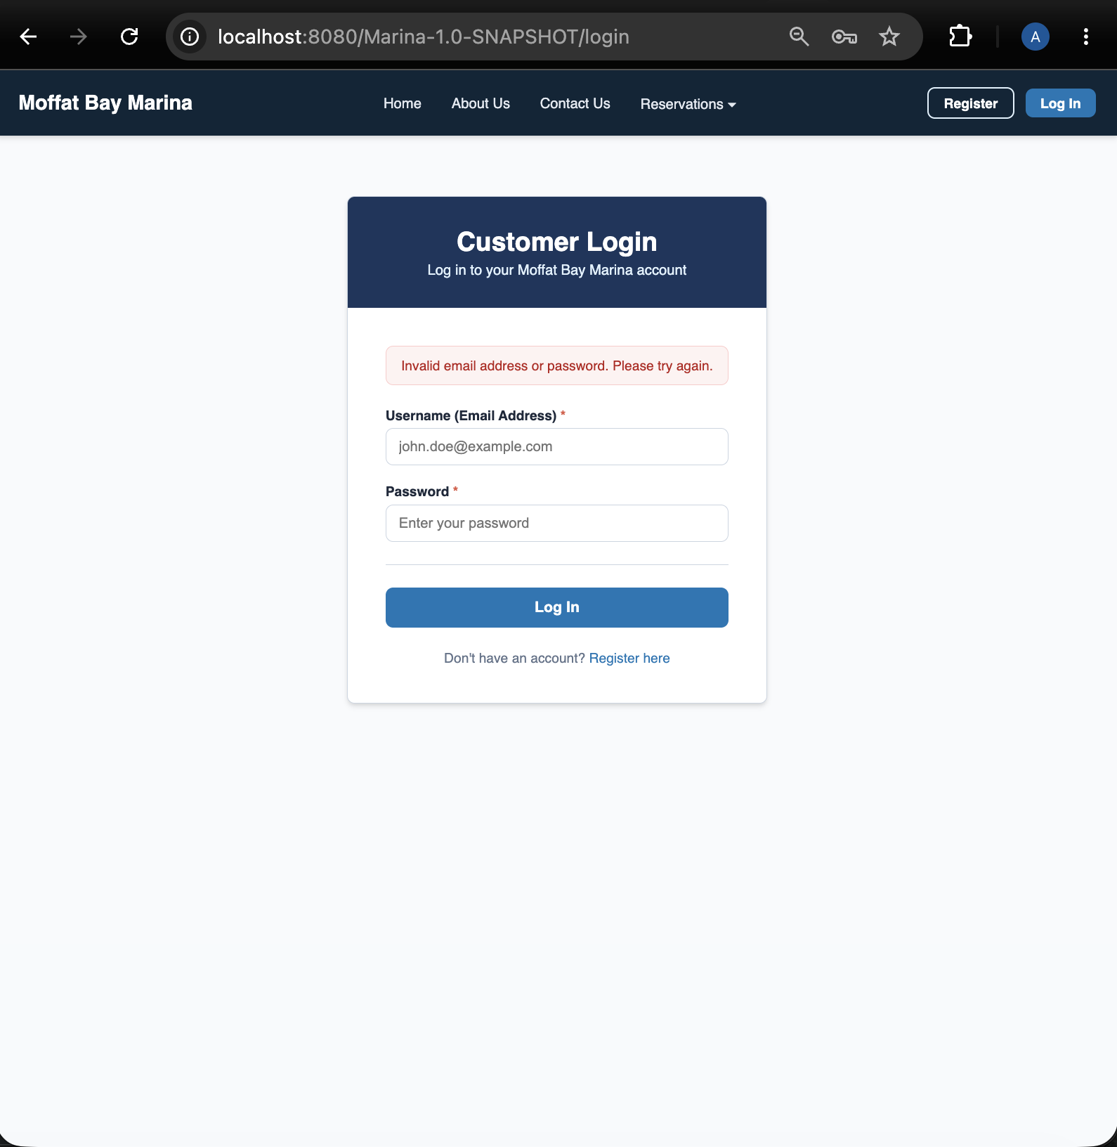
3 | Enter a valid registered email address paired with an incorrect password, then submit. | The system rejects the login attempt and flags the password mismatch. | <yes/no> | YES  
4 | Leave both fields blank and click submit. | Client-side or server-side validation catches the empty fields and highlights required inputs. | <yes/no> | YES  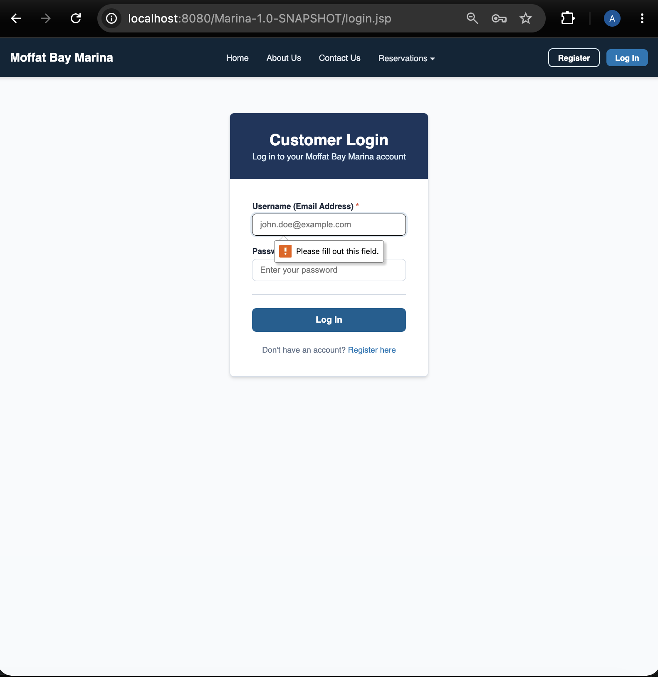
5 | Verify security behavior regarding error specificity. | Error messages avoid exposing whether the email or password specifically was incorrect, protecting account security. | <yes/no> | YES  
Comments | The login form displays cleanly. Registered users with correct passwords are able to log in. Incorrect passwords and unregistered users are rejected, and error message correctly does not clarify which was incorrect. Required fields are indicated.

Test 5 | Registration Page - Test 1
 | Test Objective: Verifies that a new user can successfully register by filling out valid information, passing validation rules, and writing to the database. | Developer:  Date tested: <yyyy/mm/dd> | Peer tester: A. Denzlinger  Date tested: 2026/09/04
Step | Action | Expected results: | Developer pass/fail | Tester pass/fail
1 | Navigate to the User Registration page. | Registration form fields (name, email, password, confirmation, etc.) render properly. | <yes/no> | YES  
2 | Fill in all required fields with valid, un-registered data. | Form inputs accept text and format correctly. | <yes/no> | YES  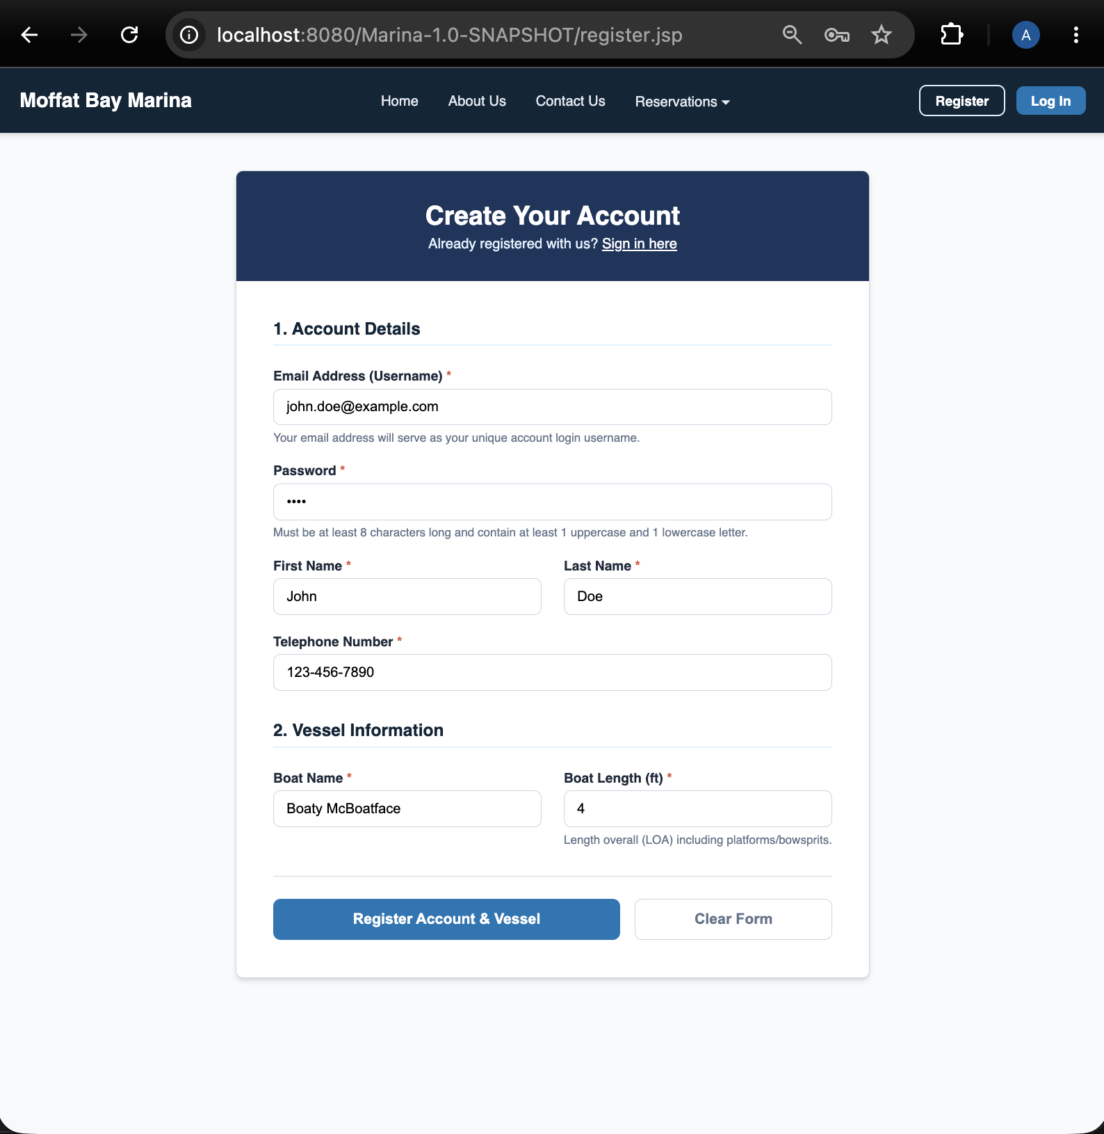
3 | Enter secure password into the password field. | Field accept the values securely with masking enabled. | <yes/no> | YES  
4 | Click the "Register" or "Create Account" button. | Data is transmitted and processed by the registration script. | <yes/no> | YES  
5 | Verify database persistence and redirection. | A new record is successfully inserted into the database table, and the user is redirected to a confirmation or login screen. | <yes/no> | YES  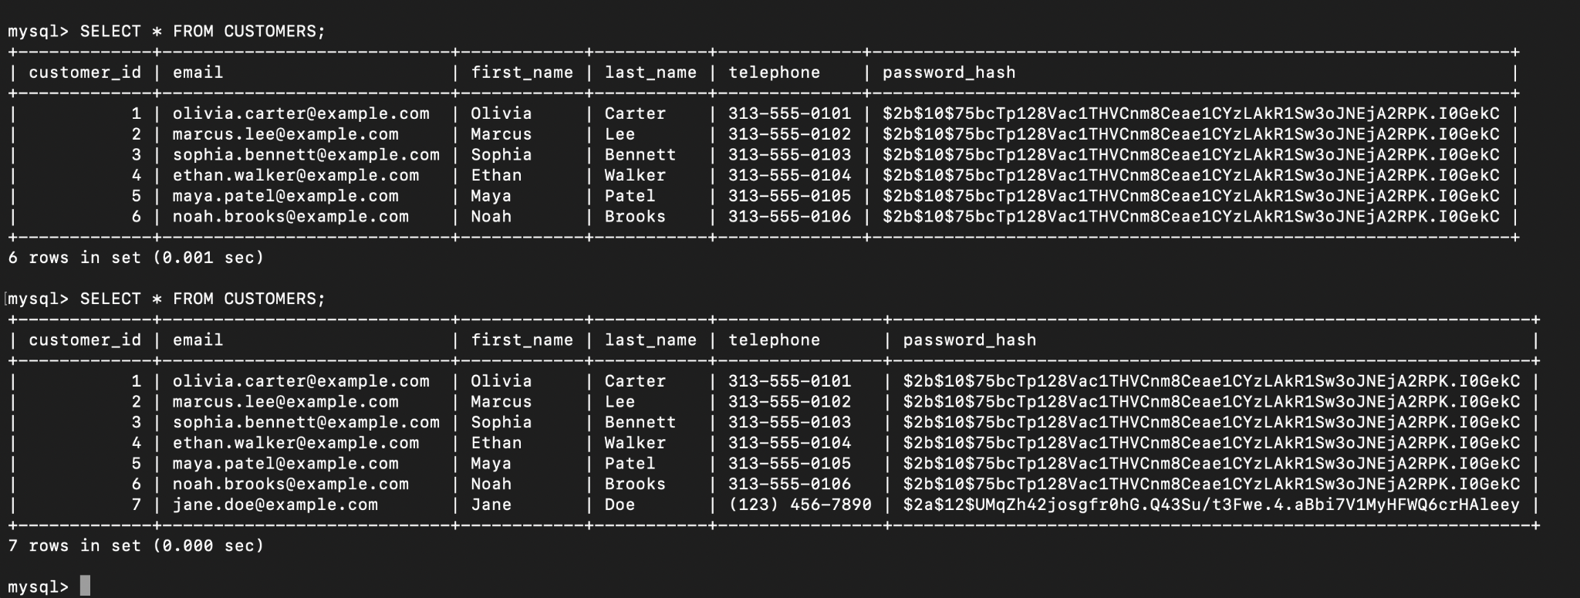
Comments | Registration form displays as expected. Form accepts text and masks password as expected. Password requires a number, but user hint below the field does not indicate that: “Must be at least 8 characters long and contain at least 1 uppercase and 1 lowercase letter.” Daniel found issue in the HTML, and fixed. Another note - the placeholder on the phone number form field has this format (123) 456-7890, but the database has this one: 123-456-7890. I entered the phone number using the placeholder format on the form, and now the database has mixed formats. Recommend updating the placeholder to reflect the existing database format and enforcing it on the input field.

Test 6 | Registration Page - Test 2
 | Test Objective: Verifies that the registration form blocks incomplete submissions, mismatched passwords, and duplicate email addresses. | Developer:  Date tested: <yyyy/mm/dd> | Peer tester: A. Denzlinger  Date tested: 2026/09/04
Step | Action | Expected results: | Developer pass/fail | Tester pass/fail
1 | Navigate to the User Registration page. | Registration form is active. | <yes/no> | YES  
2 | Attempt to submit the form with one or more mandatory fields left blank. | Submission is blocked, and validation highlights the missing fields. | <yes/no> | YES  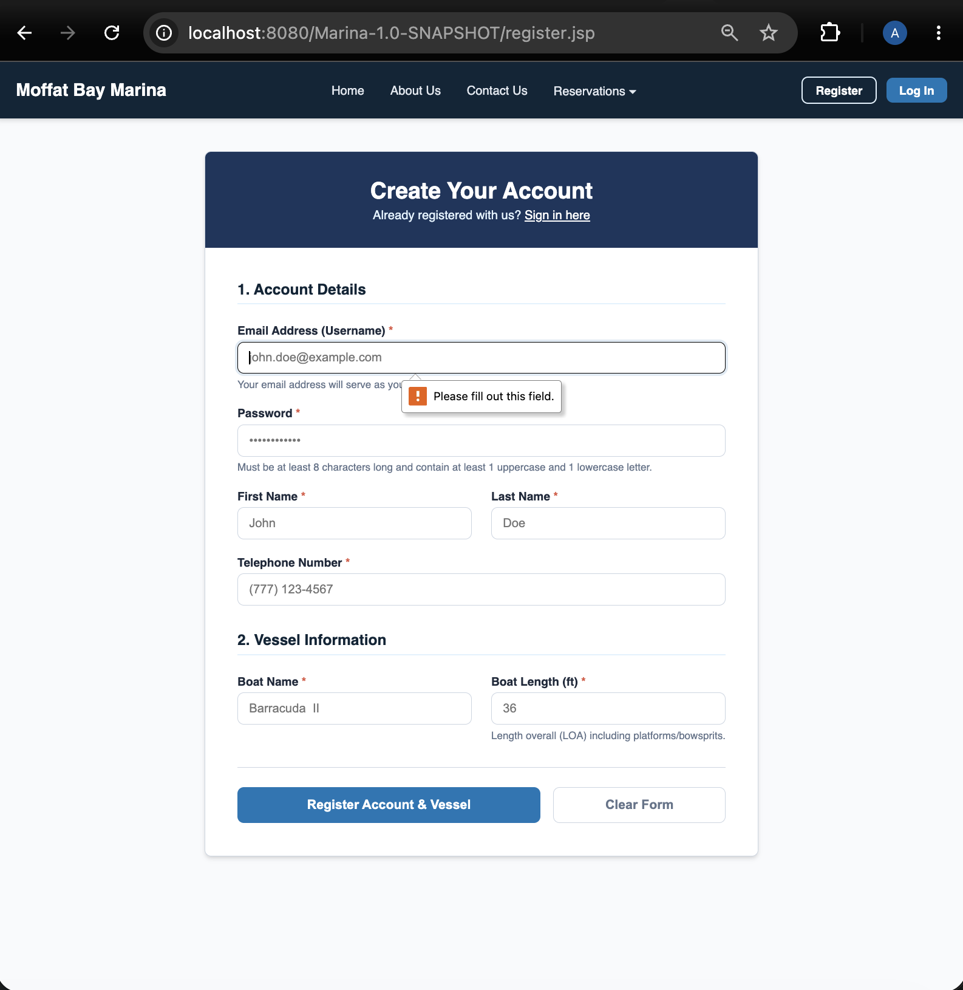
3 | Enter an email address that already exists in the database, fill remaining fields, and submit. | The system rejects the registration and notifies the user that the email is already registered. | <yes/no> | NO  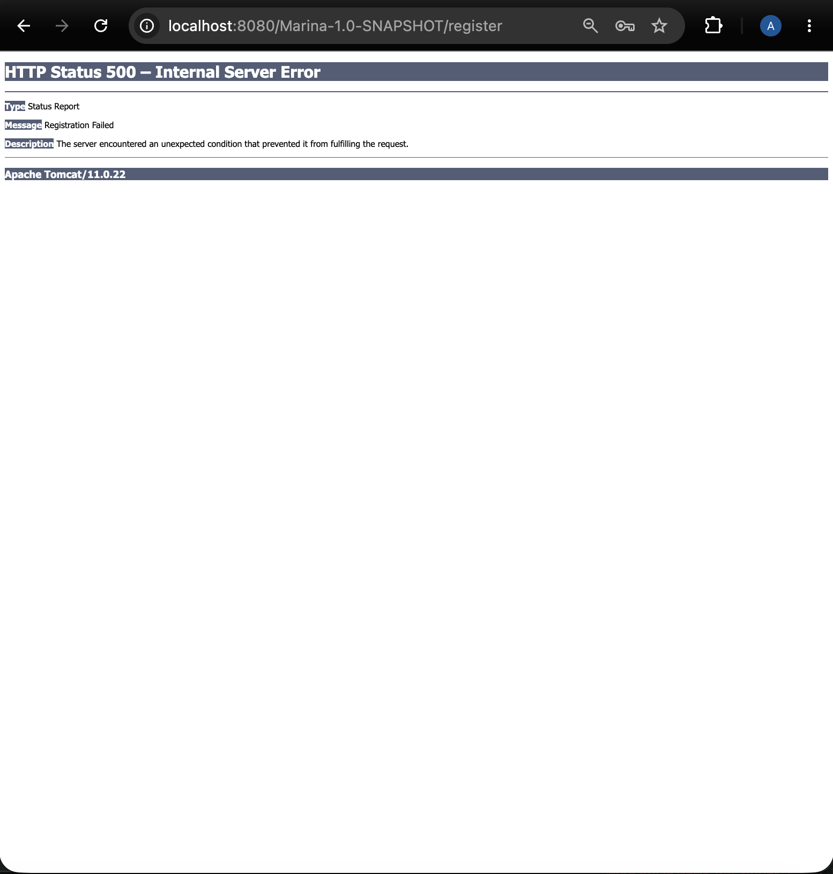
4 | Enter an improperly formatted email address (missing '@' or domain) and submit. | Client-side HTML5 or backend validation catches the invalid email syntax and prompts for correction. | <yes/no> | YES  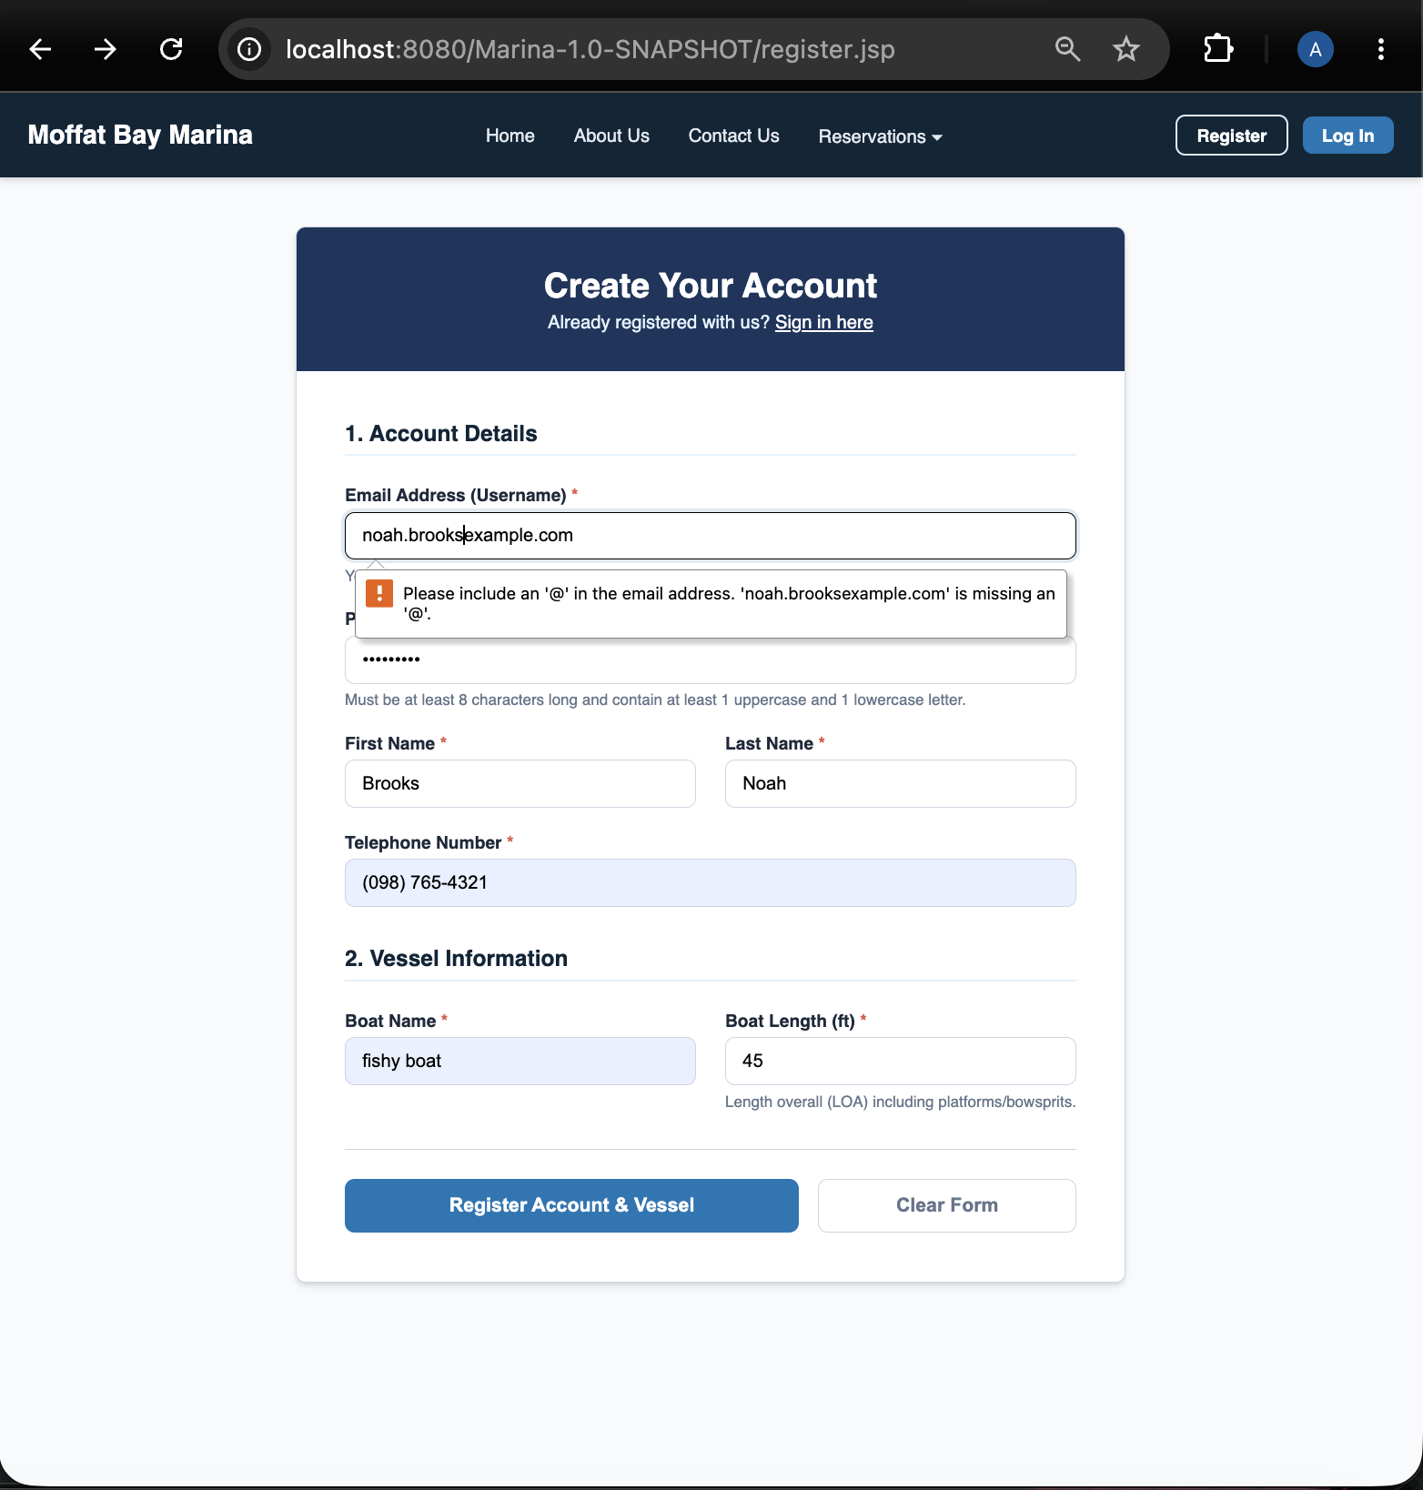
5 |  |  | <yes/no> | <yes/no>
Comments | Registration page displays as expected. Submissions blocked if required fields are blank. Attempting to register with an already registered username results in Internal Server Error rather than error message to the user. Daniel found/fixed the server, and is working through how to inform the user. Improperly formatted email addresses are caught and users are prompted to fix.

Test 7 | Reservation Page - Test 1
 | Test Objective: Verifies that selecting invalid dates (e.g., past dates, check-out before check-in) or leaving required fields blank blocks submission and displays appropriate error messages. | Developer:  Date tested: <yyyy/mm/dd> | Peer tester:  Date tested: <yyyy/mm/dd>
Step | Action | Expected results: | Developer pass/fail | Tester pass/fail
1 | Navigate to the Slip Reservation page. | The reservation form layout loads with all date selectors, slip type options, and submit controls visible. | <yes/no> | <yes/no>
2 | Leave mandatory fields (such as slip type or dates) blank and click submit. | Client-side or backend validation blocks submission and highlights the missing fields. | <yes/no> | <yes/no>
3 | Enter a check-in date set in the past and attempt to submit. | The system rejects the date selection and displays an error prompt regarding past dates. | <yes/no> | <yes/no>
4 | Attempt to select a slip size inappropriate for the boat. | Selections are filtered for the customer’s specific boat size, or an error prompt displays and prevents submission.
5 | Enter a check-out date that precedes the check-in date and submit. | The application flags the date conflict and prevents form progression. | <yes/no> | <yes/no>
6 | Verify error feedback clarity. | Error prompts provide clear instructions for correcting date range issues without crashing the backend. | <yes/no> | <yes/no>
Comments | Comments should be substantive; this means there should be at least 2-3 well-structured sentences with constructive feedback.

Test 8 | Reservation Page - Test 2
 | Test Objective: Verifies that entering valid reservation criteria successfully processes through backend logic and forwards data to the reservation summary view. | Developer:  Date tested: <yyyy/mm/dd> | Peer tester:  Date tested: <yyyy/mm/dd>
Step | Action | Expected results: | Developer pass/fail | Tester pass/fail
1 | Navigate to the Slip Reservation page. | The reservation form is active and ready for input. | <yes/no> | <yes/no>
2 | Select a valid future check-in and check-out date range. | The date inputs accept and format the selected values correctly. | <yes/no> | <yes/no>
3 | Choose an available slip from the dropdown options. | The specific slip selection registers within the form state. | <yes/no> | <yes/no>
4 | Click the submit button. | The form data transmits securely to the backend script for processing. | <yes/no> | <yes/no>
5 | Observe post-submission routing. | The backend successfully handles the session data and redirects the user to the Reservation Summary page. | <yes/no> | <yes/no>
Comments | Comments should be substantive; this means there should be at least 2-3 well-structured sentences with constructive feedback.

Test 9 | Reservation Summary Page - Test 1
 | Test Objective: Verifies that the Reservation Summary page accurately retrieves and displays user-selected parameters (dates, slip type) passed from the reservation form and backend session. | Developer:  Date tested: <yyyy/mm/dd> | Peer tester:  Date tested: <yyyy/mm/dd>
Step | Action | Expected results: | Developer pass/fail | Tester pass/fail
1 | Complete a valid reservation submission to arrive at the Reservation Summary page. | The summary page renders with dynamically populated session data. | <yes/no> | <yes/no>
2 | Compare the displayed check-in and check-out dates against values entered on the reservation form. | The dates match the user's initial inputs exactly with no data loss or corruption. | <yes/no> | <yes/no>
3 | Verify that the selected slip matches user selections. | The designated slip category is displayed accurately on screen. | <yes/no> | <yes/no>
4 | Inspect user account or contact details rendered on the summary layout. | Corresponding user metadata aligns with the authenticated active session. | <yes/no> | <yes/no>
5 | Test page refresh behavior on the summary view. | Data persistence remains stable, preserving query parameters without clearing state prematurely. | <yes/no> | <yes/no>
Comments | Comments should be substantive; this means there should be at least 2-3 well-structured sentences with constructive feedback.

Test 10 | Reservation Summary Page - Test 2
 | Test Objective: Verifies that the backend calculation accurately determines the total estimated cost based on the length of stay and slip rate. | Developer:  Date tested: <yyyy/mm/dd> | Peer tester:  Date tested: <yyyy/mm/dd>
Step | Action | Expected results: | Developer pass/fail | Tester pass/fail
1 | Access the Reservation Summary page for a known reservation duration (e.g., 3 nights). | The summary layout displays cost breakdown elements. | <yes/no> | <yes/no>
2 | Verify the base nightly rate displayed for the chosen slip type. | The correct nightly rate corresponding to the selected slip tier is retrieved from the database logic. | <yes/no> | <yes/no>
3 | Confirm that the total calculated nights correctly reflect the date difference. | The duration calculation correctly computes the number of nights stayed. | <yes/no> | <yes/no>
4 | Compare the displayed total estimated cost against manual calculations (rate x nights). | The displayed total cost precisely matches the calculated amount, including applicable fees. | <yes/no> | <yes/no>
5 | Click the final confirmation or back button. | Navigation correctly directs the user to either final booking confirmation or edit options. | <yes/no> | <yes/no>
Comments | Comments should be substantive; this means there should be at least 2-3 well-structured sentences with constructive feedback.

Test 11 | About Us Page - Test 1
 | Test Objective: Verifies that the About Us page loads all company background history, descriptions, and visual assets correctly without layout errors. | Developer:  Date tested: <yyyy/mm/dd> | Peer tester:  Date tested: <yyyy/mm/dd>
Step | Action | Expected results: | Developer pass/fail | Tester pass/fail
1 | Navigate to the main application and click the "About Us" link in the navigation header. | The browser successfully loads the About Us route (about.php or equivalent). | <yes/no> | <yes/no>
2 | Inspect the primary header title and introductory text blocks. | Company background information and marina descriptions render cleanly with correct typography. | <yes/no> | <yes/no>
3 | Review embedded imagery and facility photos for loading accuracy. | All images load without 404 errors or missing asset placeholders. | <yes/no> | <yes/no>
4 | Verify text formatting and responsiveness across standard browser viewports. | Layout blocks maintain proper padding, margins, and text readability without overflow. | <yes/no> | <yes/no>
5 | Perform a hard refresh (Ctrl+F5 or Cmd+Shift+R). | Static assets and text content reload efficiently from the server or cache. | <yes/no> | <yes/no>
Comments | Comments should be substantive; this means there should be at least 2-3 well-structured sentences with constructive feedback.

Test 12 | About Us Page - Test 2
 | Test Objective: Verifies that internal links and navigation elements on the About Us page correctly route users to related views (e.g., Home, Reservations, Footer links). | Developer:  Date tested: <yyyy/mm/dd> | Peer tester:  Date tested: <yyyy/mm/dd>
Step | Action | Expected results: | Developer pass/fail | Tester pass/fail
1 | Open the About Us page in the browser. | The page is fully visible. | <yes/no> | <yes/no>
2 | Click the navigation link pointing to the Home or Landing page. | The browser successfully navigates back to the homepage without broken links. | <yes/no> | <yes/no>
3 | Use the browser back button to return to the About Us page. | The About Us page re-displays correctly with active navigation states intact. | <yes/no> | <yes/no>
4 | Click the navigation link pointing to the Slip Reservation page. | The user is redirected smoothly to the reservation interface. | <yes/no> | <yes/no>
5 | Inspect and click footer links on the About Us page. | Footer links route properly to their respective destination pages. | <yes/no> | <yes/no>
Comments | Comments should be substantive; this means there should be at least 2-3 well-structured sentences with constructive feedback.

