MySQL Functions

CURRENT_TIMESTAMP
- Could be used to include the timestamp whenever data is added or modified. It can also be used to filter data relative to the current moment, like grabbing only the records that have a timestamp within the last 3 days. Apart from that, when run alone without a reference to any data, it displays the current date/time.
- 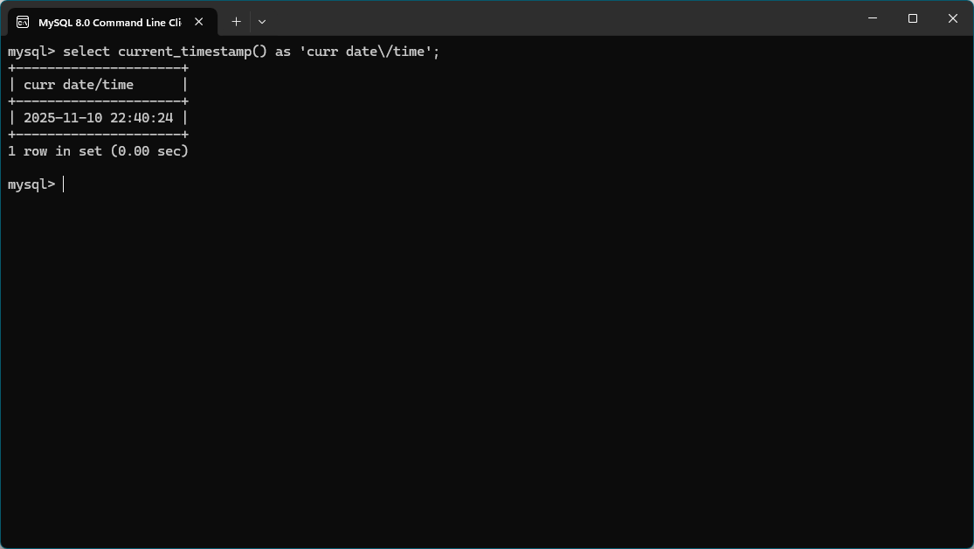

COUNT
- Could be used if you are looking to verify an appropriate amount of records exist given a query. Sticking with the movie example from the last module, maybe you have a table full of movie records and you know there should be 30 with a GENRE of HORROR. You could query to see how many records have the correct value and display the count/total to validate the table is correct.
- From a DB table that holds data on world cities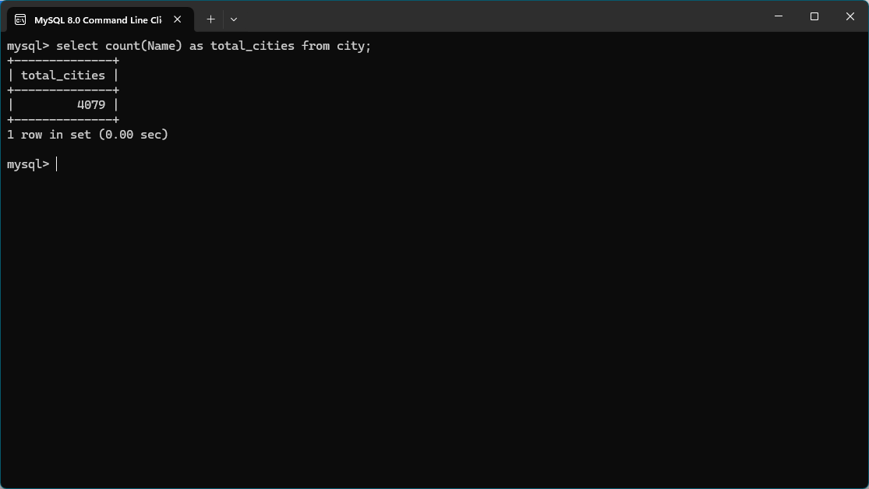

VERSION
- This one is pretty obvious. It returns the version of mySQL you are currently using. If it’s ever a question, use it and you’ll know.
- Using the command to check my version