Are all suppliers delivering on time? Is there a large gap between expected delivery and actual delivery? A month by month report should show problem areas.
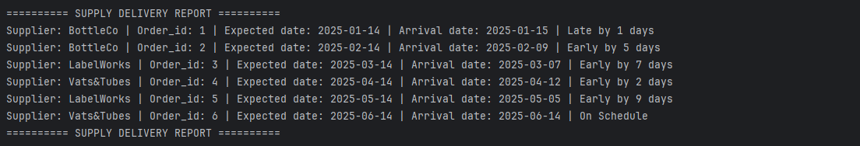

The wine distribution, are all wines selling as they thought? Is one wine not selling? Which distributor carries which wine?
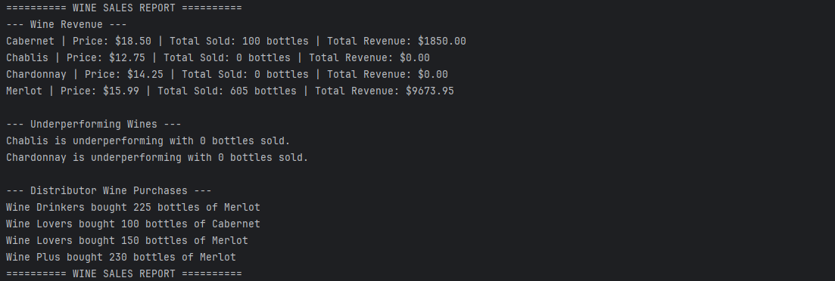
Employee time. During the last four quarters, how many hours did each employee work?
