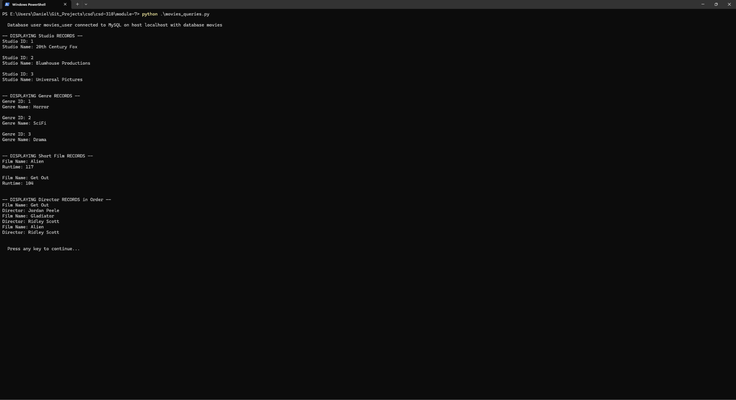

https://github.com/danrojas001/csd-310.git

