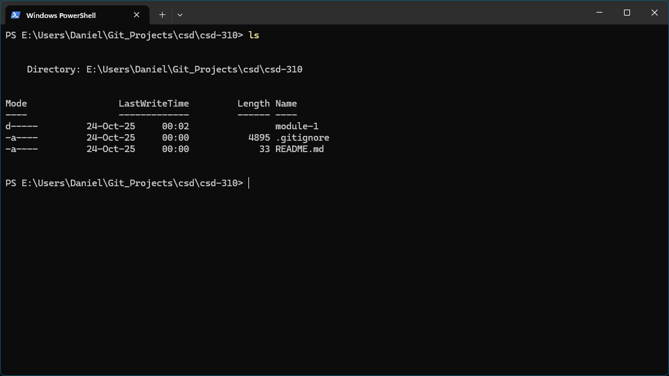

I avoid putting more than I need to in my C: drive so I placed it where I had previous work stored before.