ASTRONAUTS
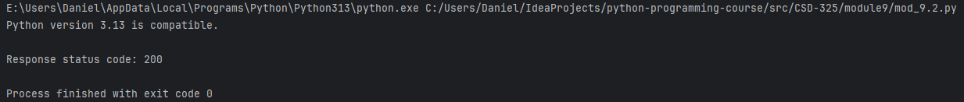

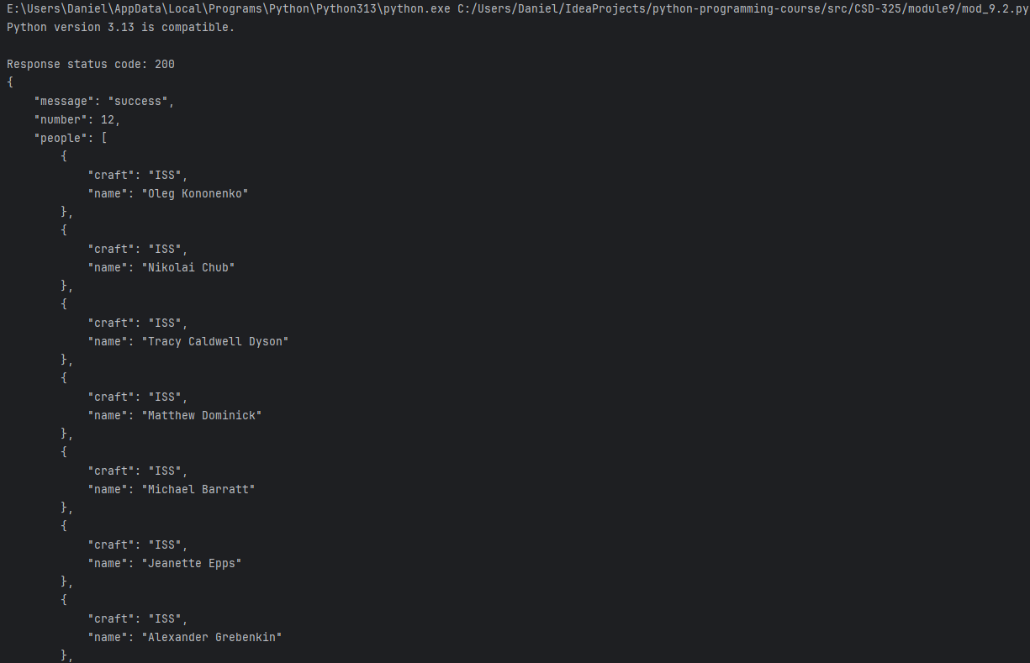
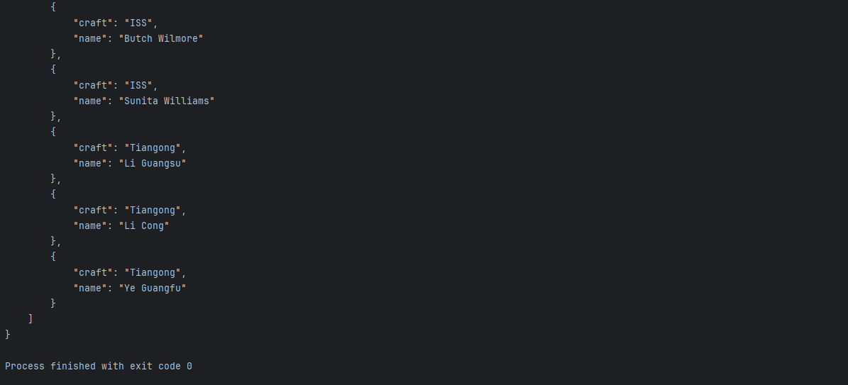
Astronauts output was too long for 1 screen.
ADVICE
