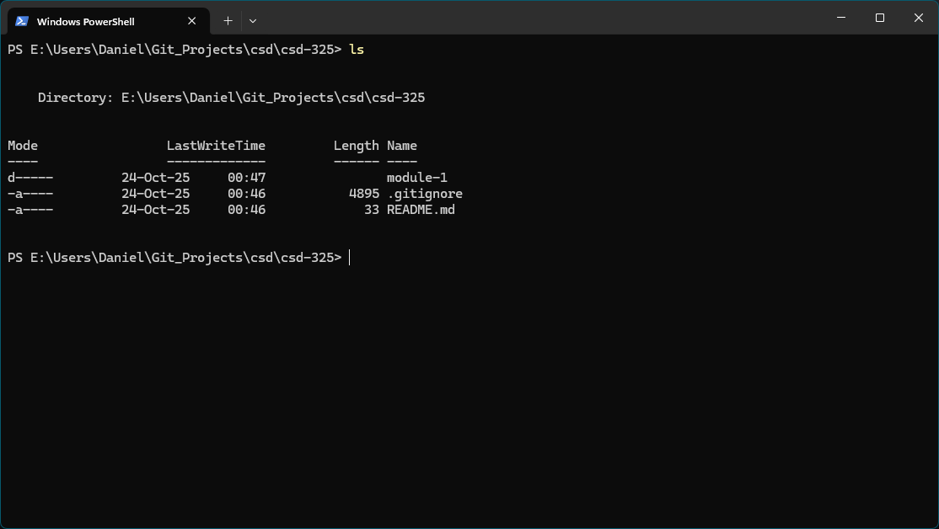

I prefer to limit what is placed in my C: drive so I made my repo on my E: drive.