Created user “student1” with password of “pass” and “csd430” DB via terminal.
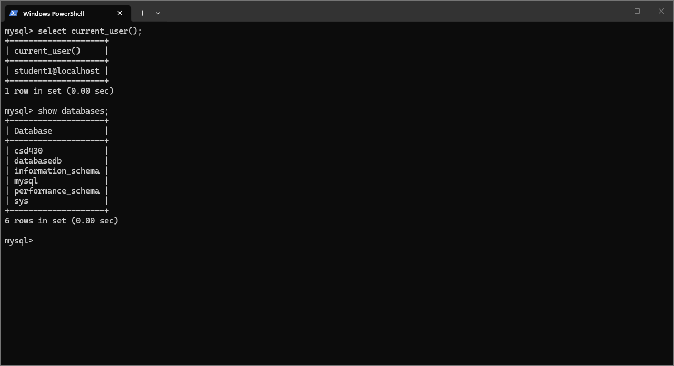

Created and populated “dan_library_data” using java.
Note - There were no instructions for the use of .php files and in mod 5.3/6.3 we are asked to provide the java code for table creation, population, and deletion.
