Please start by saving this file with the name: GUID_Surname_ENG5059P_Prelim_year

Please tick appropriate project:

ENG5059P (MSc) | YES

Student Name | Daniels Vasiljevs
Student GUID Number | 2500414v
Degree programme | Computer Systems Engineering MSc
Working Title of Project | EEG Classification Using Machine Learning
Name of Supervisor(s) | Dr. Aleksandra Vuckovic
Academic year | 2019-2020

Your report should include the below subject headings, should be no more than 4 pages and be incorporated within this document:

Introduction (max 1 page)

The development of a Brain-Computer Interface (BCI) is concerned with establishing a channel of communication in which the user is able to interact with a system through mental effort [1]. By capturing neural activity associated with motor imagery (MI), for instance, such system are capable of functioning independently of the peripheral nervous system [1]. Consequently, a closed feedback loop can be formed in which the system observes, measures, interprets and classifies Event-Related Desynchronisation (ERD) of the Electroencephalogram (EEG) into a series of commands [2]; ERD is characterised by measuring the underlying EEG signal’s power in specific frequency bands [1, 2]. Doing so enables ‘hands-free’ device control of wheelcharis, robotic arms and speech synthesisers, for instance [2, 3]. Moreover, BCI’s are especially useful as assistive and rehabilitative technologies for patients having suffered complete or incomplete spinal cord injuries, respectively [1 - 3]; where rehabilitative BCI systems provide engagement feedback during motor training tasks [1]; whilst assistive technologies essentially substitute limbs – targeting immobalised or ‘locked-in’ users, granting them a greater degree of freedom in the form of device control [3].

In order to utilise BCIs, each user must undergo an offline callebration phase, in which the interface attempts to account for inter-user biosignal variability, and only then can the BCI be used [1]. However, the ability to extract user-specific features – and what features – that yield highey accurate classification models capabile of operating within real-time enviornments remains a challenge [2, 3]. Furthermore, so as to maximise the effectiveness and applicability of such systems, interfaces must consider both uni- and bi-manual motor imagery tasks with a reasonabile degree of accuracy [2]; user experience (UX) is crucial for impared users [3].

This project is concerned with extending the current research and development of supervised machine learning models (and the corresponding feature sets utilised) so as to address the said challenges; essentially maximising the classification rates of uni- and bi-manual MI tasks – enabling models to account for left, right and both hand motor imagination tasks [1]. Moreover, emphasis is placed on maximising transfer learning across patients due to the small datasets available and the amount of time required to populate them [2, 3]. Consequently, the amount of time required users to callebrate the interfave should be greatly reduced. Lastly, attention to processing power is deemed necessary due to the real-time constrains imposed by the operating environment of the interface.

Aims/Objectives of project

The aims of this project are to research, implement and benchmark a Convolutional Neural Network (CNN) classification model capable of discriminating between uni- and bi-manual motor imagery (MI) tasks, for each of the participating subjects; extending the number of limbs that are accounted for [1]. Objectives include:

- Utilising the labelled EEG dataset, appropriately preprocess and filter epochs, generating topology-preserving multi-spectral images [4];

- Utilising the said dataset (and features), train a CNN model to discriminate between three motor imagery classes, namely the imagination of left, right and both hand movements [4];

- Benchmark the newly implemented model against existing implementations utilising the same dataset.

Resources required

The following software and hardware resources are required for the successful fulfullment of the projects primary and secondary aims and objectives:

- Electroencephalogram (EEG) signal data (including epochs obtained from subjects);

- Access to a computer with adequate processing power for machine learning;

- Python 3.7, including the SciPy, NumPy, Pandas, Matplotlib, MNE and SciKit-Learn (or TensorFlow) libraries; and

- Internet access;

GANTT chart

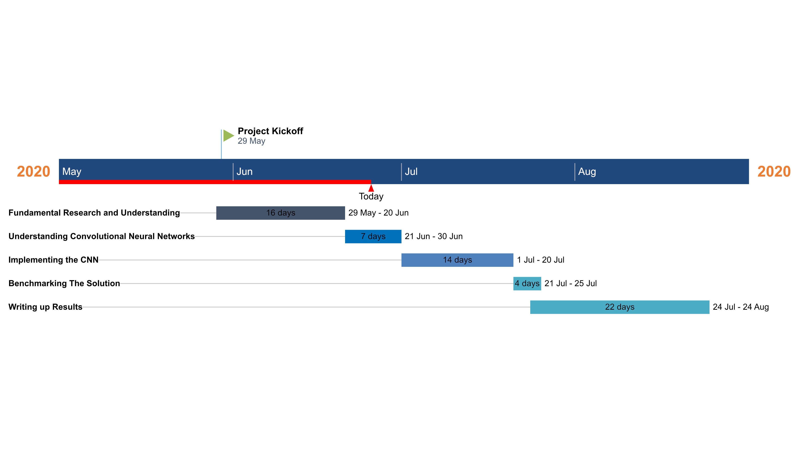

References

[1] C. McGeady, "Second Year Progression Report", Glasgow, 2020.

[2] A. Vuckovic, S. Pangaro and P. Finda, "Unimanual Versus Bimanual Motor Imagery Classifiers for Assistive and Rehabilitative Brain Computer Interfaces", IEEE Transactions on Neural Systems and Rehabilitation Engineering, vol. 26, no. 12, pp. 2407-2415, 2018. Available: 10.1109/tnsre.2018.2877620 [Accessed 20 February 2020].

[3] S. Sreeja, D. Samanta, P. Mitra and M. Sarma, "Motor Imagery EEG Signal Processing and Classification using Machine Learning Approach", Jordanian Journal of Computers and Information Technology, no. 0, p. 80, 2018. Available: 10.5455/jjcit.71-1512555333 [Accessed 23 June 2020].

[4] P. Bashivan, M. Yeasin, I. Rish and N. Codella, "LEARNING REPRESENTATIONS FROM EEG WITH DEEP RECURRENT-CONVOLUTIONAL NEURAL NETWORKS", in ICLR 2016, 2016.

