Phage-host time shift assay in liquid broth

Based on method described by Poullain et al. (2008). The evolution of specificity in evolving and coevolving antagonistic interactions between a bacteria and its phage. *Evolution: International Journal of Organic Evolution*, *62*(1), 1-11.

*Another measure of the performance of phage isolates was obtained by monitoring phage‐imposed reduction in bacterial growth rate (RBG). This assay was performed to obtain phage performance on susceptible bacteria only. Measures were made on 15 arbitrarily selected bacterial colonies of the 24 colonies used in the streaking assay and on the ancestral bacteria. Bacterial colonies were introduced in microtitre plates containing liquid KB medium at 5.8 × 107± 4.47 × 107 per mL, along with 3.44 × 107 phage particles or without phage (control). Absorbance at 630 nm was measured using a spectrophotometer (microplate reader EL 800, Bio‐Tek Instruments Inc., Winooski, VT) at t= 0 and then again after 20 h of static incubation at 28°C. The reduction in bacterial absorbance “RBG” induced by phage i on bacterial colony j, was calculated as RBGij=[abs630(t= 20) − abs630(t= 0)]ij/[abs630(t= 20) − abs630(t= 0)]controlj. Each cross‐infection was performed in triplicate at the same time. Thus only data corresponding to RBGij < 0.95 were considered in the analyses (positive infection). Data are presented as 1 – RBGi for more clarity. At the end of the assay, we detected a significant edge effect of the microtiter plates (see also* [*Oliver et al. 1989*](https://onlinelibrary.wiley.com/doi/full/10.1111/j.1558-5646.2007.00260.x#b44)*;* [*Johnsen et al. 2002*](https://onlinelibrary.wiley.com/doi/full/10.1111/j.1558-5646.2007.00260.x#b32)*). Therefore, the analysis was performed using 20 central clones instead of 24. Note that starting densities of coevolved phage were assessed on the ancestral bacteria. If a trade‐off exists between infectivity range and the probability of infecting the ancestral bacteria, starting phage densities may be underestimated, which in turn will underestimate the cost. This assay was also used to investigate the pattern of specialization in RBG at the population level by averaging the RBGi of evolved and coevolved phage isolates on the coevolved susceptible and ancestral bacteria.*

In the Bacillus system I don’t think we will see much if we grow things without shaking, but we can try.

1. Streak out to colonies
2. Pick colonies and grow in oxygen limitation (overnight)
3. Adjust OD to be the same in all colonies
4. Distribute host in plate
5. Add phage samples
6. Read OD at T0
7. Incubate with/without shaking for ~24hrs
8. Read OD at Tend
9. From a glycerol stock streak out a sample on LB+Cm (5µg/ml) to achieve single colonies. Incubate overnight in 30°C to allow colony growth.

* *Plate for this stage do not require CaCl2 in the medium but it is not a problem to have it in there.*
* *30°C used so colonies remain small and isolated from each other. 37°C can be used for shorter incubation times*
* *Also streak out the ancestor host (WT or ΔspoIIE).*

1. Preparation of cultures to use as inocula for growth rate experiments

Based on Hall et al. (2013, "Growth rates made easy." MBE 31(1):232) method 2.2:

*Rich medium, overnight oxygen-limited cultures. Inoculate 10 ml of rich medium in a tightly sealed 15 ml centrifuge tube. Allow the culture to stand overnight without shaking. The culture density will be limited by the available dissolved oxygen, and as a result, there will be fewer dead cells, and viable cells will be in a physiological state that allows rapid resumption of growth. The result is shorter and more consistent lag times.*

I think this can be downscaled to microcentrifuge tube.

* 1. Distribute 1.2 ml LB +10mM CaCl2 + 5µg/ml chloramphenicol into each of 24 green microtubes.
  2. Pick a single colony into a single tube of media: 20 colonies from the experiment sample, 2 colonies of the ancestor and 2 tubes left as blanks.
  3. Close tubes tightly and incubate overnight at 37°C without shaking

=== Next Day ==

1. Prepare lysates for infection

Currently, we will be challenging a host with phages from the same time point (“*Current*”), from the previous teansfer (“*Past*”) and from the next transfer (“*Future*”).

*Lysates contain chloroform and spores (which are chloroform resistant)*

* 1. Briefly mix lysate by inverting the tube a few times.
  2. Centrifuge 10 min at max speed (~7,000 Xg)
  3. Transfer 270µl lysate sample to microcentrifuge tube

To reduce spores in sample aspirate sample from top of liquid in the tube.

1. Inocula culture dilutions

The goal here is to start all the cultures with similar OD. First, we need to measure the OD of overnight tube cultures: transfer 200µl of each culture into a well of 96-well plate and measure OD600 in Synergy plate reader

* 1. Distribute 1.9 ml LB +10mM CaCl2 + 5µg/ml chloramphenicol into each of 24 2ml microtubes.
  2. Transfer 190µl of each overnight culture tube to a well of 96-well plate
  3. Measure OD600 in Synergy plate reader.
  4. Dilute innocula cultures to OD600=0.1: remove (190/OD) µl from 1.9ml tube and replenish to 1.9ml by adding same volume of overnight culture. For LB only tubes

1. Plate setup

First, diluted bacterial cultures will be distributed to wells and then phages will be added. Two identical plates will be set to compare growth and growth reduction with- vs. without- shaking.

1. For each of the 20 cultures, distribute 190µl/well in 4 wells of each plate (see plate map).
2. To each well add 10µl of phage (from above) or DSM.

|  |  |  |  |  |  |  |  |  |  |  |  |  |  |
| --- | --- | --- | --- | --- | --- | --- | --- | --- | --- | --- | --- | --- | --- |
|  | **1** | **2** | **3** | **4** | **5** | **6** | **7** | **8** | **9** | **10** | **11** | **12** | **Phage** |
| **A** | LB1 | 1 | 2 | 3 | 4 | 5 | 6 | 7 | 8 | 9 | 10 | ANC1 | NO |
| **B** | LB1 | 1 | 2 | 3 | 4 | 5 | 6 | 7 | 8 | 9 | 10 | ANC1 | PAST |
| **C** | LB1 | 1 | 2 | 3 | 4 | 5 | 6 | 7 | 8 | 9 | 10 | ANC1 | CURRENT |
| **D** | LB1 | 1 | 2 | 3 | 4 | 5 | 6 | 7 | 8 | 9 | 10 | ANC1 | FUTURE |
| **E** | LB2 | 11 | 12 | 13 | 14 | 15 | 16 | 17 | 18 | 19 | 20 | ANC2 | NO |
| **F** | LB2 | 11 | 12 | 13 | 14 | 15 | 16 | 17 | 18 | 19 | 20 | ANC2 | PAST |
| **G** | LB2 | 11 | 12 | 13 | 14 | 15 | 16 | 17 | 18 | 19 | 20 | ANC2 | CURRENT |
| **H** | LB2 | 11 | 12 | 13 | 14 | 15 | 16 | 17 | 18 | 19 | 20 | ANC2 | FUTURE |

1. For static plate:
   1. Read OD600 in synergy 2 (T0)
   2. Place plate in 37°C incubator
2. For shaken plate:
   1. Read OD600 in synergy 2 (37°C, 1200RPM continuous shaking, every 5min, 22hr)
3. Read OD600 of static plate in synergy 2 (Tend)

Follow up

Here is the data from the shaken plate.

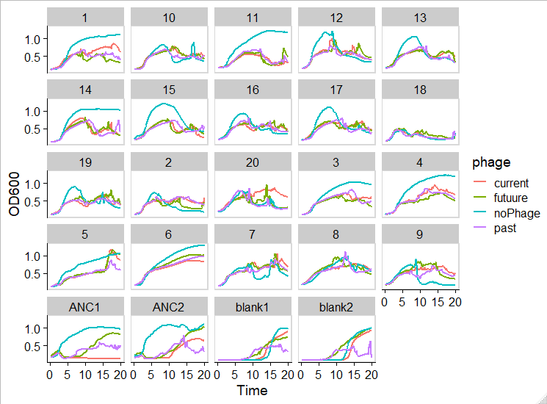

Incubation for ~20hrs is too long for the static plates

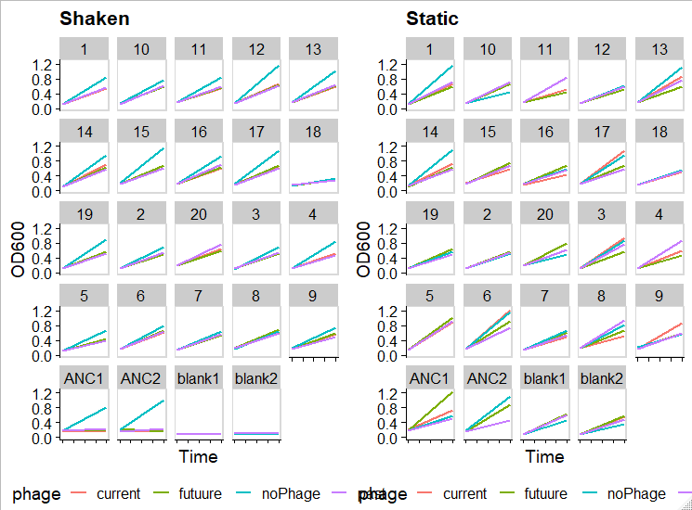

1. Pick colonies and grow overnight in closed tubes (10ml in 15ml tube)
2. Dilute to OD 0.1 as previously but in
3. Distribute 10µl phage* or DSM per well (touch tip to one side of well)

*use ancestral phage diluted x100 in DSM

1. Add 190µl host (touch tip to other side of well)
2. Read OD at t=0
3. Incubate plate at 37°C
4. Read OD at t=4,6,8 hours post infection

|  |  |  |  |  |  |  |  |  |  |  |  |  |  |
| --- | --- | --- | --- | --- | --- | --- | --- | --- | --- | --- | --- | --- | --- |
|  | **1** | **2** | **3** | **4** | **5** | **6** | **7** | **8** | **9** | **10** | **11** | **12** |  |
| **A** | ANC1 | ANC1 | ANC1 | ANC1 | ANC1 | LB | LB | ANC2 | ANC2 | ANC2 | ANC2 | ANC2 | **DSM** |
| **B** | ANC1 | ANC1 | ANC1 | ANC1 | ANC1 | LB | LB | ANC2 | ANC2 | ANC2 | ANC2 | ANC2 | **DSM** |
| **C** | ANC1 | ANC1 | ANC1 | ANC1 | ANC1 | LB | LB | ANC2 | ANC2 | ANC2 | ANC2 | ANC2 | **phage** |
| **D** | ANC1 | ANC1 | ANC1 | ANC1 | ANC1 | LB | LB | ANC2 | ANC2 | ANC2 | ANC2 | ANC2 | **phage** |
| **E** | ANC1 | ANC1 | ANC1 | ANC1 | ANC1 | LB | LB | ANC2 | ANC2 | ANC2 | ANC2 | ANC2 | **DSM** |
| **F** | ANC1 | ANC1 | ANC1 | ANC1 | ANC1 | LB | LB | ANC2 | ANC2 | ANC2 | ANC2 | ANC2 | **DSM** |
| **G** | ANC1 | ANC1 | ANC1 | ANC1 | ANC1 | LB | LB | ANC2 | ANC2 | ANC2 | ANC2 | ANC2 | **phage** |
| **H** | ANC1 | ANC1 | ANC1 | ANC1 | ANC1 | LB | LB | ANC2 | ANC2 | ANC2 | ANC2 | ANC2 | **phage** |