NDAS System Component Merge Module

Version: 3.11.1310a
Release Date: July 4, 2005

Chesong Lee cslee@ximeta.com

NDAS System Components are provided as Windows Installer merge modules. Those are used for integrating existing software with NDAS System Components including NDAS service, NDAS API DLL files and NDAS device drivers. This documents describes how to use these merge modules.

3.11.1310a fixes bugs of 3.11.1310 when the setup should update existing NDAS device drivers. Please discard 3.11.1310 and use 3.11.1310a.

Release Files
The merge modules are separated into the core module and user interface text modules. The Action module contains the NDAS device drivers, DLL files and all custom actions required for the setup. UI Text modules contain localized “Error” and “ActionText” tables referenced in the action module.
- Core Merge Module
ndas-3.11.1310a-syscomp-x86.msm
- UI Text Merge Modules
ndas-3.11.1310a-syscompui-enu-x86.msm
ndas-3.11.1310a-syscompui-jpn-x86.msm
You can choose one of the language module for your setup. For multi-language supports, you need to merge each language MSM for each localized MSI file. Windows Installer database does not support multiple languages in a single MSI file. InstallShield makes use of proprietary techniques to support multiple languages. For this case, you have to merge only core modules and manually enter rows in Error and ActionText.

Dependencies
NDAS System Component merge module depends on the following merge modules. Usually, MSM merge application will detect dependencies and will merge them also. Make sure that these are available to your merge program.
- Microsoft C++ Runtime Library 6.0
MSVCRT.51D569E0_8A28_11D2_B962_006097C4DE24
- Microsoft C Runtime Library 6.0
MSVCP60.51D569E3_8A28_11D2_B962_006097C4DE24

Configuration Variables
Core merge module contains configurable variables. When merging modules set the appropriate values.

NdasMsmRedistDirParent | NDAS System Component Directory
NdasMsmRedistDirParent | This specifies the directory for NDAS service and API DLL binaries. Use the directory identifier for the main application directory. For InstallShield Project use INSTALLDIR.
NdasMsmDriverDirParent | NDAS Drivers Parent Directory
NdasMsmDriverDirParent | This specifies the parent directory of the driver source directory. Default Value will copy driver source files under “NdasMsmRedistDirParent” directory.
NdasMsmDriverDirName | NDAS Drivers Directory Name
NdasMsmDriverDirName | This specifies the name of the driver source directory. Default value is “DRIVERS:Drivers”. It is DefaultDir type and its format is [target_shortname]|[target_longname]:[sourcename].  Refer Windows Installer SDK documentation for the formatting details.

Default Configuration will install NDAS DLL files into INSTALLDIR and NDAS device driver source files into INSTALLDIR\DRIVERS.

Using Merge Modules

Multiple NDAS software
It is not possible to install multiple NDAS system components in user’s system. When multiple software are installed, the software that is installed later will overwrite device drivers. For this reason, it is recommended not to install the software over any existing NDAS software. Existing software can be detected by the following ways.

Upgrade Code

UPGRADECODE: {E86E86BB-051E-4F19-B111-0E5D15E7CDE4}

Current NDAS Software is using this upgrade code. Use “Upgrade” Table to detect existing products and make sure that not to overwrite over the newer version of this merge module version.

Registry Detection
Also the merge module integrate “Registry Search” table to find existing version of the software. When any NDAS system components are installed following registry values are created:

Key: HKEY_LOCAL_MACHINE\Software\NDAS\Install
Value Name: ProductVersion
Value: [Version of the installed NDAS software or system component]

Key: HKEY_LOCAL_MACHINE\Software\NDAS\Install
Value Name: ProductReleaseTag
Value: NDASSCSMS (for the merge module)

Registry Locator will detect these registry values and for each value, NDAS_INSTALLED_REG_VER and NDAS_INSTALLED_REG_TAG properties will be set as value of registry values. This method is used for detecting other software using NDAS system components. It is recommended to show a warning dialog to delete existing NDAS-related software first before installing the software.
- Using InstallShield IDE for MSI Project
This section shows the process of using merge modules in InstallShield MSI Project IDE.
- Set the merge modules directory from Tools – Options or copy NDAS merge module files into predefined merge modules directory. (Figure 1)
- Go to “Installation Designer Tab” – Application Data – Redistributables
(Figure 2)
- From the InstallShield Objects/Merge Modules, select “NDAS System Component Merge Module 3.11.1310”
- After selecting the module, you will see Merge Module Properties dialog.
- From the dialog, change configurable values as needed. (Figure 3)
- Select one of UI Text merge modules from “NDAS System Component UI Merge Module 3.11.1310 (Language)”.

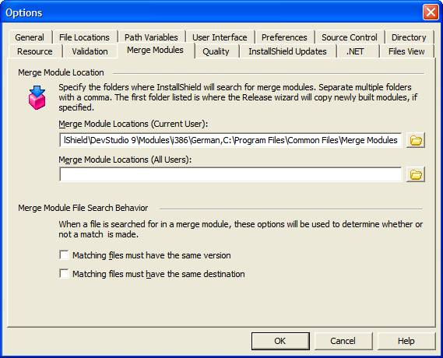
Figure 1 Merge Modules Directory Configuration for InstallShield IDE
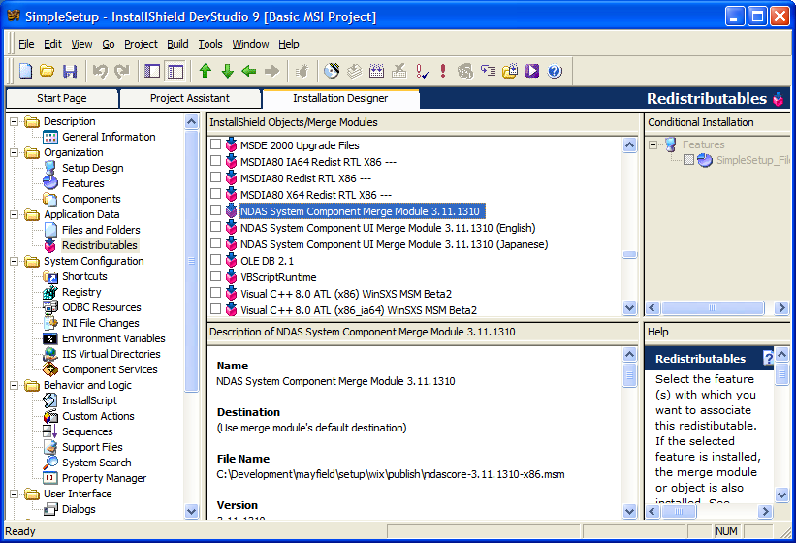
Figure 2 Selecting merge modules from InstallShield IDE

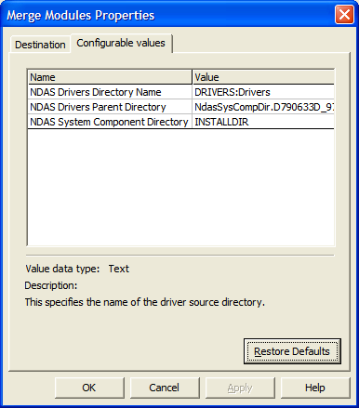
Figure 3 Change Merge Modules Properties

- Error and ActionText Tables
InstallShield may not support Merge Module Database Codepage other than 1252. In such case, you have to manually fill out the following tables with Direct Editor.

Table 1 Japanese ActionText Table
Action | Description | Template
NcRemove_NDASSCSI_INF_XC.D790633D_974B_4B0F_A30A_2D4CE2B4F532 | Driver INFの削除中...
NcRemove_NDASBUS_INF_XC.D790633D_974B_4B0F_A30A_2D4CE2B4F532 | Driver INFの削除中...
NcRemove_LPX_INF_XC.D790633D_974B_4B0F_A30A_2D4CE2B4F532 | Driver INFの削除中...
NcRemove_AllOemInf_XC.D790633D_974B_4B0F_A30A_2D4CE2B4F532 | Driver INFの削除中...
NcSetARFlags_XC.D790633D_974B_4B0F_A30A_2D4CE2B4F532 | Setting NDAS AR Configurations...
NcSetECFlags_XC.D790633D_974B_4B0F_A30A_2D4CE2B4F532 | Setting NDAS EC Configurations..
NcRemove_NDASSCSI_XC.D790633D_974B_4B0F_A30A_2D4CE2B4F532 | NDAS SCSIドライバの削除中...
NcRemove_NDASBUS_XC.D790633D_974B_4B0F_A30A_2D4CE2B4F532 | NDASバースドライバの削除中...
NcRemove_ROFILT_XC.D790633D_974B_4B0F_A30A_2D4CE2B4F532 | ROFILTドライバの削除中...
NcRemove_LFSFILT_XC.D790633D_974B_4B0F_A30A_2D4CE2B4F532 | LFSドライバの削除中...
NcRemove_LPX_XC.D790633D_974B_4B0F_A30A_2D4CE2B4F532 | LPX Protocolの削除中...
NcPreRemove_LANSCSIMP_XC.D790633D_974B_4B0F_A30A_2D4CE2B4F532 | 既存のドライバの検査と削除...
NcPreRemove_LANSCSIBUS_XC.D790633D_974B_4B0F_A30A_2D4CE2B4F532 | 既存のドライバの検査と削除...
NcCheckPreboot_LFSFILT_XC.D790633D_974B_4B0F_A30A_2D4CE2B4F532 | 既存のドライバの検査と削除...
NcCheckPreboot_LPX_XC.D790633D_974B_4B0F_A30A_2D4CE2B4F532 | 既存のドライバの検査と削除...
NcCheckPreboot_NDASBUS_XC.D790633D_974B_4B0F_A30A_2D4CE2B4F532 | 既存のドライバの検査と削除...
NcCheckPreboot_NDASSCSI_XC.D790633D_974B_4B0F_A30A_2D4CE2B4F532 | 既存のドライバの検査と削除...
NcCheckPreboot_NDASSVC_XC.D790633D_974B_4B0F_A30A_2D4CE2B4F532 | 既存のドライバの検査と削除...
NcCheckPreboot_ROFILT_XC.D790633D_974B_4B0F_A30A_2D4CE2B4F532 | 既存のドライバの検査と削除...
NcRBack_Remove_LFSFILT_XC.D790633D_974B_4B0F_A30A_2D4CE2B4F532 | LFSドライバの削除中...
NcRBack_Remove_NDASBUS_XC.D790633D_974B_4B0F_A30A_2D4CE2B4F532 | NDASバースドライバの削除中...
NcRBack_Remove_LPX_XC.D790633D_974B_4B0F_A30A_2D4CE2B4F532 | LPX Protocolの削除中..
NcRBackRem_NDASSCSI_INF_XC.D790633D_974B_4B0F_A30A_2D4CE2B4F532 | Driver INFの削除中...
NcRBackRem_NDASBUS_INF_XC.D790633D_974B_4B0F_A30A_2D4CE2B4F532 | Driver INFの削除中...
NcRBackRem_LPX_INF_XC.D790633D_974B_4B0F_A30A_2D4CE2B4F532 | Driver INFの削除中...
NcInstall_LPX_XC.D790633D_974B_4B0F_A30A_2D4CE2B4F532 | LPX Protocolのインストール中...
NcInstall_NDASBUS_XC.D790633D_974B_4B0F_A30A_2D4CE2B4F532 | NDASバースドライバのインストール中...
NcInstall_LFSFILT_XC.D790633D_974B_4B0F_A30A_2D4CE2B4F532 | LFSドライバのインストール中...
NcInstall_ROFILT_XC.D790633D_974B_4B0F_A30A_2D4CE2B4F532 | ROFILTドライバのインストール中...
NcInstall_NDASSCSI_INF_XC.D790633D_974B_4B0F_A30A_2D4CE2B4F532 | NDAS SCSIドライバのインストール中...
NcSetNdasSvcAutoStart_XC.D790633D_974B_4B0F_A30A_2D4CE2B4F532 | Setting NDAS Service configurations...
NcStartNDASSVCOnNoReboot_XC.D790633D_974B_4B0F_A30A_2D4CE2B4F532 | サービスを開始しています | サービス : [1]

Table 2 Japanese Error Table
Error | Message
28801 | LPX Protocolインストールに失敗しました。[4]エラー:[2]。[4][3]
28802 | NDASバスドライバのインストールに失敗しました。[4]エラー:[2]。[4][3]
28803 | NDAS SCSIコントローラーのデバイスドライバのインストールに失敗しました。[4]エラー:[2]。[4][3]"Digial Signature Warning Dialog"のダイアログで"いいえ"をクリックした場合には"はい"か"次へ"をクリックしてインストールを続けて下さい。
28804 | LFSドライバのインストールに失敗しました。[4]エラー:[2]。[4][3]
28805 | ROFILTドライバのインストールに失敗しました。[4]エラー:[2]。[4][3]
28806 | LPXプロトコルの削除に失敗しました。[4]エラー:[2]。[4][3]
28807 | NDAS Busデバイスの削除に失敗しました。[4]エラー:[2]。[4][3]
28808 | NDAS SCSI コントローラーの削除に失敗しました。[4]エラー:[2]。[4][3]
28809 | LFSドライバーの削除に失敗しました。[4]エラー:[2]。[4][3]
28810 | ROFILTドライバーの削除に失敗しました。[4]エラー:[2]。[4][3]
28811 | LANSCSIバスの削除に失敗しました。[4]エラー:[2]。[4][3]
28812 | LANSCSIコントローラーの削除に失敗しました。[4]エラー:[2]。[4][3]
28813 | ドライバーインフォメーションファイルの削除に失敗しました。[4]エラー:[2]。[4][3]
28814 | インストールを続ける前に、既存のインストーラーを削除するためシステムの再起動を行います。この時点ではセットアップは終了していません。セットアップを続けるためには再起動して、再びセットアップをを行うことが必要です。システムを再起動しますか？
28815 | 有効なNDASドライバがあります。[4]インストーラを続けるためにはまず、有効なNDASドライバを全部無効にしてください。
28816 | マウントされているNDASドライバがあります。[4]インストールを続けるためにはまず、NDASドライバを全部アンマウントしてください。

