Phonon DOS Calculation Using Quantum Espresso with VNF

Author: Alex Dementsov
Date: January 26, 2010

Introduction

In this short tutorial I will show the main steps of the workflow to calculate phonon DOS using Quantum Espresso with VNF.

Create New Simulation

There are two ways to create a new simulation. The first way is to go to the “Simulations” section, click on the “New” green cross like button.

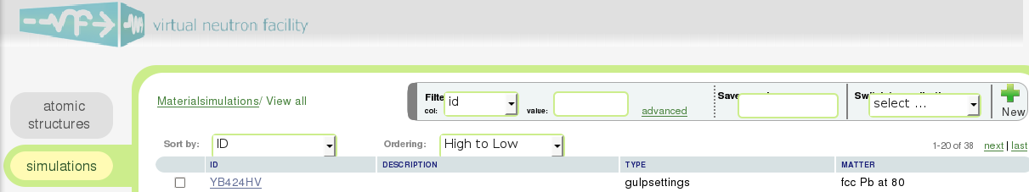
Fig. 1 Material simulations table
Here it is :)

Table of simulation packages will be displayed with short description. You will need to click on the “Quantum Espresso” link.

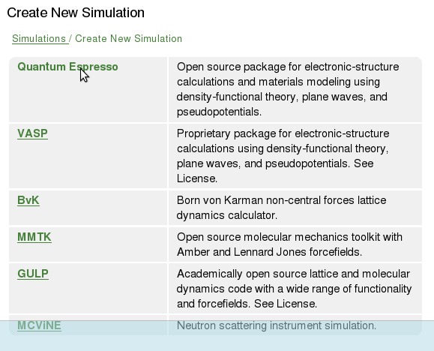
Fig. 2 Simulation packages supported by VNF
The “Create New Simulation” page will be displayed. You can first select the atomic structure.
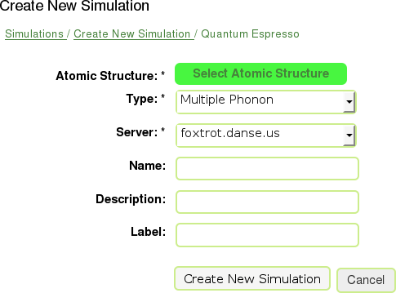
Fig. 3 Select atomic structure

You can select the atomic structure from the list or create a new one from the “Atomic Structure” section.

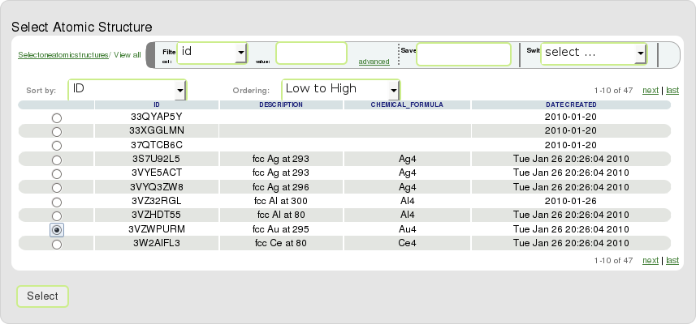
Fig. 4 List of atomic structures to select from

Currently several types of Quantum Espresso simulations are supported which include:
- Total Energy
- Electron DOS
- Electron Dispersion
- Geometry Optimization
- Single Phonon
- Multiple Phonon

This tutorial covers only “Multiple Phonon” simulations. You then need to select the server on which to run the simulation. The star (*) sign specifies the required fields. Once you set the required fields, click on “Create New Simulation” button.

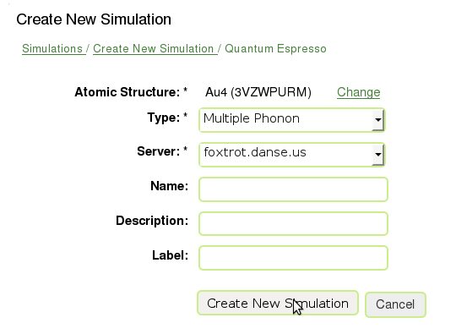
Fig. 5 Create new simulation

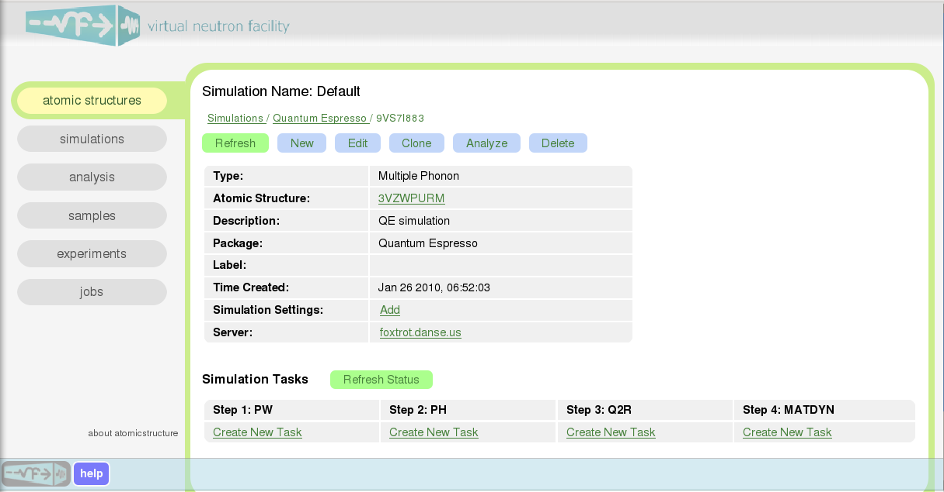
Fig. 6 Simulation view page
The Multiple Phonon simulation in Quantum Espresso consists of four steps:
Step 1. PW
Self consistent calculation of electron density. Outputs are wave functions

Step 2. PH
Phonon calculation from linear response, with output on a rough grid

Step 3. Q2R
Fourier transform to real space and obtain force constants by interpolation

Step 4. MATDYN
Calculation of all phonons from dynamical matrix, given the force constants

From the simulation view page you can also see atomic structure of the simulation by clicking on the structure id in the “Atomic Structure” field.

The second way to create the new simulation is to go to “Atomic Structures” section on the main panel and choose the atomic structure.

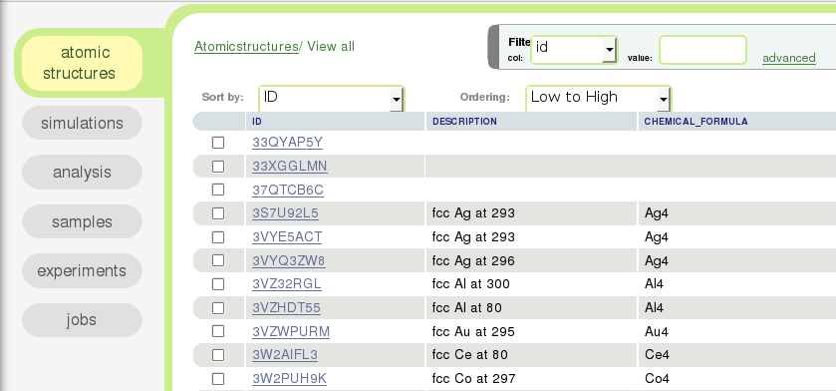
Fig. 7 Choose atomic structure for the simulation

Then go to “Phonons” subsection and in the bottom click on the link Start a new phonon computation.

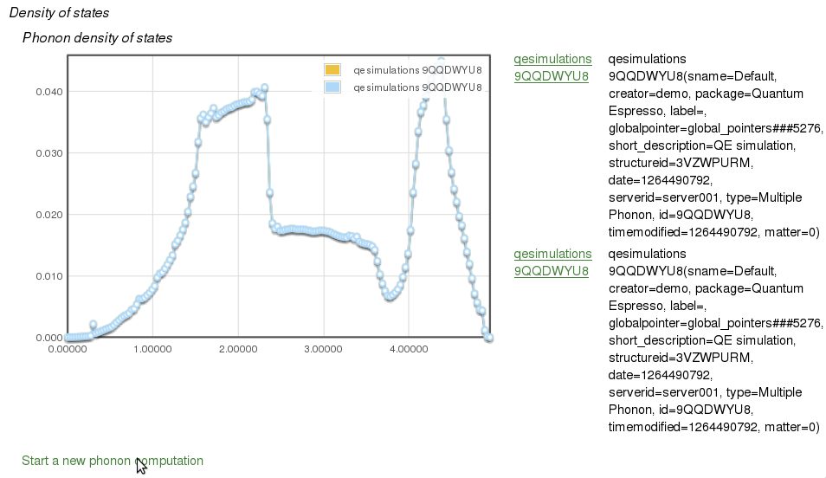
Fig. 8 Start a new phonon computation

The page will be displayed where you can select computation engine to calculate phonon DOS or phonon dispersion.

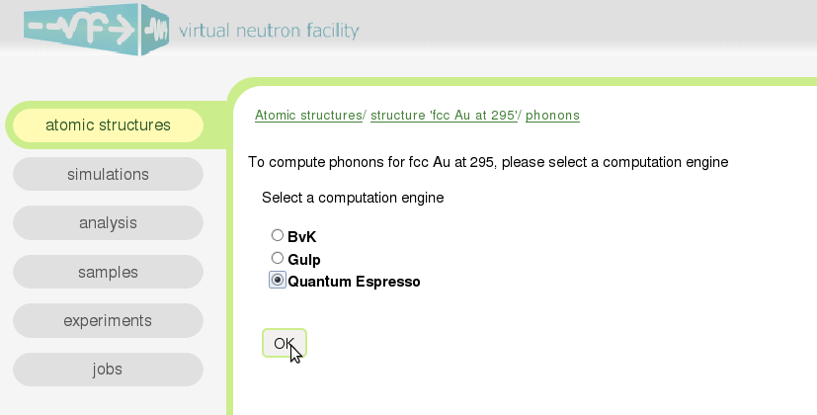
Fig. 9 Select a computation engine

Create Settings Configuration

To set the simulation environment on the simulation view page click on Add link for “Simulation Settings”. You can choose the number of processors.

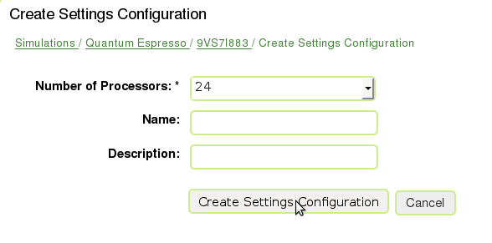
Fig 10 Create Settings Configuration page

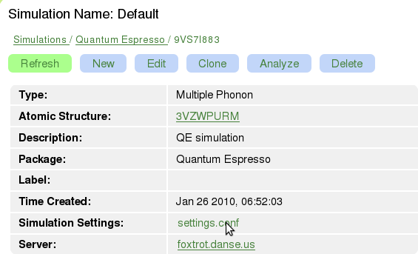
Fig. 11 Simulation Settings is created

If you want to change the number of processors or delete the configuration, you can go to the Settings Configuration page and click on “Edit” or “Delete” button.

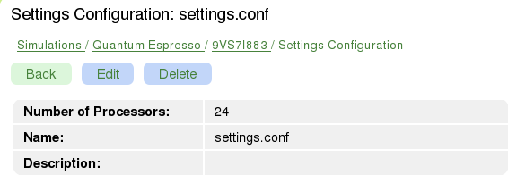
Fig. 12 Settings Configuration view

Create Simulation Tasks

Each simulation in Quantum Espresso consists of a sequence, or chain, of simulation tasks. The subsequent task depends on the results of the previous task. In most cases you will need to run PW task first, and then run other tasks depending on the purpose of your simulation. To create the new simulation task, click on Create New Task link in “Simulation Tasks” subsection.

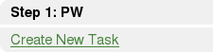
Fig. 13 Create New Task field

Each task is required to have one configuration input. To set the input for the task click on Add link.

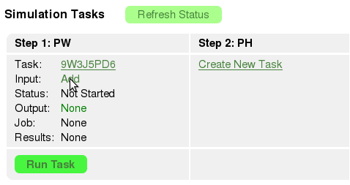
Fig. 14 Add PW configuration input

Notes:
In the future, users will be able to change the simulation task to a different one to make use of existing task results (that might have taken several weeks to run).

When you click on the link, the form for PW input is displayed

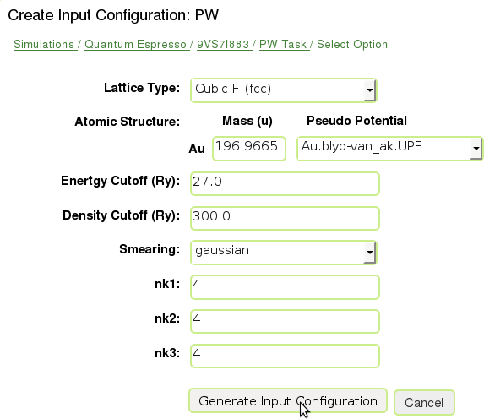
Fig. 15 PW input form

In the PW input form all of the fields are required. The values for the fields are extracted automatically from the atomic structure. Other parameters are specific to the simulation. Default values are good enough for many cases and give you the idea of the parameters. When you click on “Generate Input Configuration”, the configuration form is displayed. The parameters in the configuration are generated from the PW input form and you can edit them if you are familiar with Quantum Espresso. This text is the actual configuration input that will be used in the simulation. Feel free to copy and paste text that you want to use for the PW configuration, there are no further bindings of the atomic structure to the configuration input.

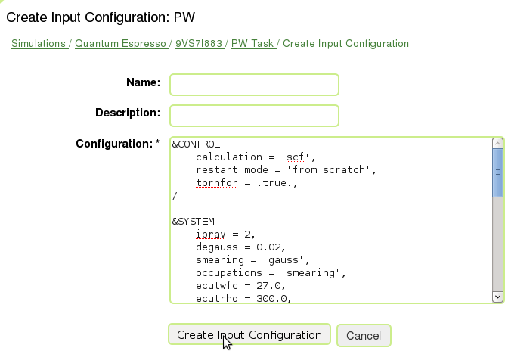
Fig. 16 PW configuration input form

When the configuration input is created you can always edit it or delete.

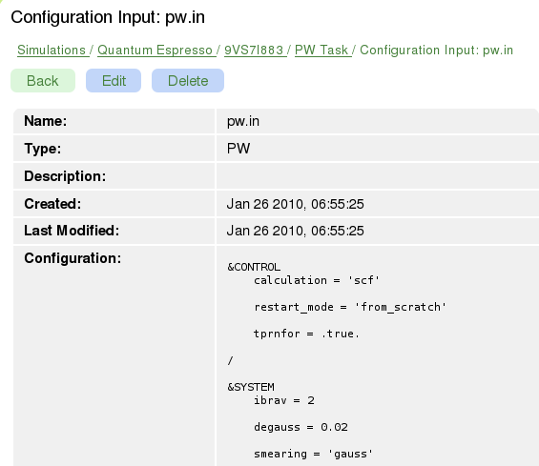
Fig. 17 Configuration input view

Running Simulation Task

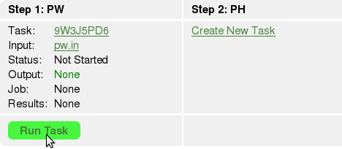
Fig. 18 PW configuration input is created. Ready to run the task!

Now we are ready to run the task. All you need to do is just to click on the “Run Task” button to submit the simulation to the specified cluster. In our example it is foxtrot.danse.us. During this process the job will be created, so the configuration and other supporting files will be transferred to the computing cluster. The job will be submitted to the jobs queue (e.g. Torque), if your cluster supports it, or run directly on the cluster without submitting to any queue.

You can run multiple jobs for one task. It is important to have this feature because sometimes jobs fail for a variety of reasons. When the job fails, you can check if the configuration file is correct or it is set too many processors and too few K-points which will affect the parallelization of the problem. To see what's wrong, just retrieve results and see the output and log files. To see all jobs, click on the link All Jobs

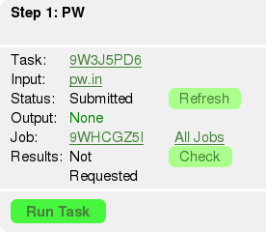
Fig. 19 Job is submitted, results are not requested yet

Retrieving Results

When the simulation job is completed it is nice to get the results of the simulation :). To retrieve the results, just click on the button “Check”. The status of the results packing will be displayed

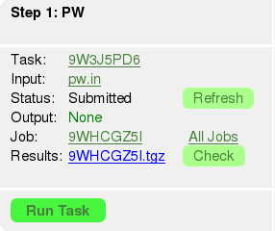
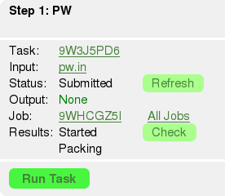
Fig. 20 Retrieving simulation results

Here is the content of the results tar ball:

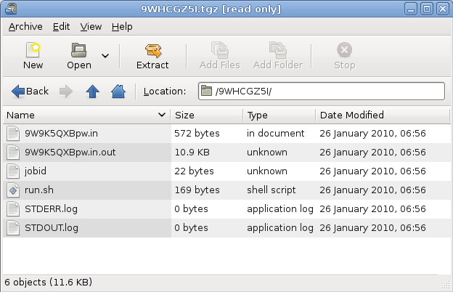
Fig. 21 PW results tar ball

To avoid the results delivery failure you can try to retrieve results again from the computational cluster after 3 min. This feature is implemented to give some time for the results to be delivered or in case if the delivery failed.
Running the PH Task

Once the PW task is successfully completed you can create PH task and set configuration input for it.
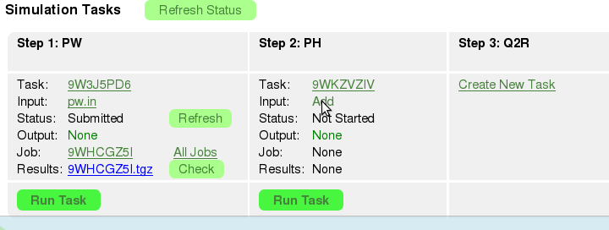
Fig. 22 Add PH configuration input

The form will be displayed where you can set the size of Q grid. All parameters in this form are required.

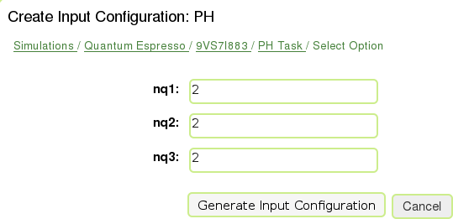
Fig. 23 PH configuration input form

When you click on “Generate Input Configuration” the configuration form is displayed. As for PW input you can edited the configuration text.

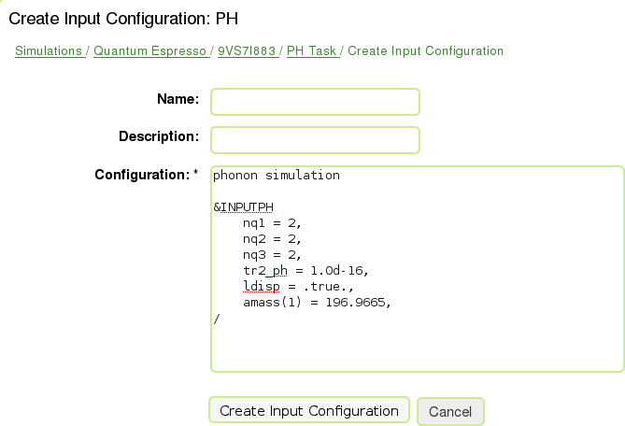
Fig. 24 PH configuration input form

When the input is created we are ready to run task

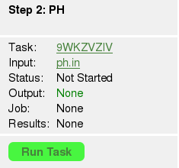
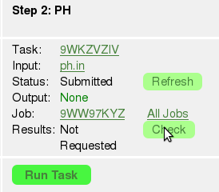
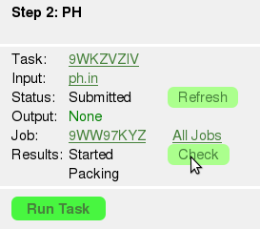
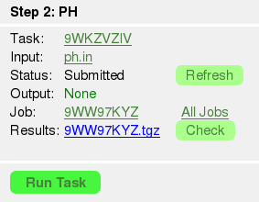
Fig. 24 Running PH task and retrieving results

When the job is completed you can request the results (see section “Retrieving Results”). The results will be packed in tarball and you can see its content:
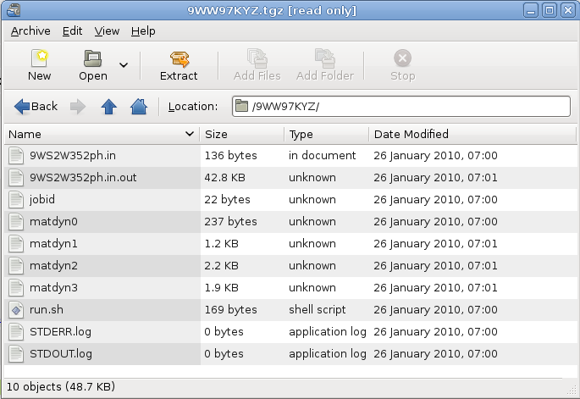
Fig. 25 PH results tar ball

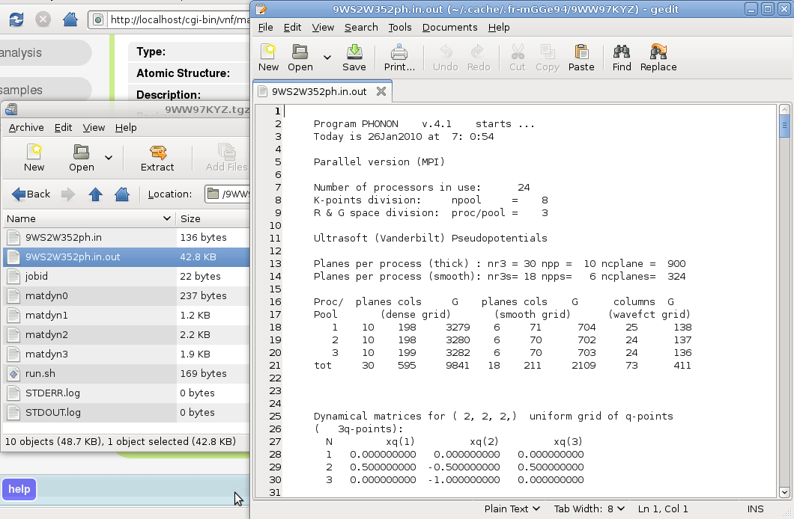
Fig. 26 PH output file

Running the Q2R Task

Once the PH task is successfully completed, you can create a Q2R task and set the configuration input for it. Q2R and MATDYN tasks are postprocessing tasks
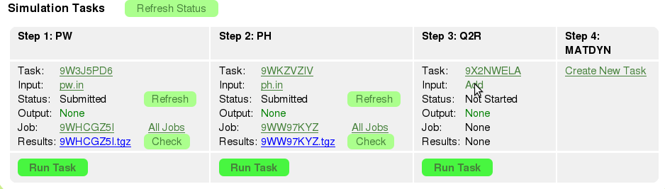
Fig. 27 Add Q2R configuration input

The form will be displayed where you can set acoustic sum rules. This parameter will be different for metals and dielectrics.

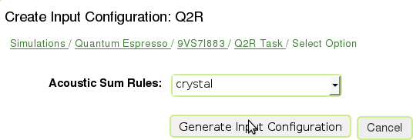
Fig. 28 Q2R configuration input form

When you click on “Generate Input Configuration” the configuration form is displayed and you can edited the configuration text.

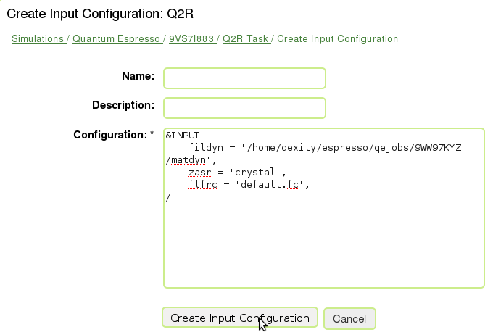
Fig. 29 Q2R configuration input form

When the input is created we are ready to run task

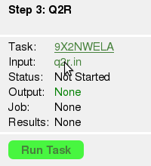
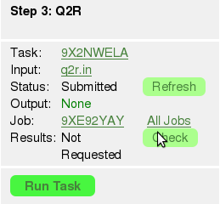
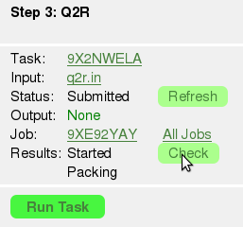
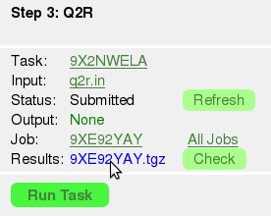
Fig. 30 Running Q2R task and retrieving results

When the job is completed you can request the results. The results will be packed in tarball and you can see its content:

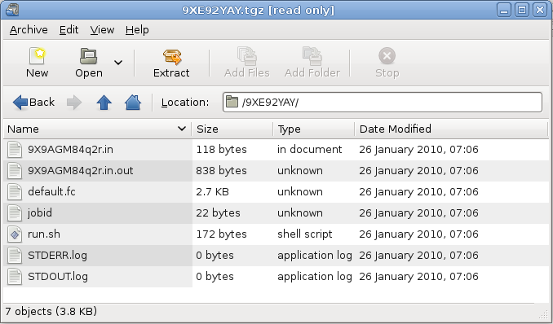
Fig. 31 Q2R results tar ball.

Force constants file (default.fc) will be used by the MATDYN task to create the phonon DOS, so make sure that it is present in the results.
Running the MATDYN Task

Once the Q2R task is successfully completed, and has created a force constants file default.fc you can create a MATDYN task and set the configuration input for it.

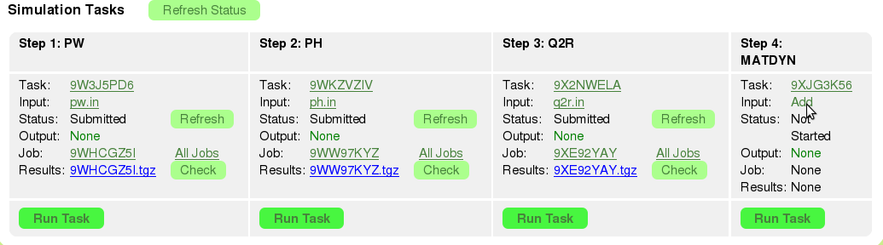
Fig. 32 Add MATDYN configuration input

Here you can have two options:
- Phonon Density of States (DOS)
- Phonons on Grid
For purpose of this tutorial we will pick the “Phonon Density of States”.

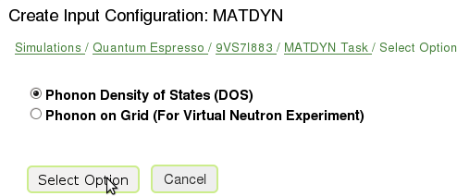
Fig. 33 Phonon Density of States

The form will be displayed where you can set size of the uniform Q-point grid.

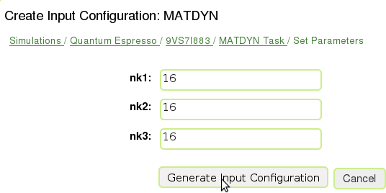
Fig. 34 MATDYN configuration input form for setting Q-point grid
When you click on “Generate Input Configuration” the configuration form is displayed and you can edited the configuration text.

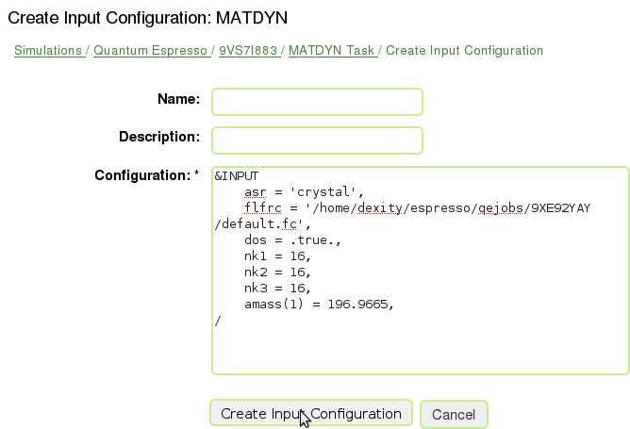
Fig. 35 MATDYN configuration input form

When the input is created we are ready to run task

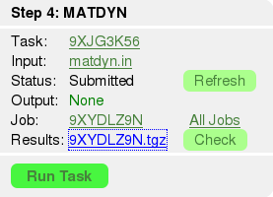
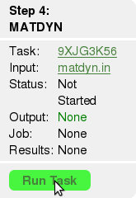
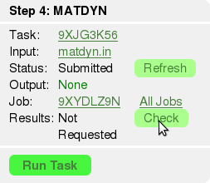
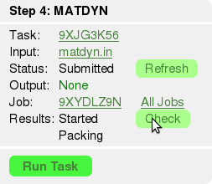
Fig. 36 Running MATDYN task and retrieving results

When the job is completed you can request the results. The results will be packed in tarball and you can see its content:

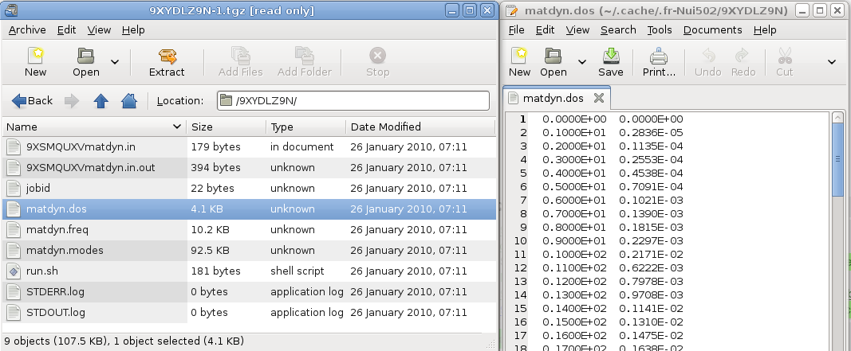
Fig. 37 MATDYN results tar ball with phonon DOS file (matdyn.dos).

At this point we received phonon DOS (matdyn.dos) that can later be used to draw a plot.

Results Analysis

For analysis of the results, we implemented a basic interface that allows you to display relevant information for the simulation. The alternative way will be to get the results tarballs retrieved for each of the tasks and use your favorite tools to analyze data. To do our results analysis of simulation, click on “Analyze” button.

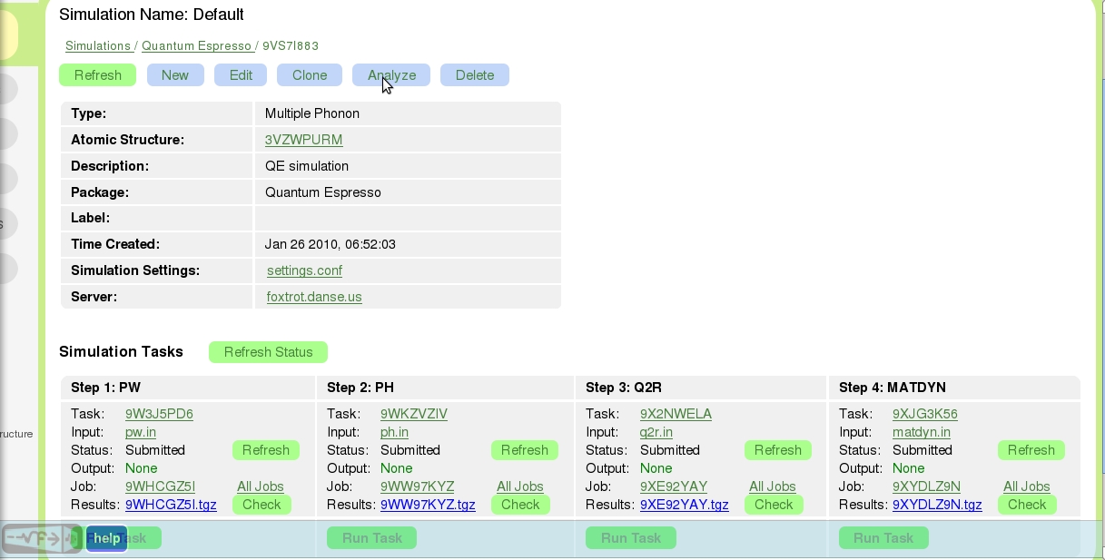
Fig. 38 Simulation view after all of the tasks are completed. Time to analyze results!

The Results panel will displayed that consists of two parts:
- Electron System
- Phonon System

Electron-phonon calculation is not supported on VNF at this time. On the results panel we can see the “Phonon DOS” plot that we have generated data for recently. To see the phonon DOS on the atomic structures page, you need to create the phonon DOS explicitly on the results page by clicking on “Create Phonon DOS” button. Clicking this button will convert matdyn.dos to IDS (Inelastic Data Storage) format.
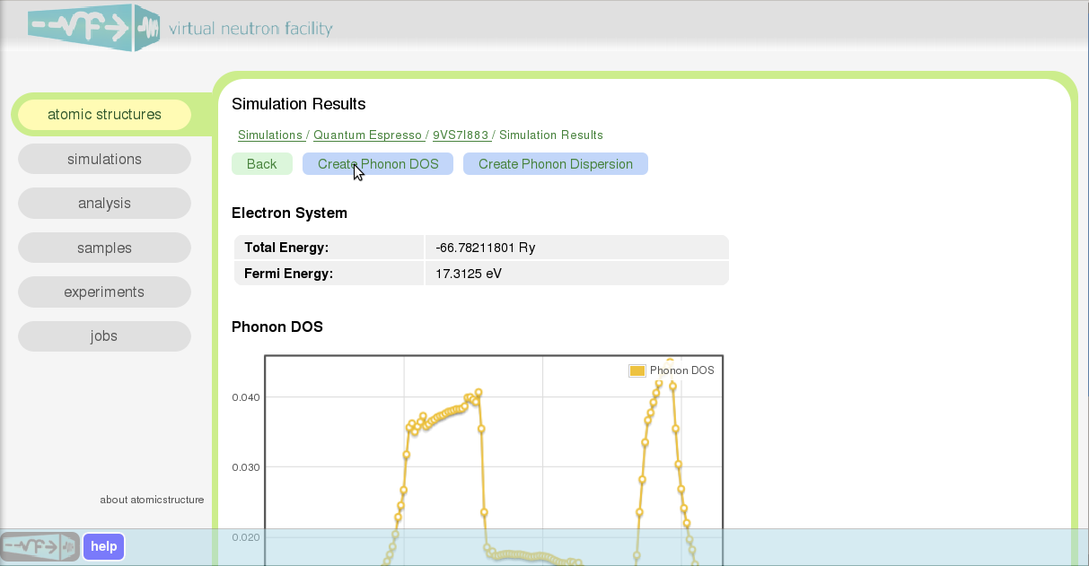
Fig. 39 Results view page

Wuala! The phonon DOS is created! Go to the simulation view page and click on the link for the Atomic Structure field. In the subsection “Phonons” you will see the plot for density of states (DOS).
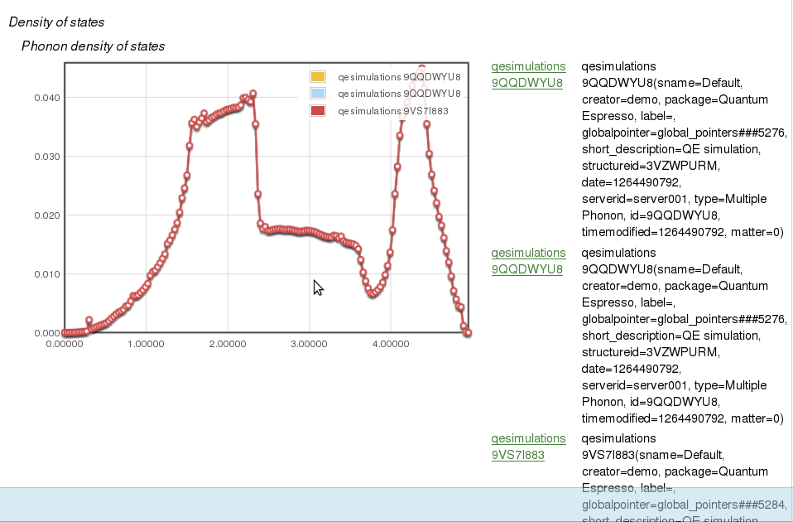
Fig. 40 Phonon DOS on the Atomic Structures page

