Rocket Rogue
Game Design Document
Press-your-luck spaceflight, surface mining, Ark campaign progression, and passive-drone survival
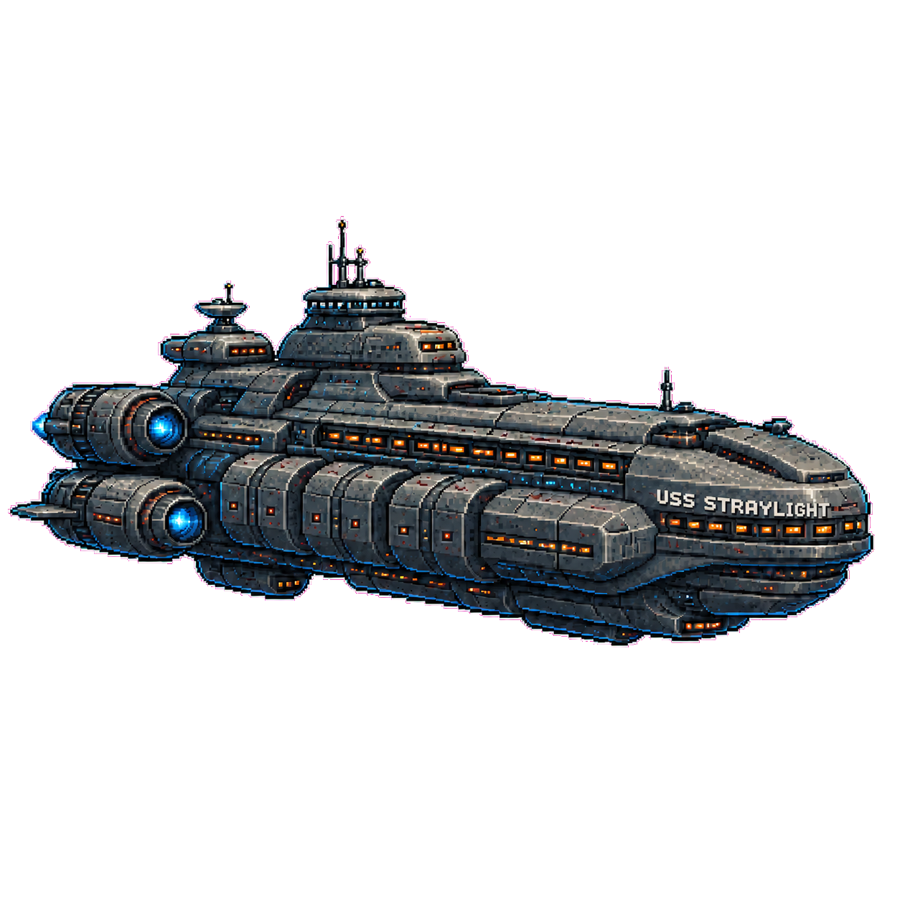
Field | Value
Document type | Professional internal Game Design Document
Working title | Rocket Rogue, with Orebit and Straylight retained as earlier naming and design influences
Repository | https://github.com/danseery/rocket-rogue
Generated | July 6, 2026
Source basis | Current repo docs, C++ core content, tests, art asset notes, and chapter checkpoint plan
Status | Living GDD for the playable PC-first C++ game, WebGL build, and near-term production direction

Design thesis
Rocket Rogue is a chunky space-mining roguelite where every major action asks the player to trade safety margin for progress: burn longer, land deeper, mine with shared fuel, or risk the Ark to reach New Earth.

Document Map
This GDD defines the game as it stands and where it goes next. It anchors design, implementation, art, and testing against the current repo.
Section | Purpose
1. Executive Overview | Product promise, player fantasy, pillars, and current build status.
2. Narrative And Chapters | Campaign premise, Ark role, stable chapter numbers, gates, and tone rules.
3. Core Gameplay | Launch, arrival, research, surface, mining, Navigation, and Ark loops.
4. Progression Systems | Ship, crew, research, materials, drones, artifacts, legacy, and economy.
5. Content Inventory | Destinations, crew archetypes, drone roles, module slots, and art assets.
6. UX, Art, Audio | Presentation direction, UI principles, asset pipeline, and audio goals.
7. Technical And QA | Architecture, save model, testing standards, and platform assumptions.
8. Roadmap And Open Questions | Production slices, future chapter work, and unresolved creative decisions.

1. Executive Overview

Product Vision
Rocket Rogue is a PC-first C++20 space-mining roguelite with a WebGL2 browser build for testing and sharing. It starts as a NASA-arcade launch gamble, then grows into landings, surface expeditions, direct-control mining, Drone Bay loadouts, and an Ark campaign beyond the solar system.
The fantasy is escalation. A fragile launch program becomes Straylight, a traveling survival base. The route runs through Moon, Mars, the Outer Planets, and Aaru Vale before Arkfall breaks the ship and the long push to New Earth begins.

Target Experience
Experience Pillar | Player-Facing Meaning | Implementation Rule
Hidden-risk launch tension | The player sees warnings and trends, never certainty. | Telemetry hints, incidents, and pressure modifiers must stay clear but incomplete.
Ship-first management | Modules, damage, return margin, and repair costs define the launch program. | Core math belongs in rocket_core; UI renders prepared state instead of duplicating rules.
Surface greed under constraint | Landing creates new value, but every action spends kits, fuel, safety, or extraction margin. | Surface Ops must show costs and risk deltas directly on decision cards.
Mining as landed overburn | The mining drone offers value under oxygen, fuel, heat, terrain, and later enemy pressure. | Mining remains one fuel-gated run per surface loop and resolves back into Surface Ops.
Persistent but painful progression | Loss matters, but records, blueprints, research, drones, and facilities survive. | Failure creates memorials, damage, and replacement pressure without soft-locking the run.
Ark campaign escalation | The return-home fiction changes from Earth to Ark, then into Ark repair and New Earth pursuit. | Chapter numbers are stable save/UI/test anchors; subtitles can change later.

Audience And Platform
Primary audience: PC players who want roguelite pressure, ship and drone loadouts, aerospace fantasy, and mining/extraction decisions without real-money gambling mechanics. The target platform is Steam; the WebGL build exists to test and share the same core game.

Current Build Status
Area | Status | Notes
Launch and telemetry | Playable | Hidden crash point, telemetry channels, incidents, return/eject choices, mitigation actions, pressure, and tests are implemented.
Hangar, crew, refit | Playable | Repair, recruit, train, rest, one-choice refit cards, crew stress, animal specialists, and module inventory are implemented.
Arrival operations | Playable | Flyby, orbit, landing gates, rewards, slingshot boosts, and save resume behavior are implemented.
Research and Surface Ops | Playable | Mars+ research, materials, artifacts, field upgrades, surface sites, hazard events, scan, push, extract, and logs are implemented.
Mining | Playable | Direct-control drone mining, fog, terrain, ore, artifacts, oxygen, heat, integrity, fuel cadence, hostile terrain, enemies, and passive defense are implemented.
Drone Bay | Playable | Persistent loadouts, slot upgrades, Mk tuning, role synergies, passive combat forecast, and mining HUD support are implemented.
Ark campaign chapters | Partly playable | Ch. 1-7 playable; Ch. 8 placeholder; Ch. 9-10 still planned.
Art direction | In progress | 90s arcade sprites and cleaned alpha assets cover planets, Ark states, rocket, thrust, explosion, drone, drill bit, and outer-system bodies.

2. Narrative And Chapters

Premise
Humanity starts with one job: prove the rocket, push farther, and bring the crew home. Mars turns flight testing into research and extraction. The Outer Planets reveal Straylight, an operational but empty Ark beyond Neptune. Its first jump reaches Aaru Vale, a friendly resource system built for search, discovery, and mining without combat. The next jump fails near Khepri Prime. Arkfall damages Straylight and turns exploration into survival, repair, and route-finding.

Story Tone
- Grounded aerospace pressure first: machinery, telemetry, crew stress, and resource margins drive the early drama.
- Wonder is earned: Mars research, artifacts, Straylight, and post-solar systems arrive as payoffs, not opening noise.
- Enemies are the rupture. The solar system and Aaru Vale stay non-hostile; Khepri Prime is the first combat break.
- Straylight becomes the player's traveling home base. Messaging changes from Return to Earth to Return to Ark once the fiction supports it.
- New Earth is the north star. It pulls Straylight through Aaru Vale, Arkfall, repair, and Ascent.

Numbered Chapter Map
# | Title | Gameplay Role | Gate / Implementation Status
1 | Proving Ground | Earth Orbit tutorial/proving loop; learn telemetry, return risk, refit, and hangar recovery. | Gate: advance to Moon. Implemented as new-game chapter.
2 | Lunar Program | Moon arrival, flyby/orbit/landing phase; route pressure increases while still teaching the program. | Gate: advance to Mars. Implemented through destination progression.
3 | Red Frontier | Mars research, Surface Ops, mining, materials, artifacts, and field upgrade loop. | Gate: advance to Outer Planets. Implemented.
4 | Breakthrough | Outer Planets and Ark discovery beyond Neptune; Ark is operational but empty. | Gate: Ark found. Implemented through Ark discovery and chapter migration.
5 | Straylight / Aaru Vale | Straylight becomes the operational Ark home; jump to Aaru Vale, a friendly non-hostile resource system, to learn search/discovery and mine fuel for the New Earth route. | Gate: leave Aaru Vale with an Ark jump. Implemented as relay_system, non-hostile, with Straylight still operational.
6 | Arkfall | The next Ark jump fails near Khepri Prime; Straylight becomes damaged and stranded. | Gate: disaster recorded and Navigation becomes the main loop. Implemented.
7 | Last Campfire | Stranded hostile-system survival from damaged Straylight near Khepri Prime. | Gate: first successful hostile-system sortie. Implemented via Khepri Prime sortie success after Aaru Vale and Arkfall.
8 | Void Compass | Rift Belt and deeper-route placeholder content; probes route-finding beyond the stranded system. | Gate: successful Rift Belt sortie or later deep-route completion. Placeholder implemented.
9 | Ouroboros | Future Ark repair loop using artifacts, recovered systems, fuel, crew, and ship sections. | Gate: repair threshold or ArkRepairing completion. Future.
10 | Ascent | Future repaired-Ark/deeper-navigation act and New Earth route pursuit. | Gate TBD. Future.

Chapter System Rules
- Chapter number is the stable identifier for save data, UI, tests, and documentation.
- Chapter subtitles are labels, not save identifiers; they can change without breaking saves.
- Chapter state is monotonic: once the player reaches a chapter, failures, reloads, or legacy migration cannot roll it backward.
- Migration reads destination tier, CampaignMilestone, ArkCondition, Ark jump flags, navigation system ID, and hostile-system sortie success.
- Chapter 5 keeps combat off the board. Aaru Vale teaches search, discovery, and mining while Straylight is still operational; enemies begin after Arkfall.

3. Core Gameplay

Macro Loop
- Prepare the ship, crew, and loadout in the hangar.
- Launch a proving flight or frontier transfer using hidden-risk telemetry and emergency tradeoff actions.
- Return, eject, or arrive; bank credits, blueprints, flight data, and consequences.
- Choose one refit card, then repair, recruit, train, or rest before the next attempt.
- When reaching Mars or beyond, resolve arrival operations, research, surface decisions, mining, and extraction.
- Spend recovered materials, artifacts, research, and drones to open new builds.
- Progress from Earth to Moon, Mars, Outer Planets, Straylight discovery, Aaru Vale, Arkfall, and hostile Khepri Prime sorties.

Launch Loop
Launch is the primary pressure engine. The player watches multiplier, route progress, telemetry channels, return risk, and seeded incidents while deciding whether to return, overburn, cut engines, open the relief valve, jettison cargo, or eject. Upgrades make risk clearer and more survivable but never perfectly knowable.
Input | Risk Lever | Reward Lever | Player Decision
Ship modules | Volatility, heat, pressure, damage, fuel imbalance. | Thrust, cooling, sensors, hull, escape, payout, mining support. | Build for reach, warning quality, survival, or reward.
Crew state | Stress cancels effective training and worsens NAV/ABORT pressure. | Training improves launch performance and survival odds. | Train, rest, recruit, or accept a compromised pilot.
Telemetry incidents | Short pulses on TEMP, PRESS, VIB, NAV, MIX, or ABORT. | Short reaction windows before final danger. | Mitigate now or keep burning for better outcomes.
Overburn | Higher crash/return/damage/stress risk. | Better payout, blueprints, readiness, and refit shelves. | Leave at data goal or push for better gains.

Arrival, Research, And Surface Ops
Successful transfers open flyby, orbit, and landing operations. Mars is the first research frontier: arrival becomes a chance to spend materials, decode artifacts, start a surface expedition, and decide when to return home.
Phase | Core Question | Current Implementation
Flyby | Can the crew exploit the pass without hitting approach hazards? | Minigame rewards progression and slingshot boosts.
Orbit | Can the crew hold a stable track for science and credits? | Orbit minigame grants science-style progression rewards.
Landing | What can the expedition investigate now that it arrived? | Research phase and Surface Ops unlock from Mars onward.
Research | Which new options should materials, blueprints, and artifacts unlock? | Module/facility/tool/drone unlocks and artifact identification.
Surface Ops | How much should the crew risk before extracting? | Survey, scan, push, one mining run, Drone Ops, extraction, hazard/events, bounded log.

Mining Mini-Game
Mining is the landed version of overburn. The drone digs through chunked terrain under oxygen, heat, fuel, scanner cooldown, cargo, and drill integrity pressure. The player can stow payload, abort, or fail; the outcome feeds back into the same surface payload, hazard, artifact, and extraction model.
Resource | Function | Design Requirement
Shared fuel / Ark fuel | Deployment and ongoing run cadence. | Must be visible as the shuttle-vs-drone tradeoff.
Oxygen | Short-run timer; baseline is 15 seconds before upgrades. | Extensible by crew, Resource Drone, and field upgrades.
Drill integrity | Mining health and failure threshold. | Damage comes from hard rock, hazards, enemies, and overheating.
Drill heat | Soft limiter on drilling aggression. | High heat slows drilling and can damage integrity.
Scanner | Reveals fog-of-war, ore, artifacts, and later enemy silhouettes. | Cooldown must make information a decision, not a free map.
Cargo | Reward value that increases extraction strain. | Higher payload must tempt the player and raise extraction danger.

Ark Navigation Loop
After Arkfall near Khepri Prime, Navigation becomes the mission-selection layer. The player chooses local destinations from the damaged Ark, spends Ark fuel, prepares a shuttle sortie, flies the press-your-luck transfer, lands or orbits, mines/researches under hostile pressure, then returns to the Ark with fuel, materials, artifacts, and repair leads.

4. Progression Systems

Ship, Modules, And Refit
Ship progression runs through slots and refit choices. Post-mission rewards show three cards; the player installs one before hangar operations resume. Modules must state what threat they answer, what number they move, what they cost, and what they trade away.
Slot / Family | Gameplay Role | Examples
Engine | Reach, exposure time, volatility, surface drilling hooks. | Sparrow Engine, Kestrel Engine, Nova Drive, Regolith Auger.
Fuel | Return margin, pressure stability, long-haul capacity, mining yield hooks. | Stable Tank, Slush Tank, Deep Reservoir, Ore Sorter.
Hull | Damage tolerance, repair economics, hard-surface durability. | Patchwork Hull, Titanium Rib, Ablative Skin, Diamond Bearings.
Cooling | Heat control and overburn/mine endurance. | Radiator Vanes, Cryo Loop, Sacrificial Heat Sink, Coolant Sleeve.
Sensors | Warning quality, pressure uncertainty, mining scan width. | Analog Telemetry, Hazard Radar, Predictive Guidance, Surface Mapper.
Escape | Ejection and crew survival outcomes. | Spring Capsule, Abort Tower, Phoenix Pod.

Crew
Crew are animal specialists with class identity, training, stress, injury, death, and memorial consequences. Training improves performance; stress cancels effective training and raises NAV/ABORT pressure. Replacement recruitment prevents dead-roster soft locks while preserving loss.
Crew Class | Focus | Launch / Surface Fantasy
Capybara Tank | Survival | Endurance, oxygen safety, calm under heat.
Beaver Engineer | Resilience | Repairs, drill integrity, hard-failure mitigation.
Fox Ace | Navigation | Extraction risk relief, abort safety, route confidence.
Prairie Dog Scout | Digging | Survey, scanning, tunnel efficiency, drill power.
Squirrel Hoarder | Resource Gathering | Rare-material odds, cargo payoff, material greed.
Chipmunk Speedster | Exploration | Movement speed, traversal, repositioning.

Research, Materials, And Artifacts
Research unlocks decisions, not just bigger numbers. Materials, blueprints, and artifacts open module families, crew facilities, surface tools, drone systems, and Ark repair hooks. Artifact research grants mechanical insight now; story payload comes later.
Progression Currency | Source | Primary Spend / Meaning
Credits | Recovered launches, orbits, mining/artifact rewards. | Refits, repair, training, rest, recruitment.
Frontier readiness | Useful proving profiles and transfer data. | Gate to the next solar-system frontier.
Blueprints | Overburns, research, artifacts, surface discoveries. | Research unlocks and long-term player choices.
Common / rare / exotic materials | Surface Ops and mining. | Research projects, special components, drone slots, drone tuning.
Artifacts | Deeper surface and mining cache recovery. | Identification, blueprint insight, future Ark repair/story threads.
Shared fuel / Ark fuel | Surface expedition reserve and Ark reserve. | Mining deployment/cadence, shuttle routes, Navigation sorties.

Drone Bay And Passive Defense
Drone Ops is the loadout layer for mining. It begins as environmental support and becomes passive combat after post-solar hostile progression. The player equips drones into persistent bay slots, upgrades favorites from Mk I to Mk III, and compares synergies before the mining run starts.
Drone | Availability | Role
Mining Drone | Drone Bay | Auto-mines revealed ore and improves passive material output.
Resource Drone | Drone Bay | Adds oxygen/fuel endurance and lowers extraction strain.
Survey Drone | Drone Bay | Improves scanner radius and hidden POI/enemy detection.
Stabilizer Drone | Drone Bay | Reduces hard-rock bounce, chatter, and drill integrity loss.
Attack Drone | Perimeter Drone Network | Passive shots, crits, area control, and enemy slowdown after Arkfall.
Defense Drone | Perimeter Drone Network | Shields, reactive armor, counter-hits, and hazard/enemy damage relief.

Legacy And Failure
The game can hurt the player without dead-ending the campaign. Vehicles lose modules. Astronauts die or come home injured. Memorials persist. Rescue costs bite. Records, unlocks, blueprints, facilities, artifacts, and drones keep the program moving.

5. Content Inventory

Destinations
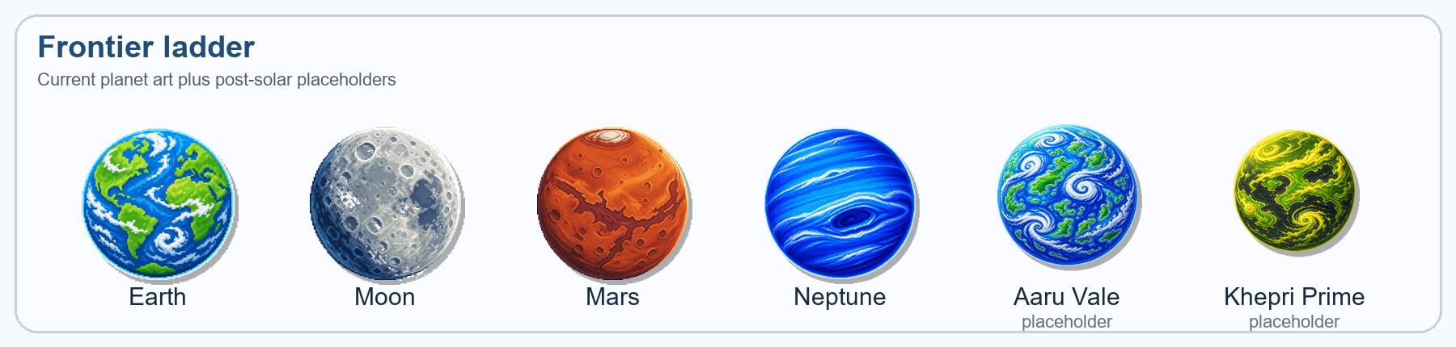
Planet art strip: current solar-system sprites plus placeholder outer-system bodies for Aaru Vale and Khepri Prime.
Destination | Tier | Campaign Role | Enemy Rule
Earth Orbit | 0 | Tutorial/proving loop and first risk/reward learning. | No enemies.
Moon | 1 | Lunar Program arrival and route-risk escalation. | No enemies.
Mars | 2 | First research, Surface Ops, mining, artifacts, and materials. | Environmental hazards only.
Outer Planets | 3 | Breakthrough and Ark discovery beyond Neptune. | No enemies.
Aaru Vale | 4 | Friendly post-solar resource system after Outer Planets; teaches search, discovery, and mining without combat. | No enemies.
Khepri Prime | 5 | First hostile-system sortie from damaged Straylight after Arkfall. | Hostile contacts and passive defense allowed.
Rift Belt | 6+ | Void Compass placeholder for deeper-route content. | High-risk hostile/deep-route content.

Planet And Resource Pillars
USG direction frames destinations around Danger, Durability, and Value. Object and resource presentation shows Weight, Durability, and Value, plus whether an object is tetherable, collectible, destructible, or a hazard. This model guides generated planets, moons, anomalies, boss planets, and Ark repair locations.

Asset Inventory And Pipeline
The current art pipeline uses magenta #ff00aa chroma-key source images, cleaned alpha PNGs, fixed packing sizes, and WebGL asset registration. The repo already includes planet sprites, operational and damaged Ark sprites, rocket/thrust/explosion sheets, mining drone and drill-bit sheets, and future outer-system planet/moon sprites.
Asset Group | Current Files | Design Use
Solar-system bodies | earth, moon, mars, mercury, venus, jupiter, saturn, uranus, neptune | Frontier ladder and destination presentation.
Ark states | ark-operational.png, ark-damaged.png | Operational Straylight after Breakthrough and through Aaru Vale; damaged Straylight after Arkfall near Khepri Prime.
Flight sprites | rocket.png, thrust-sheet.png, explosion-sheet.png | Launch, return, failure, and aerospace feedback.
Mining sprites | mining-drone.png, drill-bit-sheet.png | Direct-control mining and tactile digging feedback.
Future systems | outer-system planets and moons | Aaru Vale friendly resource system, Khepri Prime hostile system, Rift Belt, and post-solar Navigation map expansion.

6. UX, Art, And Audio Direction

UX Principles
- Every action card must show cost, payoff, risk, and availability on the card.
- Do not hide tradeoffs: shared fuel, Ark fuel, oxygen, return risk, extraction pressure, and drone availability stay visible.
- Use stable action IDs and shared UI helpers so native and browser builds call the same actions.
- Solar-system screens teach. Post-Arkfall screens press harder.
- Debug tools must never obstruct modal or mission-critical UI.

Visual Style
The visual direction is chunky, blocky, geometric, colorful, and retro arcade with modern polish. The game looks like a hands-on space program, not a spreadsheet. Sprites must read as real game objects at speed; placeholders are acceptable only when ownership, role, state, and threat level remain clear.

Audio Direction
Audio sharpens tension without smothering decisions: telemetry alarms, pressure pulses, engine strain, relief valve/jettison feedback, drill resistance, scanner pings, drone shots, shield hits, and Ark jump/disaster beats. Music can stay energetic and space-arcade, with calmer Ark-home cues while Straylight searches Aaru Vale before Arkfall.

7. Technical Architecture And QA

Architecture
Layer | Responsibility
src/core | Deterministic game rules: content, RNG, progression, save data, flight tuning, research, mining, presentation helpers, and tests.
src/game | Browser-session orchestration, screen transitions, launch/mining controls, panel HTML generation, and render snapshots.
src/render | WebGL2 drawing, texture upload, procedural visuals, mining/flight render state. No gameplay decisions.
src/platform | Browser bridge for persistence and panel updates.
web | HTML/CSS/JS shell, DOM event routing, and exported C++ action calls.
docs/assets | Design docs, source extracts, art asset inventory, and generated deliverables.

Save And Migration Rules
The current save format is versioned, line-based, and dependency-free. SaveSchema owns field keys and delimiters. New gameplay fields default safely when missing, round trip through tests, and migrate legacy state into the highest valid monotonic chapter without rolling back player progress.

Testing Standards
Core tests are design contracts for launch outcomes, telemetry, crew stress, economy, research, Surface Ops, mining, drone builds, Ark campaign, saves, panel presentation, and content IDs. Future systems need tests for the rules players touch: gates, costs, availability, rewards, chapter advancement, and save/load compatibility.
Validation Area | Expected Coverage
Chapter progression | New games start at Chapter 1; chapters advance through destinations/Ark jumps/sorties; no rollback.
Surface and mining | Mining spends fuel, runs once, blocks further survey/push, stows/aborts/fails correctly, and persists through save/load.
Drone Bay | Unlocks, slots, loadouts, tuning, synergies, combat forecast, and passive combat outcomes.
Ark fiction | Return labels, Ark fuel copy, operational/damaged visuals, Navigation availability, and hostile-system gates.
UI parity | Shared presentation helpers cover browser/native parity, modals, action IDs, and top-level metrics.

8. Roadmap And Open Questions

Recommended Production Slices
Slice | Goal | Exit Criteria
A. Chapter polish | Make Chapters 1-7 clear in UI/docs and fixture saves. | Chapter display, gates, test fixtures, and player-facing copy match.
B. Aaru Vale friendly system | Turn Chapter 5 into Aaru Vale: a friendly fuel-navigation chapter centered on Straylight as the Ark home. | Aaru Vale destinations, fuel objectives, search/discovery onboarding, Ark operational visuals, and New Earth route hints.
C. Arkfall presentation | Make the second jump/disaster land as a campaign beat. | Damaged Ark visual swap, disaster sequence, Navigation handoff, and hostile warning tone.
D. Hostile sortie depth | Deepen Last Campfire/Void Compass content. | Khepri Prime/Rift maps, passive-drone combat reads, rewards, and recovery paths play differently from Aaru Vale.
E. Ark repair loop | Implement Ouroboros resources, facilities, and repair thresholds. | Repair UI, artifact/fuel/module requirements, damaged-to-repairing state, and save tests.
F. Ascent and New Earth route | Define repaired Ark navigation and endgame objective. | Route fiction, gate conditions, chapter 10 content plan, and ending/continuation model.

Open Design Questions
- Should Aaru Vale be one authored friendly resource system, a small generated cluster, or a guided first route for Ark-scale navigation from Straylight?
- How literal should New Earth be: a final destination, a mythic route, a colony candidate, or a recurring hope marker?
- What artifact tone should the game settle on: ancient alien mystery, lost human infrastructure, cosmic horror, or grounded scientific anomaly?
- How much of Surface Ops should remain menu-driven versus move into the direct-control mining scene?
- Should Ark repair use named ship sections, resource thresholds, boss planets, rescued personnel, or all of those in staged gates?
- How should the animal crew abilities become more active without breaking the current launch and mining loops?

Source Inventory
Refresh this GDD when these sources change materially:
Source | Used For
README.md | Implemented feature inventory, build/platform boundaries, controls, and portability notes.
docs/DESIGN.md | Core pillars, risk model, refit economy, architecture, and presentation ownership.
docs/ARK_CAMPAIGN_NAVIGATION_PLAN.md | Ark campaign mapping, chapter titles, gates, Navigation loop, and enemy timing.
docs/POST_ARRIVAL_PHASES.md | Research, Surface Ops, environmental hazards, enemy timing, and POC scope.
docs/MINING_MINIGAME_PLAN.md | Mining goals, entry flow, fuel/oxygen rules, terrain/reward design, and hostile mining.
docs/MINI_DRONE_SYSTEM.md | Drone roles, slot/tuning progression, synergies, passive combat, and HUD expectations.
docs/AGENT_DESIGN_CONTEXT.md | Design priority order, art direction, animal crew direction, and Ark/base progression.
docs/reference/USG_NOTES.md | Primary direction: planet/resource pillars, chunky Ark/Straylight art, animal classes, passive defense.
docs/reference/ROGUELIKE_OUTLINE.md and ROGUELITE_ELEMENTS.md | Supporting roguelite/base/survival/digging vocabulary and future hooks.
src/core and tests/core_tests.cpp | Implemented content, tuning, chapter state, save fields, presentation helpers, and regression coverage.
assets/art/README.md | Art asset pipeline, Ark/planet/rocket/mining sprite inventory, and #ff00aa source cleanup convention.

