GAME DEVELOPMENT
Do you have a unique game idea, an adorable OC, and your own magical world, but aren't satisfied with the current art commissions and want a more original storytelling approach?
Table of Contents
About Game Development
Is GameDev so difficult as people say?
Work Process
Game Development Price.
Term of Service
Contact Information
Payment & Refund Policy
Copyright & Usage Rights

About Game Development
🔸 Is GameDev so difficult as people say?
Well.. yes ~(>_<。)＼. Even in 2026, with widespread availability of leading development libraries and technologies like Unity / Unreal, or even advanced AI like ChatGPT or Claude Code, game development remains a very difficult field for an individual to undertake a project on their own.
Game development isn't as simple as people think, just "draw something" and "write code to make it work." The process actually requires collaboration from many different areas, from writing game mechanics to designing and illustrating characters and backgrounds, animation and visual effects, not to mention storyline and world building. Despite being an IT student, self taught Art and worked in game industry for over 3 years, I couldn’t complete a full game project without the help of my friends and colleagues.
Because it's so difficult, many of my friends have interesting ideas and worlds with amazing characters, and they really want to use games as a way to tell their stories, but they can't do it themselves. So I with our team decided to open this service to help people build their own worlds.
🔸 Work Process:
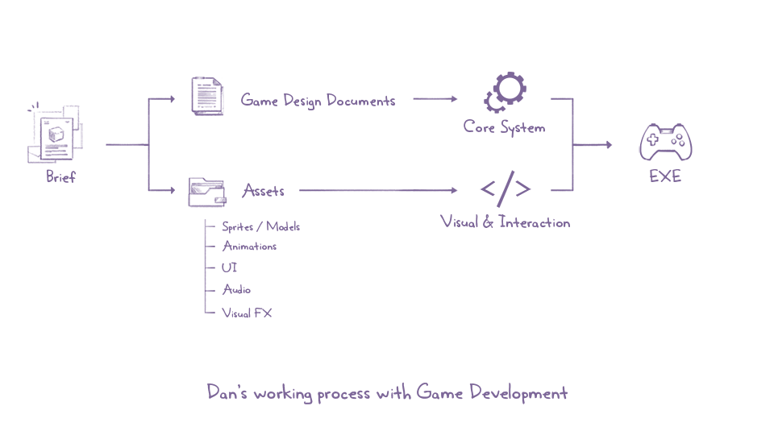
The project will only begin when a complete Game Design Document is available, along with all Assets (including Sprites / Models, Animations, Audio, UI, and VFX if any).
During the development process, Assets can be freely modified (within permitted limits) an unlimited number of times without charge. However, changing the Game Design is strictly prohibited as it will affect the entire system. If you really want to make changes, I will gladly help you for free, but please don't overuse this ≧ ﹏ ≦.

🔸 Game Development Price
Based on scale, games can be divided into five categories: Hypercasual (Flappy Bird), Casual (Candy Crush Saga), Midcore (Clash Royal), Hardcore (CS:GO), and AAA (GTA V).
The price below only includes technical services (game programming, environment setup, interface integration, graphics optimization…). It does not include Game Design, Illustration, Animation, BGM / SFX or Visual FX…
 | Prototype | Demo | Full
Hypercasual | 700 | 1200 | 6000
Casual | 1200 | 2300 | 11000
Midcore

The price above is an estimated price, as the game varies greatly in complexity and length. Both commercial and non-commercial are the same.

TERM OF SERVICE
By placing a commission, you agree to the terms below. Please read everything carefully so we can have a smooth and magical collab!

Contact Information
I accept commision through any platform noted in my Profie.
My active hours are 20:00-23:59 UTC+7, and I usually reply within 24 hours.
If you pay via PayPal, I’ll send you a proper invoice to keep things secure and organized.
When placing your order, please include: Game Design Document and full Assets.

Payment & Refund Policy
🔸 Price
Prices above are based on non-commercial purpose. Commercial Fees will be charge by Total Price x2-3 base on each purpose.
Private commission comes with 50% Fee.
Prices may be changed due to complexity of commission.
Short/rush deadline must have to be charged around 50-100% Total Price, depending on your brief.
Commission prices may be updated regularly without prior notice.

🔸 Payment
100% upfront payment is required before I start. For large projects, we can split it into 2 payments upon agreement.
PayPal only. I don’t accept other payment methods.
I will hold your slot for 7 days after confirmation. If no payment is made, the slot will be released.
If you send the wrong amount or there's a payment error, I’ll do my best to help. However, I’m not responsible for incorrect PayPal emails.

🔸 Refund
100% if I haven’t started working on your commission (not include the Paypal extra fee).
50% if I've done Visual & Interaction and started Core System.

🔸 Tax & Fee Notice
As a Freelancer in Vietnam, I am required to pay a 10% personal income tax on all earnings. Therefore, a 10% tax fee will be added on top of the total invoice amount. This helps me stay compliant with local tax laws while continuing to provide quality work as an independent creator.

Copyright & Usage Rights
Required credit: “Dan @dansenak249” in Developmer section.
There’s nothing more here, you can do what ever you want even monetizing your gameヾ(≧▽≦*)o.

🔸 Developer Rights
Self-promotion. I may post finished game video/capture on my social media or use it in my portfolio unless marked as a private commission.
I reserve the right to cancel the commission and issue a refund if the client is disrespectful or places unfair demands.
I may slightly adjust the layout or style during the process for better quality, as long as it aligns with the original brief.
Other copyright to which I am entitled under international law.

