ILLUSTRATION
 | Clean sketch | Painting | Animated
Illustration + BG |  | 250 | 400
Full Body | 70 | 150 | 250
Half Body | 40 | 90
Bust up | 25 | 60

For further information, check Payment.

TERM OF SERVICE
By placing a commission, you agree to the terms below. Please read everything carefully so we can have a smooth and magical collab!
Table of Contents
Jump to a Section
Work Process
Contact Information
Payment & Refund Policy
Copyright & Usage Rights

Work Process
🔸 Workflow:

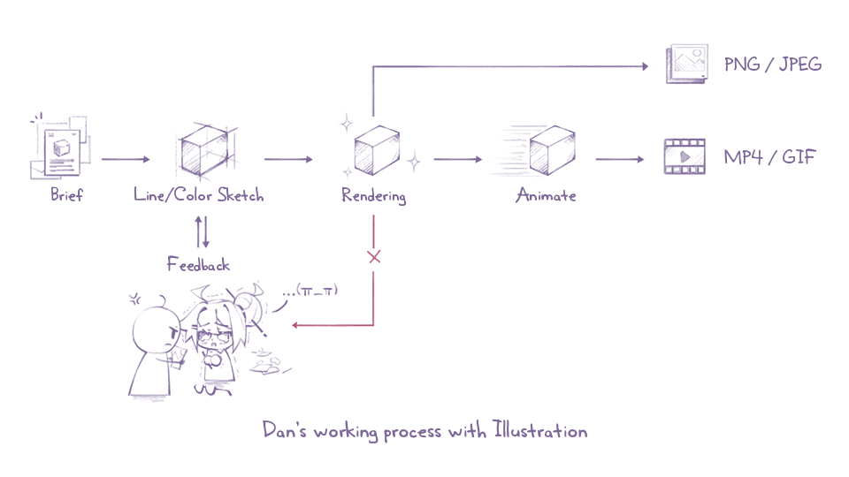
Few Sketch options will be made base on your brief. Small fix could be proceed free until you satisfied.
Extra fee would be charged from your 4th change or if you need another different sketch option.
On Rendering steps, major changes are not available.
I don’t accept vague feedback like “make it cuter” or “cooler” unless it's explained clearly. Please give specific instructions, e.g. “change the star to a heart” or “add a bow.”
If I don’t receive feedback within 4 days, I’ll move forward with the current version and no further changes will be accepted.

🔸 File
 | Type | Resolution (px) | Note
Illustration | PNG | 3840 x 2160 | 350 DPI
Animation | MP4 | 1920 x 1080 | 60 FPS

If you need another size or format, contact me for further discussion.

🔸 Time
Total commission time: 60 days from Brief received day.
Longest update time: At least once a week.

Contact Information
I accept commision through any platform noted in my Profie. For Art Commissions, I recommend Vgen.
My active hours are 20:00-23:59 UTC+7, and I usually reply within 24 hours.
If you pay via PayPal, I’ll send you a proper invoice to keep things secure and organized.
When placing your order, please include: Image refs, pose/emotion, canvas size, deadline (if any), and usage purpose.

Payment & Refund Policy
🔸 Price
Prices above are based on non-commercial purpose. Commercial Fees will be charge by Total Price x2-3 base on each purpose.
Private commission comes with 50% Fee.
Prices may be changed due to complexity of commission.
Short/rush deadline must have to be charged around 50-100% Total Price, depending on your brief.
Commission prices may be updated regularly without prior notice.

🔸 Payment
100% upfront payment is required before I start. For large projects, we can split it into 2 payments upon agreement.
Vgen or PayPal only. I don’t accept other payment methods.
I will hold your slot for 7 days after confirmation. If no payment is made, the slot will be released.
If you send the wrong amount or there's a payment error, I’ll do my best to help. However, I’m not responsible for incorrect PayPal emails.

🔸 Refund
100% if I haven’t started working on your commission (not include the Paypal extra fee).
100% if I cannot complete the Artwork.
50% if I've finished Sketchs and start Rendering.
10% if I'm over 1 days late without a valid reason. You can request a full refund, and I’ll stop right away.

🔸 Tax & Fee Notice
As a Freelancer in Vietnam, I am required to pay a 10% personal income tax on all earnings. Therefore, a 10% tax fee will be added on top of the total invoice amount. This helps me stay compliant with local tax laws while continuing to provide quality work as an independent creator.

Copyright & Usage Rights
🔸 Without Commersial Use
I retain full copyright of the artwork unless a transfer is agreed upon (additional fee required).
You may use the commissioned art for personal use only: avatars, overlays, banners, etc.
You may NOT
Print or sell the artwork, or use it commercially without proper licensing
Repost without credit
Use for AI/NFT/filter modifications, I do not allow my work to be used for AI training, AI blending, or filtered edits that distort the original intent.

🔸 With Commersial Use
Requires an additional x2-3 of the base price.
Required credit: “by Dan @dansenak249”
If you violate copyright, I reserve the right to file DMCA claims and publicly address the issue.

🔸 Artist Rights
Self-promotion. I may post finished artwork on my social media or use it in my portfolio unless marked as a private commission.
I reserve the right to cancel the commission and issue a refund if the client is disrespectful or places unfair demands.
I may slightly adjust the layout or style during the process for better quality, as long as it aligns with the original brief.
Other copyright to which I am entitled under international law.

