Daniel Shu

LA211

Professor Reeves

14 February 2017

Stonehenge Architecture

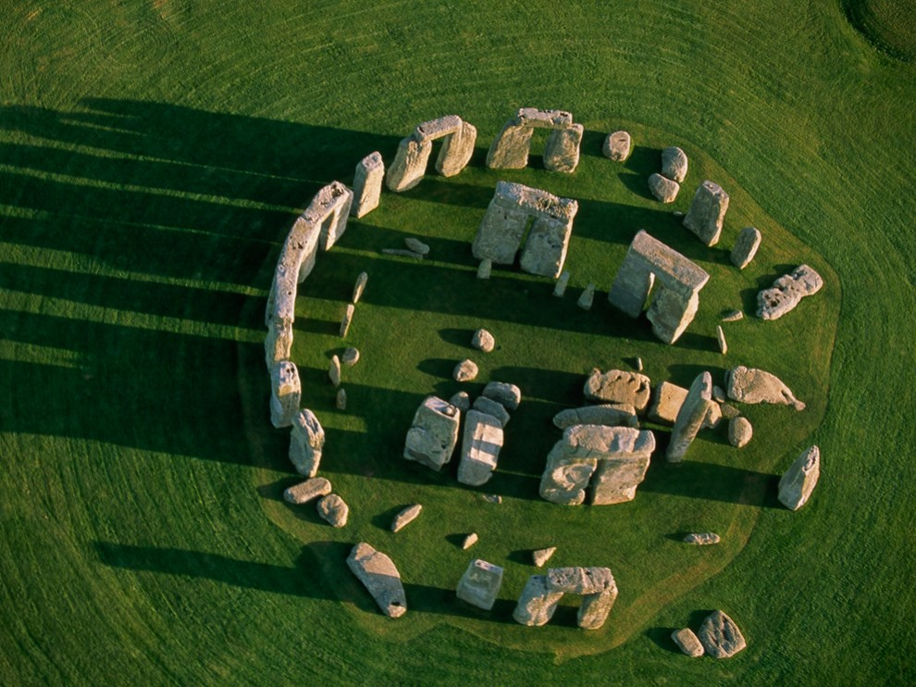

The Stonehenge is an enormous monument made from stone, located in England near Salisbury. According to LiveScience, research shows that the monument was built more than 5,000 years ago and forms just one part of a larger, highly complex landscape. However, the exact date the piece of work was built remains a matter of dispute. According to *The Age of Stonehenge* by Duke Edwards, There is no agreement amongst archaeologists as to whether the sarsen stones were erected as early as 2600-2500 BC, in the period after 2550 BC or even towards the end of the millennium period around 2300 BC or later. The largest of the stones visible in the monument is known as sarsens, which are up to 30 feet tall and weigh 25 tons. It consists of a series of 56 pits which is around the number of weeks in a year Speculations propose that glaciers carried the stones and the monument makers didn’t have to move them all the way from Wales. Water transport through raft was a possibility scientists considered.

The mystery of the makers of the Stonehenge is also up to debate. It was assumed to have been built in the Neolithic age and was used for social congregations. According to *The Structural History of Stonehenge* by Andrew Lawson, the special nature of Stonehenge as a complex monument constructed by mere barbarians is stressed. Many also speculated that pilgrims utilized the site for ritual purposes. The location of where Stonehenge was built was Salisbury Plain, which was considered to be a sacred area long before Stonehenge was even constructed. Notably, the Northwest entry aligns with the Equinox. Over 10,000 years ago, large pine posts, which acted as totem poles, were erected at the site. Hunting was also very popular at the site. These pieces of evidence point to the fact that Stonehenge was built for a very significant reason, possibly a sacred ritual site.

I thought the Stonehenge was extremely fascinating and provoked my curiousity due to its size and weight. Standing up to 30 feet tall and weighing up to 25 tons, these stones cannot be carried by a small group of people. Moreover, I was even more bewildered when I thought about how many people and how much it took to build something of this mass. It also made me particularly interested in what it was built for. This quarter I was fortunate enough to learn about the architecture and ideas of the mysterious Stonehenge in my Landscape Architecture class. During the Summer of 2016 I studied abroad in London, England and was able to visit this magnificent piece of man-made construction. What I enjoyed most learning about it was its mystery, the fact that no one really knew for sure what it was built and used for, and who built it. When visiting it, I realized that it was pretty much in the middle of nowhere, and was located in a very arbitrary spot in the middle of a massive plain field of grass. I was to stop by a transport center about 10 minutes away and after I bought the tickets, I waited in a long line to board a bus that only sat about 20 people. This was a weird experience as I wondered why they built the center so remote and that there was absolutely nothing around the monument for miles. Overall it was a very interesting and memorable experience.

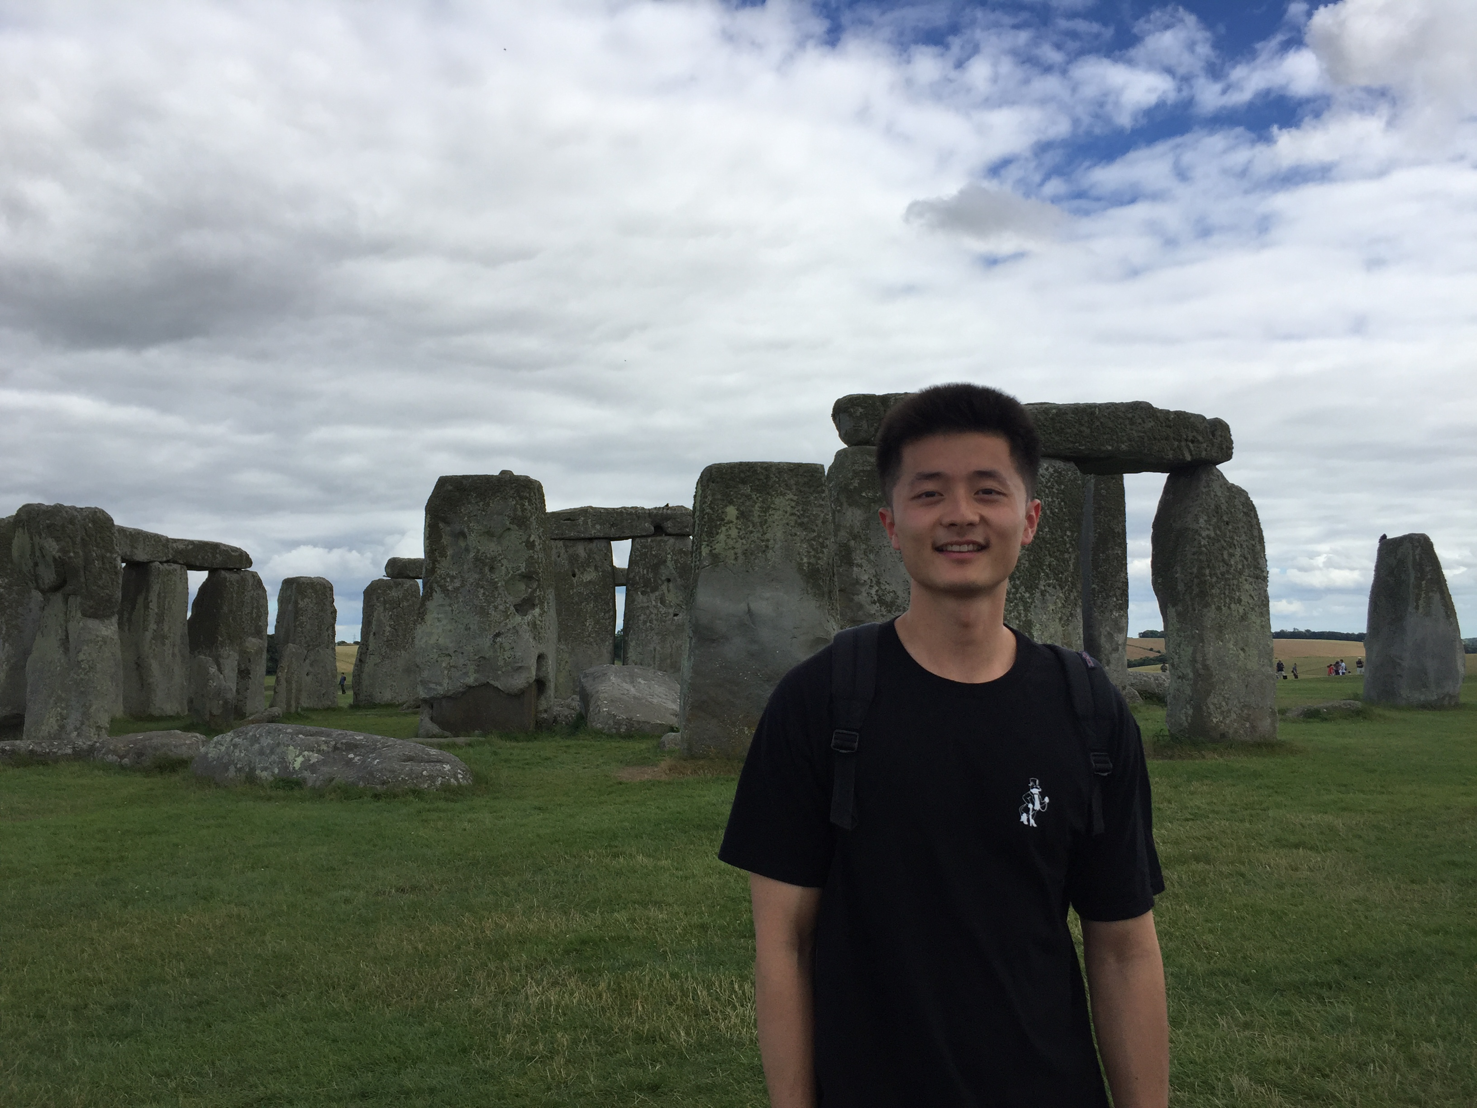

Sources:

1. Lawson, Andrew J. *The Structural History of Stonehenge*. N.p.: British Academy, 1992. Print.
2. Duke, Edward. *The Age of Stonehenge*. N.p.: n.p., n.d. Print.
3. Jarus, Owen. "Stonehenge: Facts & Theories About Mysterious Monument." *LiveScience*. Purch, 03 Oct. 2014. Web. 14 Feb. 2017.