XOR gate:

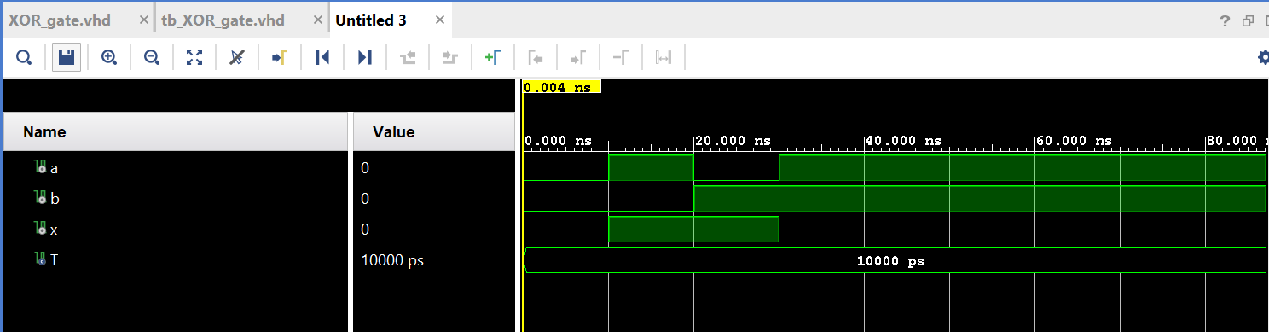

D flip-flop:

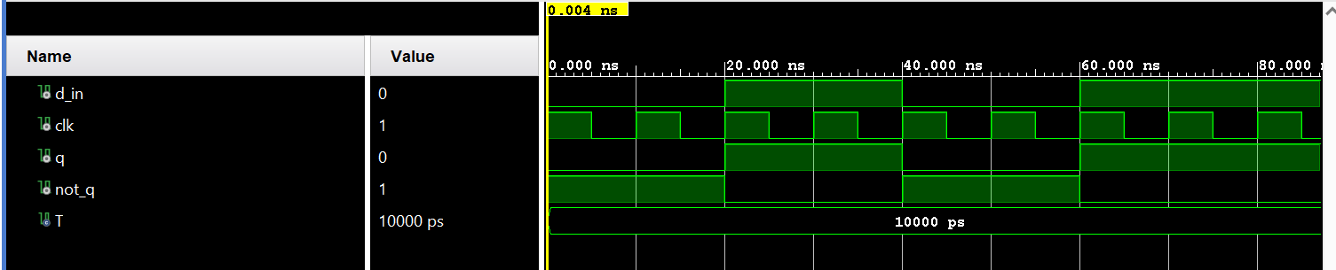

Register:

Shift register:

