

Trends Marketplace | Daniel Smetana | smeta018@umn.edu

**What is Bokeh?**

* Bokeh is an interactive and highly customizable data visualization library within Python that excels in creating beautiful graphics across all levels of complexity. Bokeh is optimized for working with large data sets, thanks to built-in pandas connectivity, and offers extremely flexible backend usage as a result of its ability to be integrated into web-based solutions and apps.

**Hypothesis**

* Bokeh is a simple way to create professional interactive graphics for a variety of business needs, regardless of the data type.

**Example Displays**

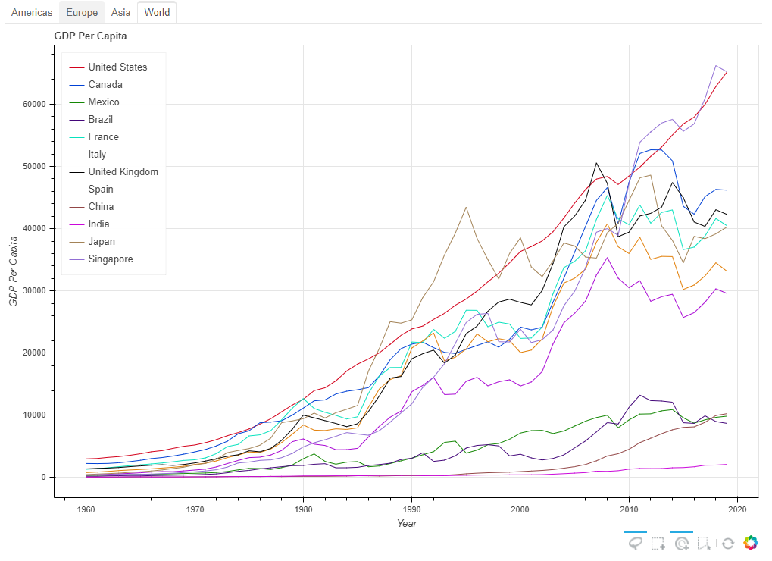

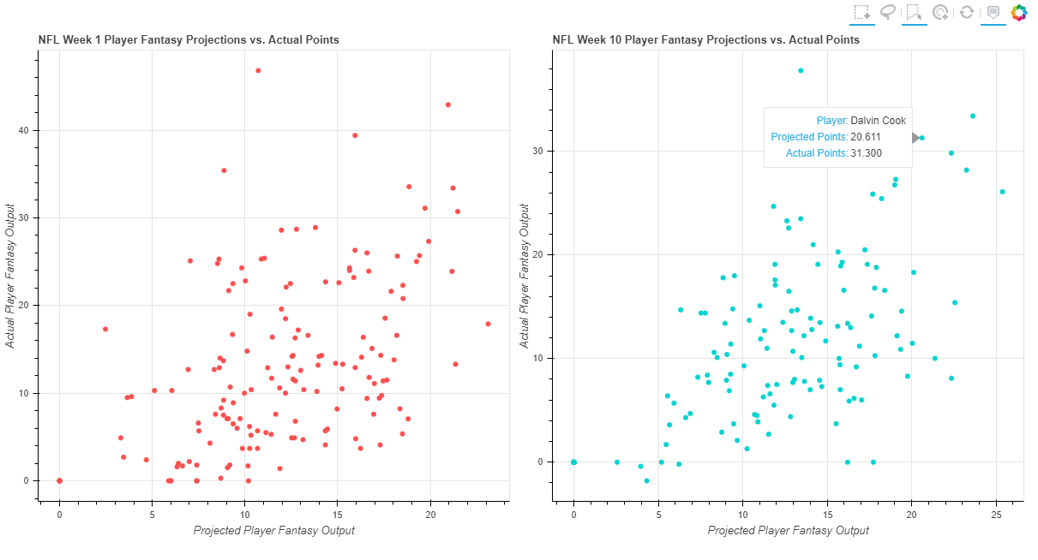

**Bokeh Tools**

* Bokeh offers numerous built in tools that make adding engaging interaction to graphics as easy as a few lines of code. These tools offer a wide range of options for *end users* to customize how they are viewing the graphics, with tools ranging from those that simply alter the view/scope of the visualization to tools that actually add points, lines or shapes to the graphic itself within the interface of interaction.

**Business Applications**

* Creating clean and easy-to-understand interactive graphics that are easily shareable throughout all levels of an organization
  + Bokeh offers superior data visualization tools for both simple and complex graphics alike
  + Thanks to the built-in interaction tools, every consumer of a graphic can completely customize their experience based upon their specific needs
    - Executives, Managers, and Analysts alike can all use a singular visualization and alter the scope depending on the information they desire to see, in turn eliminating the need to redundantly recreate similar graphics depending on the audience
* Building powerful data applications when combined with other common Python libraries
* Easy integration of graphics into web pages – designed to work directly with Django and Flask

**Conclusion**

* For data visualization, Bokeh is an extremely efficient and powerful tool that is unrivaled in its ability to create stunning interactive graphics that can be shared in countless ways.