**1. Per-Client Data Analysis:**

● What is the label distribution (class imbalance) per client?

● How many samples does each client have?

● Are there significant differences in data size or class diversity across clients?

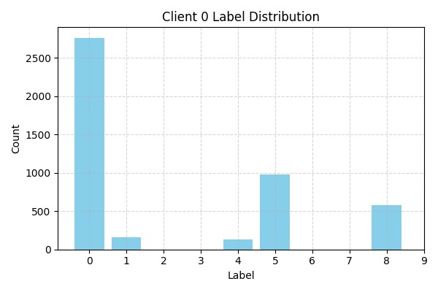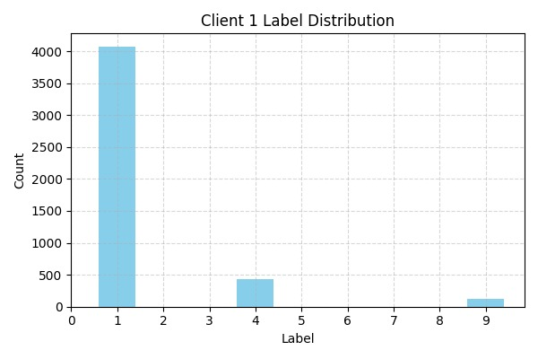

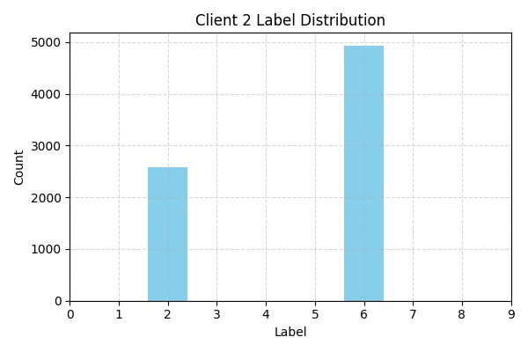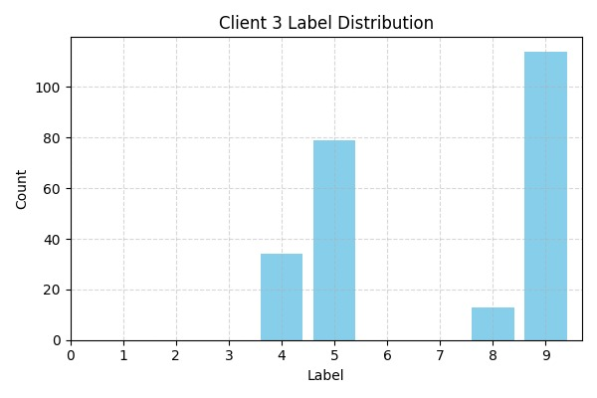

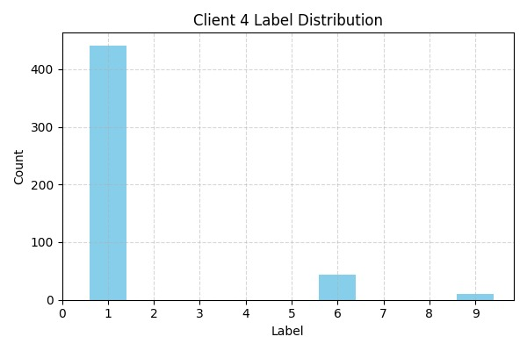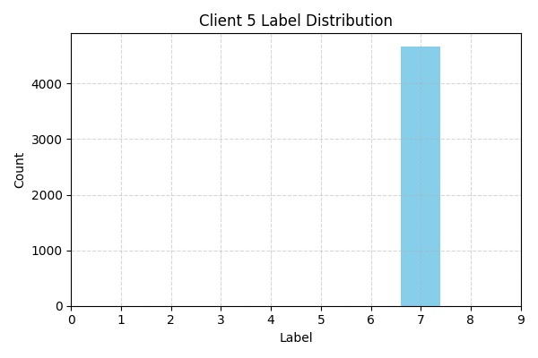

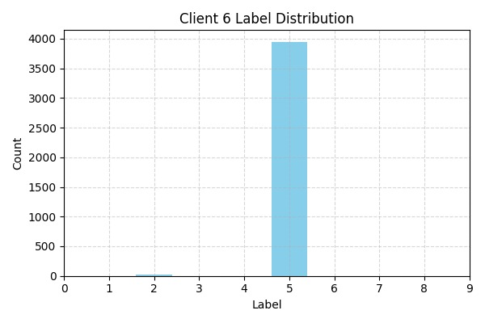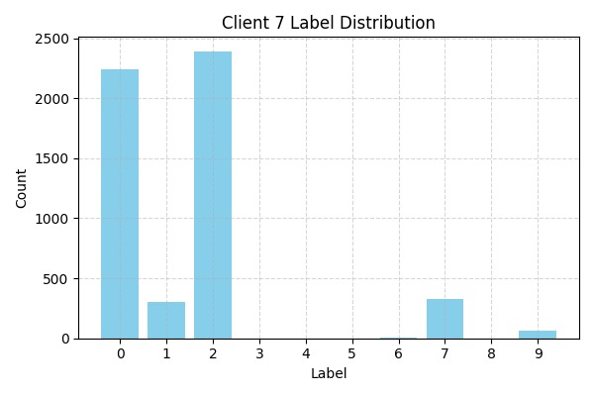

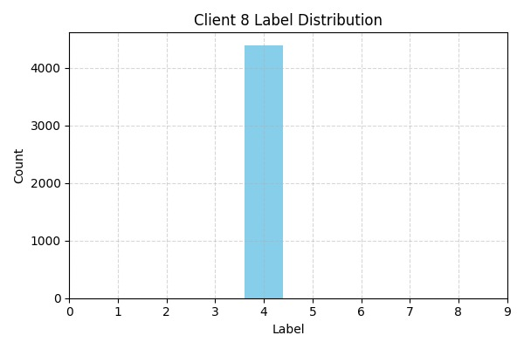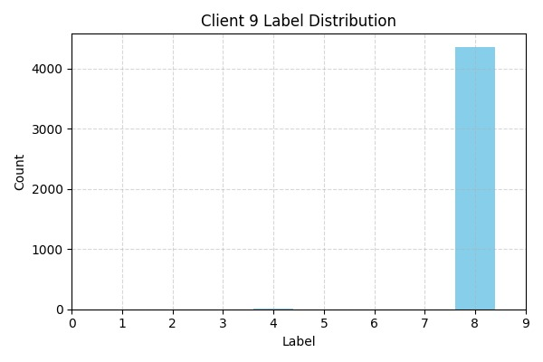

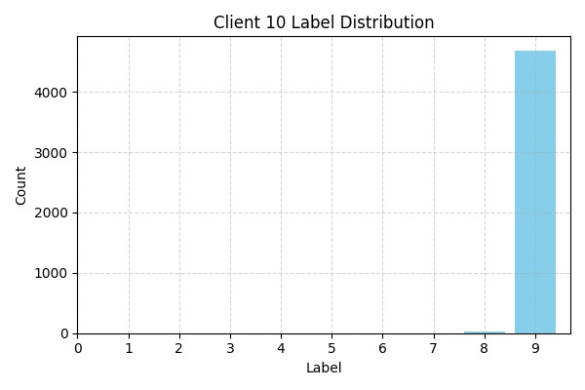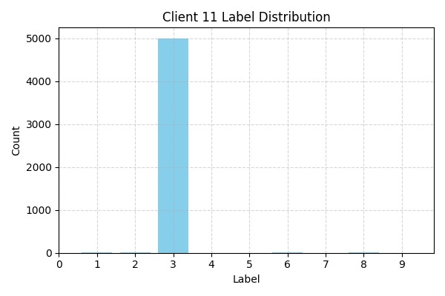

**Total number of samples each client has:**

|  |  |
| --- | --- |
| **Client ID** | **Sample count** |
| 0 | 4607 |
| 1 | 4632 |
| 2 | 7513 |
| 3 | 240 |
| 4 | 495 |
| 5 | 4668 |
| 6 | 3972 |
| 7 | 5330 |
| 8 | 4395 |
| 9 | 4366 |
| 10 | 4717 |
| 11 | 5065 |

