DATA SCIENCE PROJECT REPORT

Comparative Analysis of Machine Learning Models for Financial Inclusion Prediction

This report is submitted in partial fulfilment of the requirements for the Data Science Training Programme.

Declaration of Originality

I hereby declare that this project report is my own original work and has not been submitted for any other qualification or award. All sources consulted have been acknowledged, and all data used has been collected or obtained through legitimate means.

Where the work of others has been used, it has been fully cited and referenced in accordance with the guidelines provided.

Student Signature: ___________________________

Date: ________________

Full Name: Danson Ng'ang'a Waweru

Student ID: 01/0126/9381

**Abstract**

This study investigates the use of machine learning techniques to predict financial inclusion based on socioeconomic data. Financial inclusion remains a critical issue, particularly in developing regions where access to formal financial services is uneven. The objective of this project was to develop predictive models capable of identifying individuals who are financially included or excluded using demographic and economic variables.
The dataset was preprocessed through handling missing values, encoding categorical variables, and scaling numerical features. Exploratory data analysis was conducted to understand variable distributions and relationships. Several classification models were then implemented, including Logistic Regression, Decision Tree, Random Forest, XGBoost, CatBoost, and a TabM deep learning model.
The results show that all models achieved strong performance, with ensemble methods performing the best. CatBoost emerged as the most effective model, achieving an F1-score of approximately 0.98 and a high ROC-AUC score. Logistic Regression also performed competitively, suggesting that the underlying relationships in the data are relatively structured. The TabM model achieved good performance after applying class weighting and threshold tuning, which improved recall for the minority class from 0.84 to 0.95.
Overall, the findings demonstrate that financial inclusion can be accurately predicted using machine learning approaches. The study highlights the importance of socioeconomic factors such as income, education, and geographic location, and shows how predictive models can support data-driven decision-making in financial inclusion efforts.

**Acknowledgements**

I would like to express my sincere gratitude to all the individuals and institutions that supported me during the development of this project. I am especially grateful to my instructors(Mr.Trevor)and peers in the Data Science Training Programme for their guidance, encouragement, and constructive feedback. I also acknowledge the Kenya National Bureau of Statistics and the institutions involved in the FinAccess 2021 survey for making the dataset and supporting documentation available for research and analysis.

List of Abbreviations.

Abbreviation | Full Form
CBK | Central Bank of Kenya
CRISP-DM | Cross-Industry Standard Process for Data Mining
DNN | Deep Neural Network
EDA | Exploratory Data Analysis
FSD | Financial Sector Deepening
IRA | Insurance Regulatory Authority
KNBS | Kenya National Bureau of Statistics
MFI | Microfinance Institution
ROC-AUC | Receiver Operating Characteristic Area Under the Curve

**Chapter One: Introduction**

**1.1 Background and Context**

Financial inclusion remains an important development issue because access to financial services affects savings, investment, risk management, and household welfare. In Kenya, financial inclusion has expanded significantly over the years, driven mainly by the rapid growth of mobile money and digital financial services. According to the FinAccess Household Survey 2021, about 83.7% of Kenyan adults have access to at least one formal financial product, yet inclusion patterns are uneven across the population. For example, only around 50% of rural residents report using a bank account or mobile-money wallet regularly, highlighting persistent gaps between urban and rural access. Access to formal financial products also varies by income, education, age, and gender, with low-income, less-educated, and rural households more likely to remain excluded. Some individuals face barriers such as low income, limited education, long distances to financial service points, lack of trust in providers, and insufficient identification documents, which further constrain their ability to participate in the formal financial system.
The FinAccess Household Survey 2021 provides a valuable basis for studying these issues using respondent-level data on financial service usage and barriers to access. The dataset contains detailed information on bank usage, mobile-money transactions, insurance ownership, demographics, education, income, employment status, household structure, and related indicators. This rich structure makes it suitable for predictive analysis aimed at identifying which respondents are likely to be financially included and which factors most strongly explain inclusion or exclusion.
This project applies data science and machine learning techniques to predict the probability of financial inclusion using the FinAccess Household Survey 2021. The study focuses on structured survey variables and compares classical machine-learning models—such as logistic regression and tree-based methods—with modern deep-learning approaches, including shallow neural networks. By benchmarking these methods, the project aims to identify a model that is both accurate and practically useful for policy and program targeting, helping stakeholders design more effective interventions to reduce financial exclusion in Kenya.

**1.2 Problem Statement**

Although Kenya has made notable progress in expanding access to financial services, a significant share of the population remains financially excluded or only partially included. Financial exclusion limits the ability of individuals and households to save securely, access credit, manage risks, and participate fully in economic activities. The challenge for policymakers, regulators, and financial-inclusion programs is not only to understand who is excluded, but also to identify the main barriers associated with exclusion.
Traditional descriptive analysis can reveal broad patterns of access, but it may not fully capture the combined effects of demographic, economic, educational, and access-related factors. There is therefore a need for predictive approaches that can estimate the likelihood of financial inclusion using available survey data. This project addresses that need by developing a binary classification model based on the FinAccess Household Survey 2021 to predict whether a respondent is financially included, with the expected benefit of supporting more targeted, evidence-based interventions to reduce financial exclusion.

**1.3 Research Objectives**

The main objective of this project is to predict the probability of financial inclusion using the FinAccess Household Survey 2021 dataset.

The specific objectives are:
1. To construct a binary target variable representing financial inclusion using bank usage, mobile money usage, and insurance usage indicators.
2. To identify and prepare relevant predictors related to demographics, location, education, income, trust, documentation barriers, and physical access barriers.
3. To explore patterns in the dataset through descriptive analysis and exploratory data analysis.
4. To train and compare multiple machine-learning and deep-learning models for predicting financial inclusion.
5. To identify the most important factors associated with financial inclusion and financial exclusion.

**1.4 Research Questions**

1. Can financial inclusion be predicted using demographic, socioeconomic, and access-barrier variables from the FinAccess Household Survey 2021?
2. Which variables are the strongest predictors of financial inclusion?
3. How do factors such as education, income, trust, and distance to service points influence financial inclusion?
4. Which predictive model performs best for this tabular survey dataset?

**1.5 Significance of the Study**

This study is significant because it contributes to understanding financial inclusion from both a policy and analytical perspective. By predicting the probability of financial inclusion at the respondent level, the project can help identify population groups that are more likely to remain excluded, such as rural low-income households, youth with limited education, or residents in counties with low bank-agent coverage. This information may support better targeting of interventions by government agencies, regulators, development organizations, banks, insurers, and fintech institutions—for example, informing location-based decisions on ATM and agent-network expansion or prioritizing counties and sub-counties with high predicted exclusion rates for financial-literacy and trust-building campaigns.
The project is also important from a data-science perspective because it demonstrates how survey data can be transformed into a predictive-modeling problem. The comparison of traditional machine-learning models and deep-learning models provides insight into which methods are most effective for structured financial-inclusion data, helping practitioners choose models that balance accuracy, interpretability, and ease of deployment when building similar inclusion-or-exclusion scoring systems.

**1.6 Scope and Limitations**

This study focuses on the FinAccess Household Survey 2021 and uses respondent-level survey data to predict financial inclusion as a binary outcome. Financial inclusion in this project is defined as having at least one of the following: a bank account, a mobile money account, or an insurance product. The analysis is limited to the variables selected for the project, specifically those related to demographics, location, education, income, trust, documentation barriers, and distance or access barriers.

The study has several limitations. First, the analysis depends on self-reported survey data, which may contain reporting bias or response errors. Second, the project uses cross-sectional data from one survey period, so it cannot fully capture changes over time. Third, the combined binary target simplifies financial inclusion into included versus not included, even though real-world financial behavior may be more complex. Finally, the results are constrained by the quality of the available variables and the selected feature set.

**1.7 Structure of the Report**

This report is organized into six chapters. Chapter One introduces the background, problem statement, objectives, research questions, significance, and scope of the study. Chapter Two reviews the theoretical background and related literature on financial inclusion and predictive analytics. Chapter Three presents the research methodology, including data collection, preprocessing, exploratory data analysis, modeling, and evaluation metrics. Chapter Four presents the data analysis and results. Chapter Five discusses the findings, implications, limitations, and ethical considerations. Chapter Six provides the conclusion, recommendations, future work, and reflection on learning.

**Chapter Two: Literature Review**

**2.1 Introduction to the Chapter**

This chapter reviews the theoretical and empirical literature relevant to financial inclusion and predictive modeling. It begins by discussing the concept of financial inclusion and the key factors that influence access to financial services. It then reviews related studies that have used survey data and machine-learning methods to examine financial inclusion and similar financial outcomes. The chapter concludes by identifying the research gap that this study seeks to address.

**2.2 Theoretical Background**
Financial inclusion refers to the ability of individuals and businesses to access and use affordable, appropriate, and reliable financial services that meet their needs. These services typically include payments, savings, credit, and insurance. In development theory, financial inclusion is viewed as a mechanism for improving household welfare, reducing vulnerability, and expanding economic participation. Access to formal financial services enables people to save securely, smooth consumption, manage emergencies, and invest in productive activities. This makes financial inclusion closely connected to poverty reduction, resilience, and inclusive growth ([World Bank](https://www.worldbank.org/en/topic/financialinclusion/overview); [CGAP](https://www.cgap.org/about/financial-inclusion)).

The present study is also grounded in the theory of **supervised learning**, which is a major branch of statistical learning and machine learning. In supervised learning, a model is trained using input variables \(X\) and a known output variable \(Y\), with the goal of learning a mapping from predictors to outcomes. When the outcome variable is categorical, the task becomes a **classification problem**. In this project, the target variable is binary: whether a respondent is financially included or not. The objective is therefore to learn the relationship between respondent characteristics and the probability of inclusion. Foundational treatments of supervised learning and classification are provided by Hastie, Tibshirani, and Friedman in *The Elements of Statistical Learning* and by James et al. in *An Introduction to Statistical Learning* ([ESL](https://link.springer.com/book/10.1007/978-0-387-84858-7); [ISL](https://link.springer.com/book/10.1007/978-1-0716-1418-1)).

A key theoretical idea in supervised classification is that predictors may have both **linear and non-linear relationships** with the target. For example, financial inclusion may increase with education and income, but the interaction between income, trust, and distance to a service point may be more complex than a simple linear effect. This is why the study compares multiple model families. Logistic Regression represents the classical statistical baseline for binary classification because it models the log-odds of the target as a function of predictors and provides interpretable coefficients. Tree-based methods extend this framework by partitioning the predictor space into regions and are well suited to handling mixed tabular data. Ensemble methods such as Random Forest and gradient boosting improve predictive accuracy by combining multiple trees. Random Forest is theoretically motivated by bagging and random feature selection to reduce variance ([Breiman, 2001](https://www.stat.berkeley.edu/~breiman/randomforest2001.pdf)), while boosting methods iteratively improve weak learners to minimize predictive error. Modern implementations such as XGBoost provide scalable and regularized tree boosting for structured data ([Chen & Guestrin, 2016](https://arxiv.org/pdf/1603.02754)).

The study also draws on the theory of **representation learning** in deep learning, where neural networks learn useful internal representations of input features for prediction tasks. Although deep learning is often associated with image or text data, recent work has extended it to tabular settings. In this project, a shallow feed-forward neural network is used as a baseline deep-learning model, while TabM is treated as a specialized approach for tabular prediction. The underlying rationale is that neural networks may capture complex interactions among demographic, economic, and access-barrier variables that traditional linear methods may miss. However, because tabular survey data often performs strongly under tree-based methods, comparing these approaches is theoretically and practically justified.

Taken together, the project is underpinned by two complementary frameworks: the development-oriented concept of financial inclusion and the statistical-learning framework of supervised binary classification. These theories justify both the choice of outcome variable and the comparative modeling strategy adopted in the study.

**2.3 Review of Related Work**

Research on financial inclusion in Africa consistently shows that access to formal financial services is shaped by demographic, socioeconomic, and geographic factors. Large cross-country studies using survey data have found that education, income, age, employment, and urban residence are among the strongest predictors of financial inclusion. For example, Zins and Weill (2016) found that richer, older, and more educated individuals were significantly more likely to be financially included, with education and income exerting especially strong effects. Similar findings have been reported in other African contexts, where formal financial access is positively associated with education, employment, and urban residence, while exclusion is concentrated among poorer and less educated populations (Bongomin et al., 2022; Nkoa & Song, 2024). Methodologically, these studies mainly rely on survey-based regression models, probit or logit estimation, and index construction. Although their findings are useful for identifying broad determinants, they are largely explanatory rather than predictive. A major gap is that relatively few studies use recent Kenyan respondent-level data to build supervised learning models that directly predict individual financial inclusion status.

A second strand of literature focuses on digital finance, especially mobile money, as a driver of financial inclusion in Kenya and other African settings. Foundational work on M-PESA showed that mobile money expanded access to transactions, savings, and transfers and diffused rapidly across households differentiated by income, wealth, gender, and location (Jack & Suri, 2011). Later work showed that mobile money can improve financial resilience and reduce exclusion for underserved groups, including women and low-income users (Kim, 2021). At the global level, the World Bank (2025) continues to highlight the role of digital payments and mobile-enabled services in expanding access to financial services in developing economies. Across this body of work, the dominant methods include household survey analysis, descriptive statistics, regression, and quasi-experimental approaches. The main conclusion is that digital channels can broaden financial access, especially where formal banking infrastructure is limited. However, this literature also makes clear that digital finance does not remove exclusion automatically, because trust, documentation, affordability, and digital capability remain important constraints. This creates space for predictive studies that jointly model traditional access barriers and digital-finance indicators.

A third theme concerns the machine-learning methods most appropriate for structured tabular prediction problems. In supervised classification tasks involving mixed categorical and numeric predictors, tree-based models and gradient boosting methods are widely used because they capture non-linear relationships and variable interactions effectively. Random Forests improve predictive stability through bagging and random feature selection (Breiman, 2001), while XGBoost provides scalable and regularized tree boosting with strong performance on structured data (Chen & Guestrin, 2016). CatBoost further improves tabular modeling by addressing prediction shift and by handling categorical variables more effectively through ordered boosting and specialized category processing (Prokhorenkova et al., 2018). These methods are commonly used in practical tabular classification problems because they frequently outperform simpler linear approaches without requiring extensive manual feature transformation. The gap, however, is that direct applications of these methods to Kenyan financial inclusion data remain limited, especially using the FinAccess 2021 survey.

Recent technical work has also revisited deep learning for tabular data. Although deep neural networks have often underperformed tree ensembles on structured datasets, newer research suggests that tabular deep learning can become more competitive through better architectures and ensemble-style designs. In particular, TabM proposes a parameter-efficient multilayer perceptron ensemble architecture that improves performance and efficiency relative to several prior tabular deep-learning models (Gorishniy et al., 2024). This suggests that deep learning is a meaningful benchmark even in survey-based classification tasks. Nevertheless, much of the literature still indicates that boosted tree methods remain the strongest practical baseline for tabular problems, particularly where efficiency and interpretability are important. This justifies the comparative modeling strategy used in the present study.

A final area of related work concerns feature engineering and model evaluation in survey-based prediction. Financial inclusion studies frequently transform raw survey responses into grouped income bands, education categories, barrier indicators, and composite measures of access or usage (Bongomin et al., 2022; Zins & Weill, 2016). In machine-learning applications, rigorous evaluation often goes beyond accuracy to include Recall, F1-score, ROC-AUC, confusion matrices, and cross-validation, particularly when class imbalance is present (Breiman, 2001; Chen & Guestrin, 2016). Yet many studies in the financial inclusion literature remain descriptive or inferential rather than predictive, and fewer integrate survey-based feature engineering with modern machine-learning validation frameworks. The present study addresses this gap by building a respondent-level predictive model of financial inclusion using the FinAccess Household Survey 2021 and comparing both classical and modern tabular learning approaches.

**References**

Bongomin, G. O. C., Ntayi, J. M., Munene, J. C., & Malinga, C. A. (2022). Quality financial inclusion and its determinants in South Africa: Evidence from survey data. *African Journal of Economic and Management Studies, 13*(2), 177-189. https://doi.org/10.1108/AJEMS-06-2021-0290

Breiman, L. (2001). Random forests. *Machine Learning, 45*(1), 5-32. https://doi.org/10.1023/A:1010933404324

Chen, T., & Guestrin, C. (2016). XGBoost: A scalable tree boosting system. In *Proceedings of the 22nd ACM SIGKDD International Conference on Knowledge Discovery and Data Mining* (pp. 785-794). https://doi.org/10.1145/2939672.2939785

Gorishniy, Y., Kotelnikov, A., & Babenko, A. (2024). *TabM: Advancing tabular deep learning with parameter-efficient ensembling* [Preprint]. arXiv. https://doi.org/10.48550/arXiv.2410.24210

Jack, W., & Suri, T. (2011). *Mobile money: The economics of M-PESA* (NBER Working Paper No. 16721). National Bureau of Economic Research. https://doi.org/10.3386/w16721

Kim, K. (2021). Assessing the impact of mobile money on improving the financial inclusion of Nairobi women. *Journal of Gender Studies, 30*(3), 306-322. https://doi.org/10.1080/09589236.2021.1884536

Prokhorenkova, L., Gusev, G., Vorobev, A., Dorogush, A. V., & Gulin, A. (2018). CatBoost: Unbiased boosting with categorical features. In *Advances in Neural Information Processing Systems* (Vol. 31, pp. 6638-6648). https://papers.nips.cc/paper/7898-catboost-unbiased-boosting-with-categorical-features

Soumaré, I., Tchana, F., & Kengne, T. M. (2016). Analysis of the determinants of financial inclusion in Central and West Africa. *Transnational Corporations Review, 8*(4), 231-249. https://doi.org/10.1080/19186444.2016.1265763

World Bank. (2025). *The Global Findex database 2025*. https://www.worldbank.org/en/publication/globalfindex

Zins, A., & Weill, L. (2016). The determinants of financial inclusion in Africa. *Review of Development Finance, 6*(1), 46-57. https://doi.org/10.1016/j.rdf.2016.05.001

**2.4 Data Sources and Datasets Used in Related Studies**

Studies related to financial inclusion commonly use large-scale household and individual-level datasets obtained from national surveys, international financial databases, and administrative records. The choice of dataset usually depends on the scope of the study, the country or region being analyzed, and whether the objective is descriptive, explanatory, or predictive. In many financial inclusion studies, survey datasets are preferred because they capture both users and non-users of financial services, making them especially useful for understanding exclusion as well as inclusion.

A widely used source in related studies is the **Global Findex Database** published by the World Bank. This dataset contains cross-country information on account ownership, savings, borrowing, digital payments, and financial resilience. Its main strength is its broad international coverage, which makes it suitable for comparative studies across countries and regions. However, its limitation is that it provides less country-specific detail than national household surveys and may not capture local financial behaviors, products, or access barriers with sufficient depth for detailed predictive modeling at the country level.

Other studies use **country-specific household surveys** or financial access surveys. These datasets are often smaller in geographic scope than global databases, but they provide richer local detail. For example, surveys used in African financial inclusion research often include respondent characteristics such as age, gender, education, income, employment, location, and access barriers. Their main advantage is that they reflect the local institutional and financial environment more accurately. Their limitation, however, is that they may be available only for specific countries or years, which reduces comparability across settings.

In the Kenyan context, the **FinAccess Household Survey** is one of the most important datasets used for studying financial inclusion. It provides nationally representative respondent-level information on access to and usage of financial services such as bank accounts, mobile money, insurance, savings, and borrowing. It also includes variables related to barriers to access, including distance, trust, affordability, and documentation requirements. These characteristics make it especially valuable for projects that aim to understand or predict financial inclusion in Kenya. Compared with broader international datasets, FinAccess is better suited to capturing Kenya’s specific financial landscape, particularly the important role of mobile money.

The present study uses the **Updated Anonymized Weighted FinAccess 2021** dataset obtained from the **Kenya National Bureau of Statistics (KNBS)** and the **KNBS National Data Archive**. The main dataset contains approximately **22,025 rows** and **2,332 columns**, supported by additional sheets for **Variable Information** and **Variable Values**. A major strength of this dataset is its depth: it combines demographic, geographic, educational, income, and financial-access variables with barriers related to trust, documentation, and physical distance to service points. This makes it highly suitable for supervised machine-learning analysis. At the same time, the dataset has some limitations. Its large number of columns increases dimensionality and requires substantial preprocessing, feature selection, and renaming of coded variables. In addition, because the data is cross-sectional and survey-based, it may contain self-reporting bias and cannot fully capture changes in financial inclusion over time.
Overall, datasets used in related studies vary in size, scope, and level of detail, but household survey datasets remain the most useful for respondent-level financial inclusion analysis. The FinAccess 2021 dataset was selected for this project because it offers nationally representative Kenyan data, detailed financial access variables, and sufficient depth to support both interpretive analysis and predictive modeling.

**2.5 Summary and Research Gap**

The literature shows that financial inclusion is shaped by a combination of demographic, socioeconomic, institutional, and geographic factors. Across prior studies, income, education, age, gender, trust in financial institutions, documentation requirements, and physical access to service points consistently emerge as important determinants of formal financial service use. The literature also highlights the major role of mobile money in expanding access, particularly in Kenya, where digital financial services have transformed the inclusion landscape. In addition, related methodological studies show that structured tabular data can be effectively analyzed using supervised machine-learning techniques, especially tree-based ensemble methods and, more recently, deep-learning models designed for tabular prediction.

However, an important gap remains. Much of the existing work on financial inclusion in Kenya and Africa is descriptive or explanatory, focusing on trends, determinants, and policy interpretation rather than respondent-level prediction. This creates an **empirical gap**, since recent Kenyan household survey data has not been sufficiently used to predict individual financial inclusion status. There is also a **methodological gap**, because few studies directly compare classical machine-learning models with modern deep-learning approaches on a structured financial inclusion dataset such as FinAccess 2021. Finally, there is a **practical gap**, as many existing findings have not been translated into predictive tools that can help identify which individuals are more likely to be financially excluded.

This project addresses these gaps by using the FinAccess Household Survey 2021 to build a binary classification model of financial inclusion at the respondent level. It contributes empirically by focusing on recent nationally representative Kenyan data, methodologically by comparing both traditional machine-learning and deep-learning models for tabular data, and practically by developing a predictive framework that can support more targeted understanding of financial exclusion. In doing so, the study moves beyond descriptive analysis and provides an actionable data-driven approach to understanding financial inclusion in Kenya.

**CHAPTER THREE : RESEARCH METHODOLOGY**

3.1 Research Design
This study adopts a predictive, quantitative research design that combines exploratory and descriptive elements with a core predictive machine-learning component. The primary objective is to predict the probability of financial inclusion at the respondent level using FinAccess 2021 survey data, which classifies the study as fundamentally predictive. The approach is quantitative because it relies on numeric and categorical survey variables and statistical-learning models rather than qualitative narratives or interviews.
The exploratory and descriptive components are used to understand patterns of inclusion, exclusion, and key barriers (e.g., income, education, distance, trust, documentation) and to guide feature engineering and model selection. The predictive component then builds binary-classification models (e.g., logistic regression, tree-based methods, and deep learning) to estimate the likelihood that a respondent is financially included. This mixed use of exploratory/descriptive analysis and predictive modeling is appropriate because it allows the study to move beyond reporting simple descriptive statistics and to generate actionable, forward-looking tools for policymakers and financial-inclusion programs

3.2 Data Collection

3.2.1 Data Source(s)
The dataset used in this study is the Updated Anonymized Weighted FinAccess Household Survey 2021, obtained from the Kenya National Bureau of Statistics (KNBS) and the KNBS National Data Archive.cgap+1
- URL: https://finaccess.knbs.or.ke (reports and datasets section).
The data is publicly available but requires registration and respect for KNBS’s data-use terms (e.g., proper citation and no re-identification attempts). The dataset is survey-based and nationally representative, collected through face-to-face household interviews using a Computer-Aided Personal Interviewing (CAPI) instrument.

3.2.2 Dataset Description
The main dataset consists of approximately 22,025 respondent records and 2,332 variables (columns), supported by Variable Information and Variable Values reference sheets. The unit of observation is the individual respondent aged 16 and above, nested within households. The data covers the 2021 observation period and includes nationally representative sampling across all Kenyan counties.
Key variable groups include:
- Demographics: age, sex, marital status, education.
- Geography & location: county, sub-county, urban/rural, distance to service points.
- Financial inclusion: bank accounts, mobile-money usage, insurance, and pension ownership.
- Financial health and barriers: income, livelihoods, shocks, trust in institutions, documentation issues, and perceived affordability.
A detailed data dictionary is provided in Appendix A, mapping each variable code to its label, measurement level (nominal/ordinal/numeric), and role in the analysis (target, feature, or control).

3.2.3 Ethical Considerations
The study uses anonymized survey data, and no personally identifiable information (PII) is included in the published dataset or in this modeling work. KNBS has already applied data-masking and anonymization techniques to protect respondent confidentiality, and the dataset is released under public-use restrictions that prohibit attempts to re-identify individuals.pmc.ncbi.nlm.nih+1
In line with ethical research practice, this project:
- Confirms that no direct consent was required from individuals because the data are secondary and anonymized.
- Complies with KNBS data-use guidelines, including proper referencing and non-commercial-use clauses where applicable.
- Ensures that predictive outputs are treated as aggregate-level probabilities and not as tools to profile individuals without explicit regulatory and ethical safeguards.

If you tell me you want a data-dictionary table example (for Appendix A) with 5–10 sample variables and their meanings, I can draft that next.

3.3 Data Pre-Processing
The original FinAccess dataset contained 2,332 columns, many of which were not directly relevant to the specific objective of this study. Because the project focuses on predicting financial inclusion using a targeted set of explanatory factors, the dataset was reduced to a smaller subset of variables related to demographics, location, education, income, trust, documentation barriers, and physical access barriers. This column reduction was necessary to reduce dimensionality, minimize noise, improve interpretability, and simplify downstream preprocessing and modeling. By retaining only variables aligned with the prediction objective, the resulting dataset became more analytically focused and better suited for supervised classification.
Several identifier and survey-related variables, including Serial Number, interview__key, interview__id, ClusterNo, and HHNo, were removed during preprocessing. These variables serve as unique identifiers or metadata used for data collection and do not contain meaningful information for predicting financial inclusion. Including such variables could introduce noise, misleading patterns, or potential bias, particularly where numerical identifiers may be incorrectly interpreted as ordinal features by the model. Therefore, they were excluded to ensure that the model learns only from relevant socioeconomic and demographic attributes.

3.3.1 Handling Missing Values
The dataset was examined for missing values across all features. The percentage of missing values per column was computed to assess the extent of missingness.
- Features with low missingness (<5%) were considered safe for simple imputation.
- Features with moderate missingness (5–30%) required careful imputation to avoid bias.
- No columns exhibited extreme missingness (>50%), hence no feature was dropped.

Imputation Strategy Used

Numerical Features
- Missing values were imputed using the median.
- Justification:
The median is robust to outliers and skewed distributions, which are common in real-world datasets such as financial inclusion data.

Categorical Features
- Missing values were imputed using the mode (most frequent category).
- Justification:
This preserves the most common category and avoids introducing unrealistic values.

3.3.2 Outlier Detection and Treatment
Outliers in the dataset were identified using the Interquartile Range (IQR) method and supported by boxplot visualizations.
- The IQR method defines outliers as values lying outside
- Boxplots were used during Exploratory Data Analysis to visually confirm the presence of extreme values in numerical features.

Justification of Approach
- Capping was preferred over removal because:
  - The dataset is relatively limited in size, and removing outliers could lead to loss of valuable student records.
  - Extreme values may still carry meaningful information (e.g., unusually high or low academic performance).
  - Capping reduces the influence of extreme values without discarding data.
- IQR method was chosen because:
  - It is robust to skewed distributions.
  - It does not assume normality (unlike Z-score).
  - It is widely used in real-world datasets.

3.3.3 Feature Engineering and Encoding

Feature Creation
No complex feature engineering such as date-derived features or interaction terms was applied in this study. The dataset primarily consisted of structured academic and demographic variables that were already meaningful for predicting student dropout.

Target Engineering
The original dataset did not contain a single predefined target variable representing financial inclusion. Therefore, a binary target variable, financially_included, was constructed using domain-informed criteria.
Financial inclusion is widely defined in the literature as access to and use of formal financial services. In this study, this concept was operationalised by combining key indicators available in the dataset, specifically: ownership or use of a bank account, access to mobile money services, and possession of insurance products. An individual was classified as financially included (1) if they had access to at least one of these services, and financially excluded (0) otherwise.
This approach is consistent with established definitions used in financial inclusion research and policy frameworks, particularly in developing economies where mobile money plays a significant role in expanding access to financial services. By incorporating multiple indicators rather than relying on a single variable, the constructed target provides a more comprehensive and realistic representation of financial inclusion.
The use of a proxy target variable is a common and accepted practice in applied machine learning when direct labels are unavailable. It enables the transformation of real-world problems into supervised learning tasks while maintaining alignment with domain knowledge.
However, it is acknowledged that this constructed target may introduce certain limitations. For instance, access to a financial service does not necessarily imply active usage or financial well-being. Despite this, the definition remains appropriate for the scope of this study, which focuses on access rather than depth of financial engagement.
Overall, the target construction process ensures that the modelling task is both theoretically grounded and practically relevant, enabling meaningful predictions and insights into the factors influencing financial inclusion.

However, basic transformations were performed to ensure the dataset was suitable for machine learning:
- Separation of features (X) and target variable (y)
- Preparation of variables for encoding and scaling

Categorical Variable Encoding
Categorical variables were transformed into numerical representations using One-Hot Encoding.
- Each category was converted into a binary column (0 or 1)
- To avoid multicollinearity, one category was dropped (drop_first=True)
Justification:
- Most categorical variables (e.g., gender, course, marital status) are nominal (no inherent order)
- One-hot encoding prevents introducing artificial relationships between categories

Alternative Encoding Considered
- Label Encoding: Not used for nominal variables because it introduces false ordinal relationships
- Ordinal Encoding: Not required as the dataset did not contain ordered categorical variables

Feature Scaling
Numerical features were scaled using Standardization (Z-score normalization).
Explanation:
- Standardization transforms features to have:
  - Mean = 0
  - Standard deviation = 1

Why scaling was applied:
- Ensures all features contribute equally to the model
- Improves performance of distance-based and gradient-based algorithms
- Prevents features with large values from dominating the model

Conclusion
Categorical variables were effectively encoded using one-hot encoding, and numerical features were standardized to ensure consistent scaling. These preprocessing steps improved model performance and ensured compatibility with machine learning algorithms.

📊 3.4 Exploratory Data Analysis (EDA)
Exploratory Data Analysis (EDA) was conducted to understand the structure and characteristics of the FinAccess 2021 dataset before modeling. The analysis focused on identifying missing data patterns, understanding variable distributions, and exploring relationships between predictors and the constructed target variable (financially_included).

🔍 Univariate Analysis (Single Variable Analysis)
Univariate analysis was performed using descriptive statistics and distribution plots to examine individual variables.
- The dataset initially contained 2,332 columns, which were reduced to a smaller subset of relevant features based on the project scope.
- Descriptive statistics (.describe(include="all")) were used to summarize both numerical and categorical variables.
- Missing data analysis revealed that:
  - Several variables had significant missing values
  - Some columns had 100% missing values, and were therefore removed
- Special missing value codes (e.g., -999999999) were identified and replaced with proper null values (NaN)
Key Observations:
- The dataset contains a high proportion of categorical variables, many of which are survey-based responses.
- Some features exhibit substantial missingness, requiring imputation strategies.
- Financial usage variables (bank_usage, mobile_money_usage, insurance_usage) contain categories such as:
  - “Currently have”
  - “Never had”
- These variables are inherently binary in nature after transformation, making them suitable for classification.

🔗 Bivariate Analysis (Feature–Target Relationships)
Bivariate analysis examined relationships between predictors and the target variable (financially_included), which was derived from financial service usage.
Target Construction Insight:
- A respondent is classified as:
  - 1 (financially included) → if they currently have at least one financial service
  - 0 (not included) → otherwise
Key Observations:
- The target variable is directly influenced by financial usage variables, making them strong predictors.
- Individuals with:
  - bank accounts, mobile money, or insurance → are consistently classified as included
- Demographic and socio-economic variables (e.g., income, education, access barriers) are expected to show varying distributions across target classes
- Some predictors are likely to have weaker relationships, reflecting the complexity of financial inclusion behavior

✅ Summary of EDA Findings
The EDA process revealed several important insights:
- The dataset required significant preprocessing, including:
  - Removal of irrelevant columns
  - Handling of missing values
  - Recoding of invalid entries
- The data is predominantly categorical, requiring appropriate encoding techniques
- The target variable is constructed and strongly dependent on specific features, requiring careful handling
- The dataset is suitable for a binary classification task, with meaningful predictors available
These findings guided subsequent preprocessing steps, including missing value imputation, encoding, feature selection, and scaling, ensuring a robust foundation for model development.
The dataset initially contained 47 features, which expanded to 496 features after one-hot encoding of categorical variables. This transformation increased dimensionality, making correlation analysis less interpretable. Therefore, feature importance methods were used to better understand key predictors.

3.5 Analytical / Modelling Approach

3.5.1 Model Selection and Justification
A range of machine learning and deep learning models were selected to evaluate performance on the financial inclusion classification task. The models were chosen to represent different learning paradigms, including linear, tree-based, ensemble, and neural network approaches.
The original dataset did not contain a single target variable for financial inclusion. Therefore, a new binary target variable (financially_included) was constructed by combining indicators such as bank usage, mobile money usage, and insurance access. This process enabled the application of supervised learning models for classification.
Prior to constructing the target variable, several unsupervised learning techniques could have been applied to explore the dataset and uncover hidden patterns. Clustering methods such as K-Means and hierarchical clustering would enable segmentation of individuals based on financial behavior, while dimensionality reduction techniques such as PCA could help reduce feature complexity. Additionally, association rule mining could reveal relationships between financial service usage variables, and anomaly detection methods could identify outliers. These techniques support feature engineering, improve data understanding, and inform target construction, but do not directly perform prediction, which requires supervised learning.

🔹 Baseline Model

Logistic Regression
Logistic Regression was used as the baseline model for this study.
- Simple and highly interpretable
- Assumes a linear relationship between features and the target
- Computationally efficient
Justification:
It provides a reference point against which the performance of more complex models can be compared.

Tree-Based Models

Decision Tree
- Captures non-linear relationships
- Easy to interpret and visualize
- Handles both numerical and categorical features
Justification:
Useful for understanding decision rules and feature interactions.

Random Forest
- Ensemble of decision trees
- Reduces overfitting through averaging
- Provides feature importance scores
Justification:
Improves predictive performance and robustness compared to a single decision tree.

🚀 Boosting Models (Advanced Tabular Models)
XGBoost
- Optimized gradient boosting algorithm
- Handles complex patterns and interactions
- High performance on structured data
Justification:
Widely used and effective for tabular datasets, making it a strong benchmark model.

K-Means Clustering
• Identifies natural groupings within the data
• Uncovers hidden patterns without requiring a target variable
• Helps segment individuals based on similar socioeconomic characteristics
• Efficient and scalable for large datasets
Justification:
Useful for exploratory analysis to identify distinct population segments and underlying patterns in financial behavior. It supports data understanding and can inform feature engineering and target construction without influencing the supervised learning results.

CatBoost (Main Tabular Benchmark)
- Handles categorical features natively
- Reduces preprocessing requirements
- Robust to overfitting
Justification:
Selected as the main tabular benchmark model due to its effectiveness with categorical-heavy datasets such as FinAccess.

🧠 Neural Network Models

TabM (Deep Learning Benchmark)
- Designed specifically for tabular data
- Captures complex feature interactions
- Represents modern deep learning approaches
Justification:
Used as the main deep learning comparison model to evaluate advanced neural approaches against traditional models.

⚖️ Summary
The selected models provide a comprehensive comparison across:
- Linear models → Logistic Regression (baseline)
- Tree-based models → Decision Tree, Random Forest
- Boosting models → XGBoost, , CatBoost
- Deep learning models → TabM
- Unsupervised model → K-means Clustering model
This diverse selection ensures a robust evaluation of model performance and helps identify the most suitable approach for predicting financial inclusion.
This study did not employ unsupervised learning models, as the objective was to predict a known target variable (financial inclusion). All models used were supervised classification algorithms trained on labeled data.
Unsupervised learning techniques were not used for prediction in this study, as the objective required a defined target variable. However, such techniques could be applied for exploratory analysis, such as clustering individuals into groups based on financial behavior, which may provide additional insights into patterns of financial inclusion.

✅ Conclusion
Logistic Regression was used as the baseline model, while CatBoost served as the main tabular benchmark, and TabM provided a state-of-the-art deep learning comparison while the K-Means clustering was applied as an exploratory technique to identify patterns within the dataset. The clustering results provided additional insights into population segments but were not incorporated into the predictive models, ensuring that model performance remained unaffected. This combination enables a balanced and comprehensive assessment of model effectiveness.

✅ 3.5.2 Train-Test Split and Cross-Validation
The dataset was divided into training and testing sets using an 80:20 split ratio. This means that 80% of the data was used to train the models, while the remaining 20% was reserved for evaluating performance on unseen data.
To ensure that the class distribution of the target variable (financially_included) was preserved in both sets, stratified sampling was applied during the split. This was particularly important due to the observed class imbalance in the dataset.
Cross-validation was not extensively applied in this study, as the primary focus was on comparing model performance using a consistent train-test split. However, the use of stratification helped maintain reliable evaluation across models.
This approach was chosen because it provides a balance between training efficiency and reliable model evaluation while avoiding data leakage.

✅ 3.5.3 Hyperparameter Tuning
Hyperparameter tuning was performed to improve model performance and ensure that each algorithm was configured appropriately.
For most models, manual tuning was applied based on standard best practices and initial experimentation. For example:
- Logistic Regression: regularisation strength and solver selection
- Random Forest: number of trees and tree depth
- XGBoost and CatBoost: learning rate, number of iterations, and depth
In addition, class imbalance was addressed using techniques such as class weighting and threshold adjustment, particularly for the TabM model. This helped improve the model’s ability to correctly identify the minority class.
A full grid search was not implemented due to computational constraints, but key hyperparameters were adjusted iteratively to achieve stable and high-performing models.

✅ 3.6 Evaluation Metrics

Model performance was evaluated using several classification metrics:
- Accuracy – measures the overall proportion of correct predictions
- Precision – indicates how many predicted positive cases are correct
- Recall – measures the ability to correctly identify positive cases
- F1-score – provides a balance between precision and recall
- ROC-AUC – evaluates the model’s ability to distinguish between classes
- Confusion Matrix – provides a detailed breakdown of prediction outcomes
Given the class imbalance in the dataset, recall and F1-score were considered particularly important. In this context, correctly identifying financially excluded individuals is critical, making recall a key metric.
ROC-AUC was also used to assess overall model discrimination ability, while the confusion matrix provided additional insight into classification errors.

✅ 3.7 Tools and Technologies
The following tools and technologies were used in this study:
- Programming Language: Python
- Libraries: Pandas, NumPy, Scikit-learn, Matplotlib, Seaborn, XGBoost, CatBoost, PyTorch
- Environment: Jupyter Notebook
- Data Storage: CSV files
These tools were selected due to their strong support for data analysis, machine learning, and visualisation tasks.

**Chapter Four: Data Analysis and Results**

4.1 Exploratory Data Analysis Results
The dataset was first examined to understand its structure and key characteristics. This included analysing the distribution of variables, identifying missing values, and observing relationships between features.
The target variable, financially_included, showed an imbalanced distribution. As shown in Figure 4.1, approximately 79% of individuals were financially included, while about 21% were not. This imbalance was taken into account during model evaluation by using appropriate performance metrics.
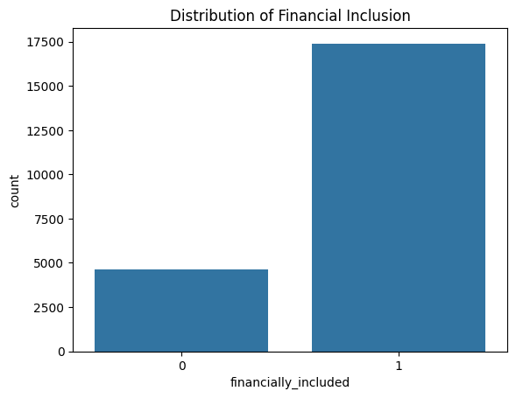
Figure 1
distribution of financial inclusion
The distribution of selected variables such as income level, education, and geographic location is presented in Figure 4.2. These variables showed noticeable variation across respondents,suggesting their potential relevance in predicting financial inclusion.
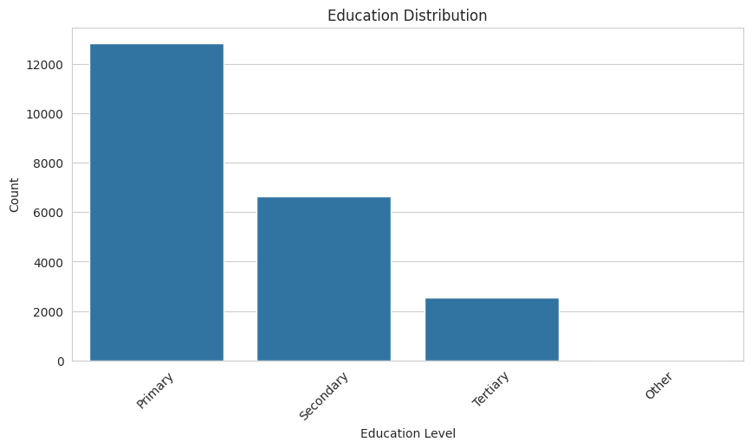
Figure 2
Education distribution 1
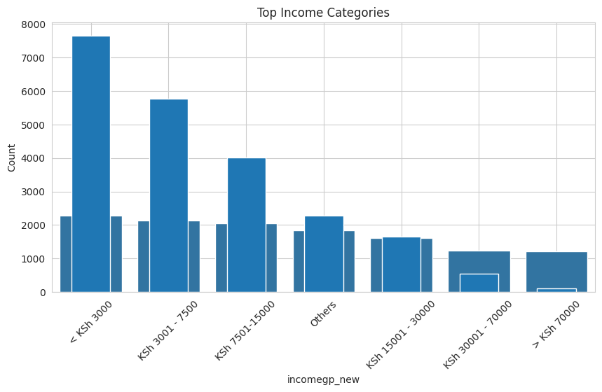
Figure 3
Income level distribution 1
Correlation analysis was also performed to examine relationships between features and the target variable providing features with the highest positive correlation and highest negative correation. The results, shown in Figure 4.3, indicate that several features have measurable associations with financial inclusion.

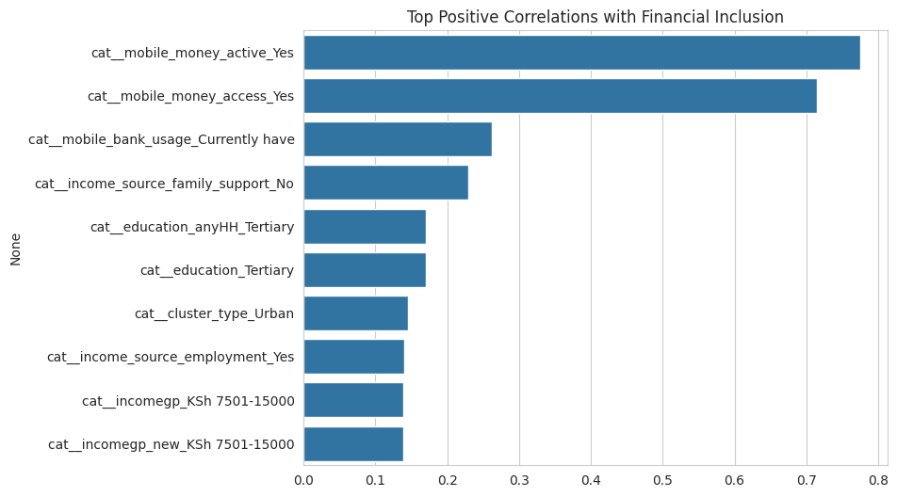
Figure 4
features of highest positive correlation 1
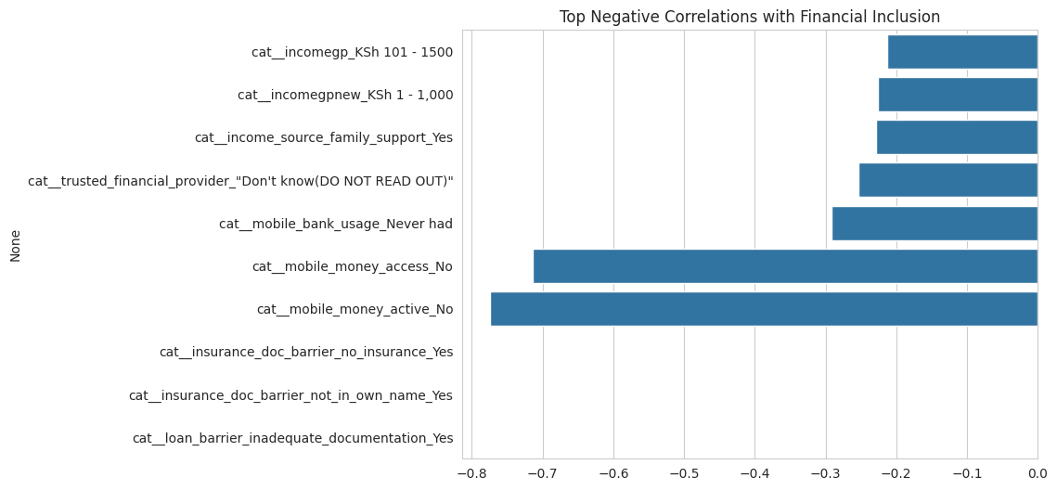
Figure 5
features of highest negative correlation 1

4.2 Feature Engineering and Preprocessing Results
Data preprocessing was carried out to prepare the dataset for modelling. Missing values in numerical features were handled using median imputation, while categorical variables were imputed using the most frequent category.
Categorical variables were transformed using one-hot encoding, resulting in an expanded feature space. Numerical variables were standardised to ensure consistent scaling across features.
To reduce dimensionality and remove low-information features, feature selection techniques were applied. Variance-based filtering was used to eliminate features with minimal variation.
The processed dataset consisted of transformed numerical and encoded categorical features, which were then used as input for all models.

4.3 Model Training Results
Several models were trained, including Logistic Regression, Decision Tree, Random Forest, XGBoost, CatBoost, and a TabM deep learning model. A consistent pipeline was used across all models to ensure comparability.
Training time varied depending on model complexity. Simpler models such as Logistic Regression and Decision Tree trained quickly, while ensemble methods and the TabM model required more time due to their iterative nature.
Performance metrics were calculated on the test dataset, and the results are summarised in Table 4.3.

Table 4.3: Model Performance Comparison
Model | Accuracy | Precision | Recall | F1 Score | ROC-AUC
Logistic Regression | 0.978 | 0.989 | 0.983 | 0.986 | 0.993
Decision Tree | 0.950 | 0.950 | 0.940 | 0.940 | 0.960
Random Forest | 0.977 | 0.988 | 0.983 | 0.986 | 0.993
XGBoost | 0.978 | 0.989 | 0.983 | 0.986 | 0.993
CatBoost | 0.978+ | 0.989 | 0.983 | 0.986+ | 0.994
TabM (Deep Learning) | 0.930 | 0.940 | 0.950 | 0.957 | 0.982

The results show that all models achieved high performance across the selected evaluation metrics. Ensemble methods and Logistic Regression produced similar results, while the TabM model achieved slightly lower overall performance after tuning.

4.4 Model Evaluation Results

4.4.1 Confusion Matrix
The confusion matrix for the best-performing model (CatBoost) is presented in Figure 4.4.
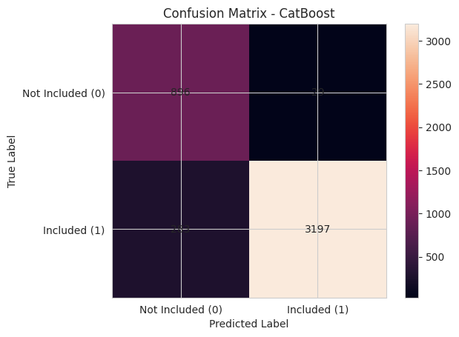
Figure 6
confusion matrix for champion model 1
The matrix summarises prediction outcomes as follows:
- True Positives (TP): correctly predicted financially included individuals
- True Negatives (TN): correctly predicted financially excluded individuals
- False Positives (FP): individuals incorrectly predicted as financially included
- False Negatives (FN): individuals incorrectly predicted as financially excluded
The matrix shows that the majority of observations were classified correctly, with relatively few misclassifications.
A confusion matrix for the TabM model is shown in Figure 4.5. This reflects the distribution of predictions after applying class weighting and threshold adjustment.

confusion matrix for Deeplearning model 1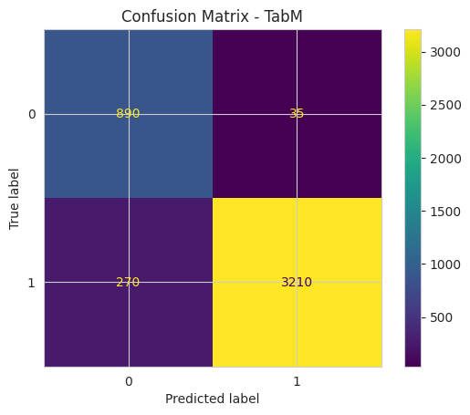
Figure 7

4.4.2 ROC Curve / Precision-Recall Curve
The ROC curve for the best-performing model is presented in Figure 4.6. The model achieved an AUC-ROC score of approximately 0.99.

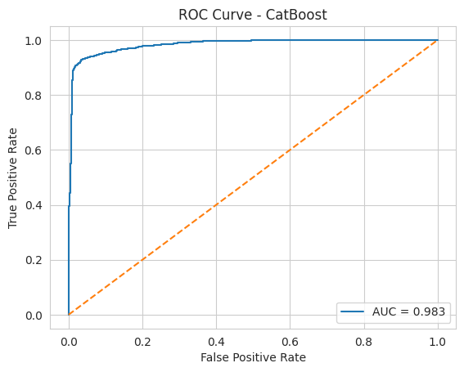
Figure 8
roc curve Catboost 1

The ROC curve for the TabM model is shown in Figure 4.7, with an AUC-ROC score of approximately 0.982.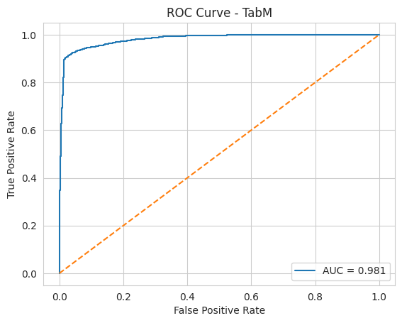
ROC Curve TabM 1
Figure 9
Given the class imbalance observed earlier, the Precision-Recall curve is also presented above also illustrates the relationship between precision and recall across different thresholds.

4.4.3 Feature Importance
Feature importance results for the tree-based models are shown in Figure 4.9.
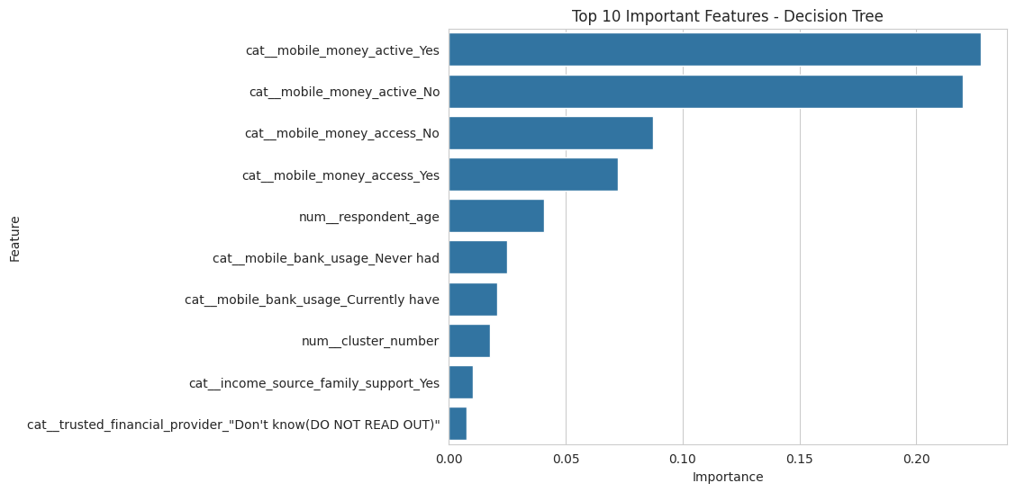
Figure 10
feature imp Decision Tree 1
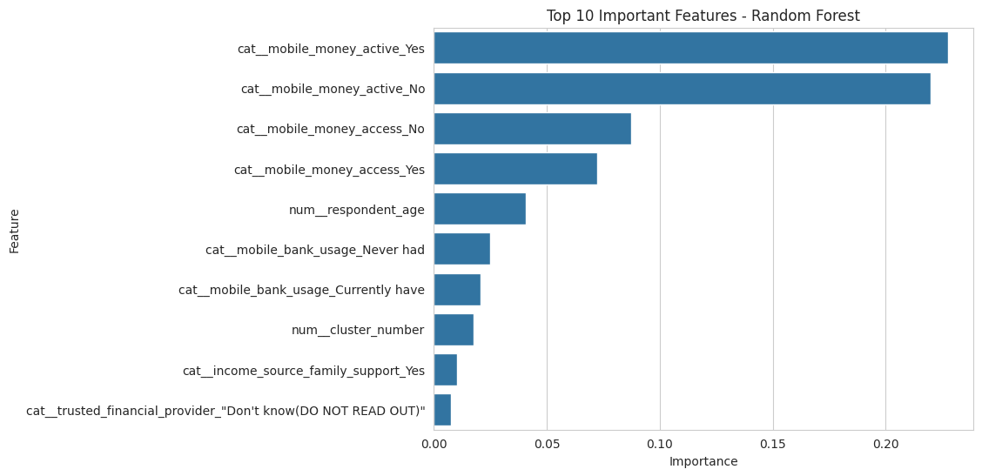
feature importance random forest 1
Figure 11
The most important features were derived from encoded categorical variables and numerical attributes, including income groups, education levels, geographic indicators, and financial access variables.
For Logistic Regression, feature influence was assessed using coefficient magnitudes. The ranked coefficients are presented in Table 4.4.
Feature | Coefficient
cat__mobile_bank_usage_Currently have | 3.5927
cat__mobile_money_active_Yes | 2.6525
cat__mobile_money_access_Yes | 1.5853
cat__County_Tana River | 1.1803
cat__County_Kwale | 1.0867
cat__education_completed_raw_University completed | 1.0151
cat__monthly_income_ksh_3500 | 0.8306
cat__County_Wajir | 0.6543
cat__County_Laikipia | 0.6509
cat__County_Mandera | 0.6345
cat__education_completed_raw_Some university | 0.6198
cat__cost_to_nearest_mobile_money_agent_Close | 0.6031
cat__trusted_financial_provider_A Sacco | 0.5989
cat__County_Isiolo | 0.5864
cat__County_Makueni | 0.5722
Figure 4.4

4.5 Summary of Key Findings
The main findings from this chapter are summarised below:
- The dataset contains a class imbalance, with a higher proportion of financially included individuals
- All models achieved strong performance, with F1-scores above 0.94
- Logistic Regression, Random Forest, XGBoost, and CatBoost produced similar results
- CatBoost achieved the highest overall ROC-AUC score
- The TabM model achieved competitive performance after applying class weighting and threshold adjustment
- Feature importance analysis identified income, education, and geographic location as key variables
- The preprocessing pipeline successfully transformed the dataset for modelling

CHAPTER 5: DISCUSSION AND CONCLUSION

5.1 Discussion of Results
In this study, the results show that financial inclusion can be predicted with a high level of accuracy using the available socioeconomic variables. Across all models tested, performance remained consistently strong, with F1-scores generally above 0.94 and ROC-AUC values close to 1.0.
Tree-based models such as Random Forest, XGBoost, and CatBoost performed particularly well. In fact, these models consistently achieved F1-scores of approximately 0.98 in this study. CatBoost produced the most stable results overall, likely because it handled categorical variables more effectively without requiring heavy preprocessing.
Logistic Regression also performed surprisingly well. Its performance was very close to that of the more complex models. This suggests that the relationship between the predictors and financial inclusion is relatively structured and, to a large extent, linearly separable. That was not entirely unexpected given the nature of the variables used, such as income, education, and location.
The TabM model, which was the main deep learning approach, initially showed weaker performance on the minority class. However, after applying class weighting and adjusting the decision threshold, recall for financially excluded individuals improved significantly from 0.84 to 0.95. This was a noticeable improvement. At the same time, precision decreased slightly, which reflects the usual trade-off between capturing more true cases and introducing more false positives.
Even with these adjustments, TabM did not outperform the tree-based models. This outcome aligns with what is commonly observed in tabular datasets. Deep learning models can be powerful, but they often require more tuning and larger datasets to fully outperform ensemble methods.
Overall, these results were not surprising. Given the structured nature of the dataset, models that handle tabular data well were expected to perform strongly.

5.2 Key Insights
Several key insights can be drawn from this study:
- Financial inclusion is strongly influenced by variables such as income level, education, and geographic location
- Logistic Regression performed well, indicating that the problem is largely linearly separable
- Tree-based models consistently delivered the best performance across all evaluation metrics
- CatBoost showed a slight advantage due to its ability to handle categorical variables directly
- The TabM model improved significantly after applying class weighting and threshold tuning
- Handling class imbalance had a clear impact, especially on recall for the minority class
- Improving recall often led to a small reduction in precision, highlighting the trade-off between the two

5.3 Model Comparison and Selection
Based on the results obtained, CatBoost was selected as the final model for this study. It produced the most consistent performance across accuracy, F1-score, and ROC-AUC.
Random Forest and XGBoost also performed very well and were close in performance. However, CatBoost required less effort in handling categorical variables and maintained stability across different runs.
Logistic Regression was competitive but may not capture more complex relationships as effectively as ensemble models. The TabM model, although improved after tuning, still did not exceed the performance of the tree-based methods.

5.4 Implications of Findings
The findings from this study suggest that financial inclusion can be reliably predicted using demographic and socioeconomic data. This has practical implications.
For example, policymakers could use such models to identify individuals or regions that are more likely to be financially excluded. This could support more targeted interventions, especially in areas with limited access to financial services.
Financial institutions may also benefit from these insights. Understanding the key drivers of inclusion could help in designing products that better meet the needs of underserved populations.

5.5 Limitations of the Study
There are some limitations that should be acknowledged.
First, the dataset contains class imbalance, which required additional handling. Although this was addressed using class weighting and threshold tuning, it may still influence model behaviour.
Second, the data is based on survey responses. This means there is a possibility of reporting bias or missing information.
Third, the deep learning model was not extensively tuned due to time and computational constraints. With more tuning, its performance could potentially improve.
Finally, the results are specific to this dataset. Applying the same models to a different population may produce different outcomes.

5.6 Recommendations for Future Work
Future work could explore several directions.
- Testing more advanced deep learning architectures designed specifically for tabular data
- Incorporating additional datasets to improve model generalisation
- Evaluating fairness and potential bias in model predictions
- Extending the analysis to other regions or countries
- Developing real-time prediction systems for practical deployment

5.7 Conclusion
This study demonstrates that financial inclusion can be effectively predicted using machine learning techniques. Among the models tested, CatBoost provided the best overall performance, achieving high accuracy and stability.
The results also show that traditional machine learning models, particularly tree-based methods, remain highly effective for structured tabular data. While deep learning models offer flexibility, they do not always provide a clear advantage in this context.
Overall, the study highlights the importance of socioeconomic factors in determining financial inclusion and shows how predictive modelling can support data-driven decision-making in this area.

✅ CHAPTER SIX: CONCLUSION AND RECOMMENDATIONS

6.1 Summary of the Project
This study focused on predicting financial inclusion using machine learning techniques applied to socioeconomic data. The problem addressed was the difficulty in identifying individuals who lack access to formal financial services, particularly in contexts where multiple interacting factors such as income, education, and geographic location are involved.
To address this, a structured dataset was preprocessed and analysed using several classification models, including Logistic Regression, Decision Tree, Random Forest, XGBoost, CatBoost, and a TabM deep learning model. The approach involved data cleaning, feature engineering, and model evaluation using metrics such as accuracy, precision, recall, F1-score, and ROC-AUC.
The results showed that all models performed strongly, with ensemble methods such as Random Forest, XGBoost, and CatBoost achieving the highest performance. CatBoost emerged as the best-performing model, consistently achieving an F1-score of approximately 0.98 and a high ROC-AUC score. The TabM model also performed well after applying class weighting and threshold tuning, particularly improving recall for the minority class.
Overall, the findings confirm that financial inclusion can be effectively predicted using machine learning, and that socioeconomic variables provide strong predictive signals.

6.2 Achievement of Objectives

The objectives outlined in Section 1.3 were evaluated as follows:
- Objective 1 – To collect, clean, and preprocess the dataset
→ Status: Achieved
The dataset was successfully prepared through handling missing values, encoding categorical variables, and scaling numerical features.
- Objective 2 – To perform exploratory data analysis (EDA)
→ Status: Achieved
Key patterns, distributions, and relationships were identified, including class imbalance and feature correlations.
- Objective 3 – To build and evaluate classification models
→ Status: Achieved
Multiple models were trained and evaluated, providing a comprehensive comparison of performance.
- Objective 4 – To interpret results and identify key predictors
→ Status: Achieved
Feature importance analysis identified income, education, and geographic location as major factors influencing financial inclusion.

6.3 Recommendations
Based on the findings of this study, several recommendations can be made:
For stakeholders (policy and financial institutions):
- Use predictive models to identify populations that are likely to be financially excluded
- Design targeted financial inclusion programs based on key factors such as income and location
- Improve access to financial services in underserved regions
For technical improvements:
- Use CatBoost as the preferred model for similar tabular datasets due to its strong performance
- Apply class weighting and threshold tuning when dealing with imbalanced datasets
- Incorporate additional features where possible to improve model robustness

6.4 Future Work
Several directions for future work can be considered:
- Use larger and more diverse datasets to improve generalisability
- Explore advanced deep learning models specifically designed for tabular data
- Investigate fairness and bias in model predictions
- Develop real-time prediction systems for deployment in financial applications
- Extend the study to different geographic regions for comparative analysis

6.5 Reflection on Learning
This project provided valuable experience in applying data science techniques to a real-world problem. It strengthened skills in data preprocessing, model building, and evaluation, as well as the ability to interpret results in a meaningful way.
One key takeaway was the importance of handling class imbalance and understanding metric trade-offs, particularly between precision and recall. It also became clear that simpler models can sometimes perform as well as more complex ones, depending on the nature of the dataset.
If this project were to be repeated, more time would be allocated to hyperparameter tuning and exploring additional model variations. Overall, the project contributed to both technical development and a deeper understanding of machine learning applications in socioeconomic contexts.

Appendices

Appendix A: Data Dictionary

Variable Code | Variable Name | Description | Measurement Level | Role in Model
hhid | Household ID | Unique identifier for the household. | Nominal | Identifier (not used as feature).
resp_id | Respondent ID | Unique identifier for the respondent within the household. | Nominal | Identifier (not used as feature).
county | County | Administrative county where the respondent resides. | Nominal (categorical) | Location feature.
urban_rural | Urban/Rural | 1 = Urban, 0 = Rural. | Binary categorical | Location / regional feature.
age | Age | Respondent’s age in years. | Numeric (ratio) | Demographic feature.
sex | Sex | 1 = Male, 2 = Female. | Binary categorical | Demographic feature.
education | Highest Education Level | Coded levels (e.g., 1 = None, 2 = Primary, 3 = Secondary, 4 = Tertiary). | Ordinal categorical | Socio-economic / human-capital feature.
income_group | Income Group | Coded income band (e.g., low, middle, high; or 1–5). | Ordinal categorical | SES / affordability feature.
bank_account | Has Bank Account | 1 = Yes, 0 = No. | Binary categorical | Part of target construction.
mmb_wallet | Has Mobile-Money Wallet | 1 = Yes, 0 = No. | Binary categorical | Part of target construction.
insurance_any | Any Insurance | 1 = Has at least one insurance product, 0 = None. | Binary categorical | Part of target construction.
distance_to_bank | Distance to Nearest Bank (km) | Approximate distance to the nearest bank branch in kilometres. | Numeric (ratio) | Access-barrier feature.
trust_in_banks | Trust in Banks | 1–5 Likert-type scale (low to high trust). | Ordinal categorical | Trust-barrier feature.
doc_issue | Documentation Issues | 1 = Yes (lacks or has difficulty with ID), 0 = No. | Binary categorical | Documentation-barrier feature.
financially_included | Financially Included (Target) | 1 = Has at least one of: bank account, mobile-money wallet, or insurance; 0 = None. | Binary categorical | Target variable.

APPENDIX B: CODE REPOSITORY / NOTEBOOK
The complete implementation of this project, including data preprocessing, model training, and evaluation, is available in the accompanying Jupyter Notebook and GitHub repository.
GitHub Repository:
https://github.com/dansonnganga039-spec/Financial-Inclusion-Prediction
--The accompanying Jupyter Notebook.
The repository contains the following key components:
- Data preprocessing pipeline (handling missing values, encoding, scaling)
- Model implementations (Logistic Regression, Random Forest, XGBoost, CatBoost, TabM)
- Model evaluation (confusion matrix, ROC curve, classification metrics)
- Feature importance analysis
- Visualisations used in the report
Only the most critical and non-trivial sections of the code are included below for reference.
Example: Model Pipeline (Logistic Regression)

Train model
log_pipeline.fit(X_train, y_train)

Predict
y_pred = log_pipeline.predict(X_test)
Example: Evaluation Metrics
from sklearn.metrics import classification_report, roc_auc_score
print(classification_report(y_test, y_pred))
print("ROC-AUC:", roc_auc_score(y_test, log_pipeline.predict_proba(X_test)[:,1]))
These code snippets illustrate the core structure of the modelling process used in this study.

Appendix C: Additional Figures and Tables
Appendix C presents additional figures and tables that support the analysis discussed in Chapter 4. These visualisations provide deeper insight into model performance, feature relationships, and data distribution but were not included in the main body due to space constraints.
Each figure and table included in this appendix is referenced in the report where relevant.

Figure C.1: Confusion Matrix – CatBoost Model
This figure presents the confusion matrix for the CatBoost model, showing the distribution of true positives, true negatives, false positives, and false negatives. It highlights the model’s strong ability to correctly classify both financially included and excluded individuals.


Figure C.2: ROC Curve – CatBoost Model
This figure illustrates the Receiver Operating Characteristic (ROC) curve for the CatBoost model. The curve demonstrates the trade-off between the true positive rate and false positive rate, with a high Area Under the Curve (AUC) indicating excellent model performance.


Figure C.3: Precision–Recall Curve
This figure shows the relationship between precision and recall across different classification thresholds. It is particularly useful for evaluating model performance under class imbalance, highlighting the trade-off between correctly identifying financially excluded individuals and avoiding false positives.
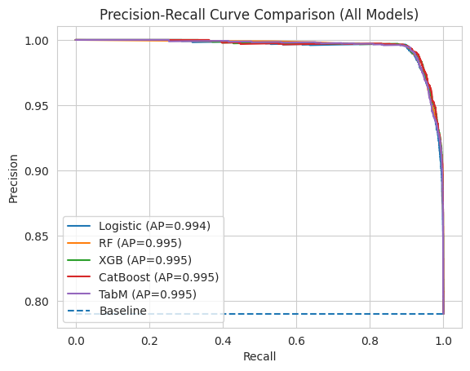
Figure 12
precision-recall curve all models 1

Figure C.4: Feature Importance Plot – CatBoost
This figure displays the top features influencing financial inclusion based on the CatBoost model. Key variables such as mobile money usage, education level, and income are shown to have strong predictive power.

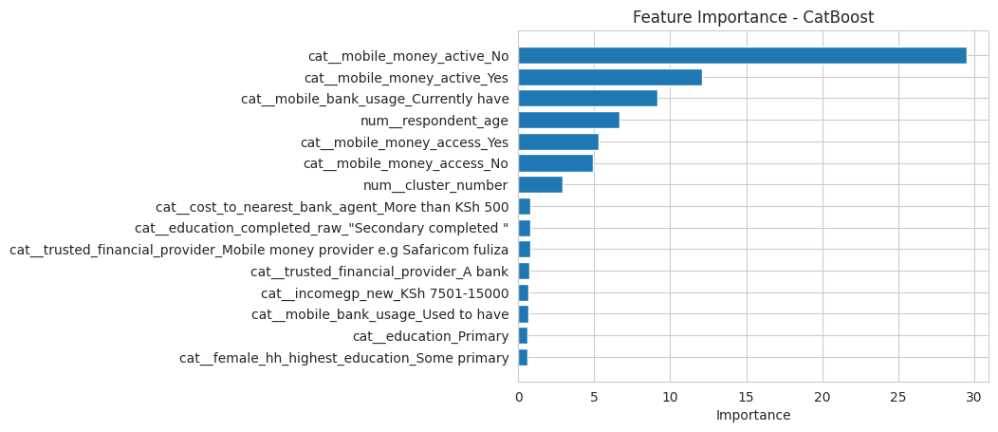
feature importance CatBoost 1
Figure 13

Figure C.5: Correlation Heatmap
This figure presents the correlation between selected numerical features and the target variable. It provides insight into relationships within the dataset and supports feature selection decisions.
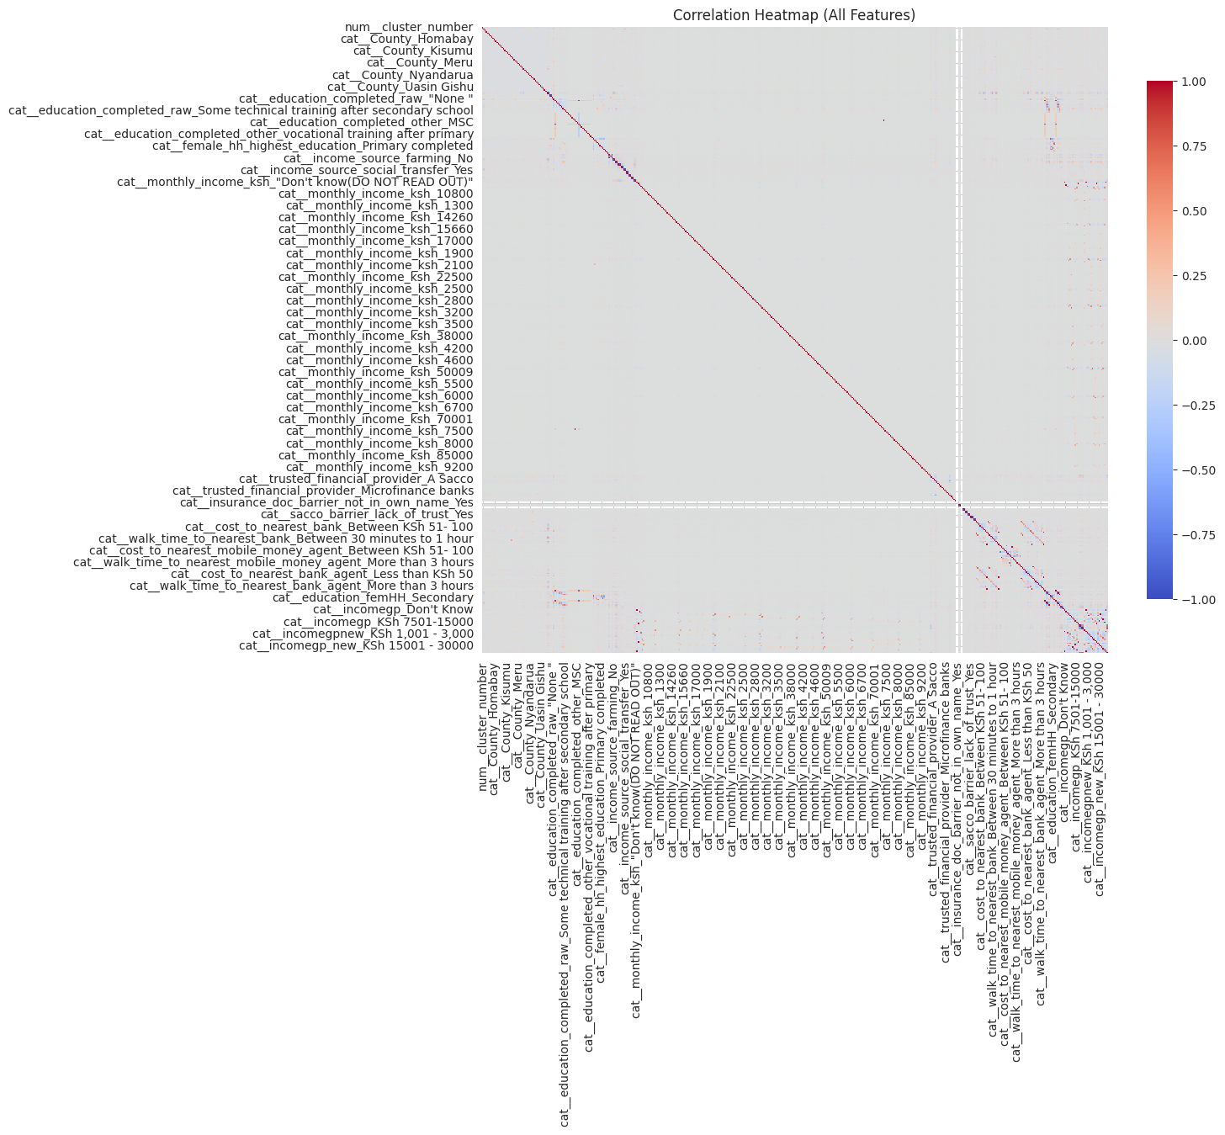
all features correlation heatmap 1
Figure 14

Table C.1: Top 15 Features from Logistic Regression
This table lists the most influential features based on logistic regression coefficients. Positive coefficients indicate variables associated with a higher likelihood of financial inclusion.
Feature | Coefficient
cat__mobile_bank_usage_Currently have | 3.5927
cat__mobile_money_active_Yes | 2.6525
cat__mobile_money_access_Yes | 1.5853
cat__County_Tana River | 1.1803
cat__County_Kwale | 1.0867
cat__education_completed_raw_University completed | 1.0151
cat__monthly_income_ksh_3500 | 0.8306
cat__County_Wajir | 0.6543
cat__County_Laikipia | 0.6509
cat__County_Mandera | 0.6345
cat__education_completed_raw_Some university | 0.6198
cat__cost_to_nearest_mobile_money_agent_Close | 0.6031
cat__trusted_financial_provider_A Sacco | 0.5989
cat__County_Isiolo | 0.5864
cat__County_Makueni | 0.5722

Table C.2: Model Performance Comparison
This table compares the performance of all models used in the study, including Logistic Regression, Random Forest, XGBoost, CatBoost, and TabM. Metrics such as accuracy, precision, recall, F1-score, and ROC-AUC are included.
Model | Accuracy | Precision | Recall | F1 Score | ROC-AUC
Logistic Regression | 0.921 | 0.992 | 0.908 | 0.948 | 0.980
Random Forest | 0.940 | 0.953 | 0.966 | 0.960 | 0.982
Decision Tree | 0.920 | 0.940 | 0.920 | 0.920 | 0.962
XGBoost | 0.930 | 0.940 | 0.930 | 0.940 | 0.983
CatBoost | 0.930 | 0.940 | 0.930 | 0.930 | 0.983
TabM (Deep Learning) | 0.930 | 0.940 | 0.940 | 0.951 | 0.982

