**Part 1**

1. Is Ex01.exe a .NET Assembly? (**Yes**/No) –Mark the correct answer.
2. Is Ex01.exe a .NET PE? (**Yes**/No) –Mark the correct answer.

Please provide a short explanation that supports your answers:

It is an assembly because in the manifest of the .exe it has the System.Reflection classes and information about the .NET assembly in the form of various properties.

It is a .NET PE because it is in the form of a Windows .exe file which means it is a Portable Executable

**Please provide the following info about the Assembly which is contained in Ex01.exe**

a.Name: Ex01 – Solution

b..Version: 21:2:1:30227

c.In which section in the assembly you can find the answers to the previous questions (a, b)? Manifest

d.Which assemblies are being referenced by this assembly?

Name: mscorlib Version: 4:0:0:0

Name: System.Xml Version: 4:0:0:0

**Analyzing the Metadata and MSIL**

|  |  |  |
| --- | --- | --- |
| **Type** | **Name** | **Members (methods, fields)** |
| Class | B2021.Ex01.Program | * public static void Main() |
| Class | B2021.Ex01.DemosLauncher | * public static void ExecutePrograms() * private static bool checkUserCredentials() * private static B2021.Ex01.DemosLauncher.eUserChoice retreiveUserSelection() * private static void showMenu() |
| Class | DemoPrograms | * public static void RunBinarySeries() * public static void RunSandMachine() * private static bool checkIfAscendingSeries(string i_Number) * private static bool checkIfDescendingSeries(string i_Number) * private static void drawSandMachine(int32 i_NumOfLines) * private static int32 generateLineOfAstrix(System.Text.StringBuilder i_SB, int32 i_PlaceInText, int32 i_Rows * private static string getInputFromUser(out int32 o_CrrntNumber) |
| Enum | eUserChoice | * public static B2021.Ex01.DemosLauncher.eUserChoice Abort * public static B2021.Ex01.DemosLauncher.eUserChoice BinarySeries * public static B2021.Ex01.DemosLauncher.eUserChoice SandClock * public instance int32 value__ |

What is the Username and Password that should be typed in order to run the application?

**Username:** DotNet

**Password:** C####

Task1

Task 2

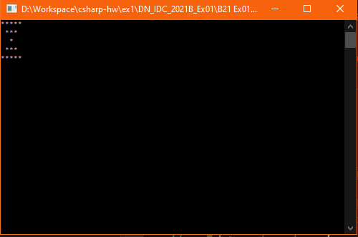

Task 3

Execution examples:

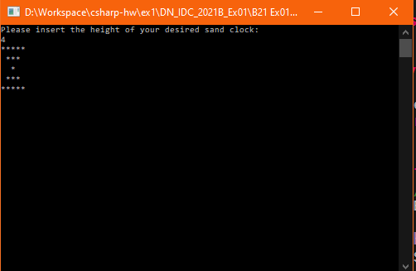

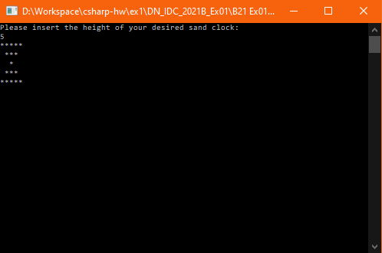

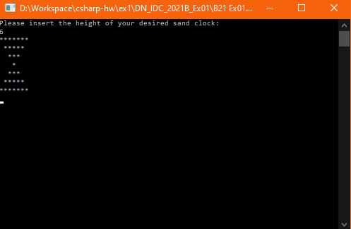

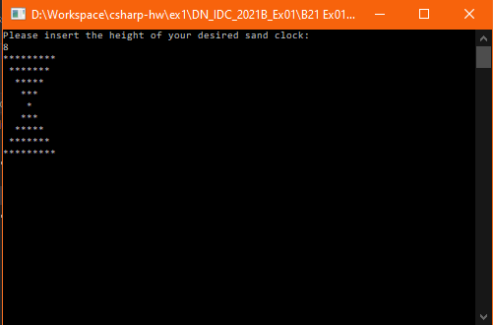

Task 4