
1. The main difference between nuclear and fossil-fuelled power stations is
an economic one.
TRUE
UNTRUE
CANNOT SAY
2. The price of coal is not relevant to discussions about the relative effic
iency of nuclear reactors.
TRUE
UNTRUE
CANNOT SAY
3. If nuclear reactors were cheaper to build and decommission than fossil-fu
elled power stations, they would definitely have the economic advantage.
TRUE
UNTRUE
CANNOT SAY

4.Physical stimuli usually win in the competition for our attention.
TRUE
UNTRUE
CANNOT SAY
5. The capacity of the human brain is sufficient to interpret nearly all the
stimuli the senses can register under optimum conditions.
TRUE
UNTRUE
CANNOT SAY
6. Eyes are able to cope with a greater input of information than ears.
TRUE
UNTRUE
CANNOT SAY

1. It is possible that permanent staff who are on holiday can have their work carried out by students.
TRUE
UNTRUE
CANNOT SAY
2. Students in summer employment are given the same paid holiday benefit as permanent staff.
TRUE
UNTRUE
CANNOT SAY
3. Students are subject to the organisation's standard disciplinary and grievance procedures.
TRUE
UNTRUE
CANNOT SAY
4. Some companies have more work to do in summer when students are available for vacation work.
TRUE
UNTRUE
CANNOT SAY

5. "No smoking" policies have mainly been introduced in response to customer demand.
TRUE
UNTRUE
CANNOT SAY
6. All banks and building societies now have a "no smoking" policy.
TRUE
UNTRUE
CANNOT SAY
7. There is no conflict of interest between a "no smoking" policy and personal freedom of choice for all.
TRUE
UNTRUE
CANNOT SAY
8. A no-smoking policy is in line with most customers' expectations in banks and building societies.
TRUE
UNTRUE
CANNOT SAY
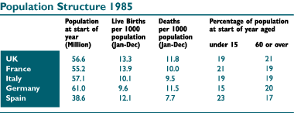
1. Which country had the highest number of people aged 60 or over at the sta
rt of 1985?
A. UK B. France C. Italy D. W.Germany E. Spain
2. What percentage of the total 15mm button production was classed as sub-st
andard in September?
AA 10.5% BB 13% CC 15% DD 17.5% EE 20% AB 23.5% AC 25%
AD 27.5% AE 28% BC 30.5%
3. How many live births occurred in 1985 in Spain and Italy together (to the
nearest 1000)?
A. 104,000 B. 840,000 C. 1,044,000 D. 8,400,000 E. 10,440,000
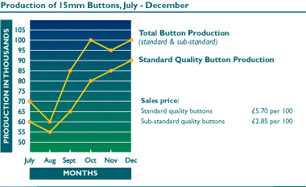
4. What was the net effect on the UK population of the live birth and death
rates in 1985?
A.Decrease of 66,700 B.Increase of 752,780
C.Increase of 84,900 D.Cannot Say
E.Increase of 85,270
5. By how much did the total sales value of November‘s button production va
ry from October‘s?
A.8.50(Decrease) B.42.50(Decrease) C.85.00(Increase)
D.27.50(Decrease) E.No change
6. What was the loss in potential sales revenue attributable to the producti
on of sub-standard (as opposed to standard) buttons over the 6 month period?
A.13.75 B.27.50 C.137.50 D.280.00 E.275.00

1. Which newspaper was read by a higher percentage of females than males in 1990?
A.The Tribune B. The Herald C. Daily News D. Daily Echo E. The Daily Chronicle
2. What was the combined readership of the Daily Chronicle, Echo and Tribune in 1981?
A. 10.6 B.8.4 C.9.5 D.12.2 E.7.8
3. Which newspaper showed the largest change in female readership between 1981 and 1990?
A.Daily Echo B.The Tribune C.The Herald D.The Daily Chronicle
E.Cannot say

4. In 1989, how much more than Italy di Germany spend on computer imports?
A.650 million B.700 million C.750 million D.800 million E.850 million
5. If the amount spent on computer imports into the U.K. in 1991 was 20% lower than in 1990, what was spent in 1991?
A.1080 B.1120 C.1160 D.1220 E.1300
6. Which countries experienced a drop in the value of computers imported from one year to the next?
A.France & Italy B.France & Holland C.Holland & Italy D.U.K. & Holland E.Italy & U.K.
CBA CBC ABCA CBBA D/AB/C BEC DCE BBA

