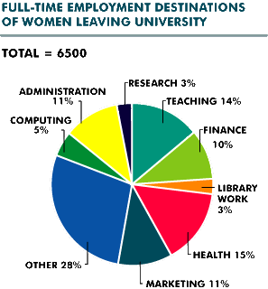
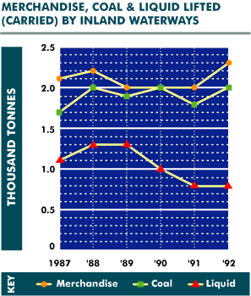
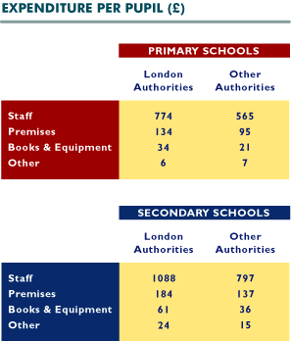
What percentage of women leaving university went into finance and administration?
10%
11%
14%
20%
21%
How many thousand tonnes of liquids were lifted in 1989?
1.3
1.5
1.9
2.0
None of these
How much more per pupil do London authorities spend on staff in secondary schools than in primary schools?
£209
£219
£232
£291
£314
Which one area of employment is least popular among female university leavers?
Cannot say
Computing
Library Work
Marketing
Research
How much more coal was lifted in 1992 than in 1987?
How much more than "other" authorities do London authorities spend per secondary pupil on premises?
0.1 thousand tonnes
0.2 thousand tonnes
0.3 thousand tonnes
1.3 thousand tonnes
2.0 thousand tonnes
£39
£47
£184
£137
£291
Which was the most popular area of work chosen by women leaving university?
How many thousand tonnes of merchandise and liquids were lifted in 1991?
Administration
Finance
Health
Sales
Teaching
1.9
2.2
2.8
2.9
3.0
What is the total cost to London authorities per secondary school pupil?
£688
£948
£985
£1,357
£1,427
Into which two areas of employment did a combined 19% of female university leavers go?
Admin & Computing
Health & Research
Marketing & Admin
Teaching & Computing
Teaching & Library
In which year was most merchandise carried?
On what do "other" authorities spend 13.8% of their total outlay per primary school pupil?
1988
1989
1990
1991
1992
Books & Equipment
Premises
Staff
Other
Cannot say
How many women went into teaching when they left university?
140
650
870
910
None of these
In 1988 how much more merchandise than liquids was lifted?
0.2 thousand tonnes
0.9 thousand tonnes
1.0 thousand tonnes
1.1 thousand tonnes
2.2 thousand tonnes
What is the total expenditure for a primary school in London with 320 pupils?
£300,360
£303,360
£330,306
£330,360
£360,303
How many more women went into computing than into research?
120
135
195
325
None of these
How much more liquid was carried in 1989 than in 1992?
0.5 thousand tonnes
0.8 thousand tonnes
1.3 thousand tonnes
1.5 thousand tonnes
1.8 thousand tonnes
What is the difference in total cost to London authorities between one secondary pupil and one primary pupil?
£260
£314
£409
£948
None of these
How many women went into computing and administration?
940
1040
1100
1140
None of these
In which year was an equal tonnage of merchandise and coal carried?
1987
1988
1990
1991
1992
Approximately what proportion of the total amount spent per primary pupil by "other" authorities is on books and equipment?
1%
3%
10%
12%
17%
24% of female university leavers go into
Finance, Research & Admin
Finance, Teaching & Research
Health, Computing & Research
Marketing, Finance & Computing
Teaching, Research & Admin
----------------------------------------------------------------------------------------------------------------------
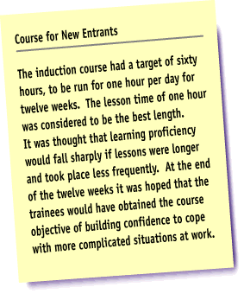
The course lasted twelve weeks.
True
False
Cannot Say
A lesson time of two hours was considered to be the best length.
True
False
Cannot Say
A target of ninety hours was set for the course.
True
False
Cannot Say
These courses are beneficial to the entire population.
True
False
Cannot Say
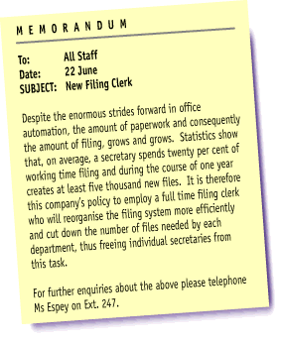
This memo should be distributed to all staff.
True
False
Cannot Say
Statistics show that, on average, a secretary spends a third of working time filing.
True
False
Cannot Say
Ms Espey should be contacted with further enquiries.
True
False
Cannot Say
All firms should employ a full time filing clerk.
True
False
Cannot Say
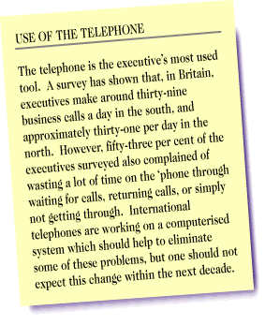
According to the survey, executives in the north make around thirty-nine business calls a day.
True
False
Cannot Say
The telephone will always be the executive's most used tool.
True
False
Cannot Say
Over half of the executives in the survey said that they waste a lot of time on the telephone.
True
False
Cannot Say
Telephones are often misused.
True
False
Cannot Say
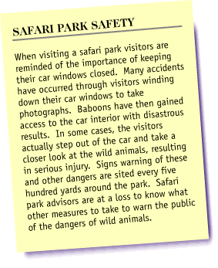
Visitors sometimes get out of their car to look more closely at the animals.
True
False
Cannot Say
Accidents have occurred when visitors wind down their windows to take photographs.
"Danger" signs are placed every fifty yards around the park.
True
False
Cannot Say
True
False
Cannot Say
The general public should be banned from safari parks.
True
False
Cannot Say
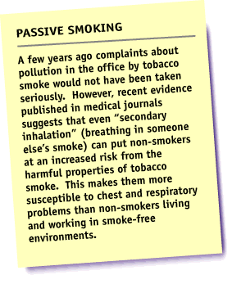
In the past, complaints about tobacco smoke pollution would have been treated seriously.
True
False
Cannot Say
"Secondary inhalation" is breathing in another's smoke.
True
False
Cannot Say
Medical journals have proposed that smoking should be banned from offices.
True
False
Cannot Say
Smokers have an increased risk of heart disease.
True
False
Cannot Say

Wise parents should praise their child's drawings.
True
False
Cannot Say
Teachers and parents should avoid talking to each other.
True
False
Cannot Say
All children watch television.
True
False
Cannot Say
All children should go to play school.
True
False
Cannot Say
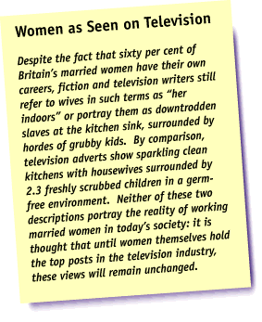
Sixty per cent of Britain's married women have their own careers.
True
False
Cannot Say
Television writers never refer to wives as "her indoors".
True
False
Cannot Say
Women hold all the top posts in the television industry.
True
False
Cannot Say
The National Statistics show that most couples have 2.3 children.
True
False
Cannot Say

