**Sanofi**

**Multaq Digital Panels:**

February 20, 2019

# Setup instructions for Digital panels

## Overview

This kiosk web application runs locally on system via Chrome web browser. It installs as a Chrome extension app and runs in Chrome browser in KIOSK Full-screen mode.

There is 1 panel version included in this setup package:

* Multaq Digital Panel

**Installation**

The following instructions was written for installing on Windows 8.1-10 system.   
Application requires having **Chrome** browser installed and that the touchscreen is set to display natively at 1920x1080 screen resolution.

1. Copy and unzip **install-Multaq.zip** to the computer’s Desktop.
2. Inside the parent folder is a folder called “documentation.” Within that folder is a file called “chrome-setup.bat”. Quit all running instances of Chrome, and then double-click the .bat file to run it. This will disable the “cross-origin security” policy of Chrome, allowing all needed files to load and run properly.

**INSTALL CHROME KIOSK APP**

1. Start Chrome and near top right, click on **Settings** > **More Tools** > **Extensions**

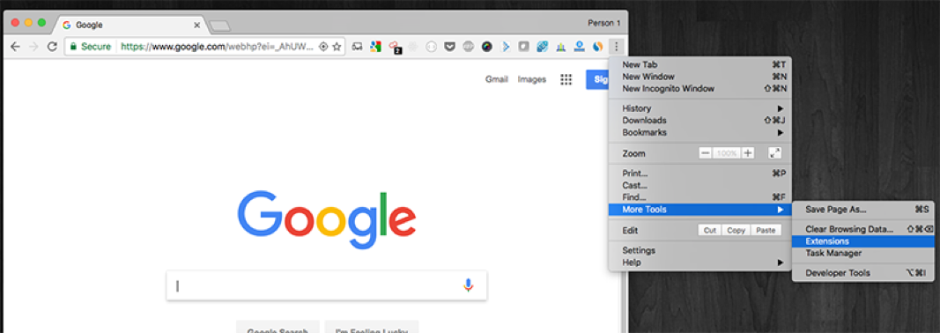

1. You should now be in Chrome’s Extension screen (url: chrome://extensions/)
2. Click on the checkbox for **Developer mode**

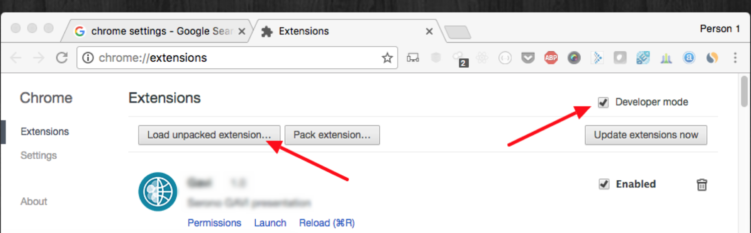

More recent versions of Chrome will look different, but the elements are still there:

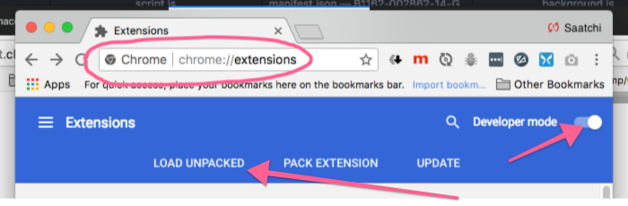

1. Click **Load unpacked**:
   1. Choose the folder corresponding to panel that will be installed, ie. *Multaq-Digital-Panel*
2. Now, you should see the installed **Multaq** app in the Extensions list.

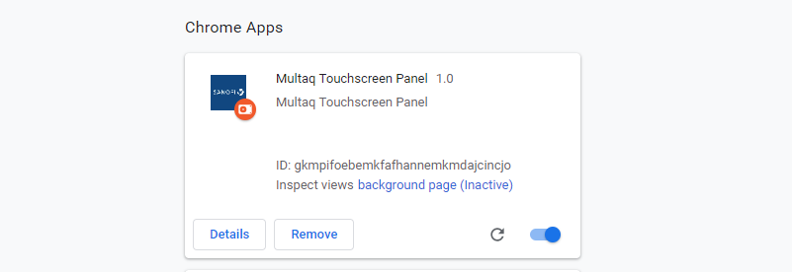

**To Start Up Digital Panel Kiosk:**

In the Chrome browser’s address bar, enter: **chrome://apps**This should open up the Apps page in Chrome.  Click on the Multaq app (Sanofi logo), which should start the app in full-screen kiosk mode.

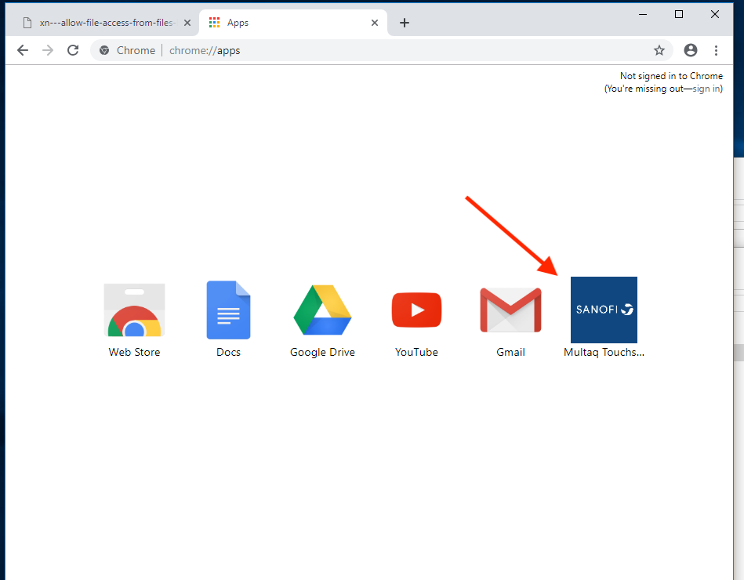

(screenshot of chrome://apps)

To Exit or Close out from full-screen window, you can press ESC, which should re-display the screen within browser window.