Team 6

Bogdanovs Igors

Bouloumpasis Christos

McKinlay Allan

Ward Daniel

Simon Aaron

**Coursework 2 - Relational Database Implementation**

AC32006 / AC52001 - Database Systems

Contents

Introduction 2

Access DiveMasters Website 2

How to login 3

CUSTOMER USER GUIDE 3

Changing Personal information 4

Ordering Product 4

Complaints 5

CUSTOMER SUPPORT USER GUIDE 5

Changing Personal information 6

Customer Support 6

ACCOUNTANT USER GUIDE 6

Changing Personal information 6

Financial Transactions 7

ADMINISTRATOR USER GUIDE 7

Products (Adding – Editing – Delete) 8

Employee, Branches (Adding – Editing – Delete) 8

Add Supplier 8

Changing Personal information 8

Branch OverView 8

FLOOR EMPLOYEES USER GUIDE 8

Changing Personal information 9

BRANCH/WAREHOUSE MANAGER USER GUIDE 9

Changing Personal information 9

Branch OverView 9

TECHNICAL GUIDE 9

SQL EXAMPLES 9

Conclusion 11

# Introduction

This report is outlined in the format of the “DiveMasters” website user guide. It covers details for the three main user groups – customer, customer support and accountant.

# Access DiveMasters Website

In order to access “DiveMasters” website you need to connect to this link:

[*https://zeno.computing.duncee.ac.uk/2016-ac32006/Team6/Dan/AC32006_Ass2/index.php*](https://zeno.computing.duncee.ac.uk/2016-ac32006/Team6/Dan/AC32006_Ass2/index.php)

To access the database server, the details are in the above directory at scripts/connectToDb.php

**Different Users and access rights:**

|  |  |  |
| --- | --- | --- |
| **Username** | **Password** | **Access Right** |
| admin | admin1 | Full access and CRUD |
| branchmanager | branch1 | View branch information |
| warehousemanager | warehouse1 | View warehouse information |
| flooremployee | employee1 | View personal information |
| customersupport | support1 | View personal information  And particular client information |
| accountant | accountant1 | View personal information  And financial transaction of the company |
| client | client1 | View personal information |

How to login

There are two ways a user can login to the “DiveMasters” website. They can either click on the ‘login’ button at the top of the screen or select the ‘login’ button in the main menu at the bottom of the screen. When the user selects either of the buttons the website will take them to the page displayed below. Via this page both registered customers, as well as employees will be able to access their customised pages.

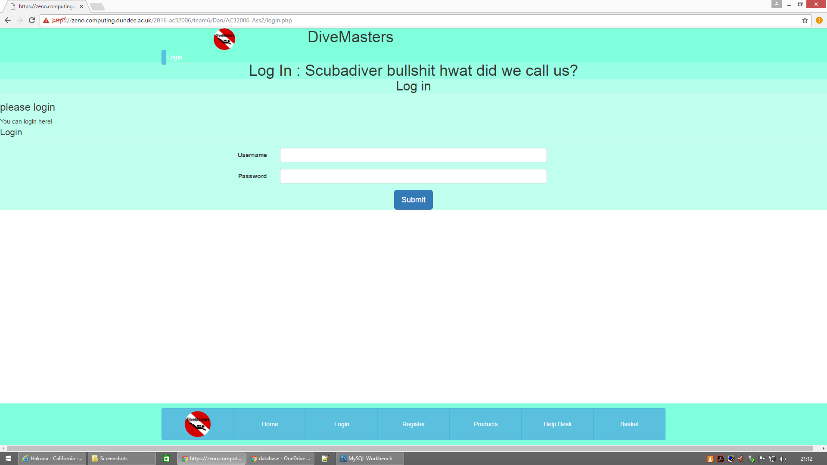

# CUSTOMER USER GUIDE

When not registered customers enter the website they are limited to a restricted-access view of the website home page; this allows them to see information about the company, view products and become an officially registered customer.



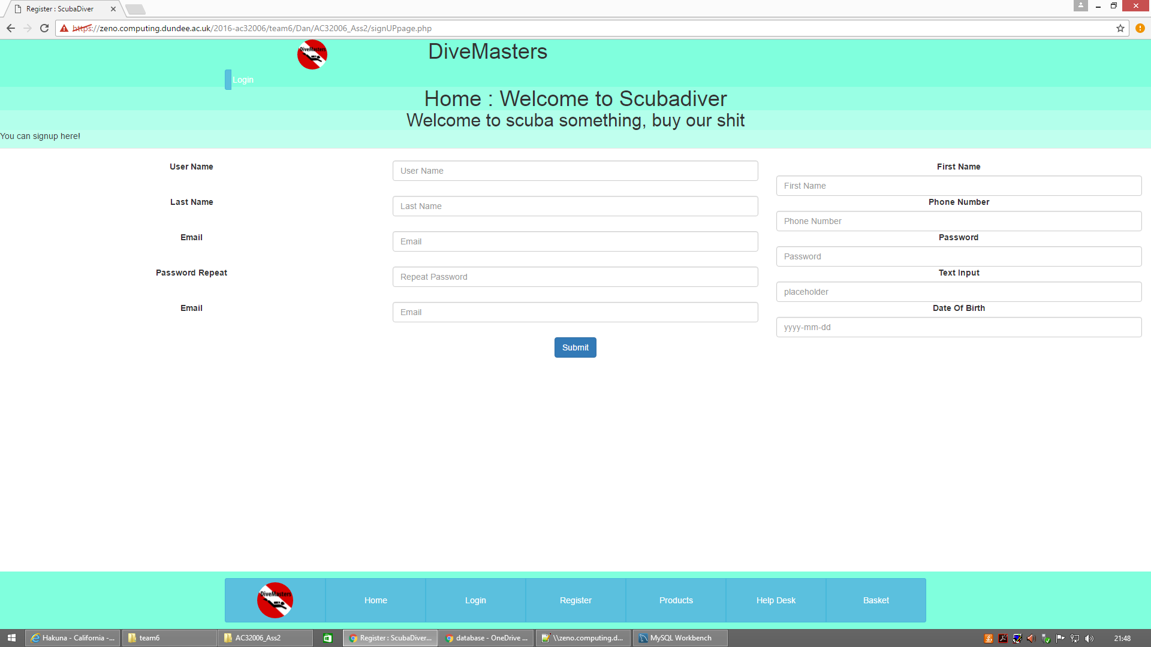If the customer wants to order a particular product they have to become registered customer first. They can do that by selecting the ‘Register’ button on the menu displayed above. This will take them to the page shown below.

Once the customer is successfully registered they become an official user of “DiveMasters” website.

## Changing Personal information

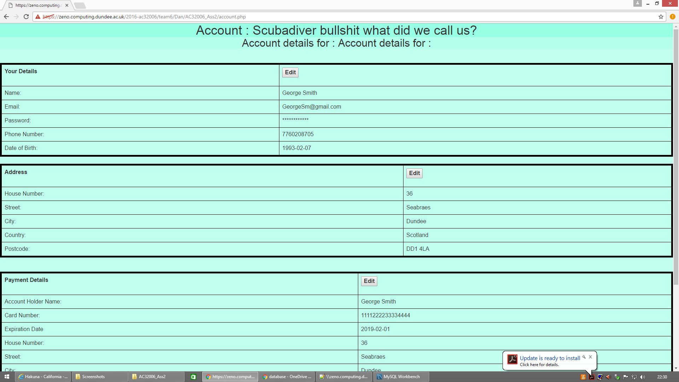When registered customers wish to change their personal details they can click on the ‘Account’ button in the Main menu. That will take them to the page displayed below. By clicking ‘Edit’ the customer is then able to change their details. After they have made any appropriate changes they have to press on ‘Submit’ for the changes to be implemented.

## Ordering Product

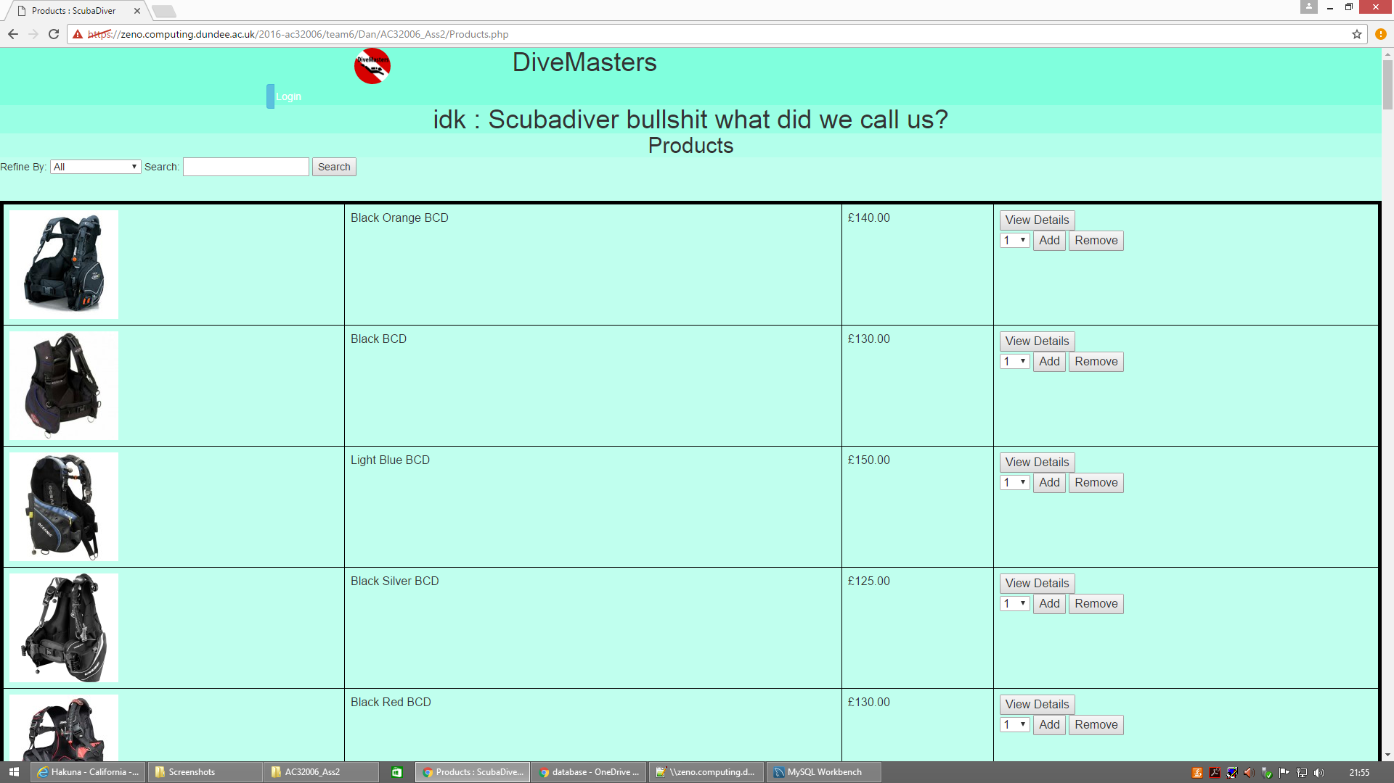A registered customer will have to click to the ‘Products’ button in the Main menu in order to browse through the available products. As displayed below, the user has the option to search between different categories of products and use key words such as color to find a particular product.

When the user has selected all products they wished for, they then need to choose the quantity they would like on the right side of the page and press ‘Add’ to add their product on the basket. In order to check all items in their basket the can either click the button in the Main menu or the ‘Basket’ button on the top of the screen.

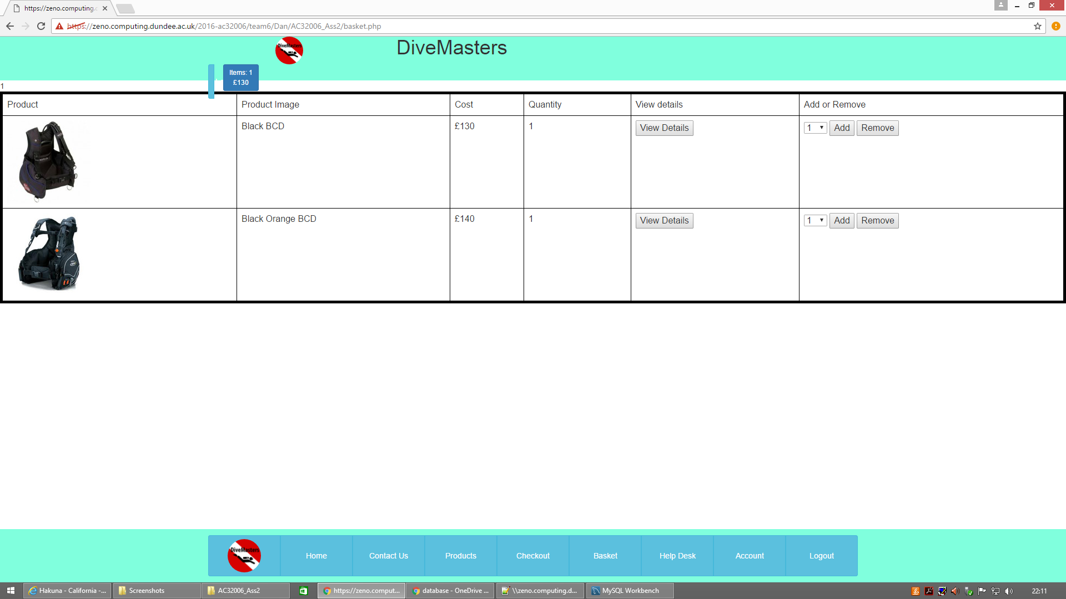The ‘basket’ page displays all the products the user has picked (as shown below).

If, at any point during the ‘browsing’ stage, they changed their mind and no longer want one of more of the items that had been placed in the ‘basket’, they can press ‘Remove’ button and any selected items will be removed from their ‘basket’. If they want to obtain more information on any of the products in their ‘basket’, they can select ‘View Details’ button on that page. Alternatively, they can access more product information/details via the ‘Products’ page.

Finally, when they have picked all the products they would like to order they then press on the ‘Check Out’ button in the Main menu in order to place their order.

## Complaints

In the event that a customer wants to make a complaint in relation to a particular order they can do so that by clicking on the ‘Help Desk’ button in the Main menu. On this page they will have to include their particular order ID and provide more details as to what is the nature of their complaint (displayed below).

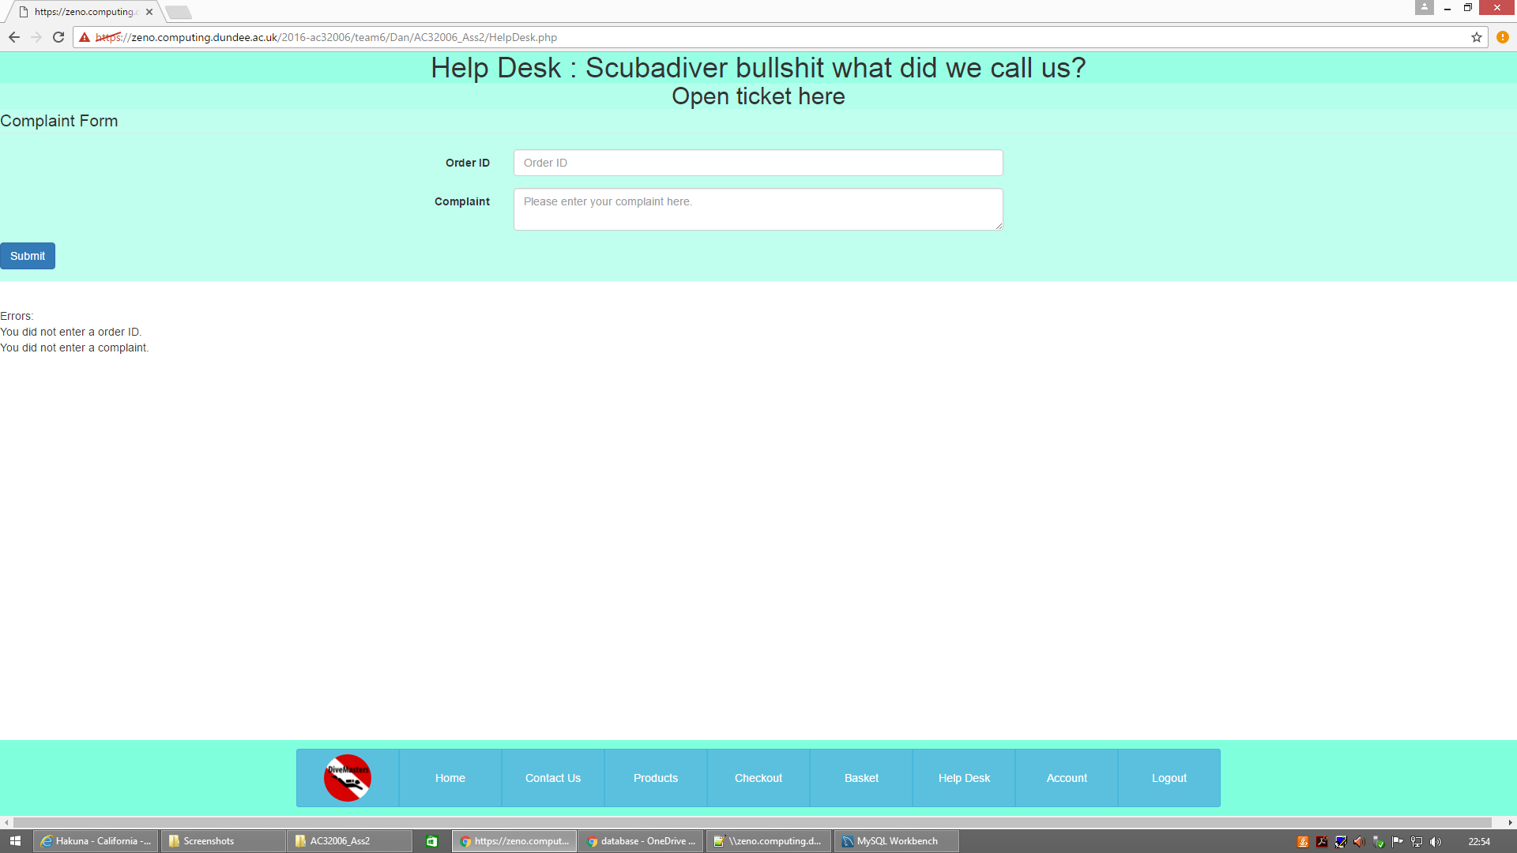When the user has finished populating the ‘Complaint’ box they can press on ‘Submit’ button to send it to the company.

# CUSTOMER SUPPORT USER GUIDE

As already mentioned above the customer support employees login via the same page as customers. All customer support employees’ accounts are created by the administrative department as part of staff pre-boarding process with the Company.

## Changing Personal information

If the customer support employee wishes to change their details they have to follow the same process as customers do. They have to select the ‘Account’ button, which will take them to the page where they can edit their details.

## Customer Support

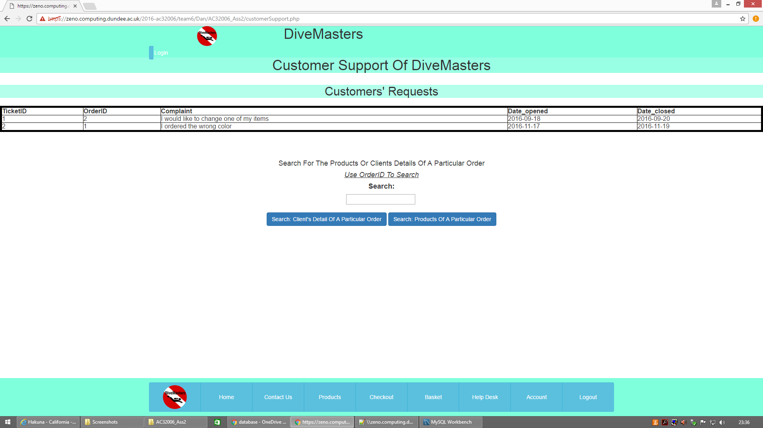The customer support employees have access the Customer Support customised page, which is displayed below.

On this page the customer support employee will be able to see all the complaints submitted by customers. The customer support employee will then be able to search for either the details of the particular customer who had placed the order or the products that this order contains in order to understand the customer’s problem better. To resolve the customer issue the customer support staff have to contact the administrative department to request any changes/corrections. Both of the searches use advance queries in order to find each answer.

# ACCOUNTANT USER GUIDE

Similarly to the customer support employee the accountant will receive all their user account information from the administrative department and login to the website in the same manner as customer support staff and customers.

## Changing Personal information

If the accounts employee wishes to change they details they have to follow the same process as customers and customer support staff do. They will have to select the ‘Account’ button, which will take them to the page where they can edit their details.

## Financial Transactions

The accountant has access to the Financial Transactions customised page, which is displayed below. In the main section of the Financial Transactions the accountant views the general incomes and outgoings of the company and the calculation of the Gross Profit that the company is making. In addition to that the accountant has three more options: “Employees Earnings

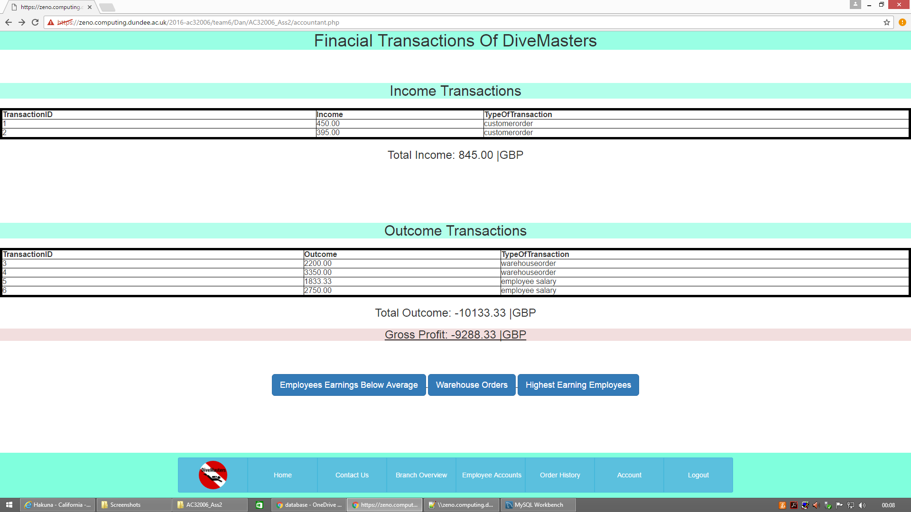Below Average”, “Warehouse Orders” and “Highest Earning Employees”. Through advance queries the accountant is able to display all the employees that earn below the average and what is the difference from the average, all of the warehouse orders in combination with the warehouse branch name and the total warehouse outcome and the all the highest earning employees, the branch name the work at, their salary and their position.

# ADMINISTRATOR USER GUIDE

Similar to every other user the admin can login in by selecting the button at the top of the screen or via the Main menu. When an admin is successfully logged to the Main menu, the bottom of the screen customises, as it is displayed below.

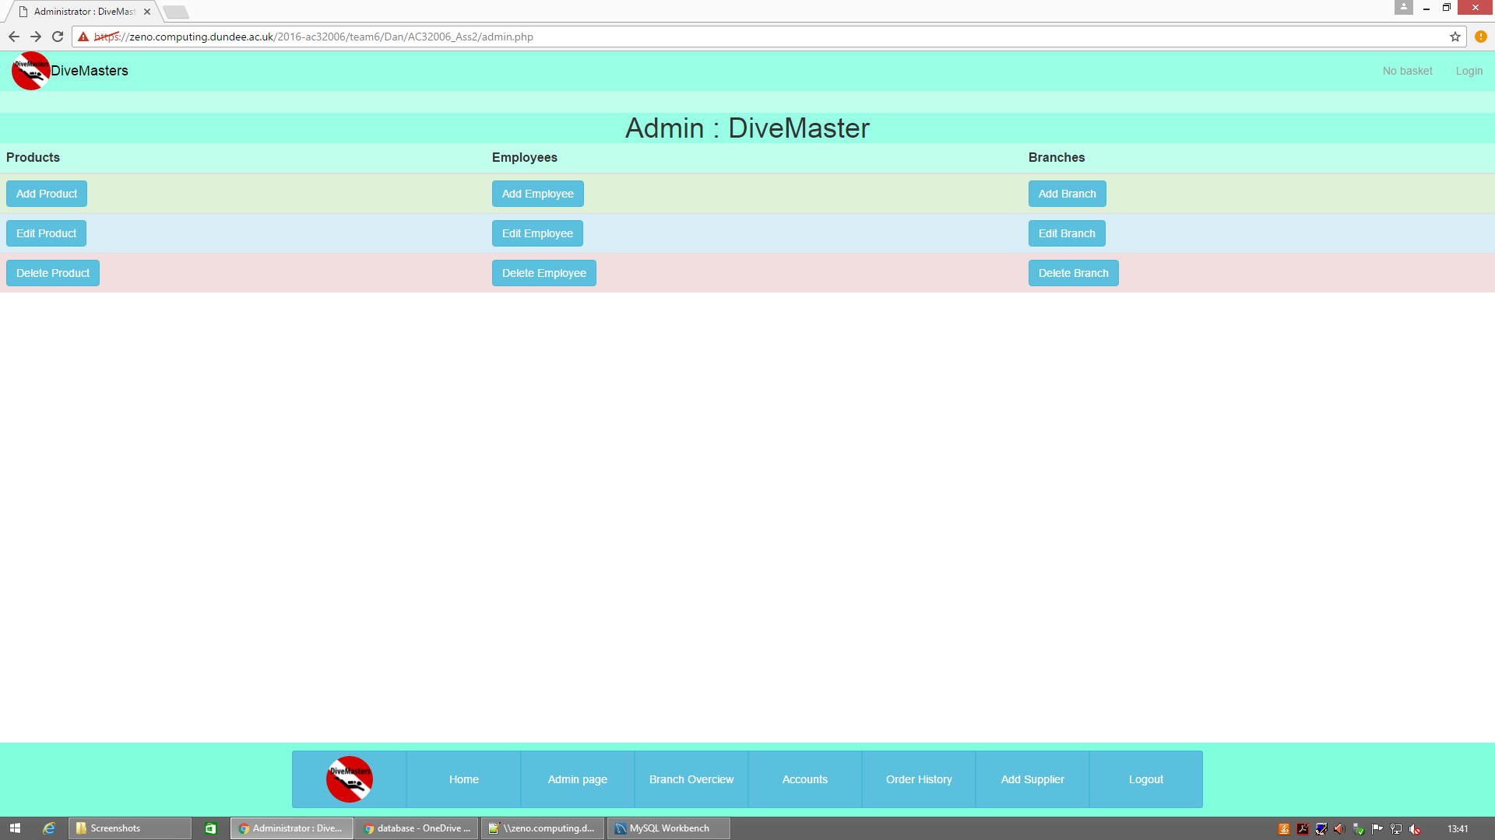

Through this menu the admin will be able to access the ‘Admin’ page where they will have full CRUD over employees branches and products, as it shown below.

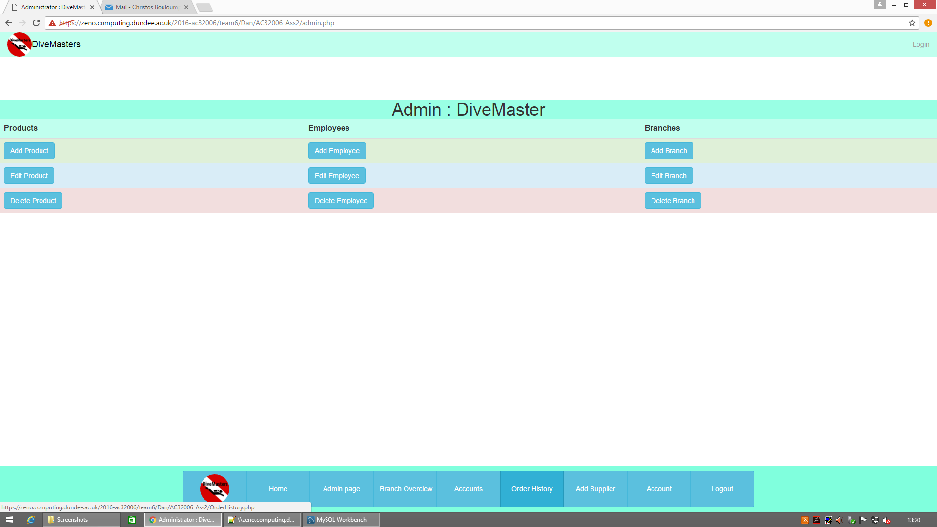

## Products (Adding – Editing – Delete)

If a admin wishes to add any new products on the companies catalogue they have to click the Add Product button and a form will appear, which the admin has to fill and press submit to insert the new product.

Similar to the adding a product the admin can edit and delete a product by pressing either the Edit Product button or the Delete Product button. In these two pages the admin will be presented with all the information about all the products in the companies catalogue, that will help them see everything they need to fill the edit and delete forms.

## Employee, Branches (Adding – Editing – Delete)

Similarly to the products the admin can add, edit and delete any information about a particular employee or a particular branch.

## Add Supplier

If in the future the company starts doing business with a new supplier the admin is able to add the new supplier in the system. The admin can do that by clicking the Add Supplier button on the Main Menu, which will take him/her to a customised form where the admin will have to fill up the suppliers information.

## Changing Personal information

Similar to every employee the admin is able to view and edit their personal detail through the account page which they can access by clicking the Account button on the Main Menu.

## Branch OverView

An admin can see the information about all the branches, and the employees that work in the same branch as them by clicking the Branch Overview button at the Main Menu.

# FLOOR EMPLOYEES USER GUIDE

As all the users of the website the floor employees can login by either clicking Login button on the top right corner or the Login button on the Main Menu. Because this type of employees do not have a lot of responsibilities in the company they are only able to view and edit their personal information.

## Changing Personal information

The floor employee can view and edit their personal details by clicking the account button which will take them to the Account page where by pressing Edit they will be able to make changes in his/her account.

# BRANCH/WAREHOUSE MANAGER USER GUIDE

Both the branch and warehouse managers can login through the two different Login buttons one at the top and one in the Main Menu.

## Changing Personal information

Both Branch and Warehouse managers can edit their personal details by clicking on the Account button. When the account page appear they can click on edit to make any changes.

## Branch OverView

Similar to the admin the managers can view general information about the a branch and in particular all the employees that work in this branch.

# TECHNICAL GUIDE

## SQL EXAMPLES

**Displaying All The Order Details**

select items_ordered.itemID, items_ordered.quantity, items_ordered.itemCost,

products.imageLink,products.productName,orders.orderID, orders.clientID,orders.orderDate, orders.address,payments_details.paymentId, payments_details.accName, payments_details.cardNumber, payments_details.expDate from items_ordered left join orders on items_ordered.orderID = orders.orderID left join products on items_ordered.productID = products.productID left join payments_details on orders.clientID = payments_details.clientID where payments_details.paymentId IS NOT NULL;

This statement can be used to display all the information about either a particular order or all the orders base on the client ID which will get when a customer in login in the website.

**Help ticket**

select help_tickets.ticketID, help_tickets.complaint, help_tickets.date_opened, help_tickets.date_closed, help_tickets.orderID, orders.orderID, orders.clientID from help_tickets left join orders on help_tickets.orderID = orders.orderID where orders.clientID IS NOT NULL group by help_tickets.ticketID;

This statement is used in the customer support page to display all the complaint from the customers based on the order ID of an order.

**Information About A Registered Customer**

SELECT clients.clientID, clients.Fname, clients.Lname, clients.phonenumber, clients.email , clients.dateofbirth, logins.loginID,logins.username, logins.passwords, address.postcode,address.street, address.housenumber, address.city, address.country FROM clients left join logins on clients.clientID = logins.clientID left join address on clients.addressID = address.addressID order by clientID;

This statement in used to display all the information about a registered client, including personal detail and login details

**Indexed products**

We index the products to allow the database to find products data faster. We decided to do that because searching around the products was done frequently in a lot of pages.

CREATE INDEX productIDIndex

On Products (ProductID);

**Admin CRUD**

The following statement were use to create, update and view branch details.

**Create**

This allowed us to insert to table at the same time

INSERT INTO branches (branch_Name, addressID) VALUES ('$name', '$newID');

INSERT INTO address (HouseNumber, street, city, county, postcode) VALUES ('$houseNo', '$street', '$city', '$county','$postcode');

**View**

Select * From branches

**Delete**

DELETE FROM branches WHERE branchID='$branchID'

We applied the above statement to products and employees.

# Conclusion

In conclusion it is important to note some of the key challenges the group have experienced during the completion of this assignment.

As our group tried to create the database we were faced with the problem that, for some unexplained reason, the system was ‘crashing’ after the implementation of 14 foreign keys. Following the first two ‘crashes’ two of the tables disappeared. When we tried to create these tables again using the same name, output in workbench displayed that this table already existed; when we tried drop that table, the console displayed that table did not exist.

This had prevented us from continuing because existing tables were connected to old foreign keys from hidden tables in the database. We had to approach Mahamadou Niakaté for assistance. He could not understand why that was happening either so he decided to give us a new schema ‘16ac3d25’ where we created 7 additional users and gave them different access by using MySQL views with PHP coding.