Team 6

Bogdanovs Igors

Bouloumpasis Christos

McKinlay Allan

Ward Daniel

Simon Aaron

**Coursework 2 - Relational Database Implementation**

AC32006 / AC52001 - Database Systems

Contents

Introduction 2

Access DiveMasters Website 2

How to login 3

CUSTOMER USER GUIDE 3

Changing Personal information 4

Ordering Product 4

Complaints 5

CUSTOMER SUPPORT USER GUIDE 5

Changing Personal information 6

Customer Support 6

ACCOUNTANT USER GUIDE 6

Changing Personal information 6

Financial Transactions 6

Conclusion 7

# Introduction

This report is outlined in the format of the “DiveMasters” website user guide. It covers details for the three main user groups – customer, customer support and accountant.

# Access DiveMasters Website

In order to access “DiveMasters” website you need to connect to this link:

(insert link)

**Different Users and access rights:**

|  |  |  |
| --- | --- | --- |
| **Username** | **Password** | **Access Right** |
| admin | admin1 | Full access and CRUD |
| branchmanager | branch1 | View branch information |
| warehousemanager | warehouse1 | View warehouse information |
| flooremployee | employee1 | View personal information |
| customersupport | support1 | View personal information  And particular client information |
| accountant | accountant1 | View personal information  And financial transaction of the company |
| client | client1 | View personal information |
| IT ?? | IT ??? | IT ?? |

How to login

There are two ways a user can login to the “DiveMasters” website. They can either click on the ‘login’ button at the top of the screen or select the ‘login’ button in the main menu at the bottom of the screen. When the user selects either of the buttons the website will take them to the page displayed below. Via this page both registered customers, as well as employees will be able to access their customised pages.

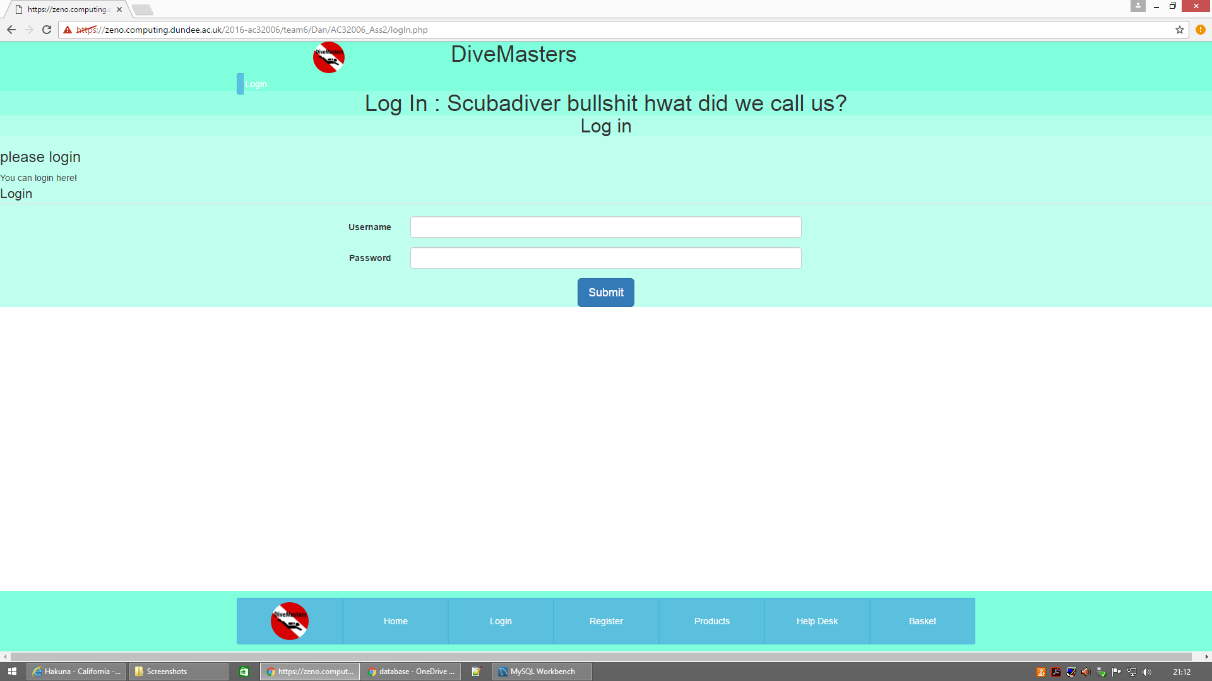

# CUSTOMER USER GUIDE

When not registered customers enter the website they are limited to a restricted-access view of the website home page; this allows them to see information about the company, view products and become an officially registered customer.



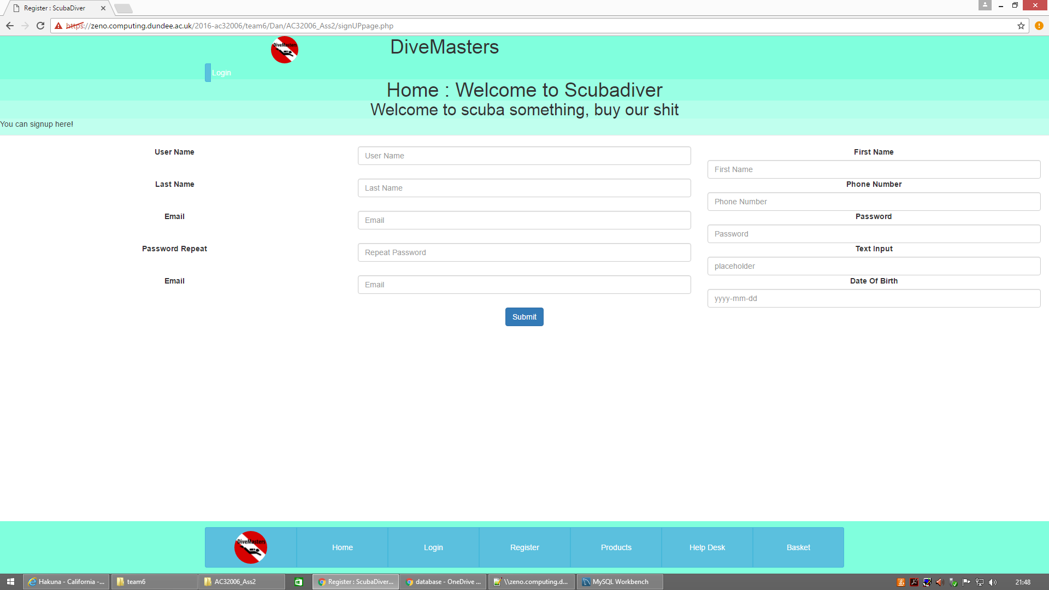If the customer wants to order a particular product they have to become registered customer first. They can do that by selecting the ‘Register’ button on the menu displayed above. This will take them to the page shown below.

Once the customer is successfully registered they become an official user of “DiveMasters” website.

## Changing Personal information

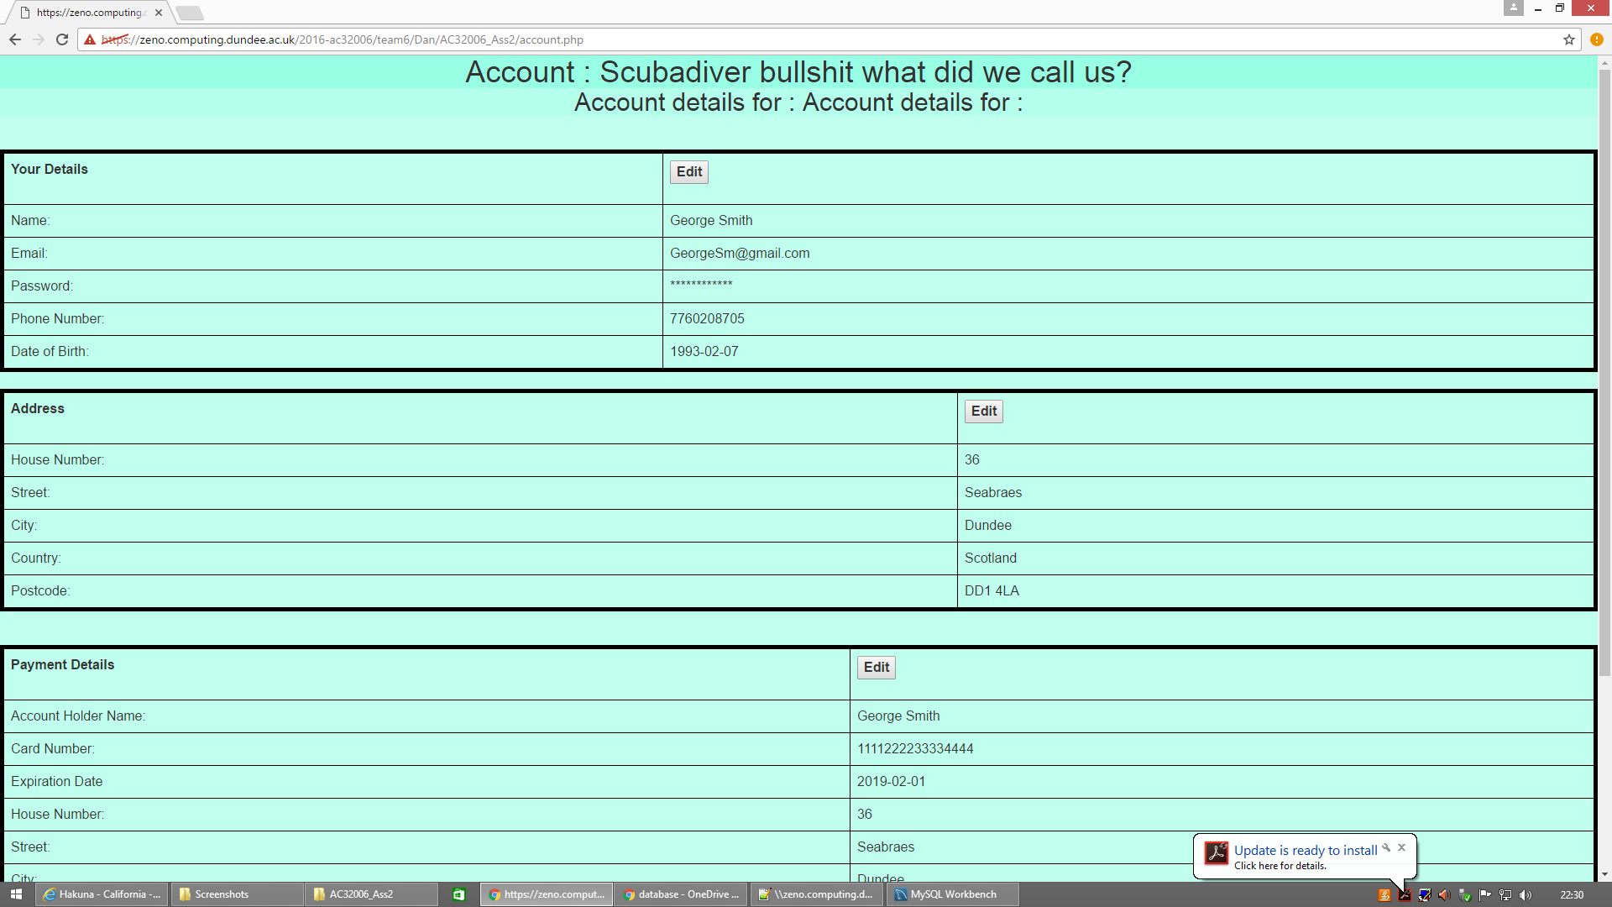When registered customers wish to change their personal details they can click on the ‘Account’ button in the Main menu. That will take them to the page displayed below. By clicking ‘Edit’ the customer is then able to change their details. After they have made any appropriate changes they have to press on ‘Submit’ for the changes to be implemented.

## Ordering Product

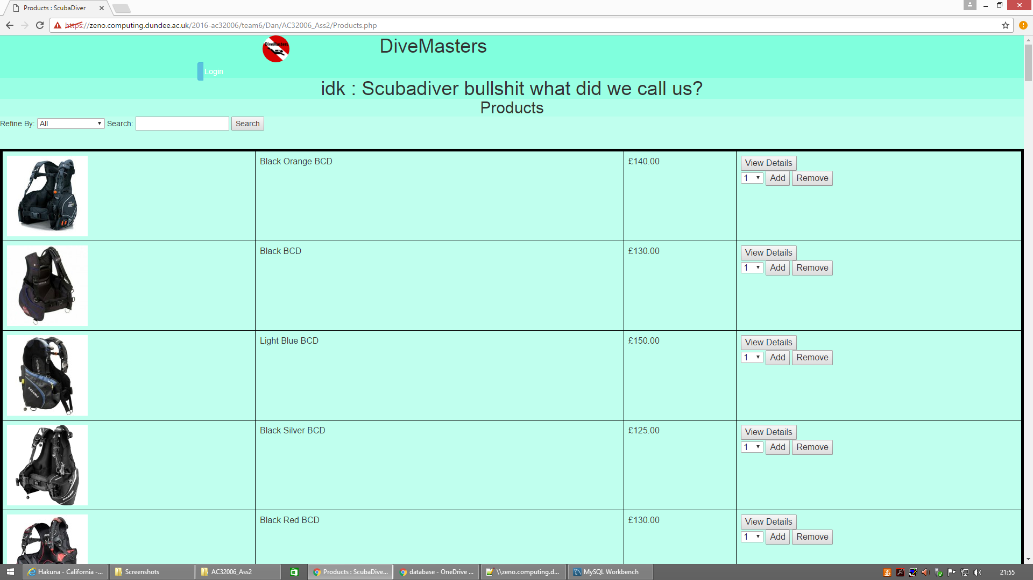A registered customer will have to click to the ‘Products’ button in the Main menu in order to browse through the available products. As displayed below, the user has the option to search between different categories of products and use key words such as color to find a particular product.

When the user has selected all products they wished for, they then need to choose the quantity they would like on the right side of the page and press ‘Add’ to add their product on the basket. In order to check all items in their basket the can either click the button in the Main menu or the ‘Basket’ button on the top of the screen.

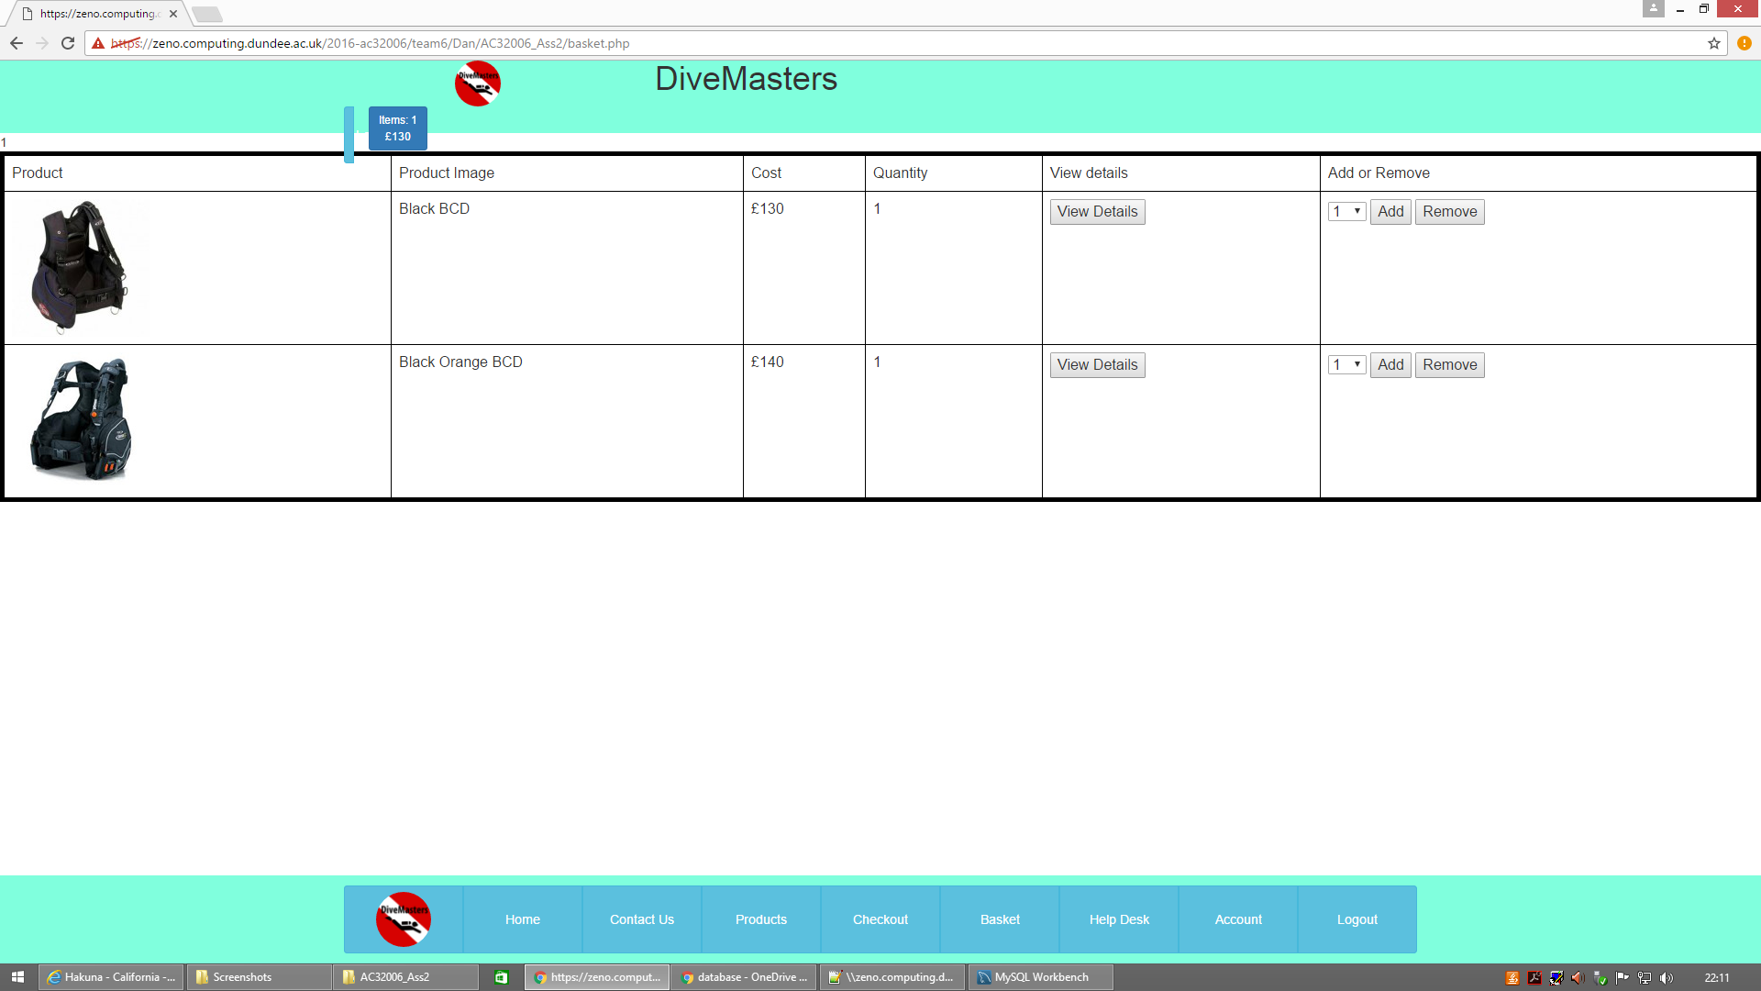The ‘basket’ page displays all the products the user has picked (as shown below).

If, at any point during the ‘browsing’ stage, they changed their mind and no longer want one of more of the items that had been placed in the ‘basket’, they can press ‘Remove’ button and any selected items will be removed from their ‘basket’. If they want to obtain more information on any of the products in their ‘basket’, they can select ‘View Details’ button on that page. Alternatively, they can access more product information/details via the ‘Products’ page.

Finally, when they have picked all the products they would like to order they then press on the ‘Check Out’ button in the Main menu in order to place their order.

## Complaints

In the event that a customer wants to make a complaint in relation to a particular order they can do so that by clicking on the ‘Help Desk’ button in the Main menu. On this page they will have to include their particular order ID and provide more details as to what is the nature of their complaint (displayed below).

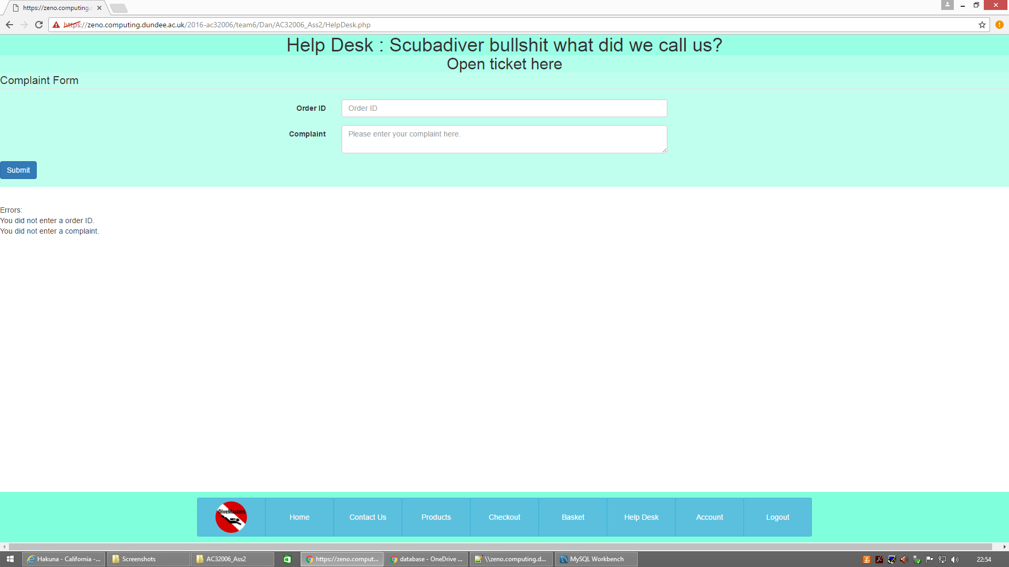When the user has finished populating the ‘Complaint’ box they can press on ‘Submit’ button to send it to the company.

# CUSTOMER SUPPORT USER GUIDE

As already mentioned above the customer support employees login via the same page as customers. All customer support employees’ accounts are created by the administrative department as part of staff pre-boarding process with the Company.

## Changing Personal information

If the customer support employee wishes to change their details they have to follow the same process as customers do. They have to select the ‘Account’ button, which will take them to the page where they can edit their details.

## Customer Support

The customer support employees have access the Customer Support customised page, which is displayed below.

On this page the customer support employee will be able to see all the complaints submitted by customers. The customer support employee will then be able to search for either the details of the particular customer who had placed the order or the products that this order contains in order to understand the customer’s problem better. To resolve the customer issue the customer support staff have to contact the administrative department to request any changes/corrections. Both of the searches use advance queries in order to find each answer.

# ACCOUNTANT USER GUIDE

Similarly to the customer support employee the accountant will receive all their user account information from the administrative department and login to the website in the same manner as customer support staff and customers.

## Changing Personal information

If the accounts employee wishes to change they details they have to follow the same process as customers and customer support staff do. They will have to select the ‘Account’ button, which will take them to the page where they can edit their details.

## Financial Transactions

The accountant has access to the Financial Transactions customised page, which is displayed below. In the main section of the Financial Transactions the accountant views the general incomes and outgoings of the company and the calculation of the Gross Profit that the company is making. In addition to that the accountant has three more options: “Employees Earnings

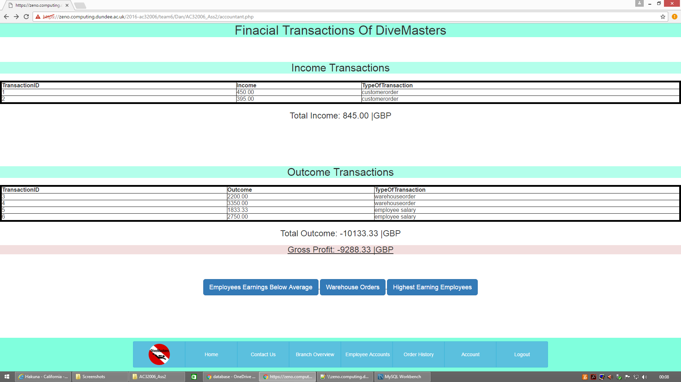Below Average”, “Warehouse Orders” and “Highest Earning Employees”. Through advance queries the accountant is able to display all the employees that earn below the average and what is the difference from the average, all of the warehouse orders in combination with the warehouse branch name and the total warehouse outcome and the all the highest earning employees, the branch name the work at, their salary and their position.

# Conclusion

In conclusion it is important to note some of the key challenges the group have experienced during the completion of this assignment.

As our group tried to create the database we were faced with the problem that, for some unexplained reason, the system was ‘crashing’ after the implementation of 14 foreign keys. Following the first two ‘crashes’ two of the tables disappeared. When we tried to create these tables again using the same name, output in workbench displayed that this table already existed; when we tried drop that table, the console displayed that table did not exist.

This had prevented us from continuing because existing tables were connected to old foreign keys from hidden tables in the database. We had to approach Mahamadou Niakaté for assistance. He could not understand why that was happening either so he decided to give us a new schema ‘16ac3d25’ where we created 7 additional users and gave them different access by using MySQL views with PHP coding.