**Introduction**

This is a use guide report for the user of DiveMasters website. Before explaining in more detail each user this assignment wants to mention some key problems the group faced while doing this assignment.

As our group tried to create our database we were faced with the problem that for some unexplained reason the system did not “like” our foreign keys, by that we mean it was keep crashing every time we tried to create the foreign keys. In every crash a different table disappeared but strangely enough when we tried to create the table Workbench told us that the table exists. At this point we though it is appropriate to drop the table, since it exists even though we could not see it, and recreate it again. When we tried that Workbench told us that the table does not exist. Finally we asked for Mahamadou Niakaté assistants. He could not understand why that was happening either so he decided to give us a new schema. However, in our new schema we did not have the three “Additional Usernames” that the other team had so we created seven users in one username with different views for each user.

**Access DiveMasters Website**

In order to access DiveMasters website you need to connect to this link:

**Different Users and access rights:**

|  |  |  |
| --- | --- | --- |
| **Username** | **Password** | **Access Right** |
| admin | admin1 | Full access and CRUD |
| branchmanager | branch1 | View branch information |
| warehousemanager | warehouse1 | View warehouse information |
| flooremployee | employee1 | View personal information |
| customersupport | support1 | View personal information  And particular client information |
| accountant | accountant1 | View personal information  And financial transaction of the company |
| client | client1 | View personal information |
| IT ?? | IT ??? | IT ?? |

**How to login:**

There are two ways a user can login on the DiveMasters website. It can either click the login button at the top or click the login button on the main menu at the bottom of the screen. When the user presses any of the buttons it will take them to the page displayed below. Through this page both registered customer as well as employees would be able to access their customized pages.

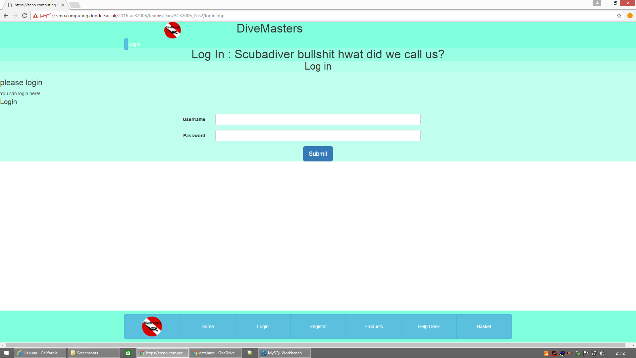

**CUSTOMER USER GUIDE**

When unregistered customers enters the website they are limited to a restricted-access, which allows them through the Main Menu at the bottom to see information about the company, view products and become a official registered customer.



If the customers want to order a particular product they have to become registered customers first. They can do that by clicking the Register Button on the menu displayed above. This will take them to the page shown below

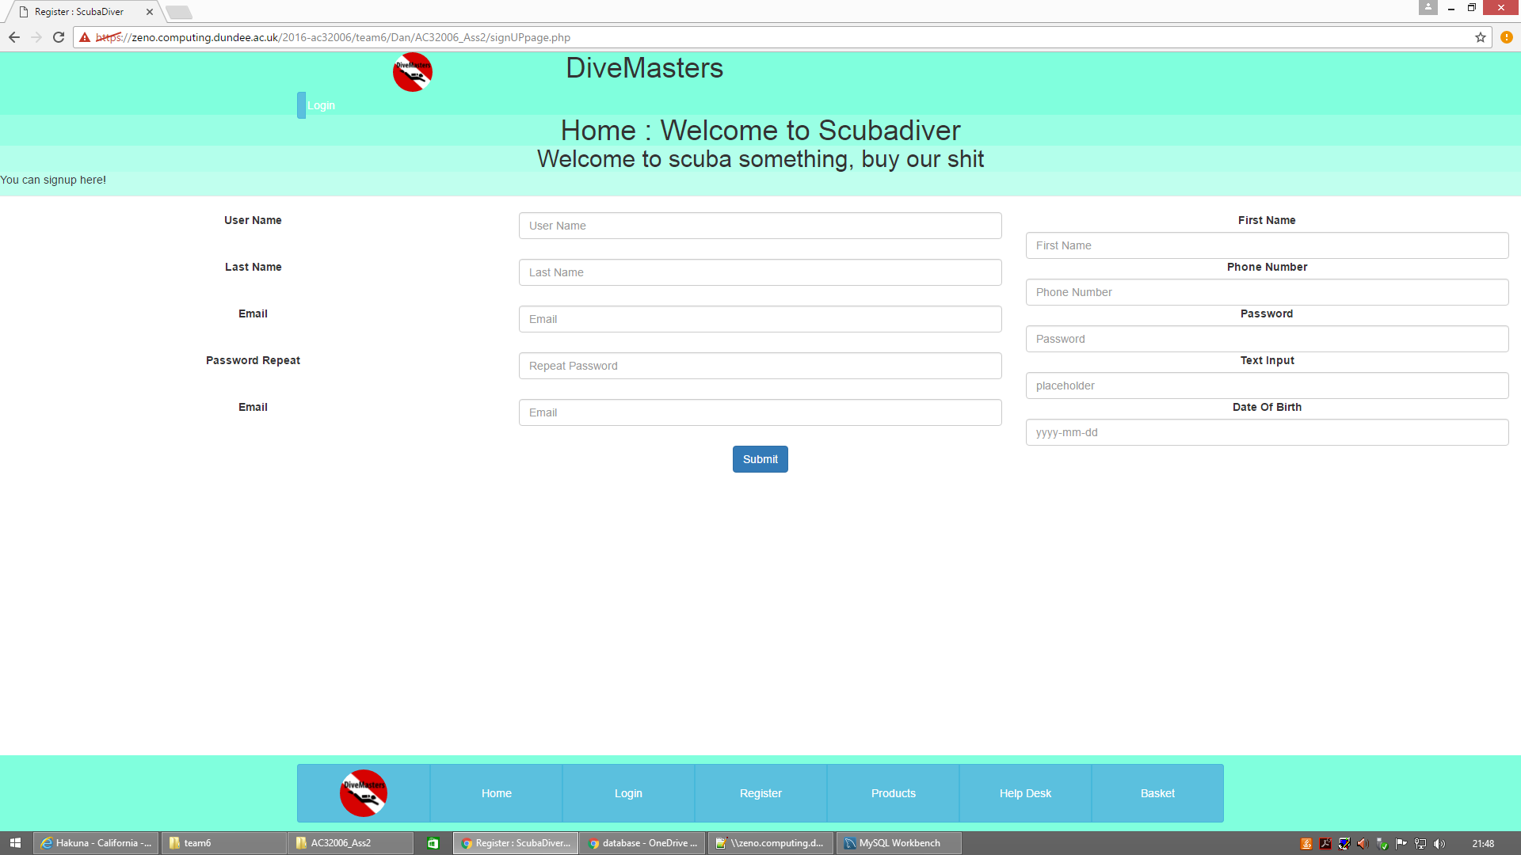After the customer has successfully registered he will be an official user of DiveMasters website.

**Changing Personal information**

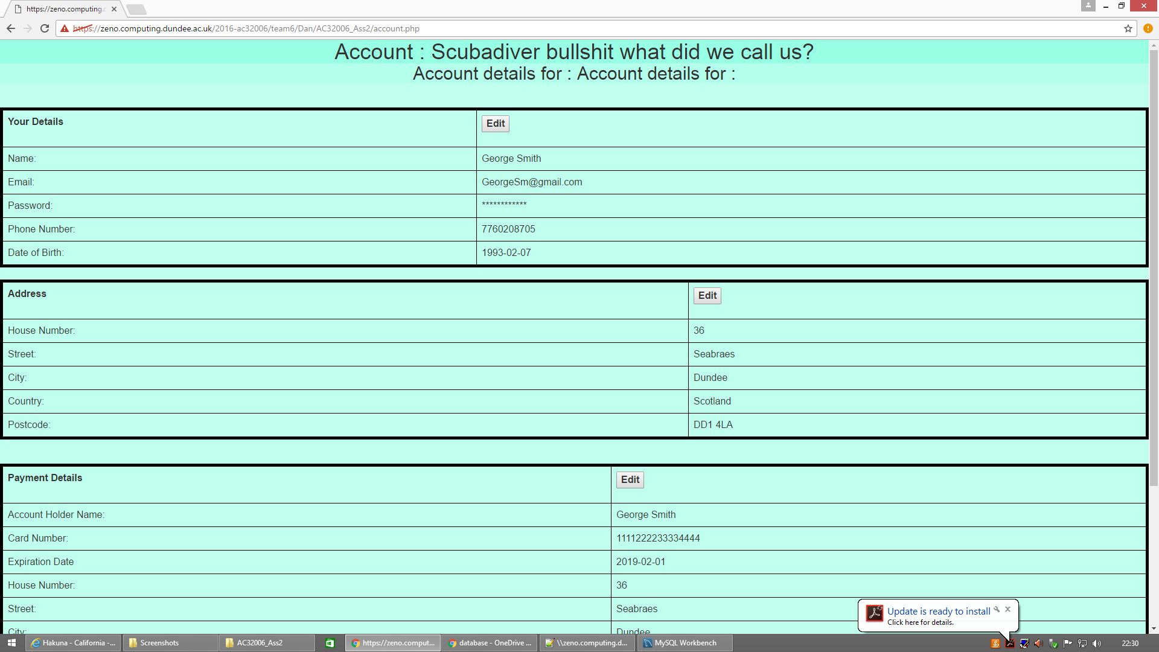When registered customers wish to change their personal details they can click on the Account button on the Main Menu. That will take them to the page displayed below. By clicking edit the customer is able to change the details. After they have edit they details they have to press Submit for the changes to go through.

**Ordering Product**

A registered customer will have to click to the Products button on the Main menu in order to see the different products and start creating an order. As displayed below the user has the option to search between different categories of products and use key words such as color to find a particular product. When users has finally found a products they want to buy they need to choose the quantity they would like on the right and press add to add their product on the basket. In order to see their basket the can either click the button on the Main Menu or the basket button on the top.

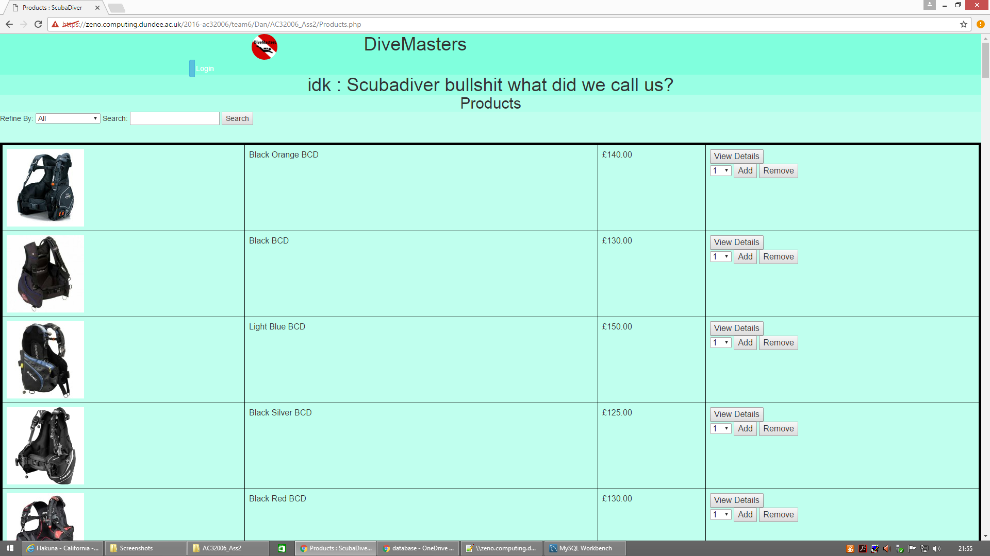

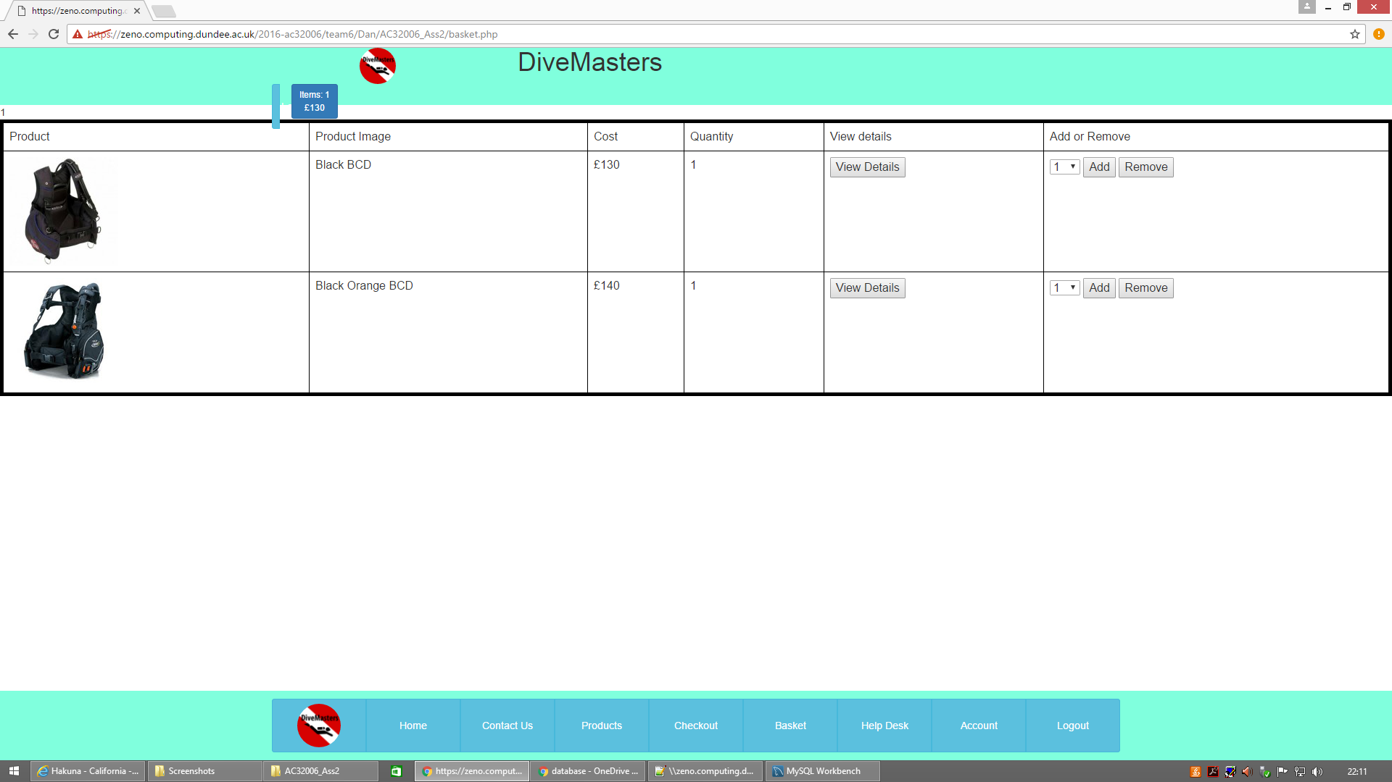In the basket page they will be able to see the products they picked as shown in the page below. If they do not wish to order one of them they can press remove and that will remove it from their basket. If they want to know more about a particular product they can press View detail in either the Basket page or the Products page and that will take them to the individual products page where there is a full description of the product.

Finally when they have picked all the products they would like to order the can press the Check Out button on the Main Menu which will take them to finalize their order.

**Place A Complaint**

In case that a customer wants to place any complaint for a particular order they can do that by clicking on the Help Desk button at the Main Menu. In this page they will have to include the order ID of the particular order and write the complaint, as is displayed in the page below.

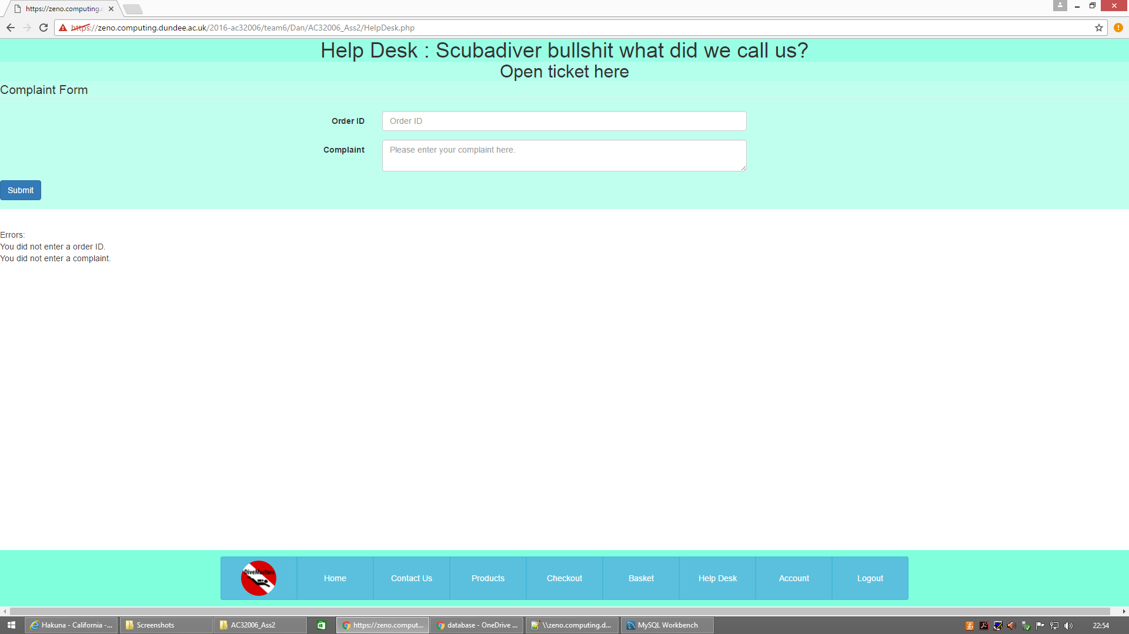 When the users has finished with the complaint they can press submit to send it to the company.

**CUSTOMER-SUPPORT USER GUIDE**

As it was mentioned above the customer support employees can login through the same page as the customers. The account about the a customer-support employee is created by the administrative department when a person gets officially employed by the company.

**Changing Personal information**

If the customer-support employee wishes to change they details they have to do the same process that a customer will do. They will have to press the Account button, which will take them to the page where they can edit their details.

**Customer Support**

The customer-support employees have access to the Customer Support customized page, which is displayed below.

In this page the customer-support employee will be able to see all the complaints placed by customers about particular orders. The customer-support employee will then be able to search for either the details of the particular customer that placed the order or the products that this order contains in order to understand the customer’s problem better. In order to solve the problem the customer support will have to contact the administrative department to make any particular changes. Both of the searches use advance queries in order to find each answer.

**ACCOUNTANT USER GUIDE**

Similarly to the customer-support employee the accountant will receive all the his/her user account information from the administrative department. Similar to the customer and the customer-support employee the accountant can login through the normal

**Changing Personal information**

If the account employee wishes to change they details they have to do the same process that a customer and the customer-support employee will do. They will have to press the Account button, which will take them to the page where they can edit their details.

**Financial Transactions**

The accountant have access to the Financial Transactions customized page, which is displayed below. In the main section of the Financial Transactions the accountant views the general incomes and outcomes of the company and the calculation of the Gross Profit that the company is making. In addition to that the accountant has three more options, which are “Employees Earnings Below Average”, ”Warehouse Orders” and “Highest Earning Employees”. Through advance queries the accountant is able to display all the employees that earn below the average and what is the difference from the average, all the warehouse orders in combination with the warehouse branch name and the total warehouse outcome and the all the highest earning employees, the branch name the work at, their salary and their position.

