Bookedit user manual
Content
Overview and main functionalities 1
Interface startup 2
Toolbar functions 2
File Menu functions 2
Edit Menu functions 3
Transform menu functions 3

Overview and main functionalities
Bookedit is a matlab tool to edit MTPK books issued from decomposition. It implements plotting tools, basic editing functions and audio transformations:
- Plot atoms, toggle view per type and length
- Select atoms, Cut or apply a gain on selected atoms
- Pitch Shifting and Time stretching of atoms
- Load / Save the modified MPTK book in native MPTK format
- Reconstruct and play the transformed/selected book

The following figure shows a snapshot of the interface

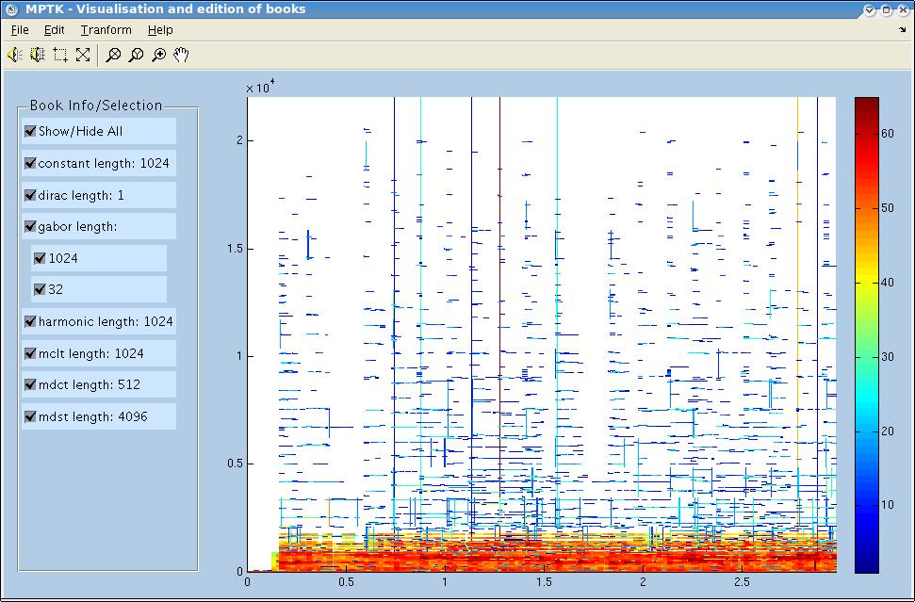
Toggle
view for
different
types
of
atom
Atoms plot (1 axe / channel)
Editable colorbar (click on it
to edit - be sure that zoom is off)
Toolbar icons (play – select - zoom)
Figure menus

Interface startup
The interface can be started with different arguments:
- No argument : At startup, a find file window asks the user for a valid MPTK book.
- bookname: a string with a valied MPTK book. In this case the book is loaded at startup

Toolbar functions
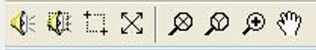
Reconstruct
visible atoms
and play
sound
Reconstruct
selected atoms
and play
sound
Toggle atom
selection mode
Grab / pan
function
Zoom in
Vertical
zoom
Horizontal
zoom
Zoom out
full

Atom selection : When the atom selection is toggled on, you can directly drag a rectangle in the plot to select an area.

Important note: when a zoom function is active (icon grey) the colormap cannot be edited.

File Menu functions
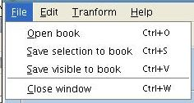
The 'File' menu contains functions for loading and saving a book. It possible to either save only the selected atoms or the visible part of the book.

Edit Menu functions
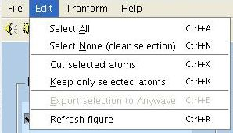
The 'Edit' menu contains functions for editing the selected atoms.
It also has a 'Refresh figure' usefull in case the GUI gets lost.

Transform menu functions
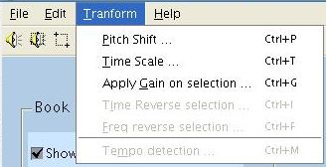
The 'Transform' menu contains functions for typical processing of audio signals.
Some functions are not implemented and thus not accessible.

