How to build MPTK with CMake

SUMMARY

Read this document to learn how to build the Matching Pursuit Tool Kit on Win32 platform using CMake and MinGW chain tool.

LAYOUT
1.Getting started 2
1.1.Required tools 2
1.2.Required packages 2
2.Basic build 2
3.Basic install 4
4.Custom build and install 4
4.1.Principle 5
4.2.Using Cmake application software 5
a)Setting build and install option 5
b)Main options 6
c)Troubleshooting 7
d)Advanced options 9
5.Fixing FFTW used plan with wisdom in FFTW configuration 10
6.Appendix 10
6.1.Getting Cmake 10
6.2.Getting MinGW 11
6.3.Installing MinGW 11
6.4.Getting libsndfile 15
6.5.Getting fftw 15
6.6.Getting Pthreads-w32 16
6.7.Help, contact and forums 16

- Getting started

Required tools
- CMake : at least version 2.4 [for further informations see appendix 6.1]
- MinGW chain tool [for further informations see appendix 6.2 and 6.3]
  - GCC (mingw-special): tested on version 3.4.2
  - make (mingw32-make): tested on version 3.8.0
  - Windows API: tested on version 3.6
  - MinGW Runtime: tested on version 3.9
  - binutils: tested on version 2.14.90

Required packages
- MPTK: at least version 0.5.3
- Libsndfile: at least libsndfile1.0.17 pre compiled dll [for further informations on how to get it and where to install the file, see appendix 6.4]
- FFTW: at least fftw-3.1.2 pre compiled dll [for further informations on how to get it and where to install the file, see appendix 6.5]
- Pthread: Pthreads-w32 at least release 2.8.0 pre compiled dll [for further informations on how to get it and where to install the file, see appendix 6.6]
- Basic build
If the required libraries and include files are installed as the appendix 6.4, 6.5 and 6.6 indicate it, you should be able to generate a build system using the basic build settings.
Suppose you unzip MPTK-v.v.v.tar.gz in directory c:\foo and you want to build MPTK binary and library files in c:\bar (you may choose to build for example in a temporary location which will differ from the place where you will eventually install MPTK). Use CMake to generate the build system, use the Make icons from the program menu to launch the CMake configuration application:
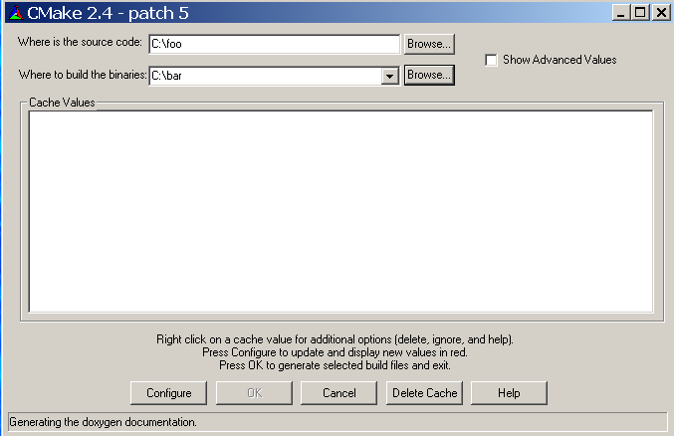
Set the « Where is the source code: » text box with the path of the directory where the source files are located (c:\foo) and the « Where to build the binaries: » with the path of the directory where you want to build the library and executable files (c:\bar).
When clicking for the first time on the [Configure] button, CMake will ask for the build tool you want to use. The build system type depends on the builder you want to use, in our case this is the MinGW chain tools, so the correct option is MinGW Makefiles:
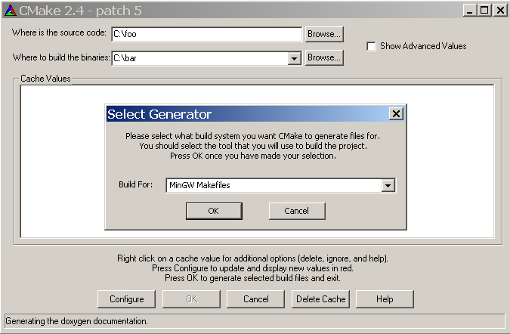
When pressing again the [Configure] button to configure the build system, CMake performs a list of tests to determine the system configuration and manage the build system. If the configuration is correct then no pop-up will appears during the tests and CMake finally shows the various options of the build underlaid in grey. In case of a configuration issue, a pop up window warns you about this issue indicating which test has failed, in this case the build option in the CMake application software will be underlaid in red. We will discuss in Section 4.2.c what to do in such a case, but let us for the moment assume that everything ran smoothly.

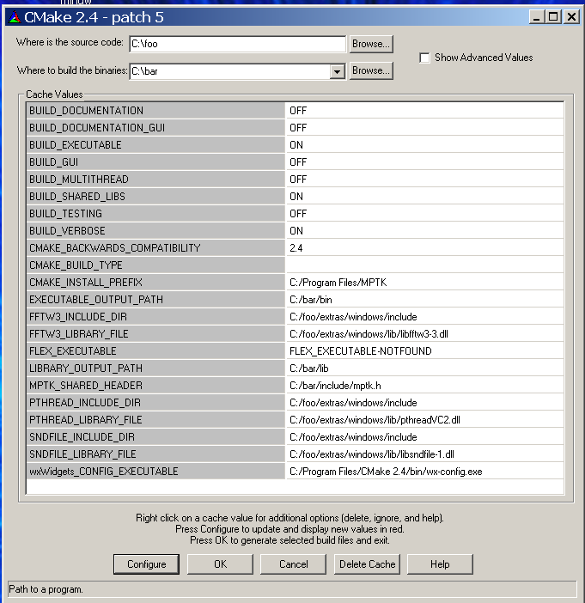
Then, press [OK] will generate the build system and close CMake .

Once the build system generated, you have to actually build MPTK, using the Command Prompt window. In Windows 2000 and Windows XP, you'll find this on the Accessories menu, in the Command Prompt window use the following sequence of commands:

C:\>cd bar
C:\bar>mingw32-make

At the end of the build the console log should appears like this:

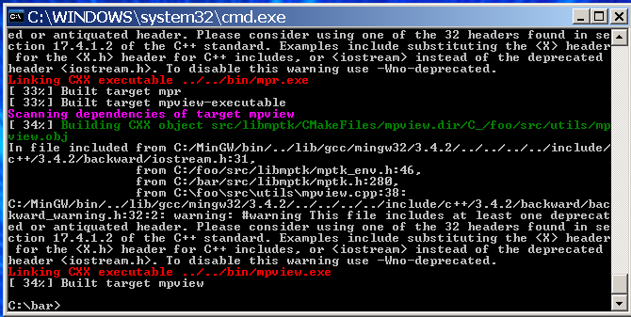
- Basic install
mingw32-make install will install in default directory C:\Program Files\MPTK. In this directory, the bin directory contains the command line executable files and the needed dll (pthreadVC2.dll, libsndfile-1.dll and libfftw3-3.dll), the lib directory contains the libmptk.a and libdsp_windows.a library files and the include directory contains the mptk.h header file.
- Custom build and install
If you want to change build and/or install options (for example to install MPTK in a different folder or to enable the parallel computing using multithread abilities provided by the OS).

Principle
In order to build the MPTK library and executable files, you have to generate a build system with CMake This build system can be parametrized using the CMake application software, which is also used to fix potential issues in the build system configuration.

Using CMake application software

Setting build and install option
Using the Graphical User Interface with the CMake application software allows you to:
- Specify build system options, such as whether to enable the use of multiple threads to speed up the Matching Pursuit decomposition or whether to generate the doxygen documentation.
- Set the prefix path used by the mingw32-make install command
- Troubleshoot the various paths required to build MPTK
- Display advanced build options via the advanced mode

When using the CMake application software, the CMake GUI appears:

When scrolling on a value and clicking, this value can be edited, the grey underlaid row under the button displays some informations about the option and required path to create the build system. In the case of an option when clicking on it, a Combo Box appears to toggle the ON/OFF values. For a path field you can edit manually or use the file browser in order to find the correct path.

After choosing options for the build and setting the required fields, click on [Configure] to configure. The configuration of the build system is checked again by CMake application software, at the end of this check if the build settings are correct, you can press [OK] in order to generate the build system and quit CMake application software.

Main options
This Graphical User Interface allows the user to set the build options for MPTK, currently named BUILD_SOMETHING, if you want to:

- Install MPTK executable files in a specific directory: set CMAKE_INSTALL_PREFIX with the path of this directory. (by default: C:\Program Files\MPTK). In this directory, the bin directory contains the command line executable files and the needed dll (pthreadVC2.dll, libsndfile-1.dll and libfftw3-3.dll), the lib directory contains the libmptk.a and libdsp_windows.a library files and the include directory contains the mptk.h header file.
- Generate the doxygen documentation for MPTK library: set BUILD_DOCUMENTATION to ON. This operation can take a lot of time, be patient. (default OFF)
- Allow MPTK to use parallel computing, set BUILD_MULTITHREAD to ON, this option allows to increase performance on multi-processor hardware architectures

Troubleshooting
Let us see a more complex use of the CMake GUI with troubleshooting. Despite all the integrated tests when CMake manages to generate the build system of MPTK, sometimes CMake application software cannot determine some parameters of your configuration. When using the Make application software, Make performs a list of tests on the build system configuration in order to generate it, if there is some issue related to the configuration, the errors list is displayed on a pop up windows. Here we have 2 include files that Make cannot found:
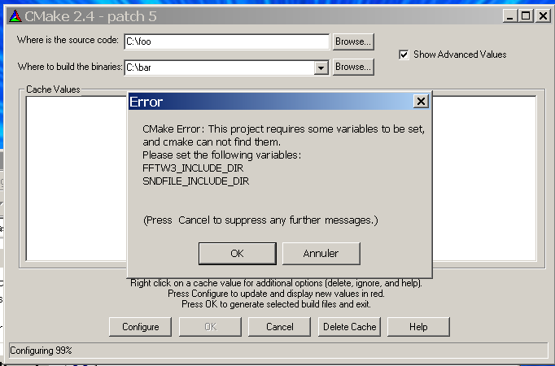

In this case the Make GUI of the should look like this:

In the case of a path, Make FFTW3_INCLUDE_DIR and SNDFILE_INCLUDE_DIR fields (for example) must be set with the path to the directory containing the include files for FFTW library and sndfile library. To set the fields values simply click on the value and use the file explorer to set the field with the correct path.

Important note: In the case of path to include files *_INCLUDE_DIR, only the directory where this include files are located is required. But in the case of a library files *_LIBRARY_FILE, the entire path to the library including its name must be indicated in the corresponding field. As in example below:
After choosing the options for the build and setting the required fields, press [Configure] to configure. The configuration of the build system is checked again by Make, at the end of this check if the build settings are correct, you can press [OK] in order to generate the build system and quit the Make GUI.

Advanced options
You can display more information and all the configuration options by switching to the advanced mode, which is set to off by default and can be toggled on by using the [Show Advanced Values] check box .

The list of the following options should be considered as advanced:

- BUILD_SHARED_LIBS: this option will install the MPTK library (libdsp_windows.a and libmptk.a) in a lib directory and the include file (mptk.h) in an include directory. This directories will be created in the CMAKE_INSTALL_PREFIX path when using the mingw-32-make install command. (default value: ON)
- BUILD_TESTING: this option allows to create tests for MPTK library and executable files using Dart server setting. (default value: OFF)
- BUILD_VERBOSE: this option displays a lot of various informations during the build.
- BUILD_EXECUTABLE: Build the executable files from MPTK (mpd, mpd_demix, mpf , mpview, mpr, mpcat) in a bin directory (default value: ON), note that this files will be installed in a bin directory created within the CMAKE_INSTALL_PREFIX path when using mingw-32-make install command. (default value: ON) Set this option to OFF is useful when you want to build only the library file in order to use its in your own application.
- Fixing FFTW used plan with wisdom in FFTW configuration
MPTK currently relies on FFTW to compute Fast Fourier Transforms. The principle of FFTW is to adaptively select the fastest running codelet to perform a given FFT, which is good for performance. However, this can lead to non deterministic behaviour of MPTK since two consecutive runs of the same command (e.g. 'mpd') with the same options on the same data can yield slightly different results. To avoid this issue we have implemented a mechanism which allows MPTK to fix which FFT codelet is used for a specific type of FFT computation. To do this, you just need to create and export a environment variable called MPTK_FFTW_WISDOM and set this environment variable with the path of the file you want to use in order to save the FFTW configuration. MPTK will create a « wisdom » file, that will be reloaded each time you use MPTK. It means that the codelets use to compute FFTW plan will be the same between two successive decompositions with the same parameters.

In order to set the environment variable used to store the FFTW wisdom file:
- Right-click on "My Computer" and select "Properties".
- Click Advanced -> Environment Variables.
- In the box entitled "System Variables" and click on new
- You will be presented with a dialogue box with two text boxes,the head text box has to be set with MPTK_FFTW_WISDOM, the bottom text box allows you to edit the Path of the FFTW wisdom file. Choose a path to store the wisdom file and a name, for example C:\Program Files\MPTK\FFTW_Wisdom
Note that this file should always be reachable, other way the fftw plan will not be used. You may have to reopen your Windows session in order to set up this new environment variable.
- Appendix

Getting CMake
CMake, is a cross-platform, open-source make system. CMake is used to control the software compilation process using simple platform and compiler independent configuration files. CMake generates native makefiles and workspaces that can be used in the compiler environment of your choice. CMake is quite sophisticated: it is possible to support complex environments requiring system configuration, pre-processor generation, code generation, and template instantiation. Please go here to learn more about CMake

There is a pre-compiled binary available on the Download page. It is provided as an executable installer. One may also download and build CMake from source. The download page also provides source releases and instructions for CVS access.
In order to build CMake from a source tree, you must first install the latest binary version of CMake because it is used for building the source tree. Once the binary is installed, run it on CMake as you would any other project. Typically this means selecting CMake as the Source directory and then selecting a binary directory for the resulting executables.

Getting MinGW
MinGW ("Minimalistic GNU for Windows") is a command-line C/C++ compiler and utilities, based on the GNU GCC project. It compiles and links code to be run on Win32 platforms (Win95 through XP). Unlike some other versions of GCC, MinGW uses the Microsoft runtime libraries, distributed with the Windows operating system. Since these runtime libraries are not distributed using GNU's General Public License (GPL), you do not have to distribute your source code with your programs unless, of course, you use a GPL library such as MPTK in your programs.
MinGW comes with everything you need to compile and link both console-mode and GUI programs that will run on Windows 95/98/NT/2K/XP; your programs will not run on Windows 3.1 or on plain DOS machines however.

Installing MinGW
Using the (possibly "Proposed"/"Candidate") Installer
If you are new to MinGW, the recommended way to begin is to download an installer executable from http://www.mingw.org/download.shtml and run it (e.g. MinGW-5.0.2.exe -- currently there is only a 'Proposed' Version). This package will install mingw-runtime, w32api, GCC, binutils and mingw32-make but it may not be the latest versions of the individual packages. Once you have all these packages (although mingw32-make is not necessary if you have MSYS or Cygwin), you may download updated individual packages like GCC and extract them into the MinGW directory.
Warning: If you have already MSYS installed or if you plan to install it, for versions prior to MSYS-1.0.11; do not install MinGW into the same path as MSYS (but it can be a subdirectory as long as non-MSYS executables are not in the MSYS bin directory)

Manually
Installing MinGW can be quite intimidating the first time because it is not obvious what you have to do. Luckily, it is actually pretty simple. To do a manual install, simply download the required files and extract them all into the same directory. For simplicity, I recommend C:\MinGW.
Download at least the following (or newer) packages from the MinGW download page
  - binutils
  - mingw32-make
  - gcc-core
  - gcc-g++
  - mingw-runtime
  - w32api
These files are gzipped tarballs, Linux users will probably be familiar with .tar.gz files, but they are not that common under Windows. Essentially they are compressed folders like zip files. In order to access the contents you will need to decompress them. Here there is two solutions, if your zip application allows you to unzip the file you should use it to unzip all the package to a folder like C:\MinGW.

In other case this requires that you have gzip and tar installed on your computer. Linux comes with these as standard in every distribution, but under Windows you will need to install them manually. Windows versions can be found at: http://gnuwin32.sourceforge.net/packages/gzip.htm and: http://gnuwin32.sourceforge.net/packages/tar.htm. Download the set-up files and install the applications. Before you use them you need to tell Windows where to find them; specifically this means adding the install directory to your PATH. To do this carry out the following procedure (Warning - adding entries to the path is totally benign, however if you delete you messup your path string then you could seriously compromise the functioning of your computer, please be careful)
- Right-click on "My Computer" and select "Properties".
- Click Advanced -> Environment Variables.
- In the box entitled "System Variables" scroll down to the line that says "Path" and double-click the entry.
- You will be presented with a dialogue box with two text boxes, the bottom text box allows you to edit the Path variable. It is very important that you do not delete the existing values in the path string, this will cause all sorts of problems for you! Scroll to the end of the string and at the end add ";<installation-directory>\bin", press OK -> OK -> OK and you are done. Here <installation-directory> is the full address of the installation directory; if you accepted the defaults when installing tar and gzip then it will (probably) be "C:\Program Files\GnuWin32". Don't forget the semicolon, this separates the entries in the path.
- Create a directory to install all the stuff into. This writer usually creates c:\MinGW and copies all of the above files in there. This will yield the following sequence of commands:
cd /d c:\MinGW
gzip -df binutils-2.16.91-20060119-1.tar.gz
tar -xf binutils-2.16.91-20060119-1.tar
cd info
ren dir dir.binutils
cd ..
gzip -df gcc-core-3.4.5-20060117-1.tar.gz
tar -xf gcc-core-3.4.5-20060117-1.tar
cd info
copy dir dir.gcc
copy dir+dir.binutils
cd ..
gzip -df gcc-g++-3.4.5-20060117-1.tar.gz
tar -xf gcc-g++-3.4.5-20060117-1.tar
gzip -df mingw-runtime-3.9.tar.gz
tar -xf mingw-runtime-3.9.tar
cd info
ren dir dir.gcc
cd ..
gzip -df w32api-3.6.tar.gz
tar -xf w32api-3.6.tar
Before you use the MinGW make command (mingw32-make) you need to tell Windows where to find it; specifically this means adding the install directory to your PATH. To do this carry out the following procedure (Warning - adding entries to the path is totally benign, however if you delete you mess up your path string then you could seriously compromise the functioning of your computer, please be careful)
- Right-click on "My Computer" and select "Properties".
- Click Advanced -> Environment Variables.

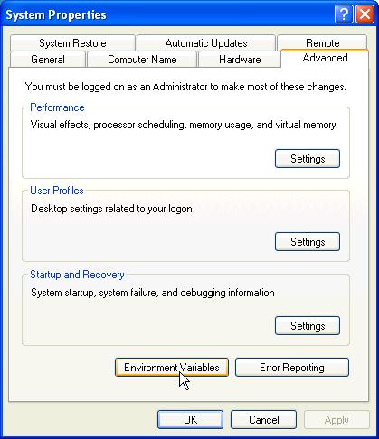
- In the box entitled "System Variables" scroll down to the field that says "Path" and click on [Edit] button.

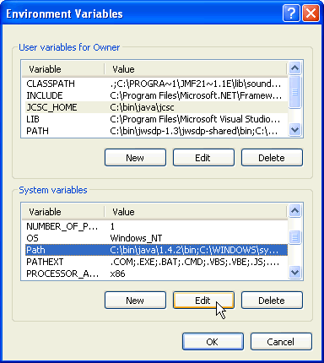
- You will be presented with a dialogue box with two text boxes, the bottom text box allows you to edit the Path variable. It is very important that you do not delete the existing values in the path string, this will cause all sorts of problems for you! Scroll to the end of the string and at the end add ";<installation-directory>\bin", press [OK] -> [OK] -> [OK] and you are done. Here <installation-directory> is the full address of the installation directory, if you had use the default setting when installing MinGW then it will (probably) be " C:\MinGW\”. Don't forget the semicolon, this separates the entries in the path.
After installing MinGW, the value of the "Path" field from System Variable should look like this:
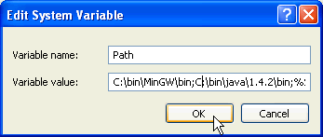
Now, you can check your installation by using the Command Prompt window. In Windows 2000 and Windows XP, you'll find this on the Accessories menu. In this Command Prompt you can use the “gcc --version” and “mingw32-make --version” commands to show up the versions of the applications you have just installed:
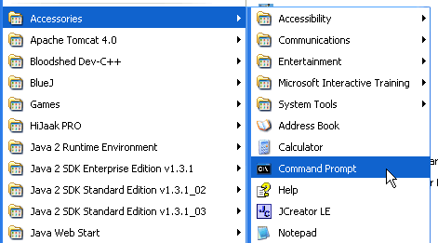
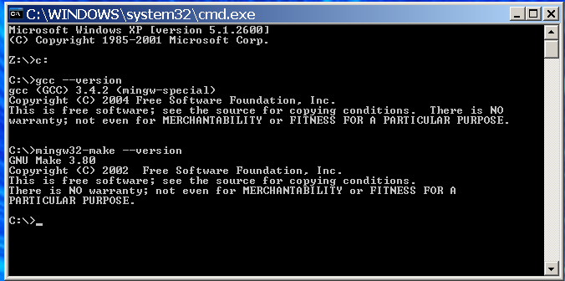

Getting libsndfile
Libsndfile is a C library for reading and writing files containing sampled sound (such as MS Windows WAV and the Apple/SGI AIFF format) through one standard library interface. It is released in source code format under the Gnu Lesser General Public License.
Where to download: http://www.mega-nerd.com/libsndfile/ in the download section the zip file is called libsndfile-1_0_17.zip or in the « released files » section of the MPTK Gforge: http://mptk.gforge.inria.fr/
This package is needed two times by MPTK, the first time during the link of the build process (for both include file and library) and the second time during the execution of MPTK applications. If you don't feel familiar with Win32 dynamic link library management, just follow this instructions:
- unzip the «sndfile.h» include file in a \extras\windows\lib directory of your MPTK source files repertory (for example C:\foo\extras\windows\include)
- unzip the «libsndfile-1.dll» dll file in a \extras\windows\lib directory of your MPTK source files repertory (for example C:\foo\extras\windows\lib)

Getting fftw
FFTW is a C subroutine library for computing the discrete Fourier transform (DFT) in one or more dimensions, of arbitrary input size, and of both real and complex data (as well as of even/odd data, i.e. the discrete cosine/sine transforms or DCT/DST).

Where to download: the zip file named fftw-3.1.2-dll.zip at http://www.fftw.org/install/windows.html, or in the « released files » section of the MPTK Gforge: http://mptk.gforge.inria.fr/

This package is needed two times by MPTK, the first time during the link of the build process (for both include file and library) and the second time during the execution of MPTK applications. If you don't feel familiar with Win32 dynamic link library management, just follow this instructions:
- unzip the «fftw3.h» include file in in a \extras\windows\lib directory of your MPTK source files directory (for example C:\foo\extras\windows\include)
- unzip the «libfftw3-3.dll» dll file in a \extras\windows\lib directory of your MPTK source files directory (for example C:\foo\extras\windows\lib)

Getting Pthreads-w32
The POSIX 1003.1-2001 standard defines an application programming interface (API) for writing multi threaded applications. This interface is known more commonly as pthreads. A good number of modern operating systems include a threading library of some kind: Solaris (UI) threads, Win32 threads, DCE threads, DECthreads, or any of the draft revisions of the pthreads standard. The trend is that most of these systems are slowly adopting the pthreads standard API, with application developers following suit to reduce porting woes.
Win32 does not, and is unlikely to ever, support pthreads natively. This project seeks to provide a freely available and high-quality solution to this problem.
Various individuals have been working on independent implementations of this well-documented and standardised threading API, but most of them never see the light of day. The tendency is for people to only implement what they personally need, and that usually does not help others. This project attempts to consolidate these implementations into one implementation of pthreads for Win32.
Where to download: http://sourceware.org/pthreads-win32/, the source tree and precompiled .DLL, .LIB and necessary header files are included in the self-extracting zip file named
"pthread-w32-v-v-v-release.exe" at: ftp://sourceware.org/pub/pthreads-win32 or in the « released files » section of the MPTK Gforge: http://mptk.gforge.inria.fr/

This package is needed two times by MPTK, the first time during the link of the build process (for both include file and library) and the second time during the execution of MPTK applications. If you don't feel familiar with Win32 dynamic link library management, just follow this instructions:
Run the self-extracting zip, you should obtain three directory, in the Pre-built.2 directory:
- from the include directory copy «pthread.h», «sched.h» and «semaphore.h» include files in a \extras\windows\include directory of your MPTK source files directory (for example C:\foo\extras\windows\include)
- from the lib directory copy «pthreadVC2.dll» dll file in a \extras\windows\lib directory of your MPTK source files directory (for example C:\foo\extras\windows\lib)

Help, contact and forums

If you need help with the software:
- check if a more recent release fixes your problem;
- if not, use the Help forum to ask questions.

Other Forums are available for open discussions about the Matching Pursuit algorithm and its MPTK implementation.
Some articles exposing scientific results related to MPTK are available in PDF format through the Released Files page.

If you want specific informations, or if you want to communicate privately with us, please write to
matching.pursuit@irisa.fr.

Request for help sent to this address won't be answered. Please use the Help forum instead.

Thank you for your interest in The Matching Pursuit Tool Kit !

