Use Eclipse for MPTK Development

http://www.eclipse.org/

TO-DO:

- Add a part on the “Replace with” functionality in the advanced features (critical function)?
- Other features to add in the advanced features ?
- Better description of the functionalities of the team menu?

SUMMARY

The aim of this document is to introduce how to use Eclipse in developing Features for Matching Pursuit Tool Kit. The treated topics are about creating an Eclipse project from file system or how to manage the synchronisation between some projects and an SubVersioN repository. Some of the features introduced in this document are really basics, but there is also most advanced features to use the full potential of the advanced Eclipse tools and its plug-ins.

LAYOUT
1.Short FAQ about Eclipse. 3
1.1.What is Eclipse? 3
1.2.History of Eclipse 4
1.3.How to download Eclipse 5
1.4.How to install Eclipse 5
1.5.Why two versions of Eclipse under Linux Os? 5
1.6.How to use your own speaking language in Eclipse 5
1.7.Useful Start-up option 5
2.Eclipse working concept 6
2.1.What about Workspace? 6
2.2.How to set a different directory for my workspace 6
2.3.What about perspective, view, Editor 6
2.4.Eclipse plug-in 7
a)How to find Eclispse plug-ins 7
b)How to install an Eclipse plug-in 7
c)How to check if a plug-in is already installed 12
d)Needed plug-in to work on MPTK with the SVN repository 14
3.How to set up subclipse 14
3.1.Team options 15
3.2.Connecting Eclipse with the distant SVN repository 17
3.3.Browse the distant SVN repository 23
4.How to create a synchronised C/C++ project with a distant SVN repository 26
5.How to create a local C/C++ project with Eclipse 32
5.1.How to import a complete file hierarchy 38
5.2.How to edit the include links 44
5.3.How to Add an Already Existent Project to the Repository 46
6.Building MPTK with Eclipse 47
6.1.For Linux and OSX plateform 47
6.2.For Windows (Win32) plateform 48
7.Advanced features of subclipse 56
7.1.Comparison between various revisions of a source file 56
7.2.Create, manage, run and debug configuration under Eclipse 57
a)For Linux and OSX plateform 58
b)For Windows (win32) plateform 62
c)How to create project to debug Matlab Mexfiles (linux) 66
8.Useful links 66

Short FAQ about Eclipse.

What is Eclipse?
« Eclipse is an open source community whose projects are focused on providing a vendor-neutral open development platform and application frameworks for building software. The Eclipse Foundation is a not-for-profit corporation formed to advance the creation, evolution, promotion, and support of the Eclipse Platform and to cultivate both an open source community and an ecosystem of complementary products, capabilities, and services.
As it says in the Purposes section of the Foundation’s Bylaws:
The purpose of Eclipse Foundation Inc.,(the "Eclipse Foundation"), is to advance the creation, evolution, promotion, and support of the Eclipse Platform and to cultivate both an open source community and an ecosystem of complementary products, capabilities, and services.
Eclipse has formed an independent open eco-system around royalty-free technology and a universal platform for tools integration. Eclipse based tools give developers freedom of choice in a multi-language, multi-platform, multi-vendor environment. Eclipse provides a plug-in based framework that makes it easier to create, integrate and utilize software tools, saving time and money. By collaborating and exploiting core integration technology, tool producers can leverage platform reuse and concentrate on core competencies to create new development technology. The Eclipse Platform is written in the Java language and comes with extensive plug-in construction tool kits and examples. It has already been deployed on a range of development workstations including Linux, HP-UX, AIX, Solaris, QNX, Mac OS X and Windows based systems. A full description of the Eclipse community and white papers documenting the design and use of the Eclipse Platform are available at http://www.eclipse.org.
You can learn more about the structure and mission of the Eclipse Foundation by reading the formal documents that establish how the foundation operates, and by reading the press release announcing the creation of the independent organization. »

From www.eclipse.org

History of Eclipse
Industry leaders Borland, IBM, MERANT, QNX Software Systems, Rational Software, Red Hat, SuSE, TogetherSoft and Webgain formed the initial eclipse.org Board of Stewards in November 2001. By the end of 2003, this initial consortium had grown to over 80 members.
On Feb 2, 2004 the Eclipse Board of Stewards announced Eclipse’s reorganization into a not-for-profit corporation. Originally a consortium that formed when IBM released the Eclipse Platform into Open Source, Eclipse became an independent body that will drive the platform’s evolution to benefit the providers of software development offerings and end-users. All technology and source code provided to and developed by this fast-growing community is made available royalty-free via the Eclipse Public License.
With the change to an independent not-for-profit corporation, a full-time Eclipse management organization has been established to engage with commercial developers and consumers, academic and research institutions, standards bodies, tool interoperability groups and individual developers, plus coordinate the open source projects. To maintain a reliable and accessible development roadmap, a set of councils (Requirements, Architecture and Planning) will guide the development done by Eclipse Open Source projects. With the support of over 115 member companies, Eclipse already hosts 9 major Open Source projects that include a total of over 50 sub projects.
To oversee and staff this new management organization, Eclipse has established a Board of Directors drawn from four classes of membership: Strategic Developers, Strategic Consumers, Add-in Providers and Open Source project leaders.
Developers and Strategic Consumers hold seats on this Board, as do representatives elected by Add-in Providers and Open Source project leaders. Strategic Developers, Strategic Consumers and Add-in Providers contribute annual dues. The founding Strategic Developers and Strategic Consumers are Ericsson, HP, IBM, Intel, MontaVista Software, QNX, SAP and Serena Software. In August 2004, Actuate joined the Eclipse Board as a Strategic Developer.
In the Eclipse Platform, code access and use is controlled through the Eclipse Public License, which allows individuals to create derivative works with worldwide re-distribution rights that are royalty free. Those who use the Eclipse Platform may also want to use one or more of the official Eclipse logos found on our artwork page. »

From www.eclipse.org

How to download Eclipse
On the official web site www.eclipse.org and more precisely on the Eclipse download page:
- There is one kind of archive for each OS (one for windows, two for Unix System and one for OSX)
- There is always a Stable and a Unstable version of the current release

How to install Eclipse
Unzip the Eclipse Zip in the place you want to install it and it's done. You have now to check if the Java run-time is correctly set.
- The –VM option set the Java run-time used to run Eclipse
- If you have an UNIX like OS, a symlink (ln -s) to the Java JRE in the Eclipse directory allows you to manage your configuration easily.

Why two versions of Eclipse under Linux Os?
The graphic lib used by Eclipse (swt) simply drive the native graphical API of your OS, for example mfc under Win32, cocoa under OSX and Gtk or motif for Linux. So there is two versions a Gtk Eclipse and a Motif Eclipse

How to use your own speaking language in Eclipse
In order to set up your own speaking language in Eclipse, you have to download a language pack at this url:
http://download.eclipse.org/eclipse/downloads/drops/L-3.2_Language_Packs-200607121700/index.php
The you have to unzip this language pack in your Eclipse directory, the language set-up is set at start up, see the next point for more information.

Useful Start-up option
When Eclipse starts, the knowledge of a few options could be useful, in most cases the command line to start Eclipse looks like that:
eclipse -nl fr_FR -nosplash -vmargs -Xmx1024m -Xms256m (for linux)
eclipse.exe -nl fr_FR -nosplash -vmargs -Xmx1024m -Xms256m (for windows)
Where the corresponding options are:
- -nl fr_FR: set the language
- -nosplash : suppress the logo at startup
- -vmargs : args for virtual Machine, here:
  - -Xmx1024m: max memory for virtual machine
  - -Xms256m: default memory for virtual machine
The options concerning memory management are useful if you have to work on a project containing an huge number of source files. In this case this option can solve some memory issues between Eclipse and the JVM, as for example the Out of Memory Exception.

Eclipse working concept

What about Workspace?
As you should think, the workspace is the directory where all your projects are stored and defined for each programming language Eclipse can manage. You can use more than one workspace, but notice that:
- Having a important number of open projects can decrease the global performances of Eclipse
- Copy/Paste a workspace usually duplicates it, so you can easily import your work on an other computer than yours, even if this computer hasn't got the same operating system.

How to set a different directory for my workspace
Since Eclipse 3.0, Eclipse asks you at each start-up which directory use as workspace, you can also use the menu file-> switch workspace command to switch the workspace when Eclipse is already started.

What about perspective, view, Editor
Unlike most IDE, Eclipse isn't based on MDI (Multi Document Interface), but has is own system for managing development: the perspectives.

A perspective is a set of coherent views which allows to work on a specified topic, according to this philosophy there is a resources perspective which allow to see the files system contains in the active workspace, and there is a C/C++ perspective to work on C/C++ source files, a SVN perspective to synchronise the project with a repository, a debug perspective, and more, for each task you need to do there is a corresponding perspective.
All this perspectives can be accessed with the little tool bar on the right high corner in the Eclipse GUI.
The views are graphical window where some information is displayed, a package explorer allows you to see the files in the current project, a svn view shows the files in the repository, etc...
Most Eclipse plug-ins add some perspectives based on views (for example CDT add some C/C++ perspective with view of the source code). Of course you can change the organisation of views and perspectives with the Window-> show view command and select the new view you want to see in the current perspective.
The window->perspective->reset perspective allow you to reset the current perspective.
In order to export/import your perspective configuration you can use the window->preferences-> export an window->preferences->import command.

Eclipse plug-in
A plug-in in Eclipse is a component that provides a certain type of service within the context of the Eclipse workbench. Because Eclipse is an extensible platform for building IDEs, it provides a core of services for controlling a set of tools working together to support programming tasks. Tool builders contribute to the Eclipse platform by wrapping their tools in pluggable components, called Eclipse plug-ins, which conform to Eclipse's plug-in contract. The basic mechanism of extensibility in Eclipse is that new plug-ins can add new processing elements to existing plug-ins. And Eclipse provides a set of core plug-ins to bootstrap this process.

How to find Eclispse plug-ins
To find plug-in dealing with C/C++ IDE - Graphical Editor Framework (GEF) Project - COBOL – UML2, this web site is recommended: eclipse.org/tools/
For other features as for example SVN synchronisation, there is two web sites eclipseplugincentral and eclipse-plugins.2y.net

How to install an Eclipse plug-in
There is two ways for installing a plug-in, depending on the plug-in type:

If the plug-in is a compressed archive (zip or tar):
- Download the file
- Extract the files from the archive
- Put respectively the /plug-in files in the /eclipse/plugins directory and the et /features files in the /eclipse/features directory
- Restart Eclipse
Let's see the case where the plug-in can be download using an URL with the example of Subclipse, a plug-in which enables you to synchronise an Eclipse project with a distant SVN repository. In order to install this plug-in, you have to use the command help->Software update-> find and install, the Install/Update popup window appears:

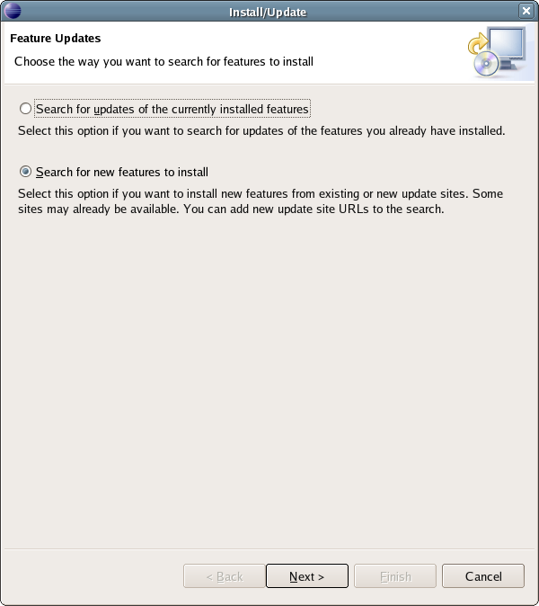
Choose as on the picture the “Search for new features to install” option. The Install popup window, which contains the list of local or remote update sites, appears, this screen allow you to install new functionalities for Eclipse from local or remote site.
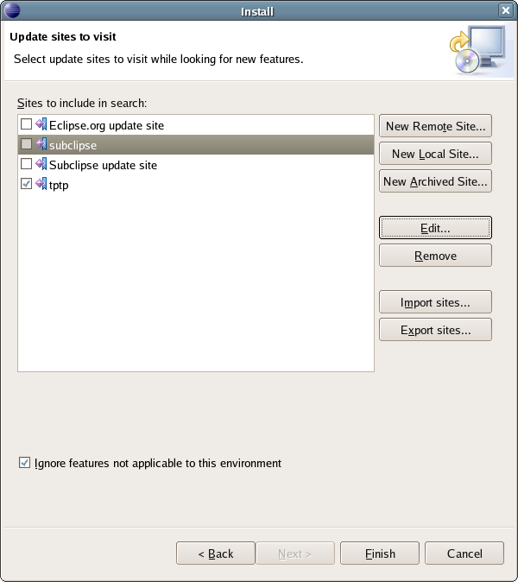
You have to create a new site in the list for searching Eclipse update, choose the “New Remote Site..” command, a pop up appears to set a name and an URL for the “New Update Site”, in the case of subclipse:

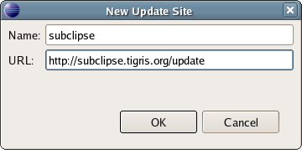
- for the name: subclipse (for example)
- for URL:http://subclipse.tigris.org/update

Once the update site is parametrized, simply follow the standard update process and the plug-in will be installed. You may need to restart Eclipse in order to set up the configuration for the new plug-in.

How to check if a plug-in is already installed
In order to check if subclipse (for example) is correctly installed, you can use the information page of Eclipse with the “About Eclipse SDK” command in the “Help” menu:

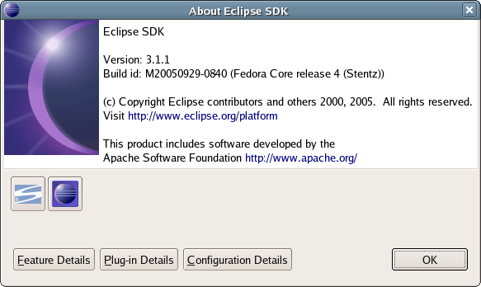
The “Plug-in Details” view allows you to check if the subclipse plug-in is correctly installed:

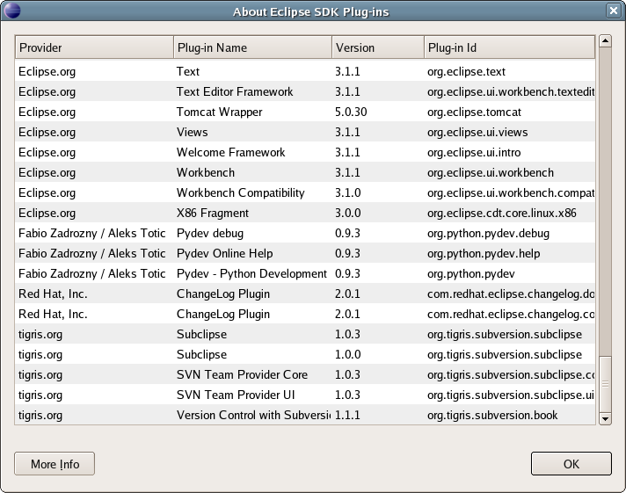

Needed plug-in to work on MPTK with the SVN repository
In order to use Eclipse to develop some source code in the C/C++ language, you need the CDT plug-in, if this plug-in is not installed, it can be installed as a update site with the following URL:

http://download.eclipse.org/tools/cdt/releases/callisto

You also need the Subclipse plug-in to manage Subversion functionalities in Eclipse, Subversion is a version control system, like CVS. However, Subversion fixes some of the flaws in CVS like "lack of versioning support for directory and file metadata, namespace problems, complexity in administration, etc.". Subversion is under development by the same people who created CVS. Subversion is used as a versioning control system to allow multiple users to develop on the system at one time. Programmers download the latest version of the code from subversion, make their changes to the code, and then upload the files back to Subversion. Subversion keeps track of the changes and then integrates the changes back into the main code base or lets the programmer know if other modifications where made between their last download and subsequent upload.
Subclipse is an Eclipse plug-in that provides the functionality to interact with a Subversion server, and to manipulate a project on a Subversion server in the Eclipse environment. Eclipse comes with a CVS plug-in already installed, but Subclipse needs to be installed. See the example of installing plug-in, it could be installed using the following URL:
http://subclipse.tigris.org/update

How to set up subclipse
One of the interests of IDE like Eclipse is to synchronise the IDE with a SVN repository, this functionality is allowed by the Subclipse plug-in from Tigris. In order to synchronise Eclipse with a repository in the INRIA's Gforge, you have to generate a public and a private key to access the forge via shh, See the Gforge FAQ on this subject.

Team options
In order to configure Subclipse you have to use the “Preferences...” command “Window” menu, a pop up window appears with all the parameters of Eclipse, the part which deals with repositories synchronisation is in the team branch:

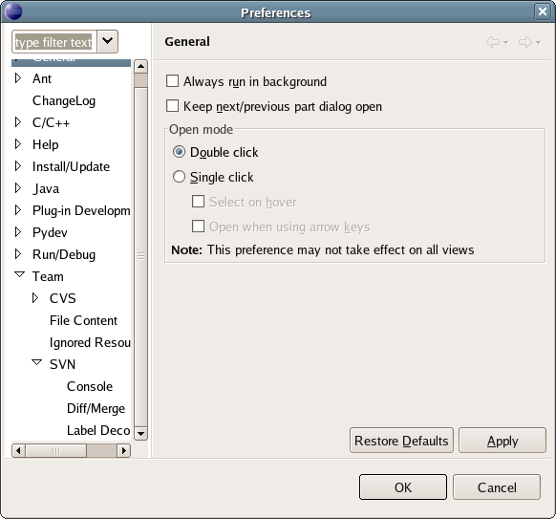
When you click on the SVN Branch of Team, a view containing preferences appears, This options seem to avoid problem, a pure Java connection should be better than an JNI one..

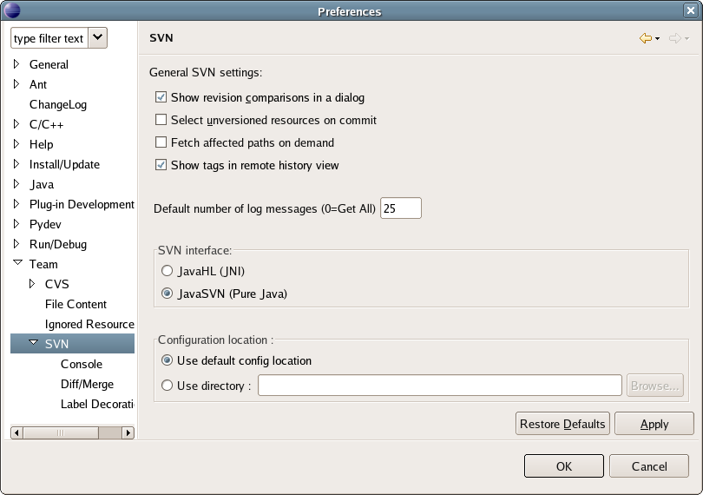

Connecting Eclipse with the distant SVN repository
You can now connect Eclipse with the SVN repository of the concerned project from INRIA's Gforge In that aim you have to use the SVN perspective of Eclipse. Use the icon shown by the arrow to activate a new perspective:

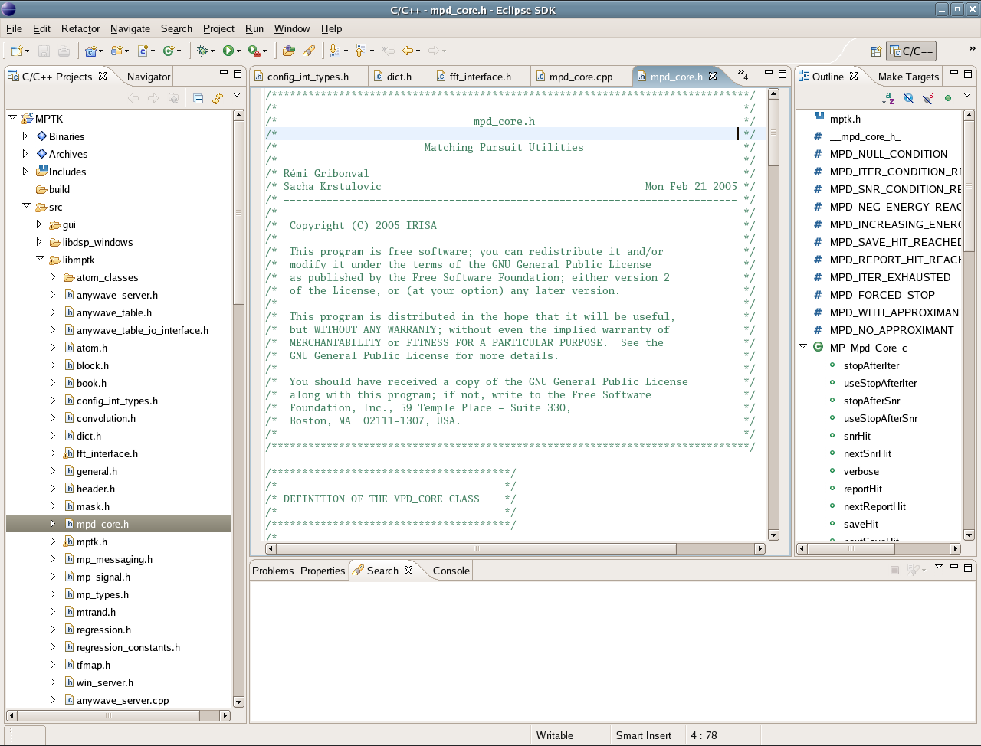
After cliquing on the icon , you have to choose the “Other...” option, which activate a pop up window containing all the kinds of perspectives you can use in your configuration of Eclipse:

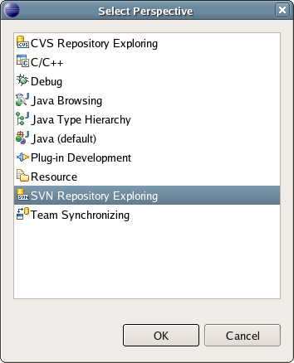
In this menu “Select Perspective” You have to choose the “SVN Repository Exploring” perspective.
In this perspective you have to link Eclipse with a new repository, make a right click in the indicated zone of the SVN repository view and choose “new” then “Repository location..”:
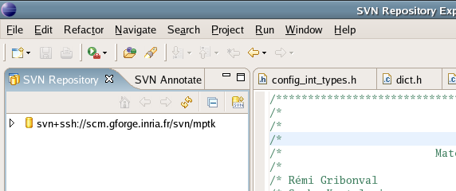

A pop up windows appears and an URL field have to be set with the repository's URL: svn+ssh://scm.gforge.inria.fr/svn/mptk/
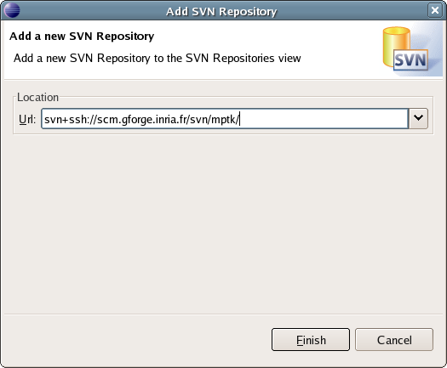
The + ssh option show that the connection is secured. At our first access to the repository, you may have to set your user name and the ssh public key you have generated and set previously in your INRIA's Gforge profile. The public key is generally stored in /udd/[user]/.ssh, if you work at INRIA, you also have to set the pass phrase used to generate your public key. In another case, please check your ssh configuration in order to determine where your public key is stored.

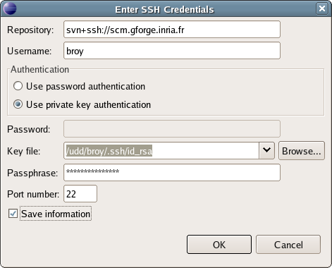
Note that Eclipse allows you to generate a public RSA key, use the Window > Preferences... menu, in the Team branch chose the CVS and SSH2 Connection Method sub-branch:

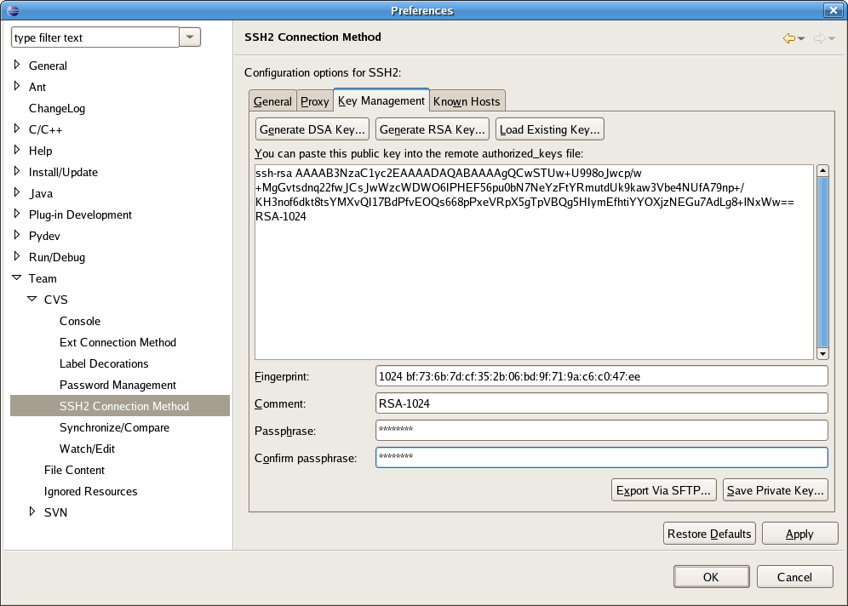
In the Key Management panel use the Generate RSA Key... command to generate a public, then :
- add a comment (ex: user@host, inria-gforge-key)
- choose a lengthy passphrase in the Passphrase field and confirm it in the Confirm passphrase field.
With your mouse, select the content of the box labelled Public key for pasting into OpenSSH authorized_keys file, copy it (that is, hit Control-C).
Click on the Save private key button to save your private key in a file.
You have to paste your public key in the Gforge website. To do this, you need to go to your account and then go to the Account maintenance tab. At the bottom of the Account maintenance tab, you should see a Shell Account Information section which contains an [Edit keys] link. Paste (that is, hit control-V) your public key(s) in the empty field below and click the Update button. As described in the Gforge FAQ.
A common problem is that the Shell Account Information field does not appear in your account page. This usually happens because you do not belong to any Gforge project. To fix this issue, request the project admin of the project you want to join to add you to the list of the project's contributors. Please, be aware that uploading your ssh public key on the server will not allow you to connect to the server immediately through ssh. To do so, you will need to wait at most 24h. If your connection is impossible 24h later, please, contact the server administrators.

Browse the distant SVN repository
The SVN Repository Exploring gives you three new views: SVN Repository, SVN Annotate, and SVN Resource History. The SVN Repository view lists all of the current repositories that you have access to. You can also create a new SVN Repository. The SVN Annotate view shows the annotations of a file in the repository. In order to view the annotations of a file, you must right click on the file and select Team > Show Annotations. The last view, SVN Resource History, shows the revision history for a file that is selected in the SVN Repository view.
In the SVN repository perspective, a right click on an Item allow you to access to a first group of commands:

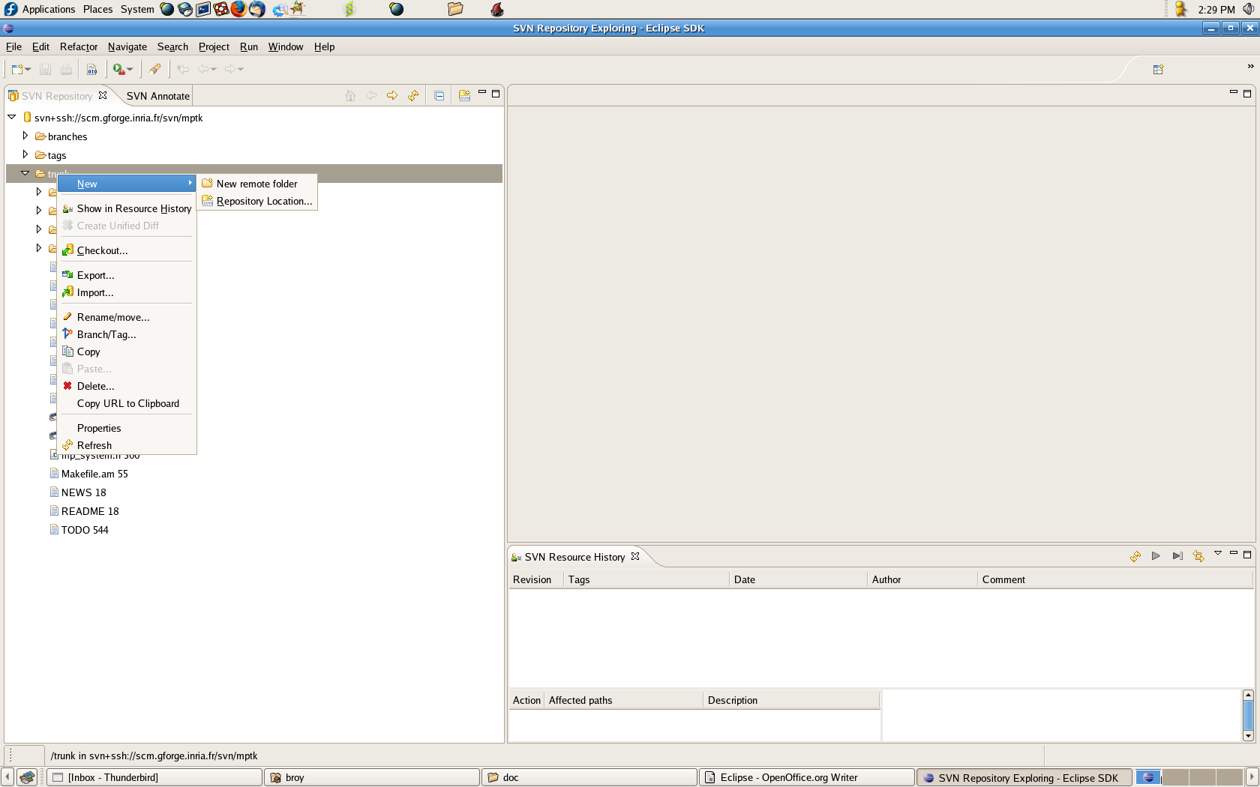
Once the access to the SVN repository available, you can browse the tree of files and directory of SVN repository on the server (note that this files system is different from your local copy) . And you have a panel of commands when a item is selected with a right click and the team sub-menu, this panel have all the basic commands for driving a distant SVN repository:
- Checkout
- Export
- Import
- Branch/Tag
- ...
These commands manage collaborative work for a team working on the same project, the interest of an IDE such as Eclipse is that you don't have to know all the command syntax in the console to use them. More over Eclipse manages for you all the platform dependants problems like the different String chains termination between Windows and Linux OS like.

How to create a synchronised C/C++ project with a distant SVN repository
You can also import source files directly from the SVN repository and create a project based on the repository, this solution is the cleanest way to synchronise a project with a repository.
In order to do that, activate the SVN perspective and right click on the branch you want to import from the distant SVN repository, in the pop up menu choose “Checkout..”:
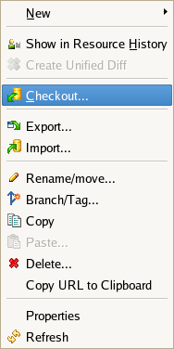
You have now to define if you want to create a new project or if you want to check out in an existent project of the workspace. Note that if the project that you are checking out already exists in the workspace, the old project will be destroyed and the project from the SVN repository will be created in its place. Otherwise a new project will be created in the workspace.

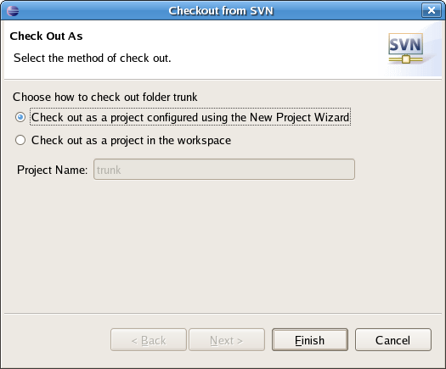
You can now set the properties of this new project:

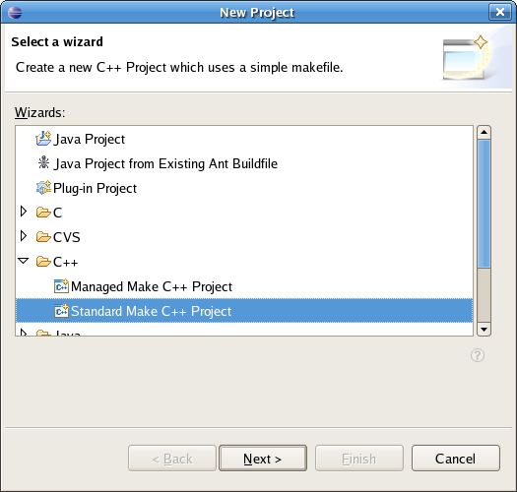
Once the project is created, switch back to the C/C++ or perspective to modify the code:

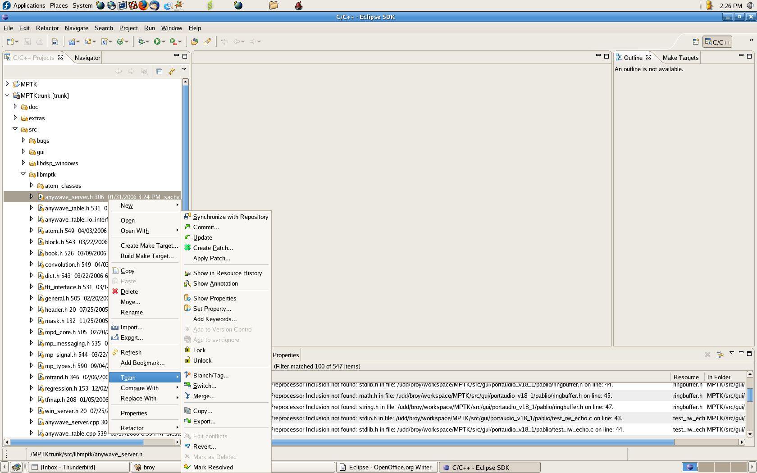
When right clicking on an item, and use the Team menu subcommand you are now able to:

- Committing Resources into the Repository:
Any resources that you have modified will be headed with a > in front of the resource name. To commit a project, right click on the project and select Team > Commit.... Then you will edit the commit comment, or add a new commit comment to document what kinds of change were made. There is also a list of previously used commit comments to choose from. Once you have committed code, the >s should be gone from modified files.

- Synchronizing Resources
To synchronize resources, right click on a project and select Team > Synchronize with Repository .... You will be switched to the Team Synchronizing view. From there you can look at your outgoing changes, and others incoming changes, and synchronize your code before committing to the repository.

- Updating/Switching your local copy of files
While you are working on a project, other members of your team may be committing changes to the project repository. To get these changes, you have to update your working copy. This function is initiated via the Team > Update menu option or from within the Team Synchronizing View. When you perform an Update, the contents of your working copy will be updated with the latest version of the resource available in the repository. For non-conflicting and auto-mergeable conflicts, there is no additional action required. The repository contents are not changed when you update. When you accept incoming changes, these changes are applied to your working copy only. The repository is only changed when you commit your outgoing changes.
While a Checkout operation checks out everything from the desired branch into a new working copy, a Switch operation only transfers the changed data to an existing working copy. This can considerably reduce the amount of time it takes to establish the desired working copy as well as dramatically reduce the load on the network during the copy process.
Switch works just like Update in that it never discards your local changes. Any changes you have made to your working copy which have not yet been committed will be merged when you do the Switch. If you do not want this to happen, you must either commit your changes before switching, or Revert your working copy to an already-committed revision (typically HEAD).

- Replacing your local copy of files
WARNING, think about use the update or switch function if it's possible, be aware that using the replace function will overwrite all your current project and may loose the modification you have done. To replace your code with the latest from the repository, you may either recheck out the project or right click on the project in the C/C++ perspective and select Replace With > Latest from repository. This will update your project with the latest changes.

- Using the compare menu
The compare menu normally allows you to compare with local history (Eclipse's own version of saved files during a session), or to compare two selected resources.
However, once a project is connected to a repository, a few new entries are present in the Compare menu:
- Compare With > Base Revision - this will compare the selected resource with the "pristine" version hidden away in the project's working copy. This happens without contacting the repository.
- Compare With > Latest From Repository - this will compare the selected resource with the latest version of this resource at the same location in the repository. This requires a lookup to see what the latest version is.
- Compare With > Revision... - this will bring up a dialogue showing the change history for the file. You can then easily compare the file against any previous revision from the repository.
- Compare With > Branch/Tag... - This option allows you to compare your working copy with another URL from the repository, presumably a different branch/tag of the same project. You are given the option of viewing the output in the Eclipse graphical compare engine, or using the SVN command to produce a unified diff. The latter operation generally runs a lot faster and is able to factor out differences in keywords. Of course the graphical compare is a nicer way to view the differences.
These comparisons are very useful for reviewing the contents of your changes before you commit them.
- Disconnecting a Project from the Repository:
WARNING: Use this functionalities only if you have to work without a remote connection to internet.
Switch to the C/C++ perspective. To disconnect a project from the repository, right click on the project and select Team > Disconnect. Eclipse will prompt asking if you wish to delete the meta-data associated with the Subversion connection. Choose No. If you choose yes, you will have to delete the project in your workspace in order to check out another copy of the code.

- Lock/unlock a files:
This command allow you to block a file and be sure that no one can do a commit during this time. But be careful, cause this command can block the dynamic of working with a SVN, you may use this function smartly...
For further information on the SVN command via subclipse, please refer to SVN help
on subclipse web site.

How to create a local C/C++ project with Eclipse
Once a workspace defined, you may need to create a new project, for example if you have got some source files with another method than using the MPTK repository on the INRIA Gforge. The kind of project depends of the programming language you want to use, in our case, rigthclick in the work space and choose “New Project” and Standard Make C++ Project in C++ branch:

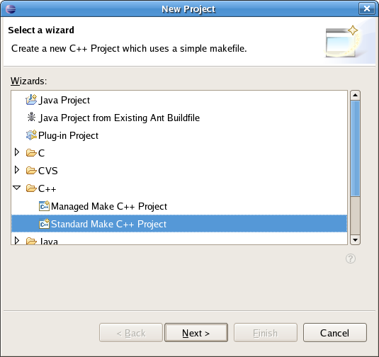
Choose a name for the project and eventually set a different workspace for this project:

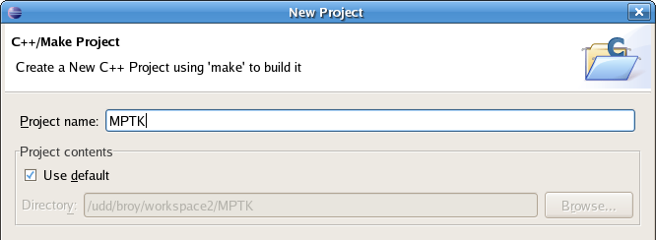
At this point Eclipse ask for using the C/C++ perspective which allows you to access all the useful view for developing in C/C++.
You will note that by default, a new project has some include links till its creation, this links correspond to Operating System links and are set from the project creation. If you want to use the CDT standard builder, sometimes you have to edit the project include links:

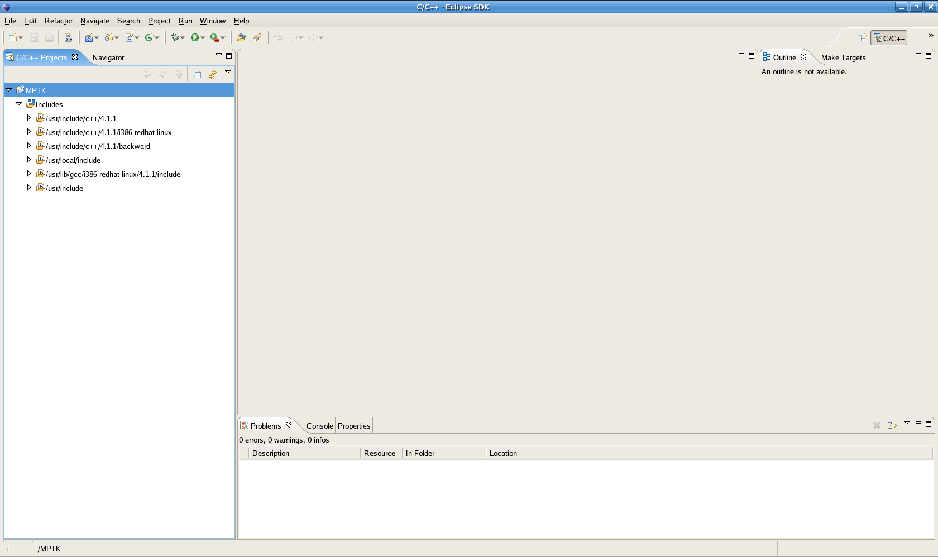

How to import a complete file hierarchy
Eclipse allows you to import a complete file hierarchy from local hard drive, a right click in the C/C++ perspective show a menu:

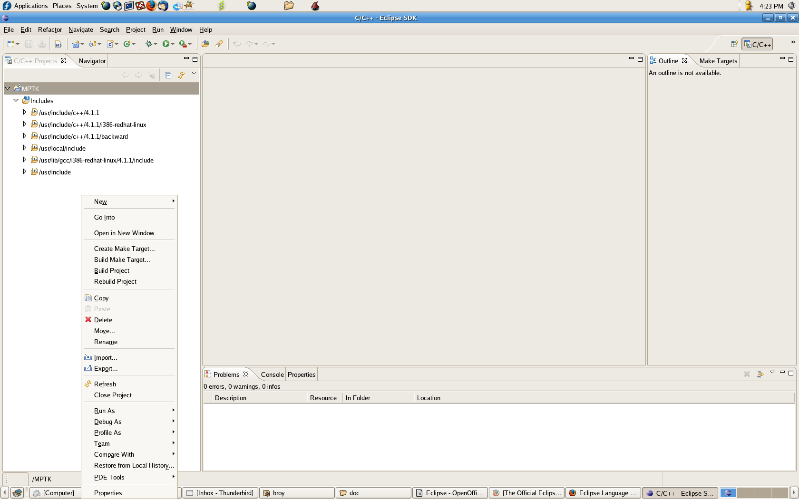
The “import” command show a pop up window, in this window choose the
“file system” import source:

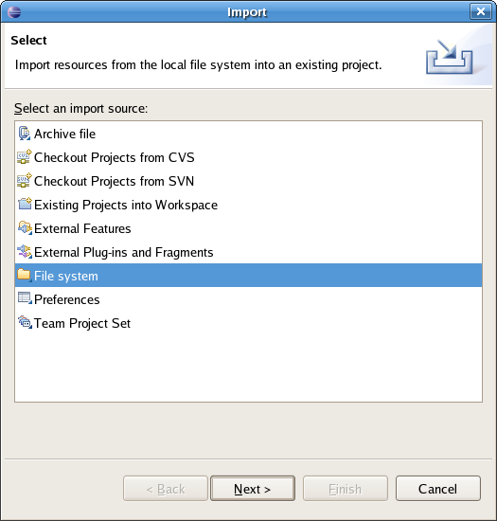
You can now set the files you want to import in the project:

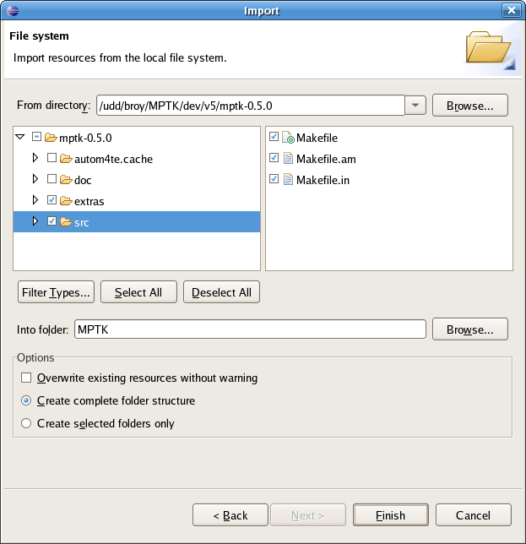

How to edit the include links
Once the project imported with one of this method, it's possible that Eclipse warm you about link paths for the used library and header files:
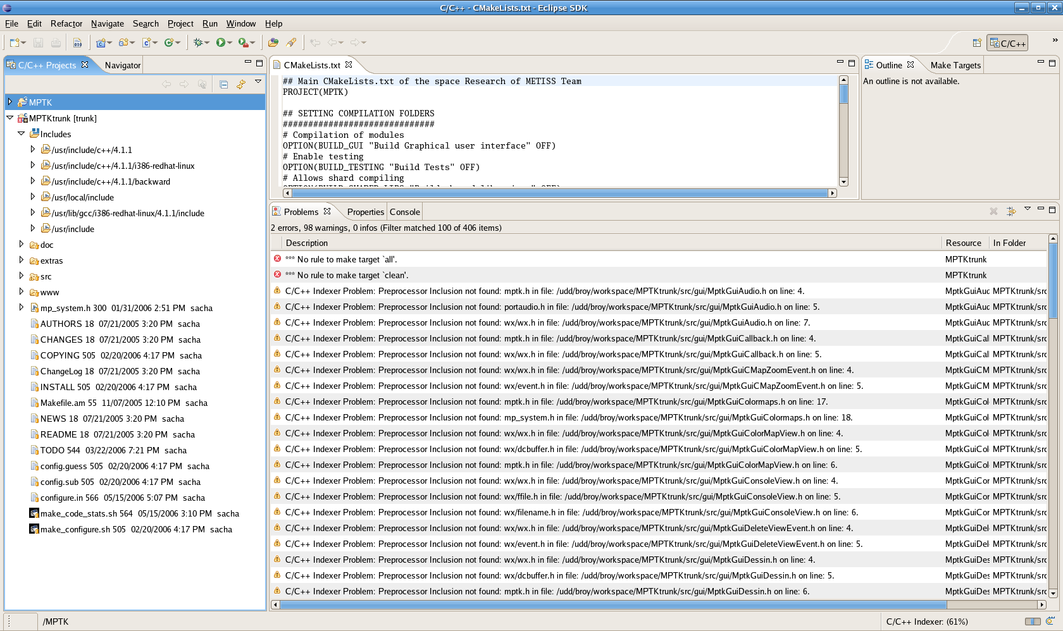

In order to correct this kind of issues, you have to access the C/C++ Include Paths in the properties of the project.

In this case, you have to edit the link and solve the issues that Eclipse warm about. There is three types of link:
- The automatic links made by Eclipse to platform dependant header
- The external links of the project
- The internal links from workspace

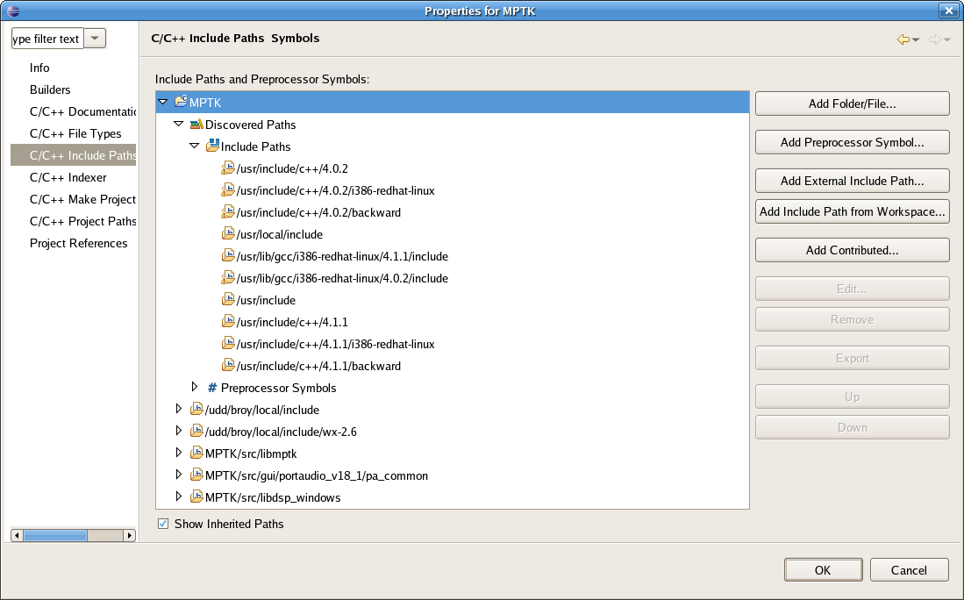
3
2
1
The first type of link is included by Eclipse, there's nothing to do here, for the two other kind of link, you have to use two different commands
- Add External Include Path
- Add include Path from Workspace
Respectively for the two last kind of links:

1
2

How to Add an Already Existent Project to the Repository
Switch to the C/C++ perspective, to add your project in the distant repository, right click on the project and select Team > Share Project....
Select SVN from the list of repository types. Click Next.
- If the project had not been previously shared, Eclipse will ask if you would like to create a new repository to share the project in or if you would like to use an already existent repository to share the project in. Choose the repository that you have already created for your project and click Next.
  - Select the radio button that says Use project name as module name. You can choose to have other module names if you are afraid of name space conflicts. Click Next.
  - Click Finish.
- If the project has been previously shared, Eclipse will ask if you wish to connect. Choose and the click finish.

Building MPTK with Eclipse
This topic is just a sugestion on how to build MPTK, using Eclipse to develop, Cmake to create the build system and Gnu chain tool (make for Linux/OSX and mingw32-make for Win32) to build. Fell free to use your own build method if you desire.

We recommand to use an out of source build using a different directory for each plateform executable files you desire to build.

For Linux and OSX plateform
The first step is to create an new project that will be use to build MPTK out of source, Call this project build for example, rigthclick in the work space and choose “New Project” and “Standard Make C++ Project” in the C++ branch:

Call this project “build” for exemple. There is actually no developed plug-in to use Eclipse with Cmake, it may certainly happen sooner. So, in the case that you have CMake installed on the computer, you can use CMake to produce the makefile to build your project directly under Eclipse, in order to do that you have to generate the build system the first time, the next time the integrated bootstrap system in CMake allow you to rebuild automatically the build system. This will yield the following sequence of commands in a console:

bash-3.1$ cd ~/workspace/build
bash-3.1$ cmake ~/worpkspace/MPTK

When using the cmake command to generate the build system, Cmake performs a list of tests to determine the system configuration and manage the build system. If the configuration is correct then the build system is generated and written. In this case the three last lines of the console log of cmake command should be:

-- Check for working C compiler: gcc
-- Check for working C compiler: gcc – works
...
-- Configuring done
-- Generating done
-- Build files have been written to: ~/workspace/build

If you experience troubleshooting using Cmake to generate the build system, please refer to the Build_MPTK_with_CMake—LINUX_OSX pdf document for further informations on how to use Cmake to generate the build system for MPTK.

The integrated build system of CDT pluggin should allows you to build MPTK. In the other case try to set a custom builder in the project properties using the path of make executable files.

For Windows (Win32) plateform
The first step is to create an new project that will be use to build MPTK, Call this project build-windows for example, rigthclick in the work space and choose “New Project” and Project in C++ branch:
Call this project “build-windows” for example. There is actually no plug-in to use Eclipse with Cmake, it may certainly happen sooner. So, in the case that you have CMake installed on the computer, you can use CMake to produce the makefile to build your project directly under Eclipse, in order to do that, you have to generate the build system the first time, the next time the integrated bootstrap system in CMake allow you to rebuild automatically the build system.

Suppose your source files are located in a project named MPTK-trunk and your project for building MPTK is called build-windows. You have to create the build system with the Cmake application software:

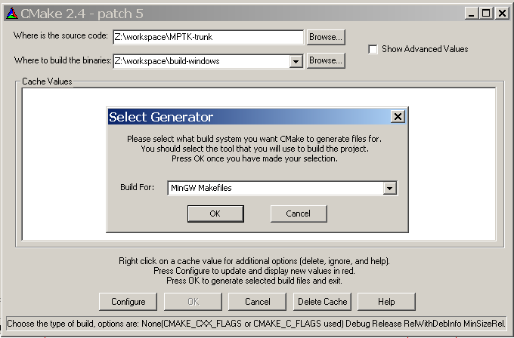
Set the « Where is the source code » textbox with the path of the directory where the source files are located (in this case: Z:\workspace\MPTK-trunk) and the « Where to build the binaries » with the path of the directory where you want to build library and executable files (in this case: Z:\workspace\build-windows).
The build system type depends of the builder you want to use, in our case this is the MinGW chain tools, so the correct option is « MinGW Makefiles ». When pressing the « Configure » button to configure the build system, Cmake performs a list of tests to determine the system configuration and manage the build system. If the configuration is correct then no popup will appears during the tests and Cmake application software finally shows the various options of the build underlaid in grey. In a Case of a configuration issue, a pop up window warms you about this issue indicating which test has failed, in this cas the build option in the Cmake application software will be underlaid in red.
If you experience troubleshooting using Cmake to generate the build system, please refer to the Build_MPTK_with_CMake—Win32 pdf document for further informations on how to use Cmake to generate the build system for MPTK under Windows plateform.

You now have to set a custom builder in order to use GNU tool Chain on Windows with MinGW. If you don't now how to install MinGW, please refer to the Build_MPTK_with_CMake—Win32 pdf document for further informations.

To set a custom builder, select the project and click on the “Properties” item in the project menu:

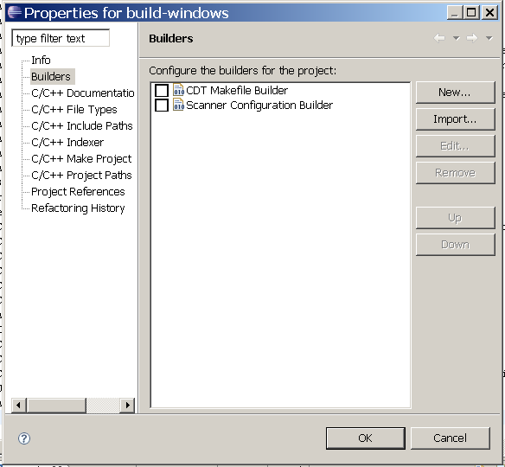
Uncheck the check box of “CDT Makefile Builder” and “Scanner Configuration Builder”, then use the “New..” button to add a custom builder:

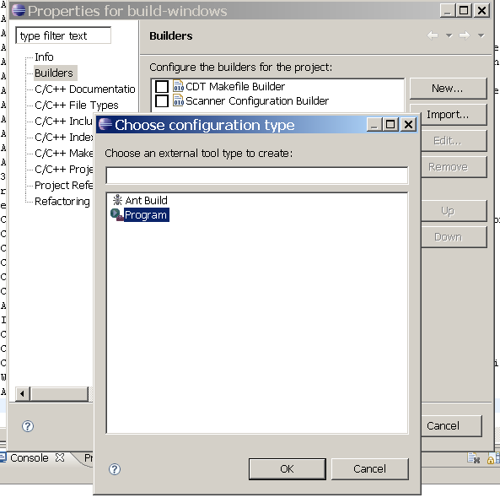
Choose “Program” in the displayed list, and click “OK” button, a pop up window appears in order to configure the builder properties:

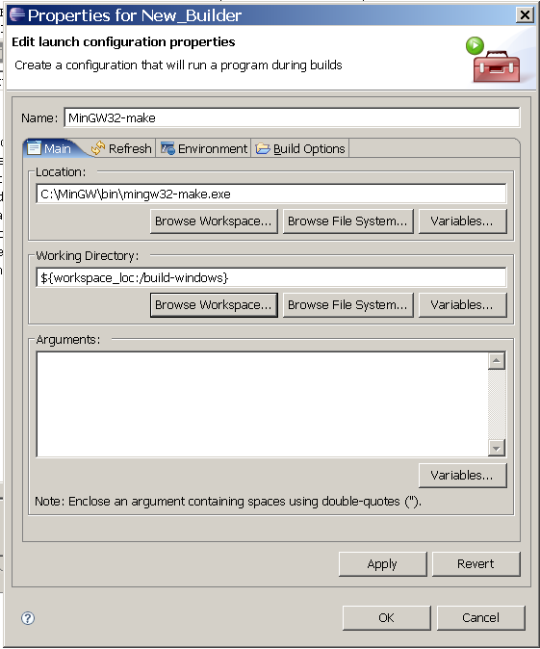
Set the following informations in the coresponding field:

- Name: Choose a name: MinGW32-make (for example)
- Location: Use the “Browse File System...” button to pick up the path of mingw32-make executable file on your system
- Working Directory: Use the “Browse Workspace...” button to pick up the path of your build directory for win32 platform

After clicking on the OK button, the builder properties windows should appears like this:
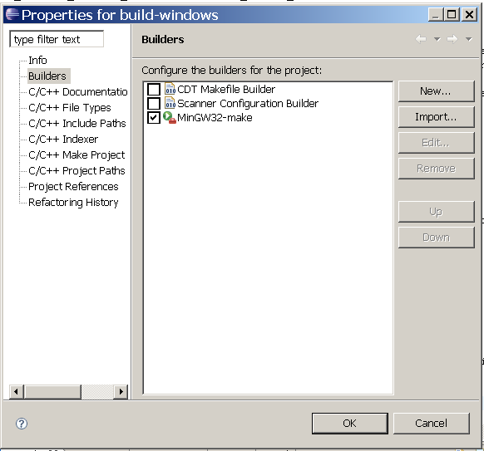
You can now use the “Build Project” item of the Project menu to build MPTK, The build log should appears like this in the console view:

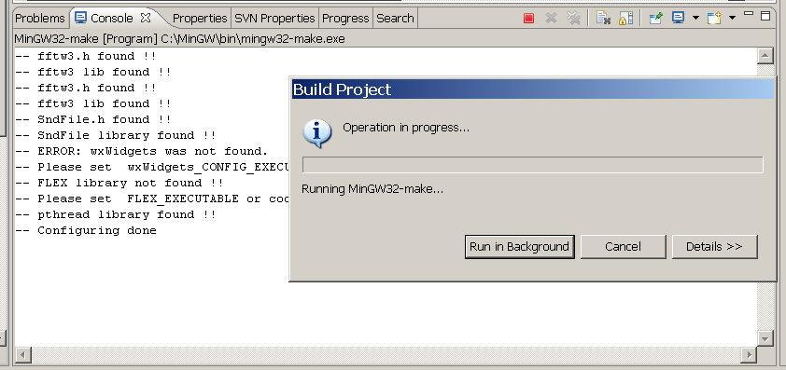
Note: Here you can see the Cmake bootstrap sytem in action, before building MPTK with mingw32-make, the build system is checked by Cmake to insure that its setting is up to date.

Once the executable files are generated you must specify in Eclipse how to manage Windows executable files, you have to change the type of files viewed by the binary parser, this type is paramatrized by default with the Elf binary type. This option allows Eclipse parser to recognise and manage the Windows executable files type, it's mandatory in order to lauch and debug this executable files directly into Eclipse environment, otherway Eclipse will not recognise the executables files as such. In the project properties select the “C/C++ Make project” branch of the properties tree, in the “Binary Parser” tab just let “PE Windows Parser” checked in the list of the Binary parser:

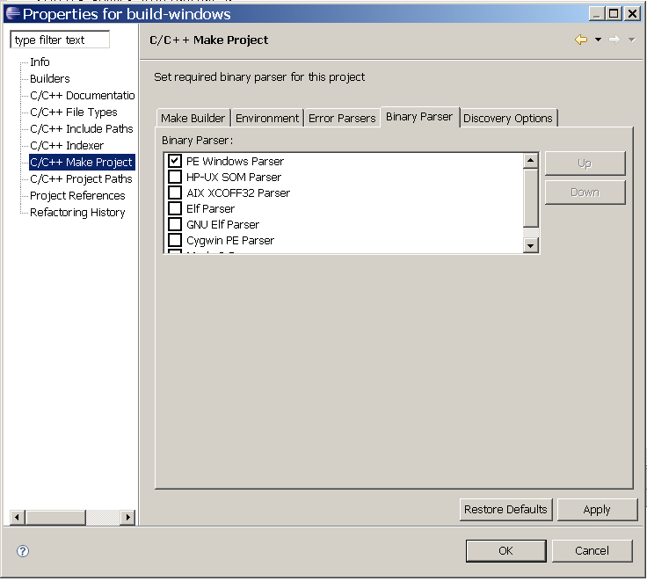

Advanced features of subclipse

Comparison between various revisions of a source file
When right-clicking on a file Eclipse allows you to compare the local source files of your project with various versions of this source files:

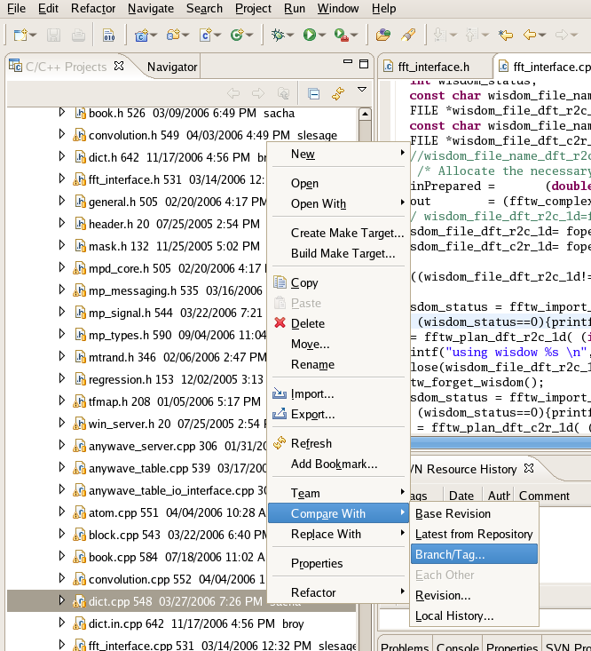

Eclipse allows different types of comparison, in order:
- Base Revision: allow you to compare the actual file with the base revision you have checkout from the SVN repository
- Latest from Repository: allow you to compare the file with the latest revision of the file from the concerned branch / tag / trunk of the SVN repository
- Branch/Tag: allow you to choose a file from a selected Branch/Tag of the SVN repository
- Revision: Allow you to compare the source file with a selected revision of this file on the SVN repository
In the case you select Revision... a browser allows you to choose a particular revision and compare,
you can see the comments typed when the revision files were committed. Some grey marks on the right slide bar show you the differences between the selected revision on the SVN and the local source code of your project. Moreover the differences are indicated and linked by a grey area in the two panel windows.

This kind of functionality is very useful to find some issue in the source code, it could be use to find change on algorithm and find a critical point in term of regression for example.

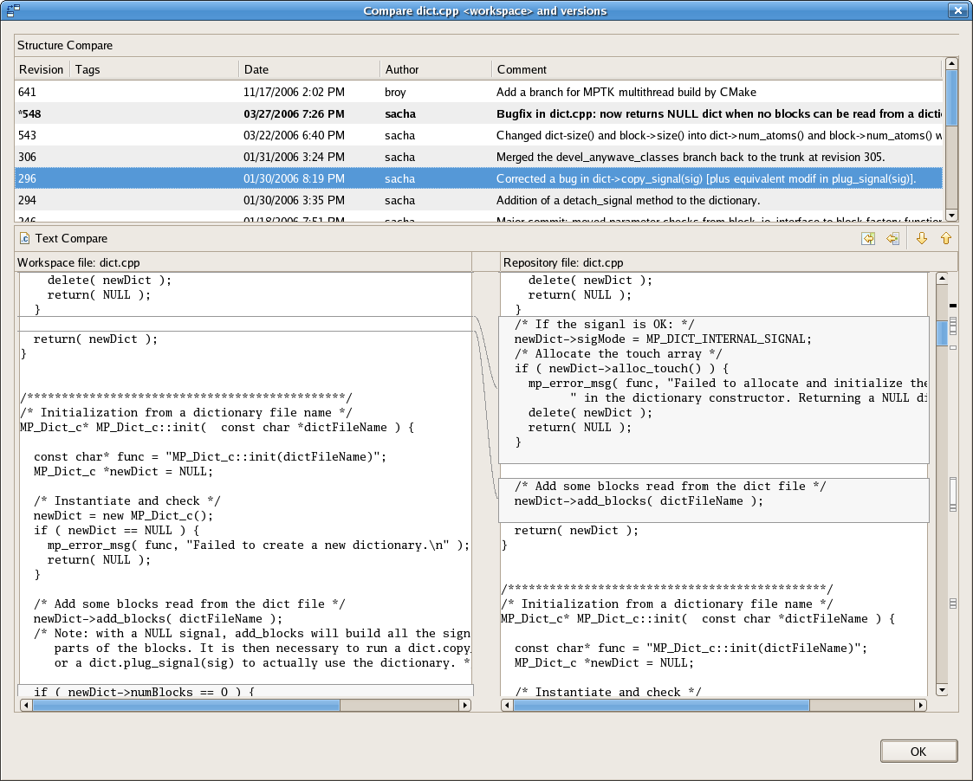

Create, manage, run and debug configuration under Eclipse
Eclipse allows to define configurations for running and debuging applications, this functionnalities are provided by the “Run...” and the “Debug...” command in the run menu.
If you to create a new run/debug project, use the “new” button and set a name in the “name:” textfield.
The two following examples show a configuration for running and debugging an MPTK executable files under Linux/OSX and Windows plateform.

For Linux and OSX plateform
The “Main” tab has a text field for the name of the project and the path of the executable file that you want to run/debug under Eclipse:
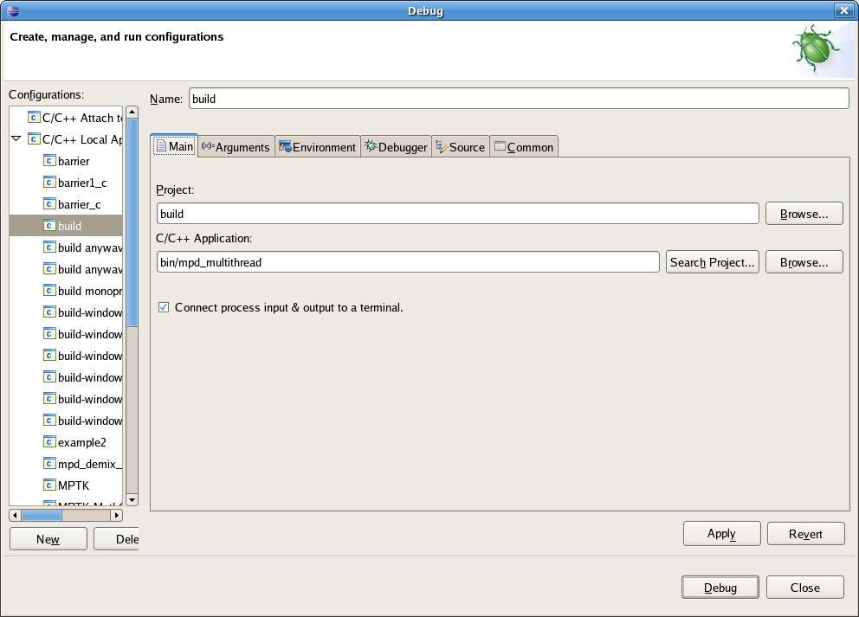
The “Arguments” tab is used to set the arguments pass to the program:
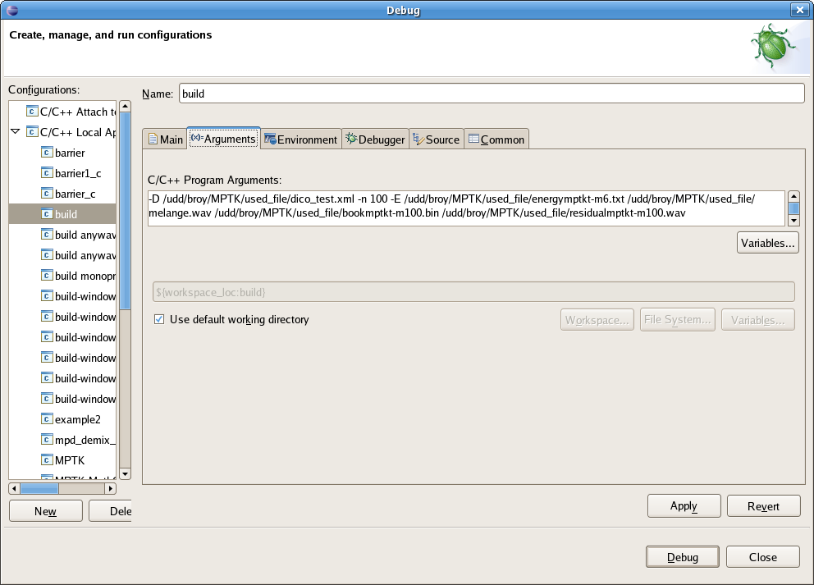
The “Environnement” tab is used to set the environnement variable used when running the executable file in Eclipse:
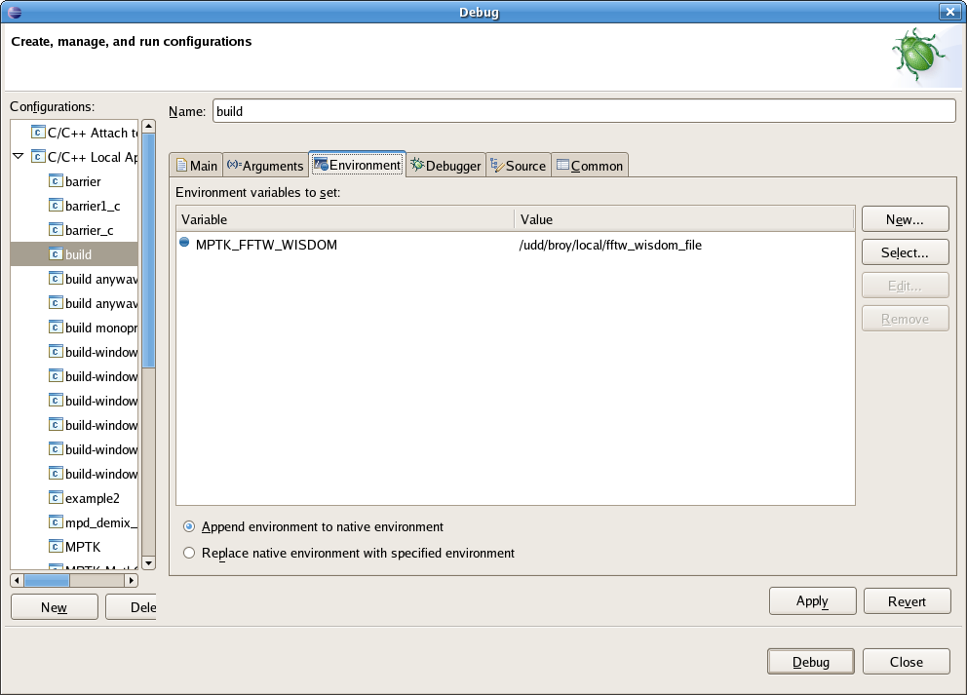
The “Debugger” tab allows to set gdb properties:
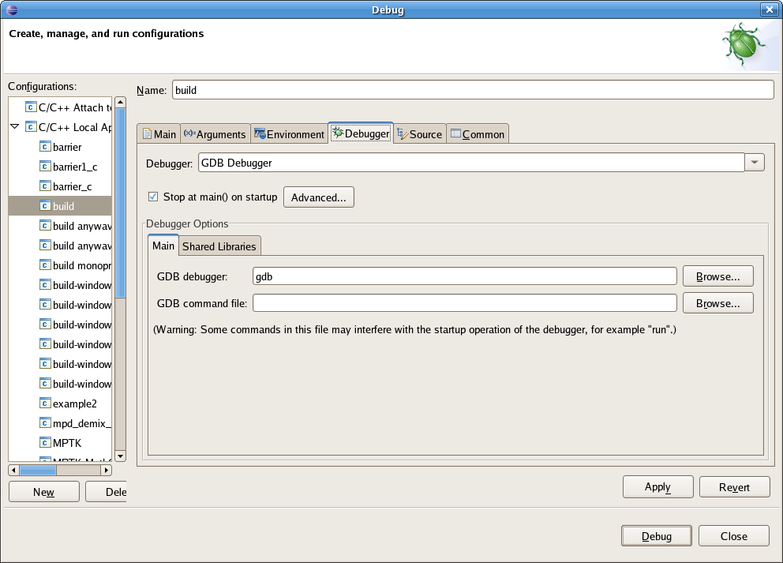
The “Shared Libraries” sub tab in the “Debugger” tab allows to set the path of the shared libraries used by the executable file, this is usefull to debug the calls to shared library:
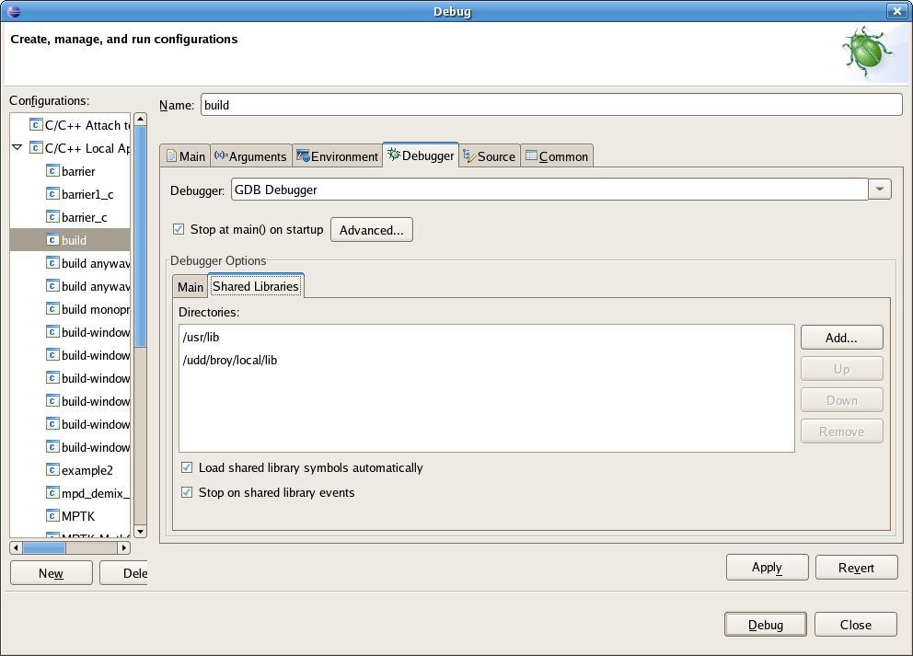
The “Source” Tab allows to set the source files path, in order to link the executable file with its own source code and display the line number of this source code when debugging:
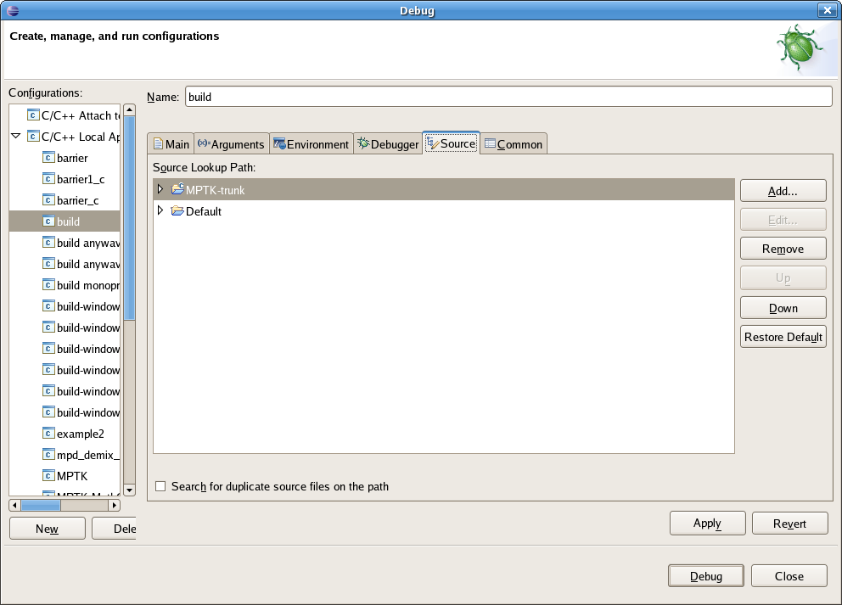

For Windows (win32) plateform
The “Main” tab has a text field for the name of the project and the path of the executable file that you want to run/debug under Eclipse:
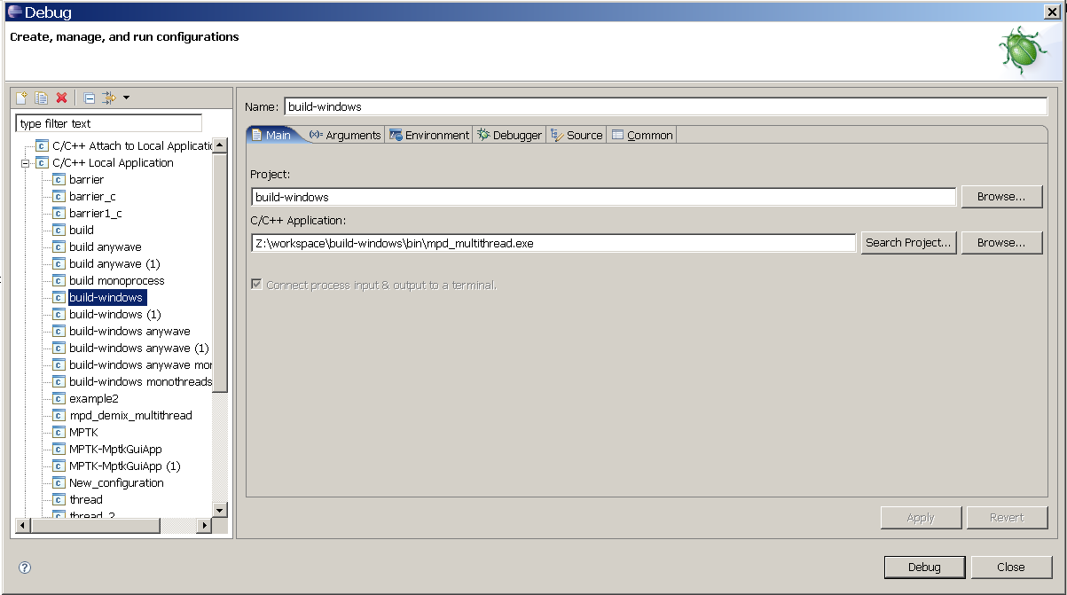
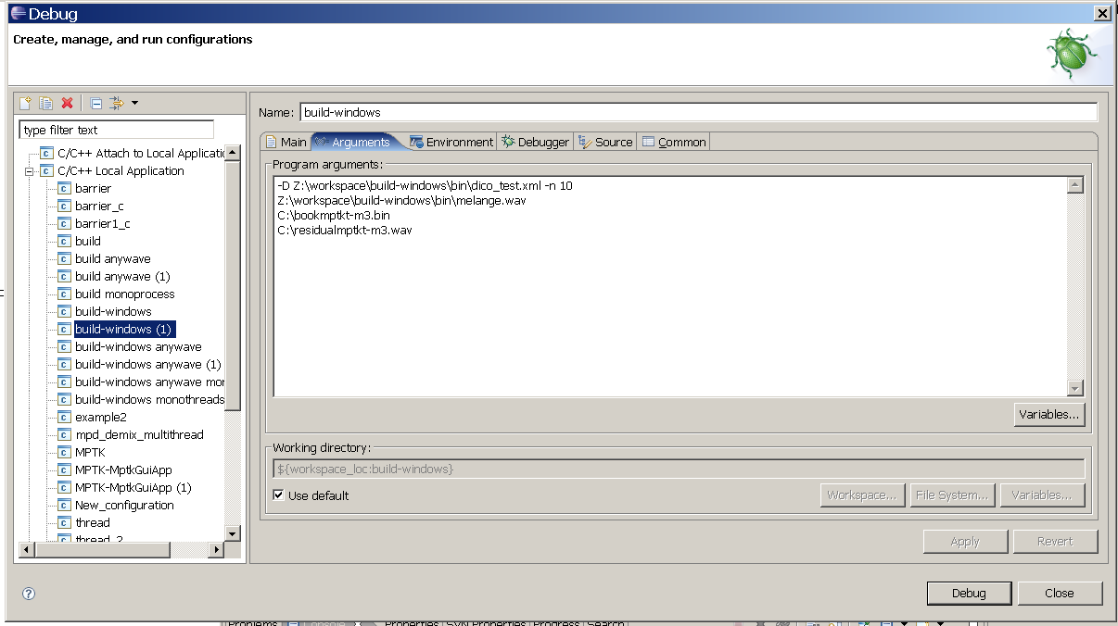
The “Arguments” tab is used to set the arguments pass to the program:
The “Environnement” tab is used to set the environnement variable used when running the executable file in Eclipse:
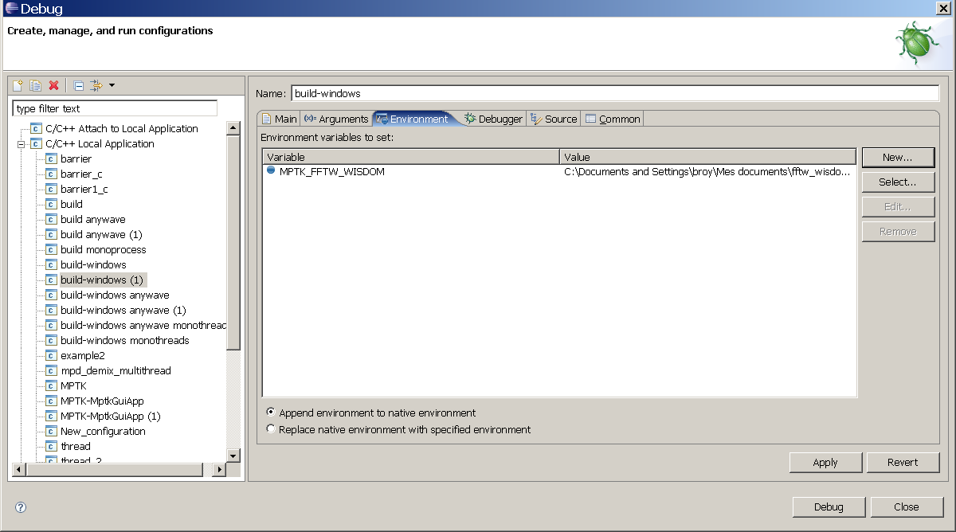
The “Debugger” tab allows to set gdb properties:
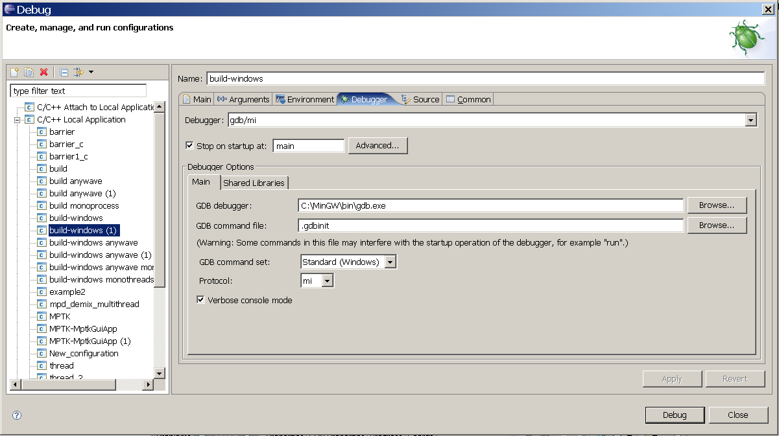
The “Shared Libraries” sub tab in the “Debugger” tab allows to set the path of the shared libraries used by the executable file, this is usefull to see the calls to shared library:
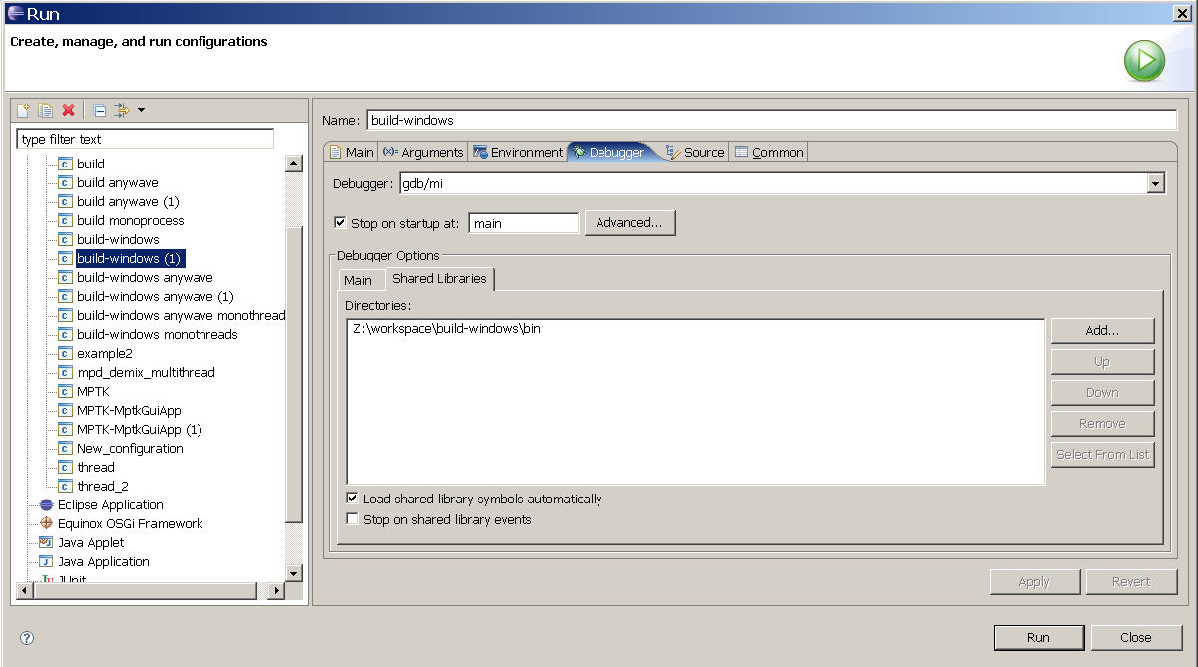
The “Source” tab allows to set the source files path, in order to link the executable file with its own source code and display the line number of this source code when debugging:
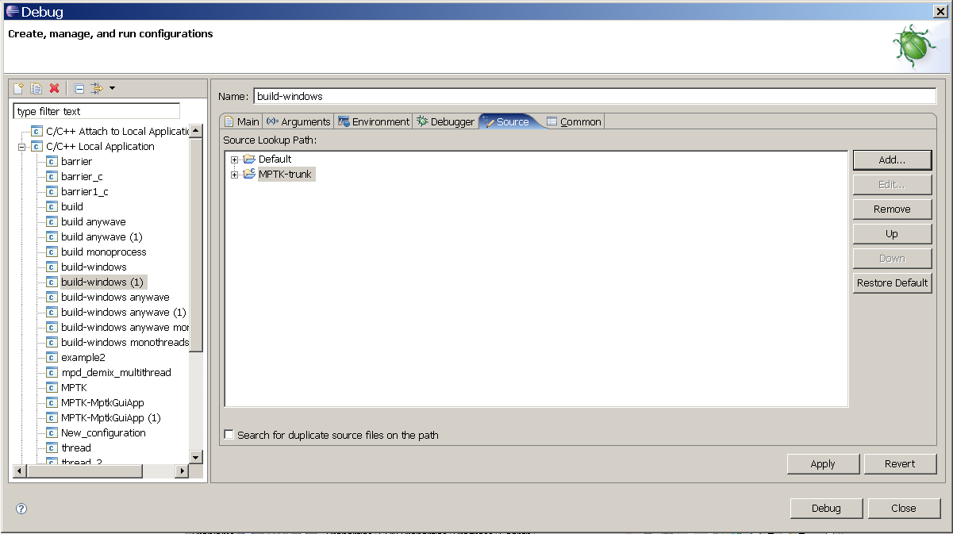

How to create project to debug Matlab Mexfiles (linux)
Eclipse can be used to debug Matlab Mex-Files. In order to achieve a new Run/Debug Project has to be created:
Note that the path to Matlab application is for example matlab_path/R2007a/bin/glnx86/MATLAB. This is very important cause the Matlab executable in bin directory will not allow to debug:
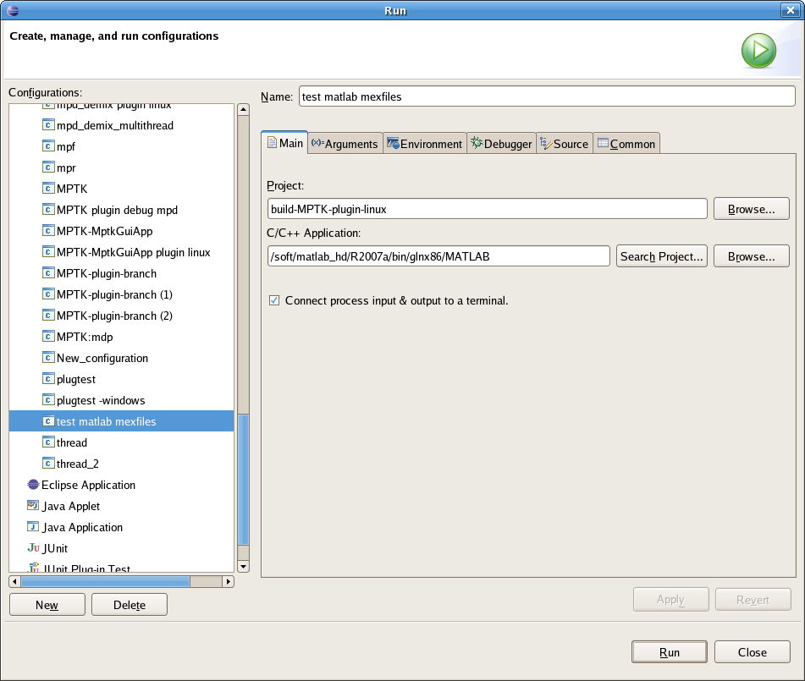
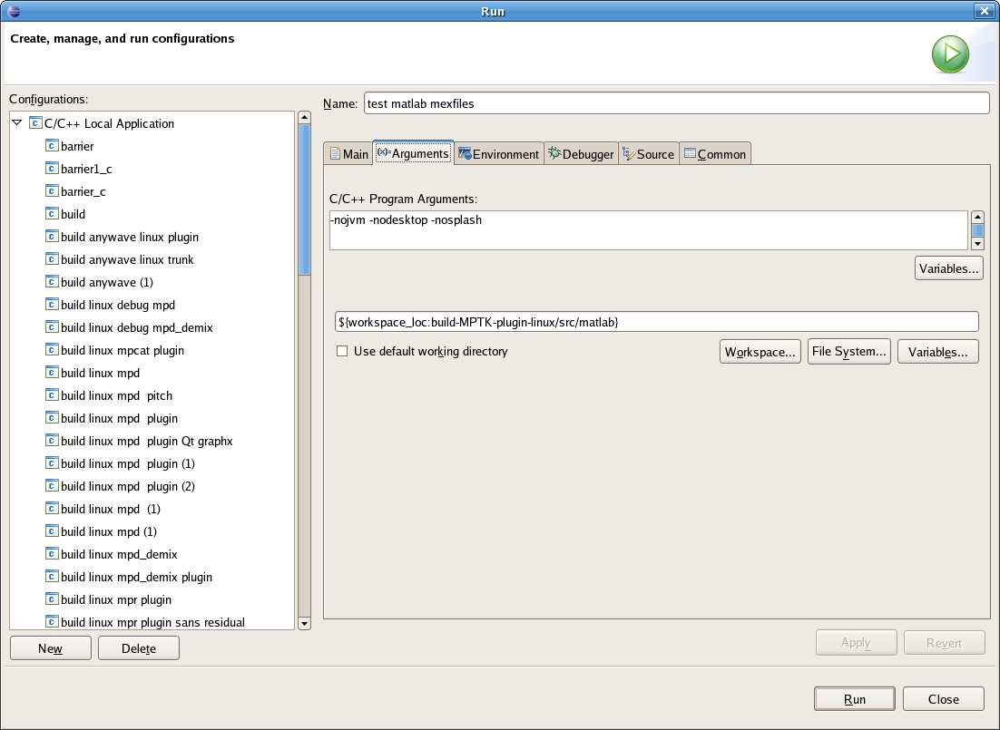
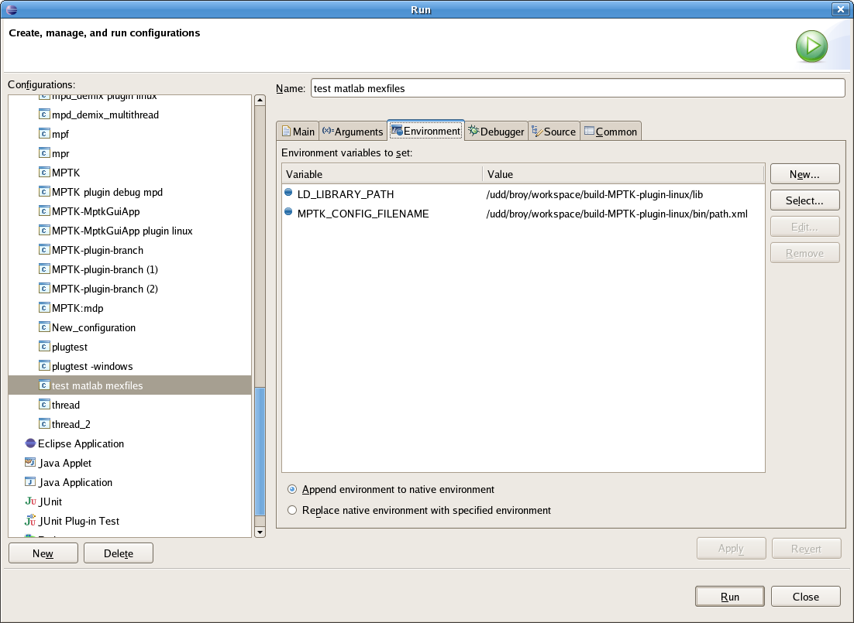
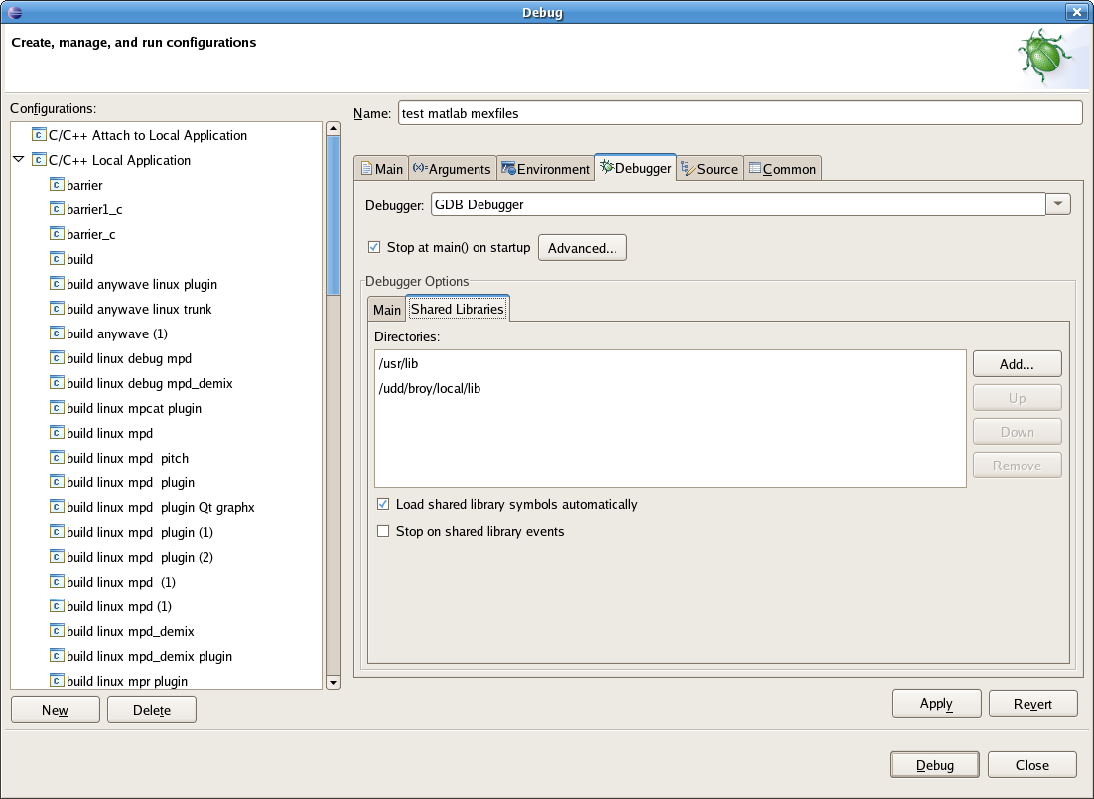
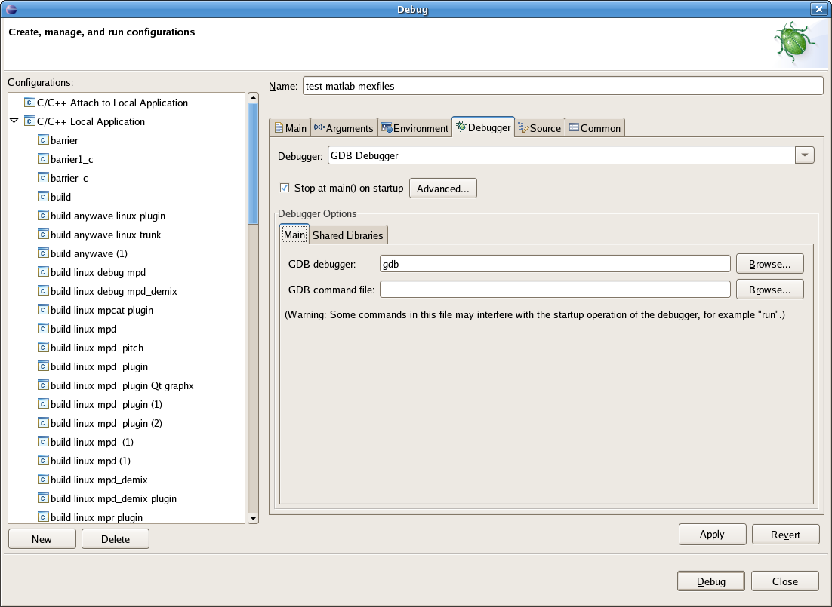
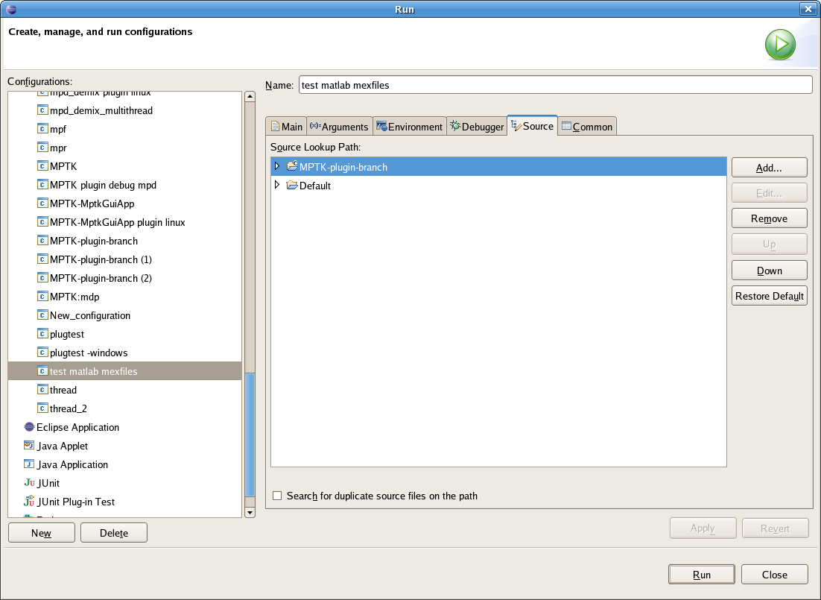
The project can be debug as usual:
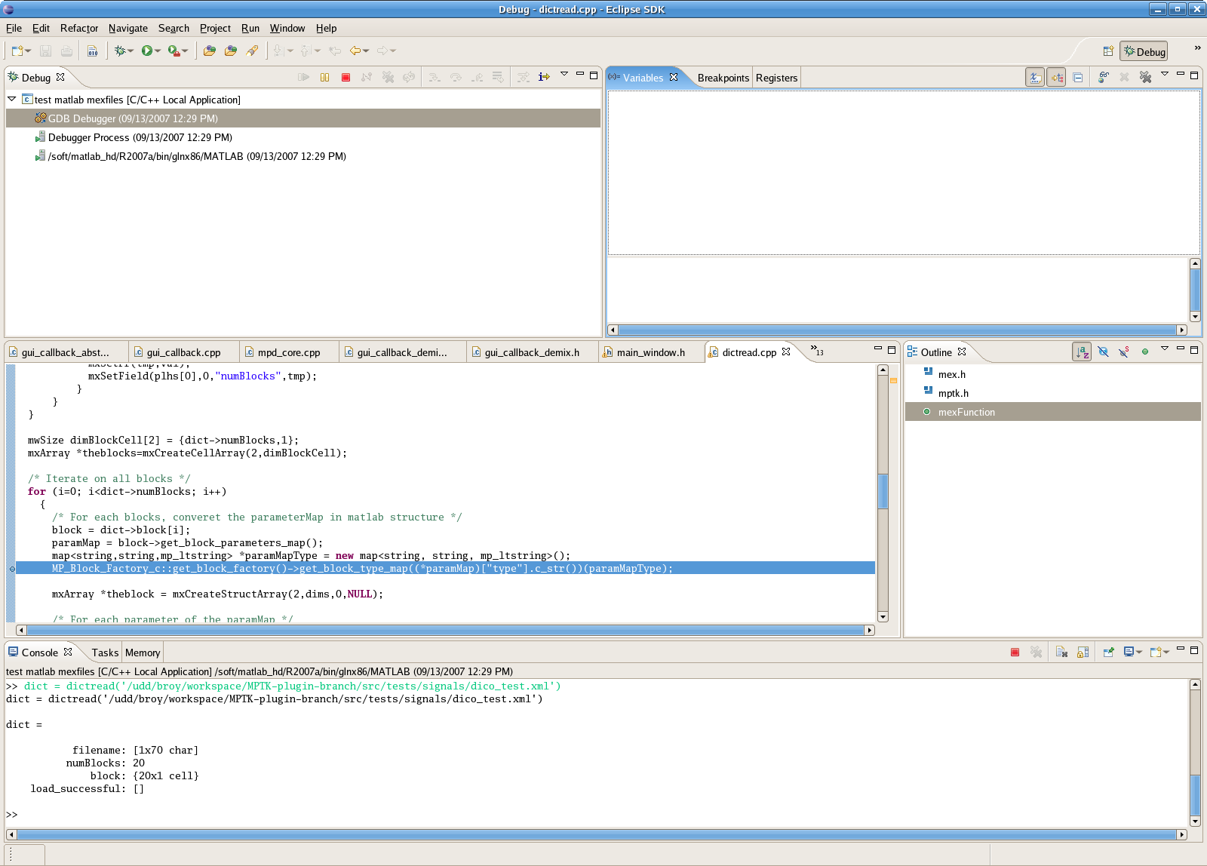

Useful links
Linux university:

Implementing GNU Auto tools in an Eclipse C++ Project
Importing Existing C++ Projects Into Eclipse
Creating a new C++ Project in Eclipse
FAQ and help:

http://wiki.eclipse.org/index.php/Eclipse_FAQs
http://svn.collab.net/subclipse/help/topic/org.tigris.subversion.subclipse.doc/html/toc.html

