Contents

CHAPTER ONE 3

INTRODUCTION 3

1.1 BACKGROUND OF THE STUDY 3

1.2 PROBLEM IDENTIFICATION 3

1.2.1 PROBLEM OF THE EXISTING SYSTEM 4

1.3 STATEMENT OF THE PROBLEM 4

1.4 AIM AND OBJECTIVES 4

Objectives of the study are: 4

1.5 SIGNIFICANCE 5

1.6 SCOPE AND LIMITATIONS 5

CHAPTER TWO 6

LITERATURE REVIEW 6

2.0 Introduction 6

2.1 PROPOSED SOLUTION 8

2.3 WHY THIS STUDY IS IMPORTANT 8

CHAPTER THREE: 10

METHODOLOGY AND SYSTEM ANALYSIS 10

3.1 METHODOLOGY 10

3.2 SYSTEM ANALYSIS AND DESIGN 10

3.2.1 DEVELOPMENT TOOLS 10

3.3 FEASIBILITY ANALYSIS 11

3.4 PROPOSED SYSTEM 11

3.5 SYSTEM REQUIREMENT 12

Hardware requirements (system configuration) 12

3.6 ACTIONS AVAILABLE AT EACH ACCESS LEVEL 12

3.7 SYSTEM DESIGN 13

CHAPTER FOUR 17

CODING AND INTEGRATION 17

4.1 Planning of Coding and Integration of System Component 17

4.2 Key Implementation Decision 17

4.3 Graphical User Interfaces 17

4.4 System Environment/Interface 17

CHAPTER FIVE 22

SUMMARY 22

CONCLUSION 22

RECOMMENDATION 22

Bibliography 24

# CHAPTER ONE

# INTRODUCTION

## 1.1 BACKGROUND OF THE STUDY

Rosters are used in some form by people all over the world, in any situation in which a group of individuals seek to perform some routine task on a rotational basis. They provide a way for people to schedule which individual in a group will be responsible for a given task at a particular time. Due to the nature of these kinds of rosters in representing a diverse range of different activities in varying time frames, most rosters today are simply printed or drawn by hand on paper. There is currently a shortage of digital duty tools to facilitate the creation and sharing of these kinds of rosters. This project take an opportunity for a system to be developed that will fill this void and bring duty system into the digital age. Most participants in any roster today will have regular access to email and a web browser, particularly in an office environment. The near-ubiquitous nature of these facilities in today's society presents an opportunity for a web-based duty system that is far superior to existing systems in terms of ease of use, convenience, and accessibility.

The duty allocation system is a web-based roster system that was created over the course of this project to take advantage of the opportunity described above. It is targeted share roles/activities in Jigawa State Radio staffs. Also the system will provide a simple, flexible, and accessible web-based interface through which admin can create and modify rosters, as well as view them and configure notifications for both staffs. The system will feature the following:

* Flexible roster options to suit a variety of tasks,
* Email confirmations and notifications, and
* Authentication and authorization of users.

## 1.2 PROBLEM IDENTIFICATION

From what I have gone through, it’s clear that the way for assigning duties to the staff is extremely bored by them because of improper rosters.

This project is trying to come up with solution by developing web app to eliminate problem that is existing in their duty system.

## 1.2.1 PROBLEM OF THE EXISTING SYSTEM

Below are some of the common problems with the existing system for assigning duty in Jigawa State Radio:

* Manual Duty System is extremely time consuming
* It’s tricky for communication between staff and admin regarding to their duty
* Absent of staff on duty due to un aware for his actual time

## 1.3 STATEMENT OF THE PROBLEM

Jigawa State Radio station use to create their duty manually for their journals. This cause many problems especially by assigning multiple programs to exceed the staff time limit and profession. That is the reasons why most of time when listening radio we may hear the caster make a lot of mistakes usually due to tiredness and stress. This is because he attempts multiple programs beyond the exact time being arranged.

This system provides all of the necessary functionality for creating, modifying, and sharing list of programs in the station to the staff, but there are many improvements yet to be made that will improve efficiency and ease of use.

## 1.4 AIM AND OBJECTIVES

The aim of this project is to develop a web app for the duty allocation system that will be used for assigning duties with timing capabilities in Jigawa State Radio to alter traditional paper-based system.

## Objectives of the study are:

* Develop website for managing duty of staffs in radio station.
* Integrate a feature which will enable radio broadcast to schedule programs for their journals or newscaster.
* Develop a feature which will be used to make sure that all the programs are assigned to specified time and each staff to respected duty.
* Design and integrate a timetabling which will enable workers to know their responsibility based on the time given.

## 1.5 SIGNIFICANCE

**This project work has significant in the following:**

1. The Duty allocation System provides a working example of a system for storing and manipulating simple rosters in a web server environment.
2. The system may be used in the future to assist developer in producing systems that are alike.
3. It will serves as a starting point which developers can study to determine what aspects of their own system could be similar, and what should be different.
4. The Duty allocation System provides the feature that can be used in an enormous variety of different scenarios throughout society, in homes, businesses, and community groups.
5. This system has the potential to the make the processes of roster creation and sharing much more efficient and effective by providing a central web-based system through which they can be organized.

## 1.6 SCOPE AND LIMITATIONS

The extent to be covered in this project is to design and implement a website for duty allocation system in Jigawa State Radio Station where management can create a roster for duty to the senior and lower staff, from admin computer to update the works that will be allocated to the station database and the allocation will be done in the admin page. The result of allocated duty will be either print or staff can still login again to view the result.

# CHAPTER TWO

# LITERATURE REVIEW

## 2.0 Introduction

There are many works done related to duty allocation. Below are some of them:

(Neil Conway, 2001)In his journal stated that the analysis he made reveals that part-time and full-time employees differed on a number of attitudes and that psychological contract fulfillment could be used to explain differences in certain attitudes (e.g., satisfaction) hence a successful achievement can only be obtain by arranging the time limit to the workers. That is the only way the worker will be in full consideration to the target task in the working hours. Also his Analysis how that the relationships between psychological contract fulfillment and outcomes were rarely moderated by work status, suggesting that part-time employees will respond in a similar way as full-time employees to adjustments in their psychological contract. Which means their most be different between the two workers. One that offer full time most be consider in high rate than part time worker.

(andreas T Ernst, 2004) Describe that shift scheduling or day-off scheduling is a common problem in the healthcare service system. This means not only in radio station but in many field and organization are facing such problem, therefore computerizing duty system will bring happy to the workers and reduce time consuming.

(Alfares, 2003) developed an efficient two-phase algorithm for cyclic days-off scheduling. Later, he developed a new integer programming model and a two-stage solution method for the flexible 4-day workweek scheduling problem with weekend work frequency constraints.

Very few researchers, however, considered an ergonomics issue when they developed work schedules. Industrial noise, thermal, and physical workloads are examples of common ergonomics hazards in the workplace. To avoid excessive exposure to any concerned ergonomics hazard, workers are either rotated among different work- stations or assigned to perform industrial tasks at different work areas within the same workday. For effective hazard exposure reduction, it is necessary to determine the work schedules such that no workers are exposed to the concerned hazard beyond a permissible daily limit.

(Nanthavanij, 2003) proposed a quantitative approach to job rotation by developing a mathematical model for the problem with equal numbers of workers and tasks. Their solution described the rotating work schedules such that the maxi- mum noise hazard exposure is minimized. They also investigated the effect of work period length on the noise hazard reduction. Later, they developed a mathematical model to determine the minimum number of workers for job rotation (2004). For the complex safety-based job rotation problem, a genetic algorithm (GA) approach was applied to obtain the mini max work assignment solution (Nanthavanij, 2003).

(Sorawit Yaoyuenyong, 2006) Showed that when the minimum number of workers for job rotation is to be determined, the WSP is a variant of the classic bin packing problem, which is a well-known NP hard problem. Thus, the optimal rotating work schedule solution is obtainable in reasonable amount of time only when the problem size is relatively small. For large problems, a heuristic approach has been a popular choice among researchers. They also developed a hybrid procedure to determine an optimal workforce without being exposed to excessive noise hazard in the manufacturing environment. Additionally, they developed heuristic job rotation procedures for workers who are exposed to single-limit and multiple-limit occupational hazards in 2008. Nanthavanij et al. (2010) included the productivity issue in their study and developed a heuristic procedure to find appropriate work schedules such that workers are assigned to the tasks that they can perform competently. This paper addresses the ergonomic under complex worker limitation and task requirements. Specifically, heterogeneous workforce with limited task flexibility, varying worker team sizes, and pre-defined task operation schedules are considered. The paper is organized as follows. First, the ergonomic WSP is explained. Then, an integer linear programming model representing this problem is developed. An approximation procedure for solving large-sized problems is proposed. Using a hypothetical example, solutions from the optimization approach and approximation procedure are compared. Finally, the efficiency and effectiveness of the approximation procedure are evaluated.

Since increasing the number of workers also increases the cost of manpower, it is important to find the right work- force size for the job rotation. Most recent works in ergonomic workforce scheduling assume that the workforce is homogeneous. In other words, any worker can be assigned to perform a given task. While this assumption simplifies the workforce scheduling problem, it is undoubtedly unrealistic. Generally, workers are different in terms of the number of tasks that can be assigned to them. If a worker is assigned to the task that he/she cannot perform, the work system performs- mince could be seriously affected and such assignment will not be acceptable. Thus far, little attention has been given to this worker limitation. Moreover, most studies assume that each concerned task needs only one worker to perform. In practice, there are numerous tasks or workstations that require two or more workers to work together. It is reasonable to assume that these workers receive the same amount of ergonomics hazard. Failure to consider the above mentioned worker limitation and task requirements could, to some extent, hinder the applications of job rotation. Specifically, the worker limitation and task requirements considered in this study are as follows:

1. Workers are not equally flexible. Some workers are well trained and can perform many tasks, while some might be able to perform only one or two tasks.
2. The numbers of workers assigned to perform individual tasks do not have to be equal.
3. Not all tasks need to be performed on a full-day basis. Some tasks might be performed only part of the day. In brief, a feasible daily rotating work schedule solution must satisfy the following conditions:

* All workers daily hazard exposures must not exceed the permissible limit.
* Workers must not be assigned to the tasks that they cannot perform.
* The number of workers assigned to any task must exactly match the number of workers required by that task.

## 2.1 PROPOSED SOLUTION

It’s clear in the above review and my case of study the same problems been addressed. All the works consider realistic staff limitation and task requirements that include heterogeneous duty with limited task flexibility, varying worker team sizes, and pre-defined task operation schedules. Its main objective is to find a daily rotating work schedule solution using a standard Web-App such that all workers’ exposures do not exceed a permissible limit. From the results of the computation experiment, it can be concluded that this procedure is more efficient and effective in solving large-sized duty allocation problems.

## 2.3 WHY THIS STUDY IS IMPORTANT

Today’s media landscape has become a mix of traditional media and new digital innovations. With the leaps in mobile technology and the change to ubiquity of Facebook, it is clear that social media is not going away and cannot be ignored. The question becomes how traditional media outlets such as radio stations choose which digital channels to incorporate into their own media mix to avoid being left behind in the race to reach their audience. In order to survive, a business must make productive use of its time, energy, and resources, as well as continue to grow its audience and outperform competitors.

There are several obstacles when updating a traditional channel to reach an audience.

Some digital channels such as Google+ never make it past the early innovation stage and are therefore never fully adopted by the target audience. Other innovations involve technology that is cost-prohibitive. Capital investment is required to purchase the domain name and to pay support staff to design, maintain, and update the site. Another issue is staffing to maintain a presence on a digital channel. Facebook and twitter need constant tending to stay up-to-date with the latest news stories and viral videos. For some radio stations, it takes a village to constantly update this content while others have a dedicated social media specialist. With the emerging world of Facebook, Twitter, Pinterest, and other social media platforms, how involved must media companies be to meet the needs and satisfy the gratifications of their listeners? How soon is too soon to “jump on the band wagon” of the newest digital trend to beat the competition? There is a constant race to be the first with breaking news, weather alerts, and the newest viral video.

# CHAPTER THREE:

# METHODOLOGY AND SYSTEM ANALYSIS

## 3.1 METHODOLOGY

In this work, agile methodology is been used where each phase of the project been break up into pieces, constant collaboration with stakeholders and continues improvement at every stage, while the data is collected through primary source which are interview and observation of people and secondary data source, which are: internet and other relevant documents.

The literature will be review from relevant books, journals, magazines, writes ups, website and publications.

## 3.2 SYSTEM ANALYSIS AND DESIGN

During the analysis of this project I ensure that each process is fully identified to achieve the intended goals and purpose. And the design of the system was top-down, dividing each process into functional areas which would be reflected in the interface and the back end implementation. The three functional areas are the main area for performing the basic functions of the system (such as the homepage), the admin area for managing staff accounts, and the staff area for viewing the assign duty. This structural breakup could be accurately reflected both in the front end interface and the back end implementation.

## 3.2.1 DEVELOPMENT TOOLS

Tools used in developing this system comprised of: VS Code for running PHP, HTML, CSS, and JavaScript in coding. And Xampp for MYSQL

CHOICE OF PROGRAMMING LANGUAGE

**HTML**

Hypertext Markup Language (HTML) is a language for marking up the content of a text document so that a web browser can display it. HTML is specified by the World Wide Web Consortium (W3C). The specification that was used for the duty allocation and optimization system web interface is XHTML

**CSS**

Cascading Style Sheet (CSS) is a specification for formatting documents that use mark-up languages such as HTML. It allows web developers to separate the presentation of their web documents from the content, and alter the presentation of a whole set of documents from a single file. Both of these features were highly desirable for the SRS web interface. CSS is specified by the World Wide Web Consortium (W3C). The specification that will be used for the duty allocation and optimization system web interface is CSS.

**PHP**

Hypertext pre-processor (PHP) is a scripting language which is interpreted by web servers to generate web pages. It is a popular language for generating dynamic content in web pages. As well as basic dynamic content, PHP also facilitates interaction with a database server. Other common applications using PHP include scripts for sending out emails and user authentication. As with any server-side scripting, there are security concerns that need to be addressed to protect the web and database servers.

**MySQL**

MySQL is an open source database software package that can be used in conjunction with PHP. PHP scripts can interface with a MySQL server to run queries and store/retrieve data. Queries to the MySQL database use the Structured Query Language (SQL) and can be used to request, modify, add or remove data. SQL queries can also be used to create and erase database tables.

## 3.3 FEASIBILITY ANALYSIS

After making an observation on the current process of sharing duty atJigawa Radio, it found that every single thing is done completely by manual. Currently, this project has decided to make computerized system. This is because they are facing problem such as corruption of data. The dataabout information of workers are store and keep not very well andsystematically. In the current process, the data are stored into the file but not in thedatabase which is lead to data duplication, repetitive data, and isolation of data fromone to another. It is also worried of something happen to the file, then all the data willlose.In the current manual system, it is very difficult to find the record and other information of staff manually. Because it has been keep on the paper and it is easy to loss. It also consumes time to search the paper of staff record one by one. The manual system requires longer time for allocation of the duty to respective staff.

## 3.4 PROPOSED SYSTEM

Duty allocation and optimization system will keep details of each and every staff by suing their unique id number which will be provided during the register time.

Admin can access information of each and every staff under particular department of work by using their id number. The list of all staffs with corresponding task in the radio will be displayed separately. Also Admin can add, delete, modify, and change information and other fields used in management and records system.

Secondly Duty allocation system can be used to make query to find quick results. It can be used to find assign task and time. This system can also be used to find total number of staffs in the station. This system will also display additional information, such as under which department the staff works. Another feature is that, we can assign particular work based on the qualification or working experience.

## 3.5 SYSTEM REQUIREMENT

## Hardware requirements (system configuration)

Processor: minimum 1 GHz x86/x64 processor, Pentium II or higher.

RAM: 2GB or more.

50GB of hard-drive space.

Monitor: Screen/VDU to display output.

Keyboard/Mouse for data input.

**Software requirements (developer tools)**

Operating System: Windows 7 or newer.

Front end: HTML, CSS, PHP

Back end: SQL (Database)

## 3.6 ACTIONS AVAILABLE AT EACH ACCESS LEVEL

Users are given access to certain features of the system depending on what access level they have been granted by the administrator. The table below outlines which of the core system features are available at each level of access.

|  |  |  |
| --- | --- | --- |
| Action | System administrator | Staffs/participant User |
| Add Staff |  |  |
| Apply Leave |  |  |
| Assign Duty |  |  |
| Change Password |  |  |
| Duty Status |  |  |
| Login |  |  |
| Logout |  |  |
| My Duty |  |  |
| My Profile |  |  |
| Salary table |  |  |
| Staff Leave |  |  |
| View Staff |  |  |

Table 1Action available at each level of access

## 3.7 SYSTEM DESIGN

**Use case design**

A Use Case diagram is meant to depict a high –level view of the relationship between systems, Use Case, and actors.

It can be used to describe functional requirements in terms of actors, which are users of the system, and use cases dealing with what the system does in response to the actor’s inputs, not the internals of howit does it

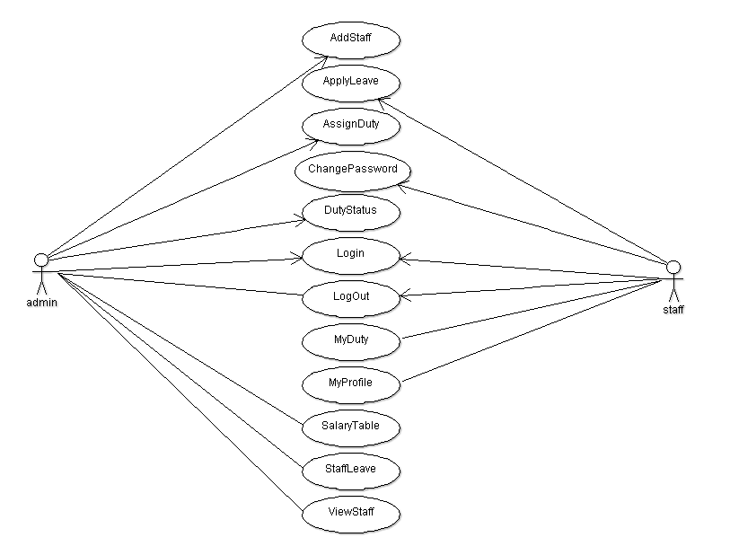

Figure 1 use case design

Database design

The database management system chosen for this project is MySQL. MySQL is a popular relational database management system that is embraced by many larger websites like twitter and Facebook, due to its ability of handling large set of data. MySQL is also very secure.

**ADD STAFF**

|  |  |  |  |  |
| --- | --- | --- | --- | --- |
| **Field Name** | **Type** | **Null** | **Extra** | **Unique** |
| Id | int (11) |  | AUTO_INCREMENT | YES |
| First name | varchar(45) |  |  |  |
| Last name | varchar(45) |  |  |  |
| Email | varchar(45) |  |  |  |
| Password | varchar(45) |  |  |  |
| Date of birth | varchar(45) |  |  |  |
| Gender | varchar(45) |  |  |  |
| Contact | varchar(45) |  |  |  |
| Address | varchar(45) |  |  |  |
| Department | varchar(45) |  |  |  |
| Degree | varchar(45) |  |  |  |

Table 2 add staff database design/table

**LOGIN**

|  |  |  |  |  |
| --- | --- | --- | --- | --- |
| **Field Name** | **Type** | **Null** | **Extra** | **Unique** |
| Username | varchar(45) |  | AUTO INCREMENT | YES |
| Password | varchar(45) |  |  |  |

Table 3 login database design/table

**EMPLOYEE LEAVE**

|  |  |  |  |  |
| --- | --- | --- | --- | --- |
| **Field Name** | **Type** | **Null** | **Extra** | **Unique** |
| Id | int (11) |  | AUTO INCREMENT | YES |
| Token | varchar(45) |  |  |  |
| Start date | int (11) |  |  |  |
| End date | int (11) |  |  |  |
| Reason | Int(11) |  |  |  |
| Status |  |  |  |  |

Table 4 Employee leaves database design/table

**ASSIGN DUTY/PROJECT**

|  |  |  |  |  |
| --- | --- | --- | --- | --- |
| **Field Name** | **Type** | **Null** | **Extra** | **Unique** |
| Project id | varchar(45) |  |  |  |
| Employee id | varchar(45) |  |  |  |
| Project name | varchar(60) |  |  |  |
| Due date | varchar(10) |  |  |  |
| End date | varchar(10) |  |  |  |
| Submission date | varchar(45) |  |  |  |
| Marks | Float |  |  |  |
| Status |  |  |  |  |

Table 5 Assign duty/project database design/table

# CHAPTER FOUR

# CODING AND INTEGRATION

## 4.1 Planning of Coding and Integration of System Component

The planning of coding and implementation of this Web App is that, i plan to code each and every page individually i.e. designing each page one after the other, in such a way that each page be must okay before moving to another one.

## 4.2 Key Implementation Decision

The key implementation of this website is that i decide to develop each and every part of the system step by step this method is called agile method in such a way that I must finish with first part before we move to second part.

## 4.3 Graphical User Interfaces

All The interfaces contained in this web are friendly that allow the user to enter information or record to the database. Below are interfaces with their corresponding properties:

## 4.4 System Environment/Interface

This web consists of the following pages:

* Main page
* Login page
* Staff dashboard
* Apply leave
* Change password
* Admin page
* Add staff

**MAIN PAGE**

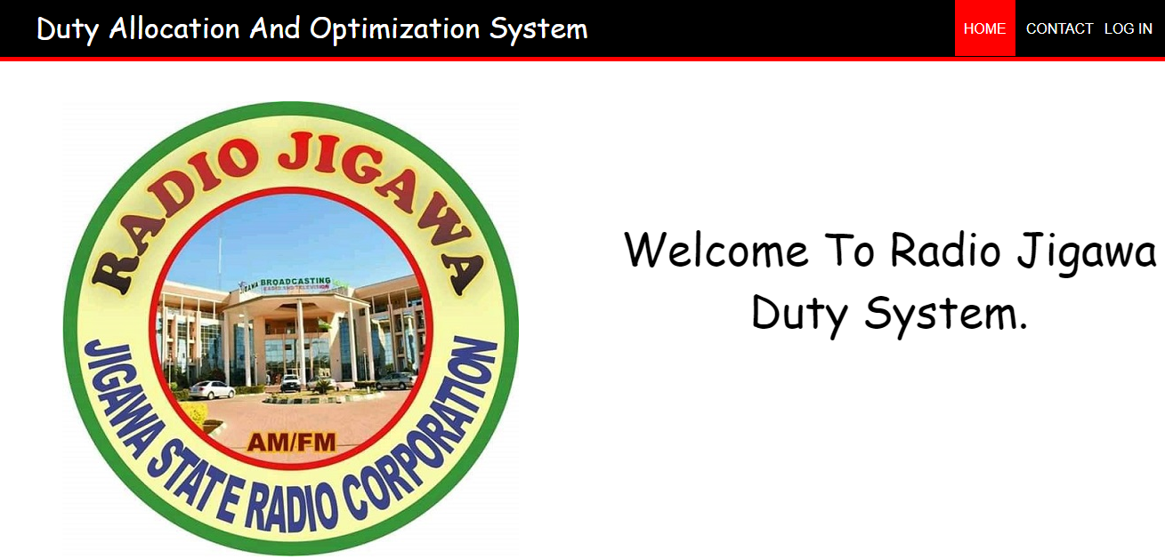

Figure 2 Main page

This is the interface that user will encounter with when visit this website. Where the user will decide on the action that system will perform i.e. by pressing Login the System will take you to the login page to let input username and password to log into the main pages, or contact to tell user detail about software authors or end the program by pressing Exit/close.

**Login Page**

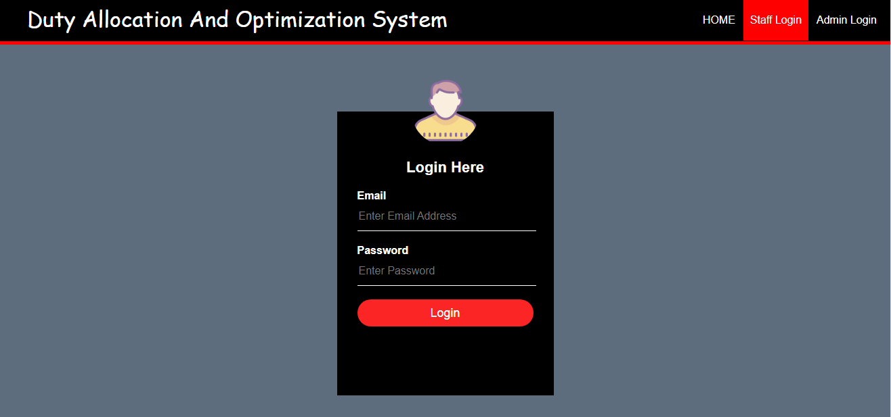

Figure 3 login page

The Login Page consists of two options (admin login and staff) with text boxes, namely email and Password; and a Login command button allowing the users to log into the system. The login page helps the users to log as a Staff who view the result, as an Administrator whose action is to allocate duty to staffs.

**STAFF DASHBOARD/PAGE**

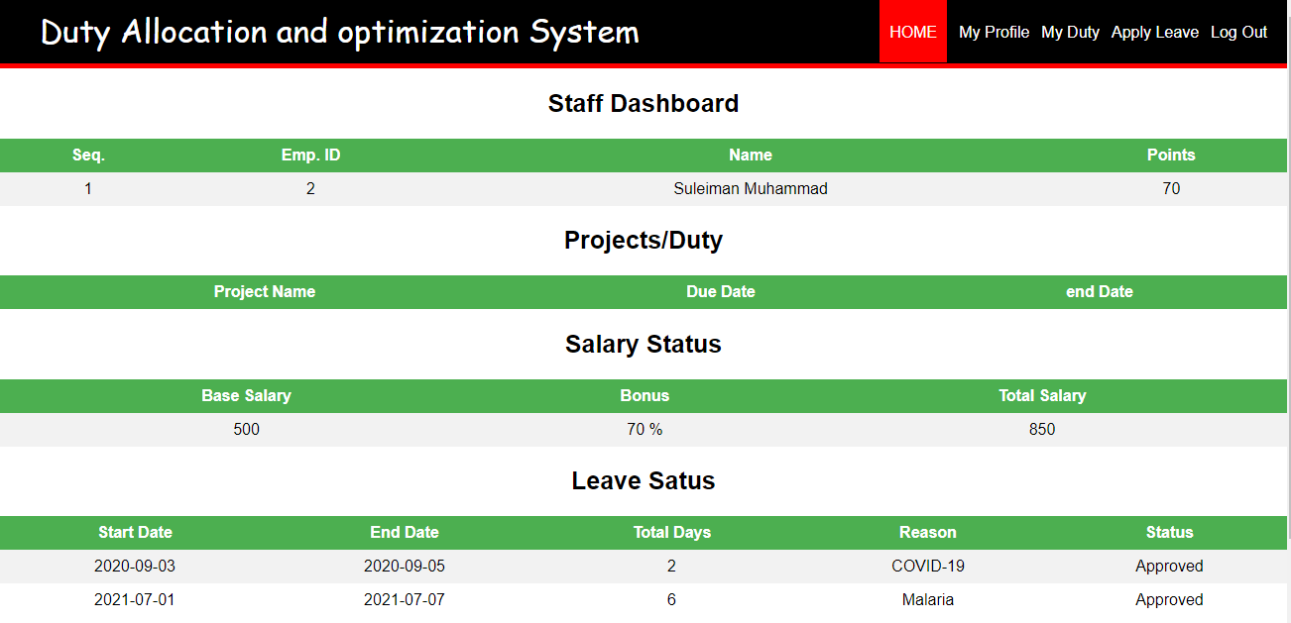

Figure 4 staff dashboard

This is where the staff can see his duty and other activities assign to him by the administrator also at this page he can make some changes to his profile and apply leave to the management.

**Apply leave**

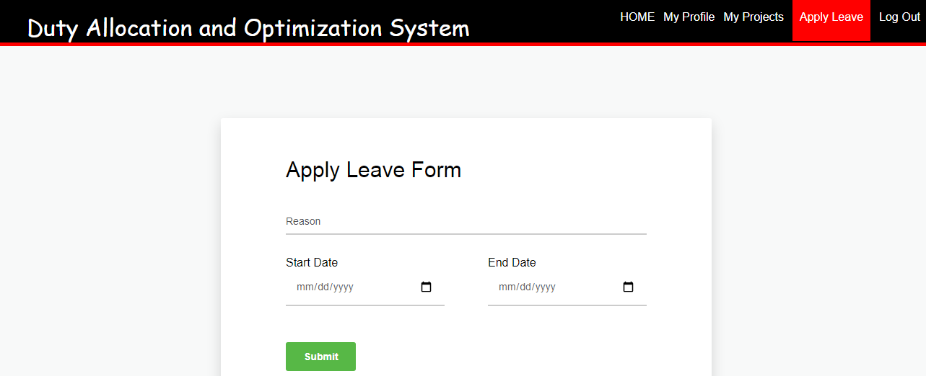

Figure 5 apply leave

The above page allow staff to apply request for leave and submit it to the admin for approval

**CHANGE PASSWORD**

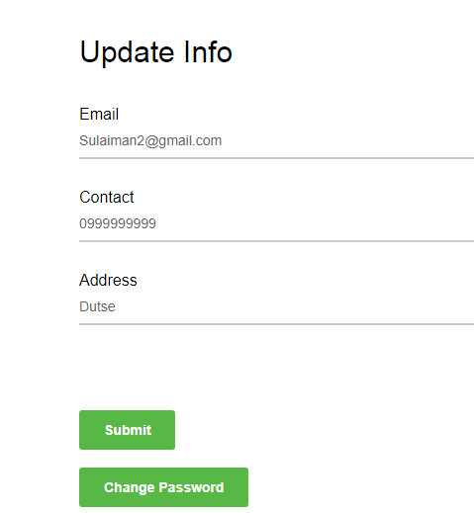

Figure 6 change password

At this page the staff/user can update or change his password with the effect to database.

**ADMIN PAGE**

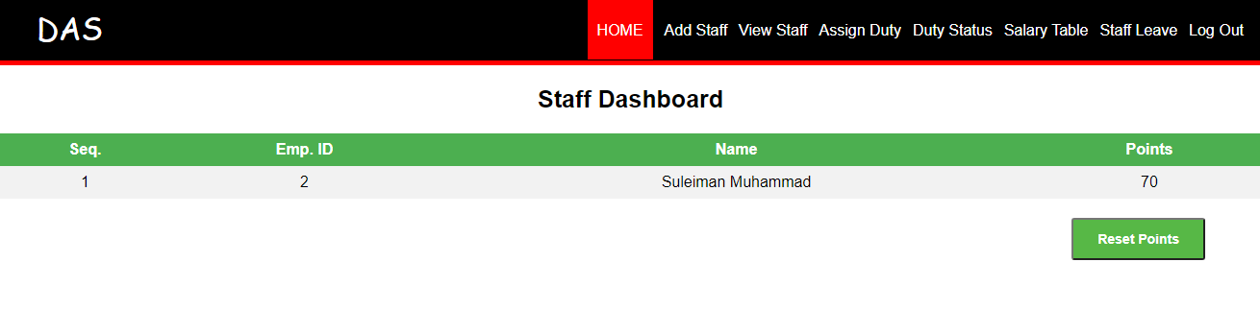

Figure 7 admin page

Various activities can be done through this page such as adding new staff, view all the staff, assign duty to each staff also admin can view the duty status of each staff, salary table, approval and denial of leave request made by the staff and some other activities.

**Add/Register new staff**

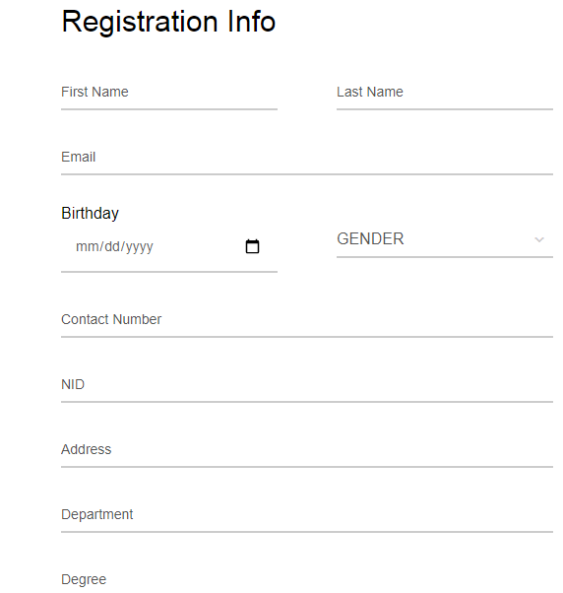

Figure 8 add/register staff page

The above page is where the admin can add or register new staff, it allow the admin to provide all necessary information related to user i.e personal information.

# CHAPTER FIVE

# SUMMARY

The project develops a duty allocation and optimization system for radio jigawa, where the management can update the schedule for staff’s roster through the system. It presents user-friendly features that will familiarize admin on the application. I use the HTML, CSS, and PHP as a front end and MySQL as the backend. After development, the website will served as a tool for the workers in the station to know their actual work time and some of their personal. The development of the site will be an effective aid for the instructors in teaching the basic operations of allocation to the staffs. It is also provided security to protect privacy and financial information of clients.

# CONCLUSION

Duty allocation and optimization System is a user-friendly Web-based system for managing broadcasting facilities in the station. It has been designed to automate, manage and look after the overall processing of schedule of staffs in their workplace. It is capable of managing request details, Staffs Details, Payment Details etc. The developed system provides solution to manual way of allocating duties problems and also provides information such as project information, duties information, and management information. The web offers stability, cost-effectiveness and usability. It provides the most flexible and adaptable standards management system solutions for radio station.

# RECOMMENDATION

This work has the following recommendation

**User Interface Development**

The next developer is recommended to create a more efficient and user-friendly web interface. This should include proper calendar-style roster display and more intuitive data input.

**Open Source Future**

The system can be adapted/modified to a number of purposes and needs by developers worldwide.

Any further work carried out on the system by myself (beyond the user interface as described above) will be primarily concerned with improving documentation and code style to facilitate open source development.

**Adaptation for Content Management Systems**

There are a number of freely available content management systems that use the LAMP architecture, and the SRS could quite readily be adapted to serve as a plugin/component for such systems.

**Other Potential Enhancements**

Any features on the Desirable Features list that weren't included in the finished project are potential future enhancements.

# Bibliography

Alfares, H. K. (2003). Survey. categorization and comparism of recent tour schedulling literatur. 145-175.

andreas T Ernst, H. J. (2004). A review of application, methods and models. *Staff scheduling and rostering*, 3-27.

Nanthavanij, S. (2003). performance analysis of ergonomics-based manual assembly line with parallel workstation and floaters. 33-47.

Neil Conway, R. B. (2001). FulL-Time versus Part-Time Employee . *Understanding the Links between Work Status, the Psychological Contract and Attitudes*, 5-8.

Sorawit Yaoyuenyong, S. N. (2006). Heuristic job rotation procedures for reducing daily Exposures to occupational hazard.

Boyd, D. E. (2008). Social networkn sites:Definition, history and schoolership. *journal of computer-mediated communication*, 210-230.

*w3schools/css/default.asp*. (2021, 5 23). Retrieved 5 23, 2021, from w3schools: www.W3schools.com