# Evaluating the Role of LiDAR Data in Agricultural Water Quality Planning

## Introduction

In 2013, Winrock International (Winrock), Delta Institute (Delta) and the Sand County Foundation (SCF) began work on the *Reducing Phosphorus Loads from Agriculture Project*, funded by the Great Lakes Protection Fund (GLPF). This ongoing project seeks to demonstrate a perfomance-based methodology to both incentivize agricultural producers to adopt runoff-mitigating practices and also provide downstream publicly-owned treatment facilities (POTWs) an alternative path to regulatory compliance, specifically as it pertains to Total Maximum Daily Loads (TMDLs) for phosphorus.

While this work was beginning, SCF, under a grant from the Fund for Lake Michigan (FFLM), conducted the *Planning for Trial Point/Non-point Water Quality Market* literature review, which recommended that an analysis LiDAR analysis be used to identify the areas of the Milwaukee River basin with significant potential for nutrient losses, citing that its integration with the Wisconsin Phosphorus Index would allow for accurate targeting of high-risk geographies. This report further evaluates this recommendation.

### Purpose

This report seeks to specifically assess LiDAR's capabilities as compared to other mapping technologies; using LiDAR in combination with NRCS, USGS and Wisconsin DNR data, including high resolution landcover, topographic data and cropland data, will enable the project team to project potential outcomes and determine the best approach for pinpointing high priority areas. The team will also evaluate the potential to utilize this high-resolution prioritization data to evaluate several producer outreach strategies that have been utilized throughout this and past projects.

### Approach

At the outset of this process, the team anticipated integrating available LiDAR data into an existing watershed model built using [ArcSWAT](http://swat.tamu.edu/software/arcswat/). However, after making two separate determinations, the team decided to take a different approach. First, it was determined that the *Reducing Phosphorus Loads* model would not be completed and validated in time to meet the timeframe constraints of this project and, thus, would not be ready to evaluate using LiDAR data. Second, during the course of the *Reducing Phosphorus Loads* project, the team learned that two researchers at Wisconsin DNR had begun building a tool specifically designed to prioritize agricultural runoff reduction activities utilizing high-resolution LiDAR data. The team reached out to Wisconsin DNR and obtained an early version of the tool, which would later be named Erosion Vulnerability Assessment for Agricultural Lands (EVAAL).

According to Wisconsin DNR staff, EVAAL is not designed to provide an assessment of performance on specific farms, but rather, to provide a rapid assessment of agricultural lands' vulnerability to soil erosion and nutrient export.

EVAAL is also designed to work with readily-available datasets, making it relatively easy to apply to a wide range of geographies, pending availability of the data required to run the tool.

For this project, the team evaluated the outputs of EVAAL from two distinct conditions: the tool would be run once using high resolution LiDAR data and once again using a readily-available 10-meter digital elevation model (DEM). The results were then compared to one another at several different scales.

#### Data

The EVAAL tool requires the user to provide a number of datasets, but can also automatcially download other datasets provided an internet connection is available. These datasets are outlined in the table below.

|  |  |  |  |
| --- | --- | --- | --- |
| Data | Source | Automatic? | LiDAR or DEM |
| Watershed boundary | USGS | No | Both |
| Culvert polylines | Manual delineation | No | LiDAR |
| LiDAR | WisconsinView | No | LiDAR |
| 10m DEM | National Elevation Dataset | No | DEM |
| Frequency- Duration Precipitation | National Weather Service | Yes | Both |
| Gridded SSURGO | USDA - NRCS | No | Both |
| Cropland Data Layer | USDA - NRCS | Yes | Both |

There are a number of intermediate datasets that are generated by EVAAL as the user progresses through each step in the process. These intermediate datasets are required in order to complete the EVAAL process, but can also be used for visualization or additional analysis. These intermediate datasets are outlined in the table below:

|  |  |  |
| --- | --- | --- |
| Data | EVAAL Step | Description |
| Conditioned DEM | 6.1 | DEM incorporating culvert polylines |
| Optimized Fill | 6.1 | Modified DEM wherein all water drains off the landscape |
| Frequency-Duration layer | 6.2.1 | Amount of precipitation for a given frequency and duration |
| Curve raster number (high) | 6.2.2 | Estimated runoff assuming poor BMPs |
| Curve raster number (low) | 6.2.2 | Estimated runoff assuming preferable BMPs |
| Internally draining areas | 6.2.3 | Areas of the landscape not connected to surface waters |
| DEM excluding IDA's | 6.2.3 | Conditioned DEM excluding internally draining areas |
| Reconditioned DEM | 6.3 | Original DEM, conditioned without internally draining areas |
| Stream Power Index | 6.4 | Index of a given area's potential for gully erosion |
| K factor | 6.5.1 | Erodability of the soils in the area of interest |
| Crop rotation | 6.5.2 | Crop rotation estimated from cropland data layers |
| C factor, high estimate | 6.5.2 | Adjustment of soil loss based on land cover and management |
| C factor, low estimate | 6.5.2 | Adjustment of soil loss based on land cover and management |
| Soil loss index | 6.5.3 | Soil loss calculated using USLE |
| Erosion vulnerability index | 6.6 | Locations most susceptible to sheet, rill and gully erosion |

#### Geography

For this evaluation, selection of an appropriate geography was an important decision requiring the balance of several factors:

1. It was desirable to select a subwatershed that could inform and be informed by the project team's ongoing work in the Milwaukee River Basin.
2. The target geography would need readily available high-resolution LiDAR data.
3. Due to the nature of the analysis, it was desirable to select a geographic comprised primarily of agricultural land use.

While LiDAR data can easily be obtained via <http://www.wisconsinview.org/>, not every county in Wisconsin has yet acquired and processed LiDAR data, excluding any watersheds that happen to fall across a county without available LiDAR data. Unfortunately, this was the case for every preferable (within ongoing project geography, primarily agricultural land use) HUC12 watershed examined. As a result, the project team sub-divided a single HUC12 watershed in order to meet each of the above parameters. This was done by first conducting sub-watershed delineation using [ArcSWAT](http://swat.tamu.edu/software/arcswat/), then selecting a sub-set of sub-watersheds within the LiDAR coverage area.

The selected sub-watershed is 27.2 square kilometers in area, falling below the 75 square kilometer threshold suggested in the documentation provided with the EVAAL tool.

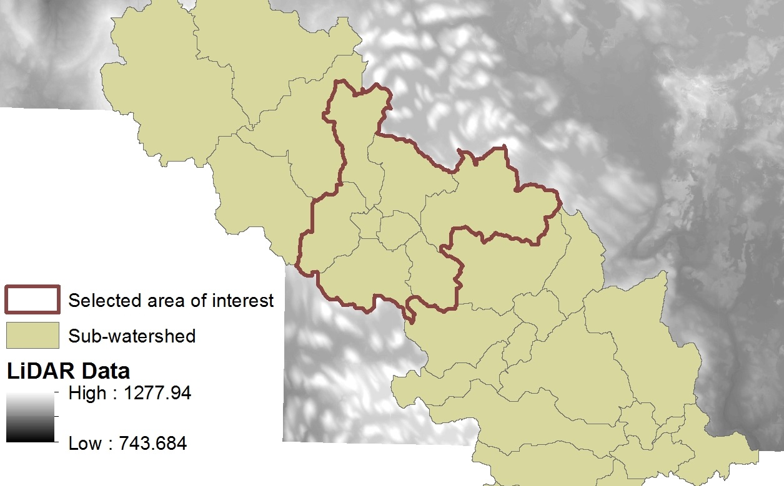

subwatershed

## Process

### Data Collection

### Running the EVAAL Tool

### Providing Feedback to Wisconsin DNR

### Analysis

#### Identifying Opportunities for BMPs

#### Identifying High Priority CLUs

## Findings

### EVAAL Applicability

#### Identifying a Suitable Geography

While the outputs of the EVAAL tool can be useful for a wide range of watershed-level analysis, including prioritization of outreach to land owners with high potential for mitigation soil loss, not all potential project geographies are suitable. During this process, area of interest selection was primarily limited by inconsistent availability of LiDAR data. This is especially notable since this project was focused on Wisconsin, a state with an unusually high level of data accessibility and coordinated LiDAR data acquisition strategy. Other states with less coordinated LiDAR-related activities may be significantly more limiting.

#### Prioritization vs. Performance Evaluation

The creators of the EVAAL tool make it clear that the tool is not intended to be used to evaluate performance on individual parcels of land or to quantify whole-watershed runoff figures. Rather, the EVAAL tool is specifically intended to aid watershed managers, project developers and other interested stakeholders in prioritizing their work, specifically as it concerns erosion mitigation. This is particularly notable for the state of Wisconsin, which has officially adopted a field-scale agricultural nutrient management planning tool called [SnapPlus](http://snapplus.wisc.edu/). SnapPlus is specifically designed to evaluate field-level nutrient losses and to help farmers plan to take measures to mitigate those losses.

This contrast between approaches - field-level evaluation vs watershed-scale prioritization - illustrates a potential for a more robust, multi-scale system for planning mitigation work within a watershed. The project team recommends future work be done to better understand how these tools can be utilized in tandem to create a more complete picture of a watershed.

### LiDAR vs DEM

compare CLU rankings (EVI) histogram of values for each EVI and compare discuss time required to run each

#### CLU Ranking

EVAAL includes a function to summarize the erosion vulnerability index (EVI) by subdivision chosen by the user. Because this project is being done in the context of agricultural nutrient management, the EVI data was subdivided by USDA Common Land Unit (CLU) to simulate the prioritization of outreach to farmers within a watershed. USDA defines a CLU as:

...the smallest unit of land that has a permanent, contiguous boundary, a common land cover and land management, a common owner and a common producer in agricultural land associated with USDA farm programs. CLU boundaries are delineated from relatively permanent features such as fence lines, roads, and/or waterways.

As outlined in step 6.6 of the official EVAAL tutorial, two CLU summary tables were generated: one based on 10-meter DEM data and the other based on the LiDAR-derived DEM. This was done to identify the degree of overlap between each dataset within a smaller subset of data. The table below illustrates the difference between two subsets (the top ten CLUs from each dataset, ranked by mean EVI) of ranked CLUs. Only three CLUs from the respective top ten CLU subsets overlapped and, while the relative position between those three CLUs was consistent, the mean EVIs differed by between 10 and 20%, demonstrating a significant sensitivity to input DEM data.

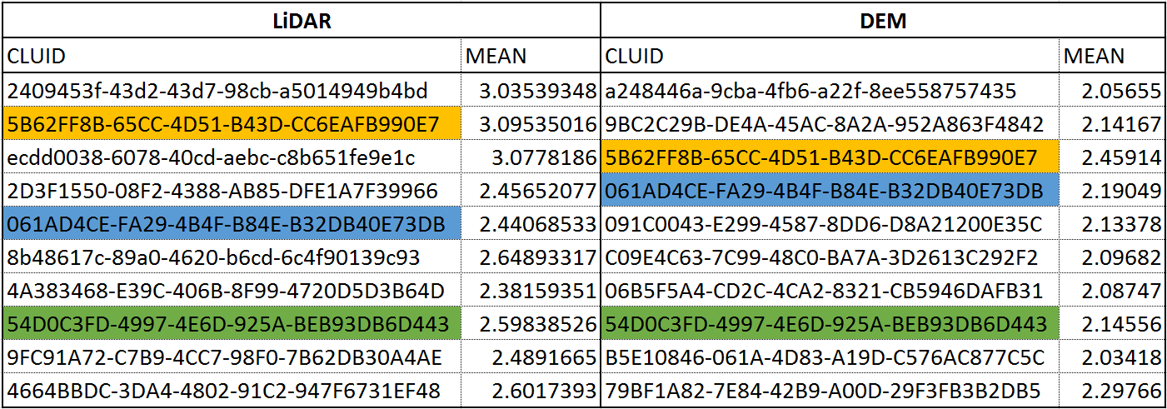

Top 10 CLUs

#### Internally-Drained Areas

Another major differentiator between the 10-meter and LiDAR-derived DEM-derived results was the lack of internally-draining areas from the 10-meter DEM data. The EVAAL tool identifies internally-draining areas by utilizing:

1. The conditioned DEM and optimized fill rasters generated in step 6.1
2. The curve number raster generated in step 6.2.2 (note: the user must choose either the high or low estimated curve raster number)
3. The frequency-duration raster generated in step 6.2.1 (note: the frequency-duration raster is dependent on the users' selection of a design storm duration and frequency. The default is 10 years-24 hours, but this value can be changed)

For the purposes of this investigation, only the default duration-frequency was tested and it is possible that different parameters could result in delineation of internally-draining areas. However, the results used for this analysis did not include any internally-draining areas. Because EVAAL excludes internally-draining areas in the process of generating the EVI, the area modeled to determine 10-meter DEM-derived data is slightly higher.

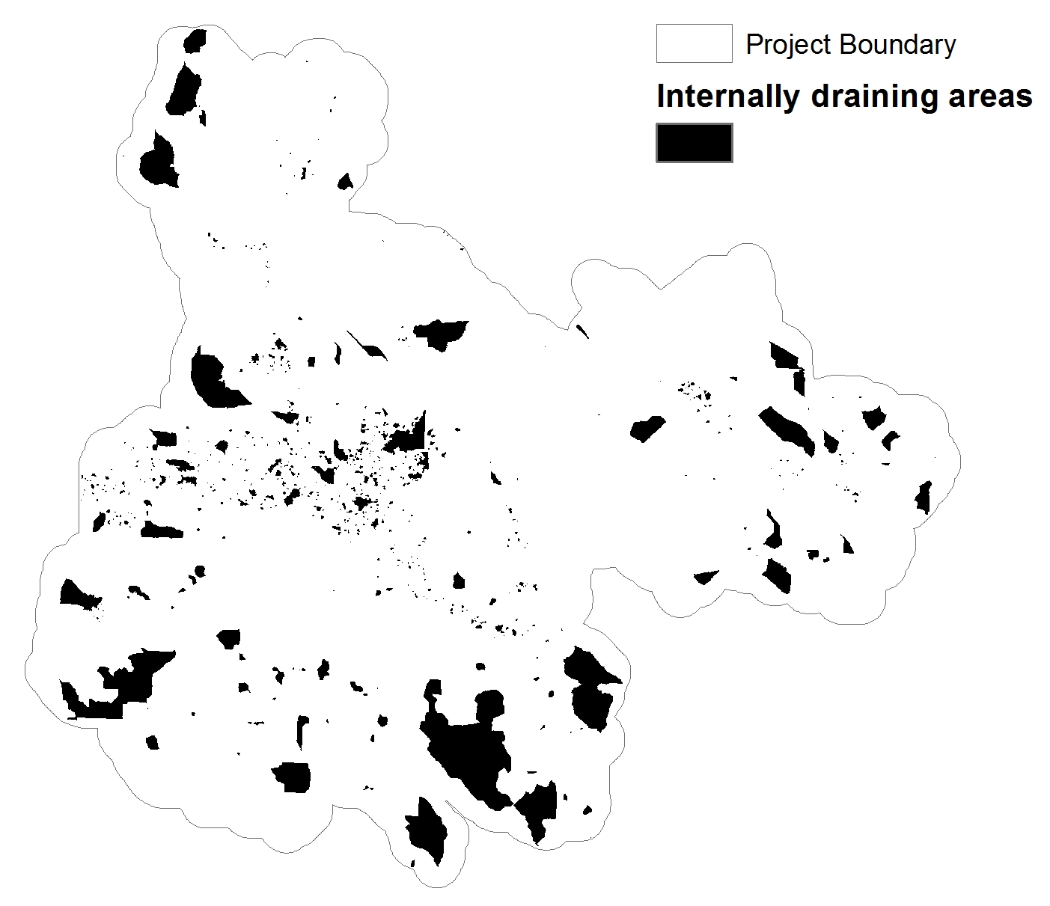

Internally-draining areas

## Next Steps

### Apply EVAAL Tool

to real-world project from the beginning. Timing of EVAAL tool realase, etc

### In Combination with Field-Scale Model Outputs

EVAAL team's validation methods, p.19, methods doc.

work with SnapPlus team to determine feasibility of integrating the two tools for field- and watershed-scale perspective